KLYARA the back office for building firms

Subcontractor Agreement
Part A, for when Klyara engages a bookkeeper. Part B, for when a Klyara client engages a trade subcontractor.

Read this before you use this document
This is a working template. It has been drafted carefully and checked against the sources listed at the end, but it is not legal advice and it has not been settled by a solicitor. Have it reviewed by a solicitor, or by the Institute of Certified Bookkeepers, before you issue it to anybody. And it cannot be used to take on a bookkeeping client until Klyara's AML supervision is in place — an ICB Practice Licence includes AML supervision and takes about 28 days to process. Until that licence is granted, Klyara cannot lawfully carry on bookkeeping by way of business.

TWO AGREEMENTS IN ONE DOCUMENT
Part A is the agreement Klyara uses when it takes on a subcontract bookkeeper — someone doing client work on Klyara's behalf. Part B is a separate template our clients can adapt when they take on a trade subcontractor. They share the same spine but they are not the same document and they must not be mixed up.
Which part do you need?
If you are | Use | Because
Klyara, hiring a bookkeeper | Part A | Not a construction operation, so no CIS
A builder, hiring a trade subbie | Part B | CIS, verification and retentions all apply
Klyara, hiring an office junior | Neither | That is employment. Use the Hire Pack.

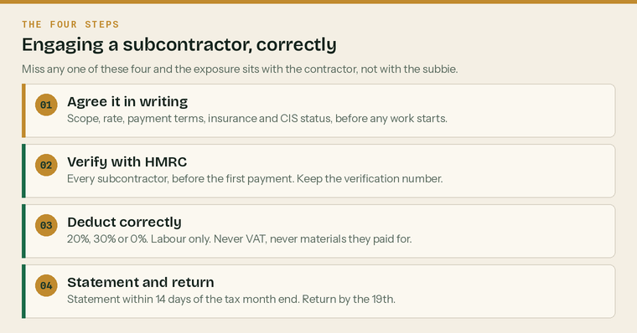
The four steps in engaging anybody. Both parts of this document follow them.
A written agreement does not settle employment status
This is the single most important sentence in this document. HMRC looks at what actually happens on the ground, not at what the paperwork says. A subcontractor who works only for you, on your hours, with your tools, is an employee no matter what either of you signed. Use HMRC's Check Employment Status for Tax tool, print the result, and keep it in the file.

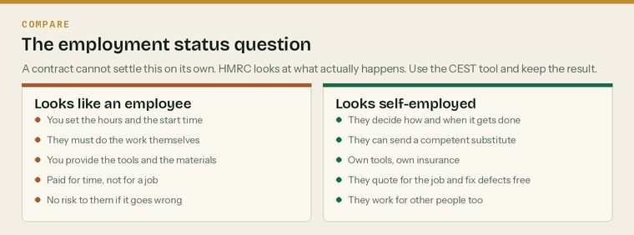
What HMRC actually looks at. Read this before you sign anything.
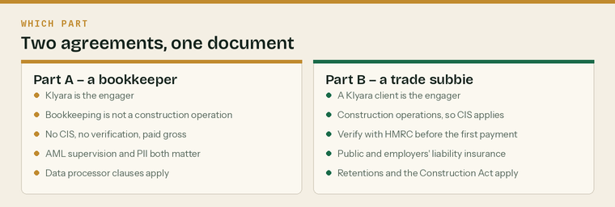
The two parts, side by side. They share a spine but they are not interchangeable.
Part A — Klyara engaging a subcontract bookkeeper

This agreement is between Klyara and the subcontractor named below. It covers a bookkeeper, payroll clerk or VAT specialist doing work on Klyara's behalf for Klyara's clients.
Subcontractor's name
Trading name, if any
Address
UTR
Company registration number, if a company
VAT number, if registered
Professional body and membership number | ICB, AAT, ICAEW, ACCA or none
AML supervisor and registration number
Professional indemnity insurer and cover | £
Start date
Rate | £ per hour, or per job

Before Part A is signed
 | Professional body membership confirmed | ICB, AAT, ICAEW, ACCA or none
 | AML supervision confirmed, or working under ours | Never assume it
 | Professional indemnity certificate seen | And the expiry diarised
 | Identity verified | The same check we run on clients
 | CEST run and the result printed | By both of us
 | Rate and payment terms agreed in writing | Before the first instruction

A1 — What the subcontractor does

A1.1 The subcontractor will carry out the work described in each written instruction from Klyara. Each instruction states the client, the work, the deadline and the fee.
A1.2 The subcontractor is not obliged to accept any particular piece of work, and Klyara is not obliged to offer any. There is no mutuality of obligation between instructions.
A1.3 The subcontractor decides how the work is done, and when, provided the deadline is met and the work meets professional standards.
A1.4 The subcontractor may send a suitably qualified and AML-supervised substitute, having told Klyara first. The subcontractor remains responsible for the substitute's work and pays them.
A2 — Status, tax and CIS

Bookkeeping is not construction work, so CIS does not apply to Part A
The Construction Industry Scheme applies to construction operations. Book-keeping for a construction firm is not a construction operation, so a subcontract bookkeeper is paid gross and accounts for their own tax. Part B is where CIS bites. Do not apply a CIS deduction to a bookkeeper's invoice, and do not include them on a CIS return.

A2.1 The subcontractor is self-employed and is responsible for their own income tax, National Insurance, VAT and any Corporation Tax.
A2.2 The subcontractor is not an employee or a worker of Klyara, is not entitled to holiday pay, sick pay, pension contributions or notice, and has no right to be offered work.
A2.3 Klyara and the subcontractor will each complete HMRC's Check Employment Status for Tax tool at the start of the engagement and again if the working pattern changes materially. The result is kept on file by both.
A2.4 If HMRC determines that the relationship was employment, the subcontractor will indemnify Klyara for the tax and National Insurance properly due, but not for any penalty arising from Klyara's own failure to keep records.
Take advice on clause A2.4 before using it
Status indemnities of this kind are common and they are also frequently unenforceable or commercially worthless — a sole trader with no assets cannot indemnify anybody. Treat it as a statement of intent, not as protection. The protection is getting the arrangement right in the first place.

A3 — Insurance

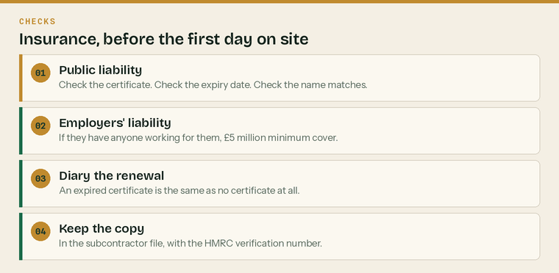
Insurance checks. All four, before the first day.
A3.1 The subcontractor will hold professional indemnity insurance of not less than £[COVER] for the duration of this agreement and for six years afterwards, and will produce the certificate on request.
A3.2 The subcontractor will hold public liability insurance and, if they employ anybody, employers' liability insurance covering at least £5 million.
A3.3 The subcontractor will tell Klyara immediately if any policy lapses, is cancelled, or is not renewed.
A4 — Confidentiality and data protection

Who is what | Which means
Klyara is the controller | We decide what data is collected and why
The subcontractor is the processor | They act only on our written instructions
The client is the data subject | The rights in our Privacy Notice are theirs

A4.1 Everything the subcontractor sees about a Klyara client is confidential, during the engagement and permanently afterwards.
A4.2 Where the subcontractor handles personal data on Klyara's instructions they act as a processor and Klyara is the controller. The subcontractor will process personal data only on Klyara's written instructions, keep it secure, help Klyara answer rights requests, tell Klyara of a personal data breach without undue delay, and delete or return the data at the end of the engagement.
A4.3 The subcontractor will not engage a sub-processor without Klyara's written consent.
A4.4 The subcontractor will use Klyara's systems and not their own storage for client data, will not email client data to a personal address, and will not hold client data on an unencrypted device.
Clause A4.2 is a controller-to-processor contract and it has required content
UK GDPR Article 28 sets out what such a contract must contain. The wording above covers the substance but a solicitor should confirm it before it is relied on. The ICO publishes guidance on the required clauses.

A5 — AML

A5.1 The subcontractor confirms they are supervised for anti-money-laundering purposes, or that they work exclusively under Klyara's supervision and within Klyara's AML policies.
A5.2 The subcontractor will report anything suspicious to Klyara's Money Laundering Reporting Officer and will not tip off the client.
A5.3 The subcontractor will complete Klyara's AML training annually and keep the record.
The data rules, in six lines
 | Only on Klyara's written instructions |  | Klyara's systems, never personal storage
 | No client data to a personal email address |  | No client data on an unencrypted device
 | A breach reported to Klyara without delay |  | Everything deleted or returned at the end

A6 — Fees, and ending it

Money | Terms
Rate | £[RATE] per hour, or as agreed per job
Invoicing | Monthly, itemised by client and job
Payment | Within [14] days of a correct invoice
Notice | [30] days, either side
Immediate termination | Serious breach, lapsed insurance, lapsed AML supervision

A6.1 Klyara pays the agreed rate within [14] days of a correct invoice.
A6.2 The subcontractor invoices monthly, itemised by client and by job.
A6.3 Either party may end this agreement on [30] days' written notice. Work already instructed is completed and paid for.
A6.4 Klyara may end it immediately for a serious breach, for a lapse of insurance or AML supervision, or for conduct that would embarrass Klyara in front of its professional body.
A7 — Clients

A7.1 For [12] months after the engagement ends, the subcontractor will not solicit or accept work directly from a Klyara client they worked on, except with Klyara's written consent.
A7.2 This does not prevent a client choosing to move of their own accord, and it does not restrict the subcontractor's general practice.
Restrictive covenants are enforceable only so far as they protect a legitimate interest
Twelve months and named clients is at the reasonable end. A blanket ban on working for any construction firm in Surrey is not, and a court will strike it out entirely rather than narrow it. Keep it tight or it protects nothing.

Signatures
The subcontractor | [name]
Signed | Print name
Position | Date
Klyara | [name], for Klyara
Signed | Print name
Position | Date

Part B — For a client engaging a trade subcontractor

This part is for our clients to adapt, not for Klyara to use
Klyara does not engage bricklayers. Part B exists because our clients constantly ask for it and because most of them are working from a verbal agreement and a WhatsApp thread. Klyara does not give employment law advice — this is a template to take to a solicitor, not a substitute for one.

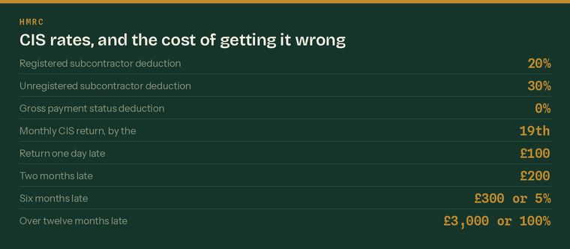
The CIS rates, and what a late return costs. All fixed by HMRC.
Contractor (you)
Subcontractor's full name
Trading name and structure | sole trader, partnership or limited company
Address
UTR
National Insurance number | sole traders
Company registration number | if a limited company
VAT number | if registered
HMRC verification number | obtained before the first payment
Deduction rate HMRC gave you | 20%, 30% or 0% gross
Public liability insurer and cover | £
Employers' liability insurer, if they have staff | £5m minimum
Bank details, confirmed by phone

Before Part B is signed
 | UTR and CIS registration status obtained | Without it, deduct at 30%
 | HMRC verification done and the number recorded | Before the first payment
 | Right-to-work check done and copied | Before the first day on site
 | Insurance certificates seen and diarised | Public liability, and employers' if they have staff
 | Cards and tickets checked | CSCS, and anything the site requires
 | Bank details confirmed by phone | On a number you already had

B1 — The work

B1.1 The subcontractor will carry out the work described in each order or quotation. Each order states the site, the work, the price or rate, and the programme.
B1.2 The subcontractor decides how the work is done, subject to the site rules, the programme, and health and safety.
B1.3 The subcontractor provides their own tools and small plant unless the order says otherwise.
B1.4 The subcontractor may send a competent substitute, having told the contractor first.
B1.5 The subcontractor will put right defective work at their own cost.
B2 — CIS

B2.1 The subcontractor confirms whether they are registered with HMRC under the Construction Industry Scheme, and gives their UTR.
B2.2 The contractor will verify the subcontractor with HMRC before the first payment and will apply the deduction rate HMRC gives: 20% for a registered subcontractor, 30% for one who is not registered or cannot be matched, and 0% for one with gross payment status.
B2.3 The deduction is applied to the labour element only. It is not applied to VAT, to materials the subcontractor paid for directly, to plant hire for the job, to consumable stores, or to fuel other than for travelling. The subcontractor will show the materials split on every invoice.
B2.4 The contractor will give the subcontractor a payment and deduction statement within 14 days of the end of the tax month, and will file the monthly CIS return by the 19th, including nil returns.
B2.5 If the subcontractor's status changes — they register, they gain or lose gross payment status — they will tell the contractor immediately.
If this happens | What it costs
Subcontractor not verified before payment | Deduct at 30%, and the exposure is the contractor's
Monthly return one day late | £100
Return two months late | £200
Return six months late | £300 or 5% of the deductions, whichever is higher
Return over twelve months late | Up to £3,000 or 100% of the deductions
Statement not issued within 14 days | A compliance failure, and the subbie cannot evidence their reclaim

B3 — Employment status

B3.1 The subcontractor is engaged as a self-employed contractor and is responsible for their own tax and National Insurance, subject to CIS deductions.
B3.2 The subcontractor is not an employee or a worker and is not entitled to holiday pay, sick pay, pension contributions or notice.
B3.3 Both parties acknowledge that this clause does not determine status. Status is determined by the reality of the working relationship. Both will complete HMRC's Check Employment Status for Tax tool at the start and keep the result.
The five questions worth asking honestly
 | Could they send somebody else in their place? | If not, that points to employment
 | Do they decide how the work gets done? | If you supervise closely, that points to employment
 | Do they provide their own tools? | If you provide everything, that points to employment
 | Do they carry any financial risk? | Fixed-price jobs and free defect repairs point to self-employment
 | Do they work for anybody else? | Exclusivity over years points to employment

B4 — Insurance and site

Cover | Who needs it | Minimum
Public liability | Every subcontractor | £[COVER], set by the job
Employers' liability | Any subbie who employs anybody | £5,000,000
Professional indemnity | Designers, and design-and-build | As the contract requires
Tools and plant | Their own problem, not yours | Their choice

B4.1 The subcontractor will hold public liability insurance of not less than £[COVER] and, if they employ anybody, employers' liability insurance of at least £5 million.
B4.2 Certificates are produced before the first day on site and on each renewal.
B4.3 The subcontractor will comply with the site rules, the CDM regulations, and all reasonable health and safety instructions, and will hold the relevant cards and certificates for the work.
B4.4 The subcontractor will provide their own PPE.
B5 — Payment, retention and ending it

B5.1 The contractor pays within [30] days of an agreed invoice or application, subject to CIS.
B5.2 Retention of [x]% is held and released [on practical completion / at the end of the defects period]. Every retention held is recorded on the retention schedule with a release date.
B5.3 Either party may end an order on [7] days' written notice. Work properly done is paid for.
B5.4 The contractor may end it immediately for a serious health and safety breach, for lapsed insurance, or for defective work not put right.
Payment terms in construction are regulated
The Housing Grants, Construction and Regeneration Act 1996 — the Construction Act — controls payment notices, pay-less notices and the right to suspend for non-payment on most construction contracts. A payment clause that ignores it may not be effective. This is the clause in Part B that most needs a construction solicitor.

Retention, and where it goes wrong
 | Every retention recorded on the schedule | Job, amount, release date
 | Release dates diarised, both ways | What is held from you, and what you hold
 | Applications and valuations kept | They are the evidence for the release
 | Defects period end date recorded | The second release usually hangs on it

B6 — Confidentiality

B6.1 The subcontractor will keep the contractor's prices, client list and commercial terms confidential, during the engagement and afterwards.
B6.2 The subcontractor will not photograph or publicise the site without written consent.
Signatures
The subcontractor | [name]
Signed | Print name
Position | Date
The contractor | [name]
Signed | Print name
Position | Date

Sources
Every figure and deadline in this document was checked against the page listed beside it on Wednesday 26 August 2026. Re-check before each use — thresholds and penalties change.
What was checked | Source
CIS deduction rates 20% / 30% / 0%, what is excluded, statements within 14 days | https://www.gov.uk/what-you-must-do-as-a-cis-contractor/make-deductions-and-pay-subcontractors
Monthly return by the 19th, nil returns, late filing penalties | https://www.gov.uk/what-you-must-do-as-a-cis-contractor/file-your-monthly-returns
Contractor's duty to verify, and to consider employment status | https://www.gov.uk/what-you-must-do-as-a-cis-contractor
Who registers for CIS, and that a higher rate applies if unregistered | https://www.gov.uk/what-is-the-construction-industry-scheme
Employment status — self-employed contractor, and the online status check | https://www.gov.uk/employment-status/selfemployed-contractor
Employers' liability insurance — £5m minimum, £2,500 a day penalty | https://www.gov.uk/employers-liability-insurance
Right-to-work checks before employment, records kept 2 years after | https://www.gov.uk/check-job-applicant-right-to-work
ICB Professional Conduct Regulations — PII, AML supervision, Rule 27 | https://www.bookkeepers.org.uk/out/262546/ICB-Professional-Conduct-Regulations.pdf

