KLYARA the back office for building firms

Subcontractor Onboarding Pack
Everything to collect before a subcontractor is paid a penny. One sheet per subbie, kept in their file.

WHY THIS EXISTS
Every unverified subcontractor is a 30% deduction the contractor should have made and usually did not. Every missing insurance certificate is a claim waiting to land on the contractor. Every subbie who works only for you, on your hours, with your tools, is an employment status argument you will lose.
None of that is difficult to avoid. It is six pieces of paper collected once, before the first payment, and diarised for renewal. This pack is those six pieces of paper.
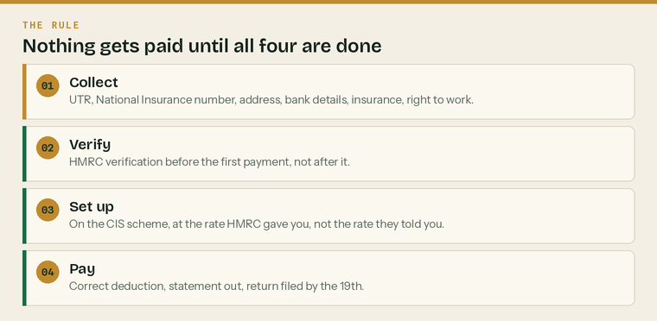
The rule. All four, before the first payment, with no exceptions for anybody.
The one rule that makes this work
Nothing gets paid until the file is complete. Not a part payment, not a sub, not £200 in cash to keep somebody going over the weekend. The moment there is an exception, there is always an exception, and the file never gets finished.

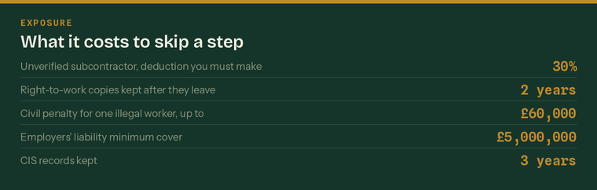
What it costs to skip a step. Every figure here is set by HMRC or the Home Office.
Print one of these per subcontractor
 | Keep it at the front of their file |  | Diary every expiry date on it
 | Review it when they come back after a break |  | Re-verify anybody you have not paid for two tax years

The subcontractor file

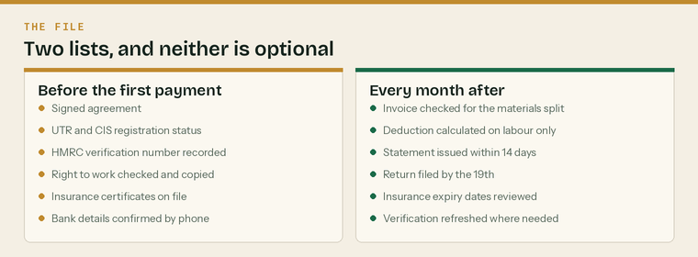
Two lists. The left one is before the first payment. The right one is every month after.
1 — Who they are
Full name | as it appears on their ID
Trading name
Structure | sole trader, partnership or limited company
Address
Postcode
Mobile
Email
Date of birth
Trade | groundworks, electrical, roofing, plastering
Date first engaged

2 — Tax and CIS
UTR | 10 digits. Without it, deduct at 30%.
National Insurance number | sole traders and partners
Company registration number | limited companies
Company UTR | limited companies
VAT number | if registered
Date verified with HMRC
HMRC verification number | record it exactly as HMRC gave it
Deduction rate HMRC gave | 20%, 30% or 0%

Registered with HMRC under CIS
 | Yes |  | No |  | Cannot be matched

Gross payment status
 | Yes |  | No |  | Not sure

Use the rate HMRC gave you, not the rate they told you
A subcontractor saying “I'm on twenty” is not evidence of anything. Verification is a call or an online check that takes two minutes and produces a number. If you cannot produce the verification number, treat them as unverified and deduct at 30%. That is not being difficult. It is the only position that leaves the exposure with the right person.

3 — Right to work
Check before the first day, for everybody, including people you have known for years and including British citizens. Checking only the people who look or sound foreign is unlawful discrimination.
How the check was done
 | Original documents |  | Home Office online share code |  | Certified identity provider

Date of check | must be before work starts
Document seen | passport, birth certificate plus NI evidence, share code
Document expiry, if time-limited | diary a follow-up check
Who did the check
Copy taken and dated | yes or no

Two years after they stop, and up to £60,000 if you get it wrong
Keep the copy for the whole time they work for you and for two years afterwards. The civil penalty for employing someone without the right to work is up to £60,000 per worker, and knowingly doing it carries up to five years' imprisonment and an unlimited fine. A correct check, done before they start, is a statutory excuse. Done afterwards, it is worth nothing.

4 — Insurance
Public liability insurer
Policy number
Cover | £
Expiry date | diary it
Employers' liability insurer | only if they employ anybody
Policy number
Cover | £5 million minimum
Expiry date | diary it

 | Certificate seen and copied | Not a screenshot of a renewal quote
 | Name on the certificate matches the name on the invoice | A surprisingly common failure
 | Cover is appropriate to the work | Roofing and groundworks need more than second fix
 | Expiry date diarised | An expired certificate is no certificate

5 — Cards, tickets and competence
CSCS card type and number
Expiry
Trade qualifications or tickets | Gas Safe, NICEIC, IPAF, PASMA, asbestos awareness
Expiry dates
Anything the site specifically requires

6 — Payment details
Account name
Sort code
Account number
Confirmed verbally on | date
Confirmed with whom | and on which number

Ring the number you already had, not the one on the email
Changed bank details arriving by email are the most common fraud in construction. Ring the mobile you have had for two years, say the last four digits back to them, and write down who you spoke to and when. It takes ninety seconds and it has saved firms five-figure sums.

7 — The agreement
 | Written agreement signed, before any work |  | Rate or price agreed in writing
 | Payment terms agreed in writing |  | Retention terms agreed, if any
 | CEST employment status check run and printed |  | Result of the CEST check filed

The month, once they are on

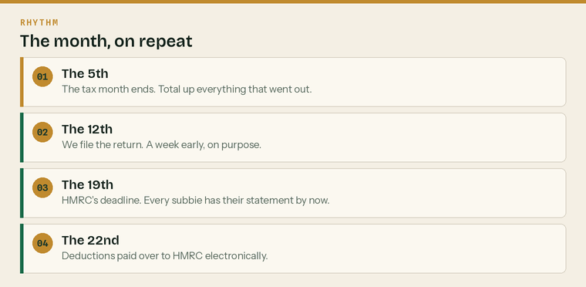
The same four dates every month, from the day they start.
Date | What happens | Who
The 5th | Tax month ends. Total the payments made to each subcontractor. | Klyara
The 10th | Records to Klyara — invoices, applications, payments made. | You
The 12th | Monthly CIS return filed, a week ahead of the deadline. | Klyara
The 19th | HMRC deadline. Statements issued to every subcontractor by now. | Klyara
The 22nd | CIS deductions paid over to HMRC electronically. | You

Checking the invoice before it is paid
 | Materials shown separately | You do not deduct CIS on materials they paid for
 | VAT treated correctly | Reverse charge, in most cases, between construction businesses
 | Plant hire shown separately | Excluded from the deduction
 | Labour figure is what the deduction is calculated on | Labour only, nothing else
 | Invoice matches the order or the application | Not the other way round

What CIS is actually deducted from
Take the gross invoice. Take off VAT, materials the subcontractor paid for directly, plant hire for the job, consumable stores, fuel other than for travelling, and manufacturing or prefabricating materials. Whatever is left is the labour, and that is what the 20% or 30% comes off.

Renewals to diary
What | When to check | What happens if it lapses
Public liability insurance | One month before expiry | They stop work until it is renewed
Employers' liability insurance | One month before expiry | They stop work until it is renewed
Time-limited right to work | Before the expiry date | You lose the statutory excuse
CSCS card | Three months before expiry | Most sites will not let them on
CIS verification | If unused for two tax years | Re-verify before the next payment
Gross payment status | HMRC reviews it annually | Rate changes; check every verification

When somebody leaves
 | Final payment and final statement issued |  | Retention release date recorded and diarised
 | File closed and dated |  | Records kept for three years for CIS
 | Right-to-work copy kept for two more years |  | Any outstanding defects noted

Signatures
Checked and complete | [name], for the contractor
Signed | Print name
Position | Date
Subcontractor | [name]
Signed | Print name
Position | Date

Sources
Every figure and deadline in this document was checked against the page listed beside it on Wednesday 26 August 2026. Re-check before each use — thresholds and penalties change.
What was checked | Source
CIS rates, what the deduction is applied to, statements within 14 days | https://www.gov.uk/what-you-must-do-as-a-cis-contractor/make-deductions-and-pay-subcontractors
Monthly return by the 19th, nil returns, penalties | https://www.gov.uk/what-you-must-do-as-a-cis-contractor/file-your-monthly-returns
Contractor must verify subcontractors with HMRC | https://www.gov.uk/what-you-must-do-as-a-cis-contractor
Registration and the higher rate for unregistered subcontractors | https://www.gov.uk/what-is-the-construction-industry-scheme
Right-to-work checks: three methods, before employment, copies kept 2 years after | https://www.gov.uk/check-job-applicant-right-to-work
Civil penalty up to £60,000 per illegal worker; 5 years and an unlimited fine if knowing | https://www.gov.uk/penalties-for-employing-illegal-workers
Employers' liability insurance minimum £5 million | https://www.gov.uk/employers-liability-insurance
Employment status, and the online status check | https://www.gov.uk/employment-status/selfemployed-contractor

