KLYARA the back office for building firms

Terms & Conditions
The terms behind the engagement letter. Read once, and then only when something goes wrong.

Read this before you use this document
This is a working template. It has been drafted carefully and checked against the sources listed at the end, but it is not legal advice and it has not been settled by a solicitor. Have it reviewed by a solicitor, or by the Institute of Certified Bookkeepers, before you issue it to anybody. And it cannot be used to take on a bookkeeping client until Klyara's AML supervision is in place — an ICB Practice Licence includes AML supervision and takes about 28 days to process. Until that licence is granted, Klyara cannot lawfully carry on bookkeeping by way of business.

HOW THESE FIT TOGETHER
The engagement letter says what we are doing for you and what it costs. These Terms & Conditions say how the relationship works. The Privacy Notice says what we do with your information. All three go out together and all three form one agreement. Where the engagement letter and these terms disagree, the engagement letter wins.

The numbers in these terms, on one line each.
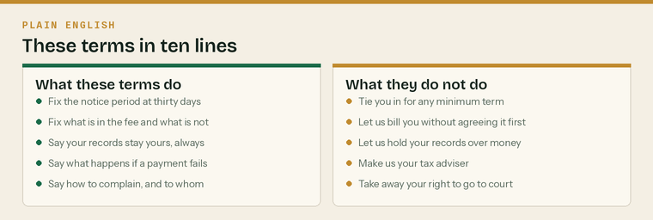
The whole of these terms, in ten lines, before you read the twelve clauses.
What you were sent, and what each one does
Document | What it does | Where it wins
Engagement letter | The work, the fee, the Schedule of Services | If it conflicts with these terms, it wins
These Terms & Conditions | How the relationship works | Second
Privacy Notice | What we do with your information | On anything about your data
Complaints Procedure | What to do if something goes wrong | On anything about a complaint

The five things most people want to know
 | Thirty days' notice, either way | No minimum term, no exit fee, no reason needed
 | Your records and data are yours | Always, including if you leave owing us money
 | The software is in your name | Not ours, deliberately
 | Nothing outside the fee without a price first | Agreed in writing, before we start
 | We are bookkeepers, not tax advisers | Clause 9 sets out what that means

1 — Who we are, and what this covers

1.1 These terms apply between Klyara (“we”, “us”, “our”) and the client named in the engagement letter (“you”, “your”).
1.2 They apply to all work we do for you, including work started before the engagement letter was signed.
1.3 The services we provide are the ones set out in Schedule 1 of the engagement letter, and nothing else. Work not in Schedule 1 is out of scope and is dealt with in clause 4.
1.4 We are a bookkeeping practice. We are supervised for anti-money-laundering purposes by [supervisor and registration number]. We are registered with the Information Commissioner's Office under registration number [ICO number].
Fill in both registration numbers before this template is used
Neither of them exists yet. The AML supervision comes with the ICB Practice Licence and takes about 28 days from application. The ICO registration is a separate, quick registration that any organisation using personal information has to make. Do not issue this document with either bracket unfilled — an empty AML line on a bookkeeping engagement is exactly the thing an inspection looks for.

2 — Starting, and what we need before we can

Before we can lawfully begin
 | Identity verified for everyone with more than 25% | Money Laundering Regulations 2017
 | Written risk assessment recorded for your file | Per our firm-wide AML policy
 | Sanctions and politically exposed person screening | Part of the same check
 | Engagement letter signed | Electronically is fine
 | Direct debit mandate set up | Or a standing order agreed
 | Professional clearance requested from your previous firm | If you had one

2.1 We cannot begin work until we have completed identity checks on you and on anybody who owns or controls more than 25% of your business. This is required by the Money Laundering, Terrorist Financing and Transfer of Funds (Information on the Payer) Regulations 2017.
2.2 We may ask for further evidence at any point, including about the source of funds, and we may decline or end the engagement if it is not provided.
2.3 Where you have been acting with another bookkeeper or accountant, we will write to them for professional clearance. We will not start substantive work until they have replied or a reasonable time has passed.
2.4 We will apply for agent authorisation with HMRC where it is needed. HMRC posts an authorisation code and this typically takes about a week. We cannot compress it and we will tell you where it has got to.
3 — What each of us does

What we do
We will | By when
Keep your books from the records you send | Monthly
Prepare and file the returns listed in Schedule 1 | By the statutory deadline
File your monthly CIS return, where it is in your plan | The 12th, ahead of HMRC's 19th
Issue subcontractor payment and deduction statements | Within 14 days of the tax month end
Send you the reports listed in Schedule 1 | By the end of the following month
Answer email and WhatsApp | Within one working day
Tell you when something looks wrong | As soon as we see it

What you do
You will | By when
Send complete records | The 10th of each month
Approve returns before we file them | Promptly, and at least 3 working days before the deadline
Tell us about changes | Straight away
Keep your own statutory records | As the law requires of you
Pay the monthly fee | The 1st, in advance

The 10th, and the £25
If records arrive after the 10th we may apply a £25 late records surcharge for that month. It exists because a late month is a rushed month and rushed months are where mistakes come from. We will always tell you before we apply it, and we will not apply it the first time.

3.1 We work from the records and information you give us. We do not audit them and we are not engaged to. Responsibility for the completeness and accuracy of the records, and for the returns made from them, remains yours.
3.2 We will query anything that looks wrong, but we cannot account for records we have never been shown.
3.3 Nothing is filed with HMRC or Companies House without your approval.
4 — Work outside the monthly fee

4.1 Anything not listed in Schedule 1 is outside the monthly fee.
4.2 We will tell you the price before we start, in writing, and we will not start until you have agreed it in writing. An email or a WhatsApp message saying yes is enough.
4.3 Our published rate card is Schedule 2 of the engagement letter. General out-of-scope work is £45 an hour, billed in fifteen-minute units.
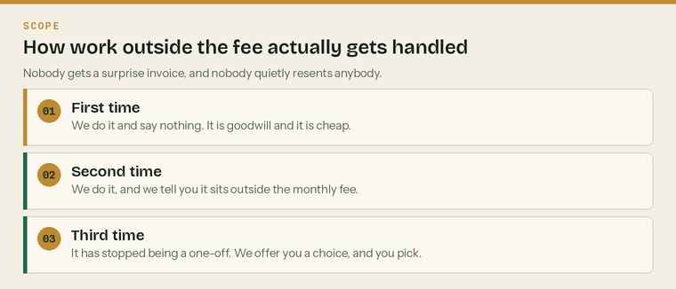
The three-strike rule. It is how a fixed fee survives contact with real work.
4.4 If the volume of your work grows past the limits in Schedule 1 for three consecutive months, we will talk to you about moving plans. Any change of plan takes effect on at least thirty days' written notice and never retrospectively.
5 — Fees and payment

The billing month | What happens
The 25th | Invoice issued for the month ahead
The 1st | Direct debit collected
The 10th | Your records due to us
The 12th | Your CIS return filed, if it is in your plan
The 19th | HMRC's CIS deadline, already met
Month end | Your reports in the portal

5.1 The monthly fee is set out in the engagement letter and is exclusive of VAT.
5.2 It is billed monthly in advance. The invoice is issued on the 25th of the preceding month and collected by direct debit on the 1st. Standing order is accepted.
5.3 The fee stated in the engagement letter is a founding client rate and is held for twelve months from your start date. We will not increase it inside that period.
5.4 After the first twelve months, and annually thereafter, we may change the fee on sixty days' written notice. If you do not accept the new fee you may end the engagement under clause 7 and nothing further is owed beyond the notice period.
5.5 Onboarding and catch-up fees, where they apply, are quoted separately and are payable on invoice.
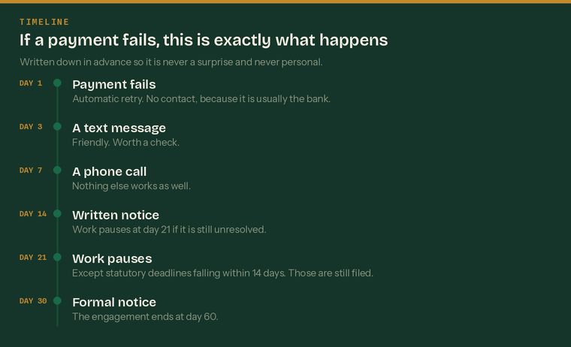
What happens if a payment fails. It is written down in advance so it is never personal.
5.6 If a payment fails we will follow the sequence above. Work pauses at day 21 and the engagement ends at day 60 if the position is not resolved.
The exception we will always honour
If a statutory deadline falls inside a pause and the work is already done, we will file it. We will not create a penalty for you over a fee dispute. We will tell you we have filed it, and the pause continues. This is not a favour — it is what a supervised practice is expected to do.

5.7 We may charge interest on overdue amounts at the statutory rate under the Late Payment of Commercial Debts (Interest) Act 1998. We would rather ring you.
5.8 We will not withhold your records, your data or your logins because of an unpaid fee. See clause 8.
6 — Your records, your data, your software

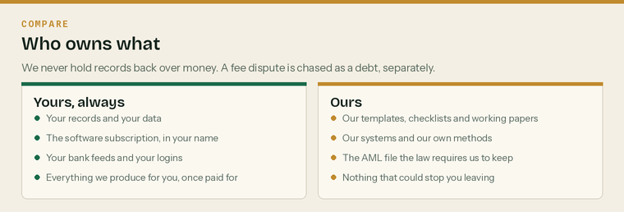
Who owns what. There is nothing here we could use as a lever, and that is deliberate.
6.1 Your records and your data are yours at all times.
6.2 Your accounting software subscription is included in your fee and is registered in your name. You are the account owner. We have access as your agent and that access can be removed by you at any time.
What you take with you if you leave
 | Your accounting software account, in your name already |  | Every record and document we hold for you
 | Your bank feed connections, untouched |  | A handover file for whoever comes next
 | Your logins, which were always yours |  | A professional clearance reply, promptly

6.3 Our own working papers, templates, checklists and internal files remain ours. You are entitled to the output, not to the machinery.
6.4 We keep client records for six years after the engagement ends, and anti-money-laundering records for five years after it ends. The five-year AML period is set by the Money Laundering Regulations 2017 and overrides a request to delete.
7 — Ending the engagement

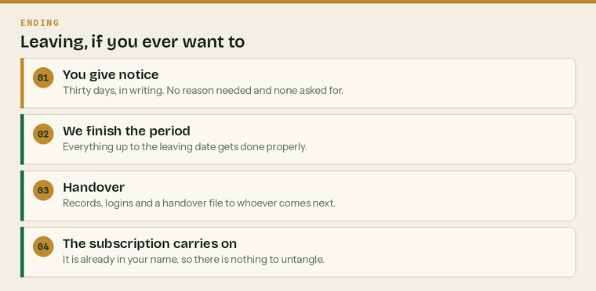
Leaving. Four steps, and none of them are difficult.
7.1 Either of us may end this engagement on thirty days' written notice. Email is writing. No reason is required.
7.2 We may end it immediately if you ask us to do something dishonest or unlawful, if the identity checks cannot be completed, if the relationship has broken down, or if fees remain unpaid after the sequence in clause 5.6.
7.3 On ending, we will complete the work for the period up to the leaving date, issue a final invoice, and hand over your records, logins and a handover file to you or to whoever takes over.
7.4 We will respond to a professional clearance request from your new bookkeeper or accountant promptly and helpfully, whether or not there is money outstanding.
8 — Liability

8.1 We will carry out the work with reasonable care and skill.
8.2 Our total liability for any claim arising from this engagement is limited to £[CAP].
8.3 Nothing in these terms limits or excludes liability for death or personal injury caused by negligence, for fraud or fraudulent misrepresentation, or for anything else that cannot lawfully be limited or excluded.
We are responsible for | You are responsible for
Doing the work with reasonable care and skill | The records being complete and accurate
Filing on time, from records received on time | Getting the records to us by the 10th
Telling you when something looks wrong | Approving returns before we file them
Keeping your information secure | Telling us when things change
Holding professional indemnity insurance | Your own statutory records

8.4 We are not liable for loss caused by information you did not give us, gave us late, or gave us inaccurately.
8.5 We are not liable for penalties or interest arising because records reached us after the deadline in clause 3, or because approval under clause 3.3 was not given in time.
8.6 We carry professional indemnity insurance of £[PII COVER]. The Institute of Certified Bookkeepers requires members in practice to hold cover appropriate to the size of the business and in any case not less than £50,000.
This clause and clause 9 are the two worth paying a solicitor to read
A liability cap has to be reasonable under the Unfair Contract Terms Act 1977 to be enforceable, and a cap set above your insurance cover protects nobody. Get the number right before this template goes anywhere near a client.

9 — What we are not

These terms are not an engagement for tax advice
We prepare and file returns from your records. We will tell you what we notice while doing it. That is bookkeeping. We do not provide tax planning advice, advice on the structure of your business, advice on employment status determinations, legal advice, contract review, investment advice or pension advice. Where you need any of those we will say so plainly and point you at somebody who does it.

9.1 We do not audit your records and this engagement is not an audit.
9.2 We do not check whether a person you engage is genuinely self-employed. We will flag arrangements that look like employment, and we will point you at HMRC's Check Employment Status for Tax tool, but the determination is yours and the liability for getting it wrong sits with you.
9.3 Where we say something is our opinion, it is our opinion. Where a decision has a tax consequence you are unsure about, take advice before you act on it.
10 — Money laundering, and confidentiality

10.1 We must verify your identity before we start and keep that evidence for five years after the engagement ends.
10.2 We are required by law to report knowledge or suspicion of money laundering to the National Crime Agency. We are not permitted to tell you if we make such a report, and doing so would be a criminal offence. This applies to every supervised bookkeeper and accountant.
Our anti-money-laundering duties, plainly
 | Verify who you are, before we start | No exceptions, for anybody
 | Keep the evidence for five years after we finish | Set by law, not by us
 | Reassess if your circumstances change | A new director, a new source of funds
 | Report knowledge or suspicion | To the National Crime Agency
 | Never tell you we have reported | Doing so is a criminal offence

10.3 Apart from 10.2, everything you tell us is confidential. We will not share it except where this agreement or the Privacy Notice says we will, where you tell us to, or where the law requires it.
10.4 We may name you as a client, or use anonymised figures, only if you have agreed in writing. We will ask; we will not assume.
11 — Complaints

11.1 If something is wrong, tell us. Most things are sorted the same day.
11.2 Our full Complaints Procedure is a separate document and is available on request and on our website. In short: raise it with us, we acknowledge within three working days and answer within ten; if you are not satisfied, a second director reviews it within twenty.
Stage | Who | How long
Tell us informally | Whoever you deal with | Usually the same day
Stage 1, in writing | Kieran | Acknowledged in 3, answered in 10 working days
Stage 2, a review | Craig | Answered in 20 working days
The ICB | Professional standards | Their timescales
The ICO | For anything about your data | Their timescales

11.3 If you remain unsatisfied, you may complain to the Institute of Certified Bookkeepers about the professional conduct of a member, and to the Information Commissioner's Office about anything to do with your personal information.
12 — The rest

12.1 Changes. We may change these terms on thirty days' written notice. If you do not accept a change you may end the engagement under clause 7.
12.2 Assignment. You may not transfer this agreement without our written consent. We may transfer it to a successor practice, and we will tell you if we do.
12.3 Third parties. Nobody other than you and us has rights under this agreement. Advice and reports we give you are for you and are not to be relied on by anybody else without our written consent.
12.4 Force majeure. Neither of us is liable for a failure caused by something genuinely outside our control. We will tell you what has happened and what we are doing about it.
12.5 Severability. If any part of these terms is unenforceable, the rest stands.
12.6 Whole agreement. The engagement letter, its schedules, these terms and the Privacy Notice are the whole agreement between us.
12.7 Governing law. These terms are governed by the law of England and Wales, and the courts of England and Wales have exclusive jurisdiction.
Boilerplate | In one line
Changes | Thirty days' notice, and you can leave if you do not accept them
Assignment | You need our consent. We will tell you if we transfer to a successor.
Third parties | Nobody else has rights under this agreement
Force majeure | Neither of us is liable for something genuinely outside our control
Severability | If one part fails, the rest stands
Whole agreement | The letter, the schedules, these terms and the Privacy Notice
Governing law | England and Wales

Acceptance
These terms are accepted by signing the engagement letter. A separate signature is not needed. If you would prefer to sign them as well, use the block below.
Signatures
The client | [Business name]
Signed | Print name
Position | Date
Klyara | [Name], for Klyara
Signed | Print name
Position | Date

Sources
Every figure and deadline in this document was checked against the page listed beside it on Wednesday 26 August 2026. Re-check before each use — thresholds and penalties change.
What was checked | Source
Payment terms, notice and scope limits | docs/21-pricing-scope-and-quoting.md (Klyara internal)
AML five-year retention and the duty to report | https://www.gov.uk/guidance/money-laundering-regulations-your-responsibilities
ICB Practice Licence and AML supervision | https://www.bookkeepers.org.uk/Running-a-Practice/Regulation/Practice-Licence
ICB PII minimum of £50,000, Rule 27 | https://www.bookkeepers.org.uk/out/262546/ICB-Professional-Conduct-Regulations.pdf
CIS return by the 19th, statements in 14 days | https://www.gov.uk/what-you-must-do-as-a-cis-contractor/make-deductions-and-pay-subcontractors
Employment status is the engager's call; CEST | https://www.gov.uk/employment-status/selfemployed-contractor
The ICO data protection fee | https://ico.org.uk/for-organisations/data-protection-fee/

