KLYARA the back office for building firms

Klyara — Channel Map
Every place Klyara should exist, in priority order


*Prepared 26 August 2026. Launch target: Monday 14 September 2026.*
How to read this
Channels are ranked by expected return per hour of Craig's time, not by audience size. A UK construction back-office firm selling £59–£329/month recurring services does not win on reach. It wins on local intent (someone searching "CIS accountant near me"), trust proof (reviews, directories, a real face) and community credibility (being the person who answered the CIS question properly, six months before the sale).
Each entry carries a Promo rule — what that community actually permits. Breaking these gets the account shadowbanned and the domain blacklisted, which is unrecoverable on Reddit in particular. Treat them as hard constraints.
Effort key: ⚡ = under 30 min setup, near-zero upkeep · ⚙ = weekly upkeep · 🔧 = real ongoing work
A note on launch sequencing (read this first)
Per the Build Manual, Klyara cannot trade as a bookkeeper by way of business until AML supervision is in place. Everything in this pack is therefore written in one of two modes:
- Publishable now — education, MTD/CIS explainers, calculators, guides, waitlist, newsletter.
Positions Klyara as the authority and builds the pipeline. This is ~90% of the content.
- Hold until supervised — "hire us", pricing-led ads, discovery-call CTAs framed as
engagement. Written and ready, marked HOLD throughout.
This is not a limitation. A four-to-six week education-first run before you can take money is exactly what a good launch looks like anyway — it builds the waitlist that converts on day one of trading.
The line that matters
A four-to-six week education-first run before you can take money is exactly what a good launch looks like anyway — it builds the waitlist that converts on day one of trading.

In this part
Every place Klyara should exist, in priority order · How to read this · A note on launch sequencing (read this first)

TIER 1 — Do these first. Non-negotiable.

1. Google Business Profile ⚙ — **the single highest-ROI channel**
- URL: business.google.com
- Why: "bookkeeper for builders [town]", "CIS accountant near me" — this is where the money is.
A verified GBP with 10+ reviews outranks paid ads for local intent and costs nothing.
- Category: Primary → *Bookkeeping service*. Secondary → *Accountant*, *Tax preparation service*,
*Payroll service*, *Business management consultant*.
- Requires: A verifiable business address (postcard or video verification). If Klyara is
home-based, use a service-area business — hide the address, set a 10–15 mile radius.
- Promo rule: N/A — it's your own listing. But GBP posts no longer expire, but only the newest shows prominently, so post weekly.
- Critical: Verification takes 5–14 days. Start it today, before anything else on this list.
2. LinkedIn — Company Page + Craig's personal profile 🔧 — **the B2B engine**
- Why: Two audiences at once: (a) small construction firm owners and office managers,
(b) year-end accountants and brokers — your Layer D referral partners. LinkedIn is where the partnership deals get done, and partnerships are cheaper than ads.
- Split: The Company Page is the shopfront. Craig's personal profile does the actual work —
personal posts get 5–10× company-page reach on LinkedIn. Craig posts; the page reshares.
- Promo rule: Open, but soft. Value posts outperform pitch posts heavily. No outbound DM spam —
LinkedIn throttles it and it burns the partnership audience specifically.
3. Facebook — Page + Groups 🔧 — **where UK builders actually are**
- Why: The single biggest concentration of UK small-builder owners aged 35–60. Trade groups
("UK Builders", "Tradesmen UK", county-level trade groups) run hot daily with exactly your audience complaining about exactly your problems.
- Split: Page = credibility and retargeting pixel. Groups = the actual channel.
- Promo rule: Most trade groups ban outright promotion and will remove you. The play is
answer questions as Craig, from Craig's personal profile, with no link, and let people click through to the profile. Many groups run a weekly self-promo thread — that's your slot. Read each group's pinned rules before your first comment. Full protocol in §Community Protocol.
4. YouTube ⚙ — **the compounding asset**
- Why: "How does the VAT reverse charge work" and "CIS deductions explained" get searched
forever. A 6-minute video ranks for years and does the selling while Craig sleeps. It's also the library your other channels cut clips from — one long video = 5 Shorts/Reels/TikToks.
- Promo rule: Open. Links in description fine.
5. X / Twitter ⚡ — **low cost, keep it claimed**
- Why: Honestly, moderate value for UK trades. But: it's free, HMRC and accountancy press are
active there, and it's where you catch MTD news cycles same-day. Cheap to maintain via scheduler.
- Promo rule: Open.
6. Instagram ⚙ — **proof and personality**
- Why: Builders use Instagram heavily for job photos. Klyara's angle isn't job photos — it's
carousels (swipeable explainers: "CIS in 6 slides") and Reels. Strong for the under-45 segment and for making a bookkeeping firm look like it belongs on a site.
- Promo rule: Open. Link in bio only (one link — use the site or a link hub).
7. TikTok ⚙ — **underrated for UK trades**
- Why: UK trades TikTok is large and active. Short, blunt, no-nonsense tax explainers perform
well because nobody else in accountancy makes them watchable. Highest organic reach ceiling of any channel on this list for zero spend.
- Promo rule: Open. Be aware: financial content sometimes gets reduced reach — keep it
educational, avoid "guaranteed savings" language.
8. Reddit 🔧 — **highest trust, highest risk**
- Why: UK tax and trade subreddits are full of high-intent questions. One genuinely good answer
on r/UKPersonalFinance about MTD reaches thousands and stays indexed by Google for years.
- Promo rule: Hardest rules on the internet. Most relevant subs auto-remove links and
ban accounts with promotional history. Reddit's sitewide guidance is roughly the 10:1 rule — 9 genuine contributions for every 1 self-referential one. New accounts posting links get shadowbanned in days. See §Reddit Protocol — it is written to keep the account alive.
The line that matters
("UK Builders", "Tradesmen UK", county-level trade groups) run hot daily with exactly your audience complaining about exactly your problems.

In this part
1. Google Business Profile ⚙ — the single highest-ROI channel · 2. LinkedIn — Company Page + Craig's personal profile 🔧 — the B2B engine · 3. Facebook — Page + Groups 🔧 — where UK builders actually are · 4. YouTube ⚙ — the compounding asset · 5. X / Twitter ⚡ — low cost, keep it claimed · 6. Instagram ⚙ — proof and personality

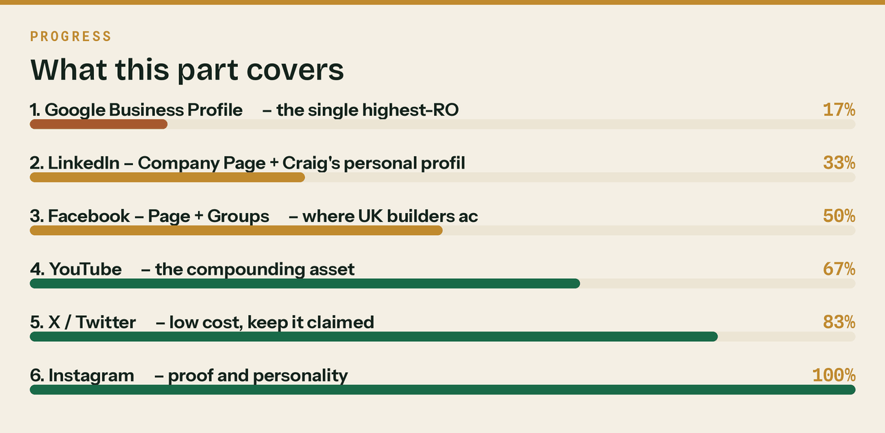
Read top to bottom. The bar is just how far through the part you are.

TIER 2 — Directories, citations and trust. Set up once, mostly ⚡.

Local SEO depends on NAP consistency (Name, Address, Phone identical everywhere). Decide the exact string once and never vary it. Suggested canonical:
Klyara
[Registered address, line 1]
[Town] [Postcode]
020 8058 1496
hello@klyara.com
https://klyara.com
# | Directory | Cost | Why it earns its place
9 | Trustpilot | Free tier | Reviews render in Google results. Free plan lets you invite reviewers.
10 | Yell.com | Free listing | Still a top-5 UK citation source for local SEO.
11 | FreeIndex | Free | Strong UK domain authority, ranks well for "[service] [town]".
12 | Bark.com | Pay-per-lead | Real inbound bookkeeping/accountancy leads. Buy leads only after AML lands. HOLD
13 | Unbiased.co.uk | Paid tier | Accountant/adviser directory with genuine UK search intent. Assess after supervision.
14 | Cylex, Scoot, Thomson Local, 192.com, Hotfrog | Free | Pure citation building. One afternoon, done forever.
15 | Nextdoor Business | Free | Hyperlocal. Weak for B2B but free and takes 10 minutes.
16 | Bing Places | Free | Imports straight from GBP. Ten minutes for a second search engine.
17 | Apple Business Connect | Free | Apple Maps listing — invisible until someone can't find you on an iPhone.

The line that matters
Local SEO depends on NAP consistency (Name, Address, Phone identical everywhere).

TIER 3 — Professional platforms. These generate *inbound* leads, not just presence.

# | Platform | Why | Timing
18 | QuickBooks Find-a-ProAdvisor | Named in the Build Manual as an inbound lead source. Businesses search it for local QBO help. Craig's certification listing him here is free lead flow. | After ProAdvisor cert (week 1)
19 | Xero Advisor Directory | Same mechanic, and captures the inbound-Xero clients the Manual says not to turn away. | After Xero partner signup
20 | FreeAgent Practice Directory | The site already claims FreeAgent certification — list there too. | Week 2
21 | ICB or AAT member directory | Public "find a bookkeeper" search, plus the credibility badge for every other profile. | On practice licence HOLD
22 | AccountingWEB (Any Answers) | UK accountancy's main community. Not a client channel — a partnership channel. This is where you find the year-end accountant partner and the continuity arrangement the Manual requires. | Week 2
23 | UK Business Forums (ukbusinessforums.co.uk) | Large, long-running, active Accounts & Finance section. Genuine small-business owners asking tax questions. Permits a signature link once established. | Week 1
24 | FSB (Federation of Small Businesses) | Membership + member directory + local events. Paid, but the networking is real for a local B2B service. | Month 2
25 | Local Chamber of Commerce | Directory listing, member events, and B2B referral flow in a defined radius. | Month 2
26 | BNI / local breakfast networking | Offline, but for a local B2B service selling to owner-operators, one BNI seat can outperform every digital channel here. Included because omitting it would be a mistake. | Month 2

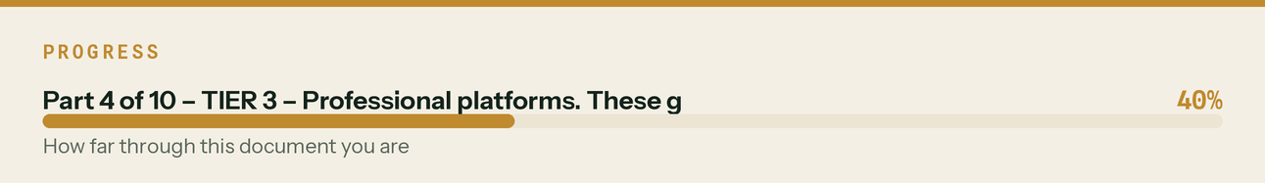

TIER 4 — Communities. This is where the credibility is built.

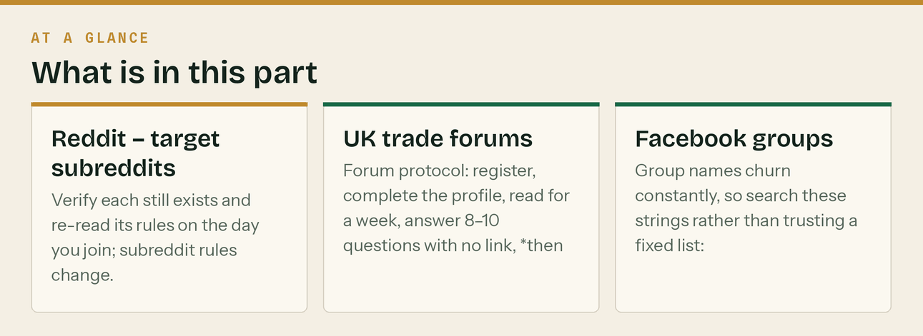
Reddit — target subreddits
Verify each still exists and re-read its rules on the day you join; subreddit rules change.
Subreddit | Fit | Promo rule (assume strictest until you read the sidebar)
r/UKPersonalFinance | ★★★★★ MTD, self-assessment, CIS refunds | Zero promotion. Heavily moderated. Value-only, no link, no signature. Highest-quality audience on this list.
r/SmallBusinessUK | ★★★★★ Exactly your buyer | Light promo tolerated in context. Never lead with the link.
r/UKBusiness | ★★★★ Owner-operators | Similar. Check for a weekly promo thread.
r/DIYUK | ★★★ Trades adjacent, very large | No promo. Useful for visibility and tone-calibration.
r/ConstructionUK | ★★★★ On the nose | Smaller. Read rules; often permits helpful expert contributions.
r/Bookkeeping / r/Accounting | ★★★ Peers, not buyers | Peer/partnership value + spotting what confuses people. US-skewed.
r/selfemployed | ★★★ Solo tier audience | Value-only.
r/AskUK | ★★ Broad | Occasional tax questions; visibility only.
r/LegalAdviceUK | ★★ CIS disputes, late payment | Absolutely no promotion. Answer helpfully or stay out.
r/Plumbing, r/Electricians, r/Carpentry | ★★ US-heavy | Low priority. UK-specific answers land occasionally.

UK trade forums
Forum | Notes
Screwfix Community Forum | One of the largest UK trades communities. Long-lived threads, strong Google indexing. Signature links usually permitted after a post-count threshold. High value.
BookaBuilderUK Trade Forum (forum.bookabuilderuk.com) | Purpose-built UK builders' trade discussion. Direct audience match.
ContractorsTalk.co.uk | UK contractor/tradesperson community.
BuildersTalk.co.uk | UK builders' community.
UKPlumbersForums.co.uk | Large, active, and plumbers are heavy CIS users.
ElectriciansForums.net | Same logic. Very active UK sub-contractor base.
DIYnot.com forums | Mixed trade/DIY, large UK traffic.
BuildHub.org.uk | Self-builders — mostly clients of your clients, but VAT questions come up constantly.
AccountingWEB Any Answers | Peer/partnership, as above.

Forum protocol: register, complete the profile, read for a week, answer 8–10 questions with no link, *then* add a signature. Signature format: Craig — construction bookkeeping & CIS | klyara.com. Never post a thread whose only purpose is the link.
Facebook groups
Group names churn constantly, so search these strings rather than trusting a fixed list:
UK Builders Tradesmen UK UK Tradesmen Network
Builders UK Construction UK CIS subcontractors
Self Employed UK Small Business UK Tradesmen Advice UK
[County] Builders [County] Tradesmen [Town] Trades
Plumbers UK Electricians UK Groundworkers UK
Scaffolders UK Carpenters & Joiners UK Bricklayers UK
Vetting: join only groups with (a) 3,000+ members, (b) posts in the last 48 hours, (c) visible moderation. Target 12–15 groups. More than that and you can't participate genuinely in any.
Also worth joining: county-level "Trades Recommendations" groups where homeowners ask for builders — you're not selling there, you're watching which local firms are busy. Those firms are your prospect list.
The line that matters
Also worth joining: county-level "Trades Recommendations" groups where homeowners ask for builders — you're not selling there, you're watching which local firms are busy.

In this part
Reddit — target subreddits · UK trade forums · Facebook groups

TIER 5 — Claim the handle, invest little.

Claim these to protect the brand name and stop anyone else taking it. Post occasionally via the scheduler, expect little.
Platform | Verdict
Threads | ⚡ Claim it. Cross-posts from Instagram in one click. Free reach.
Bluesky | ⚡ Claim it. Zero-cost handle protection.
Pinterest | ⚡ Claim it. Infographics and checklists occasionally get long-tail search traffic.
Snapchat | ⚡ Claim the handle and stop there. Straight answer: Snapchat is a poor fit. Its UK audience skews well below the 35–60 owner-operator you're selling to, it has no search discovery, no link-in-bio equivalent worth having, and content evaporates. You asked for it, so it's in the setup pack with a profile written — but do not spend content hours here. If you want a second short-video channel, the hours go to YouTube Shorts, which is searchable and permanent.
Quora | ⚡ Answer UK tax questions occasionally. Indexes well, ages well.
Medium / Substack | ⚡ Optional newsletter mirror for SEO. Only if the newsletter is running well.
Discord | ⚡ A few UK trade servers exist but are small. Low priority.
Alignable | ⚡ SMB networking. Thin UK presence. Skip unless a partner is already there.

The line that matters
Claim these to protect the brand name and stop anyone else taking it.

Off-platform channels you're missing

These aren't social, but they're where a local construction back office actually gets clients. Adding them because leaving them out would make this pack look complete when it isn't.
- Builders' merchant noticeboards — Travis Perkins, Jewson, Selco, Howdens, MKM, Buildbase. A £40 print run of A5 cards on trade counters in a 15-mile radius reaches your exact buyer at the moment they're thinking about the business, not the job. Design included in this pack.
- Van livery / site boards — the Manual specifies a van-legible mark for a reason. If either founder drives, that's free permanent local advertising.
- Trade counter partnerships — merchant staff know which local firms are growing. A referral arrangement with two trade counter managers beats a month of ads.
- Local accountant partnerships — the Manual's Layer D. Year-end accountants who don't want monthly bookkeeping are your best referral source *and* your continuity cover.
- Podcast guesting — UK construction and trades podcasts need guests constantly and Craig has a genuinely differentiated angle (CIS + reverse charge + MTD). Pitch list and template in the ops doc.
- Local press / trade press — "MTD for Income Tax hits builders" is a story local business editors will run for free. Press release drafted in this pack.
- CITB / trade association newsletters — sponsored slots and member offers.
- Existing client base of the partner accountant — the fastest route to clients 1–5.
The line that matters
These aren't social, but they're where a local construction back office actually gets clients.

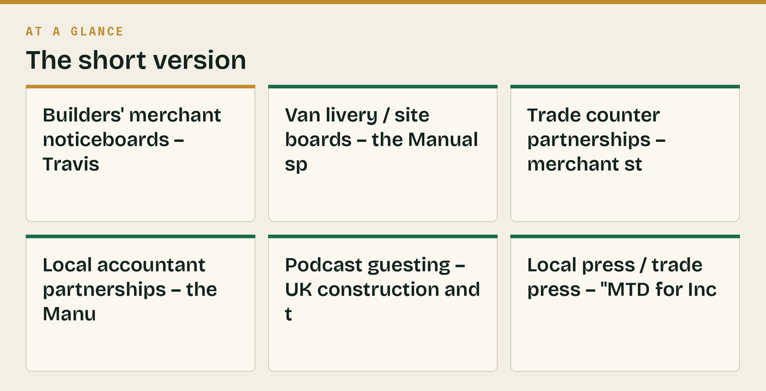
Also worth knowing
Adding them because leaving them out would make this pack look complete when it isn't.

Community Protocol — the rules that keep the accounts alive

The 9:1 rule. Nine genuine contributions for every one that mentions Klyara. Track it. If you can't be bothered to contribute nine times, don't join the community.
Craig posts, not "Klyara". In every community — Reddit, Facebook groups, forums — a named human with a face and a specialism outperforms a brand account and survives moderation. The brand account exists on the *platforms* (Page, Company Page, profile), not in the *communities*.
Never answer a question with a link. Answer the question, fully, in the comment. If the answer is genuinely long, say so and let them ask. People who want more will find the profile.
Never argue with a moderator. A removed post is a data point. A ban is permanent.
Disclose the interest. "For context, I do construction bookkeeping, so this is my day job —" costs you nothing and buys enormous goodwill. Undisclosed promotion is what gets people banned.
One account per person, aged. Do not create ten accounts. Reddit and Facebook both detect this and it takes the whole estate down.
The line that matters
In every community — Reddit, Facebook groups, forums — a named human with a face and a specialism outperforms a brand account and survives moderation.

Also worth knowing
"For context, I do construction bookkeeping, so this is my day job —" costs you nothing and buys enormous goodwill.

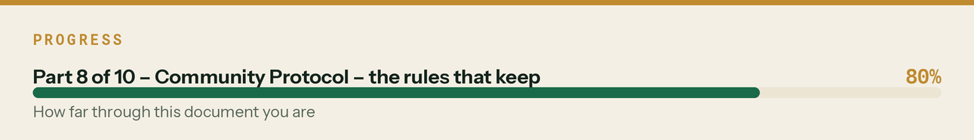

Reddit Protocol (specific, because Reddit is the easiest to get permanently wrong)

Week 1 — do nothing but read. Create the account. Fill in the profile. Subscribe to the target subs. Post nothing.
Weeks 1–3 — comment only, no links, at all. Target 30–40 genuine comments. Answer CIS, VAT reverse charge, MTD and self-assessment questions properly. This builds the comment karma that most subs gate posting behind, and teaches you each sub's tolerance.
Week 4 onward — one text post per week, maximum, and only where rules permit. Long-form, useful, no link in the body. If someone asks for a resource in the comments, *then* link.
Never:
- Link in your first 30 days
- Post the same content to multiple subs on the same day (this is the #1 spam trigger)
- Use a brand-named account in advice subs
- Delete-and-repost after a removal
Realistic timeline to value from Reddit: 8–12 weeks. It is the slowest channel here and the most durable. Start it now precisely because it's slow.
The line that matters
Week 4 onward — one text post per week, maximum, and only where rules permit.

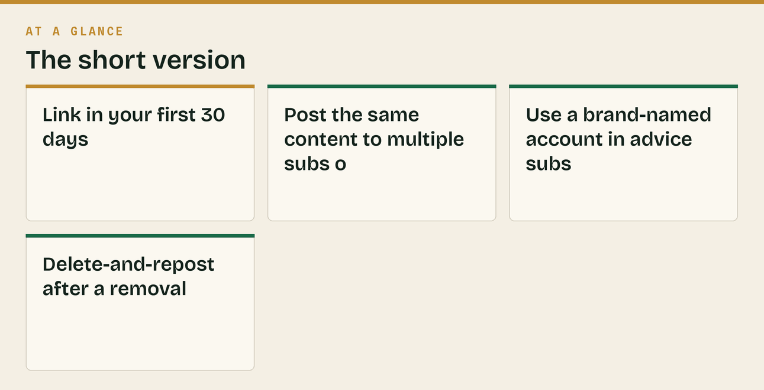
Also worth knowing
This builds the comment karma that most subs gate posting behind, and teaches you each sub's tolerance.

What to ignore, and why

Being explicit so you don't second-guess the omissions:
- Snapchat content — see Tier 5. Handle only.
- Checkatrade / Rated People / MyBuilder — these are for *trades*, not for firms selling to
trades. Klyara can't list. But they're a prospect goldmine: every listed local firm with reviews is a qualified lead with a public phone number.
- Vendasta / all-in-one marketing platforms — the Manual already killed this. Correct call.
- Cold DM automation on LinkedIn — burns the partnership audience you can't afford to burn.
- Buying followers or reviews — a bookkeeping firm caught faking reviews is finished. Never.
- TikTok/Meta paid ads at launch — wrong intent stage. Google Search ads capture demand that
already exists; social ads create demand you can't yet legally service. Revisit at 10 clients.
The line that matters
But they're a prospect goldmine: every listed local firm with reviews is a qualified lead with a public phone number.



