KLYARA the back office for building firms

Klyara — Marketing Ops Playbook
Tools, rhythm, measurement, and the things nobody put on the list

In this part
Tools, rhythm, measurement, and the things nobody put on the list

1. Scheduling tool — the decision

Month 1: post manually. Buy nothing.
You have thirty days of content and roughly two posts a day. That's fifteen minutes of manual posting, and doing it by hand for a month teaches you things a scheduler hides: which platform mangles line breaks, where hashtags actually go, what time your audience is awake, and which channels are worth the effort at all.
Buying a scheduler in week one means paying to automate channels you haven't yet proved.
Month 2 onward: Metricool, Starter tier.
Why Metricool over Buffer, Publer or Hootsuite for Klyara specifically:
It's the only mainstream scheduler that natively posts to Google Business Profile alongside TikTok, Threads, Bluesky, Pinterest, YouTube, Instagram, Facebook and LinkedIn.
That matters because GBP is your highest-ROI channel and its posts no longer expire, but only the newest shows prominently — meaning it needs posting *every week, forever*. A tool that can't schedule GBP leaves your single best channel as a permanent manual chore, which is exactly the chore that stops happening in a busy month.
Everything else is secondary to that.
The catch, stated plainly: on Metricool, X/Twitter is a paid add-on on top of the plan, and the free tier excludes LinkedIn and X entirely. So budget the Starter plan plus, if you want it, the X add-on. Expect roughly £20–28/month all in. Against the Build Manual's ~£180–245 fixed monthly cost, that's proportionate for the channel that drives local search.
Cheaper alternative if that's over budget: schedule the eight channels Metricool's plan covers, and post X manually. X is ten seconds a day and you're only posting once. Saves the add-on entirely.
Verify pricing at signup. These figures come from a Buffer-published comparison — a competitor's numbers about a competitor — and every tool in this category repriced in the last two years.
Do not buy Hootsuite. Enterprise pricing for a two-person firm, and you'd be paying for approval workflows and team seats you have no use for.
The line that matters
That matters because GBP is your highest-ROI channel and its posts no longer expire, but only the newest shows prominently — meaning it needs posting *every week, forever*.

In this part
Month 1: post manually. Buy nothing. · Month 2 onward: Metricool, Starter tier.



2. The weekly operating rhythm

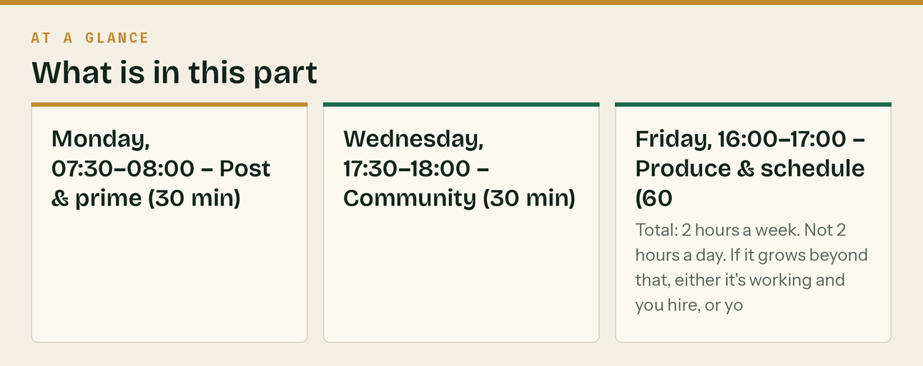
Two hours a week, on the same two slots, forever. If it isn't diarised it won't happen.
Monday, 07:30–08:00 — Post & prime (30 min)
- Publish the week's anchor post to LinkedIn (Craig), Company Page, X, Facebook
- Publish the weekly GBP post
- Reply to every comment from the weekend
- Check the calendar for this week's dates and adjust if a deadline moved
Wednesday, 17:30–18:00 — Community (30 min)
- One genuine contribution to a forum or subreddit. No link.
- Answer questions in two Facebook groups
- Reply to every LinkedIn comment and DM
- This is the slot that builds the pipeline. It is also the first slot people cancel. Don't.
Friday, 16:00–17:00 — Produce & schedule (60 min)
- Record one short video on a phone (or render one from the kit)
- Write next week's anchor post
- Schedule everything for the coming week
- Log the four numbers (below)
Total: 2 hours a week. Not 2 hours a day. If it grows beyond that, either it's working and you hire, or you're overproducing for channels that aren't returning.
The line that matters
If it grows beyond that, either it's working and you hire, or you're overproducing for channels that aren't returning.

In this part
Monday, 07:30–08:00 — Post & prime (30 min) · Wednesday, 17:30–18:00 — Community (30 min) · Friday, 16:00–17:00 — Produce & schedule (60 min)

3. Measurement — four numbers, monthly

Ignore followers. Followers are not a business metric and this audience is small by definition.
Number | Where | Target by month 3
Discovery calls booked | Cal.com | 8–12/month
Cost per booked call | Ads spend ÷ calls | Under £40. Kill ads above it.
Guide downloads | Brevo list growth | 60–100/month
GBP: calls + direction requests + website clicks | GBP Insights | Growing month on month

Everything else is diagnostic, not a goal.
UTM scheme — use it from post one
?utm_source=<platform>&utm_medium=<type>&utm_campaign=<campaign>&utm_content=<detail>
utm_source: linkedin | facebook | instagram | x | tiktok | youtube | gbp | reddit
| forum | email | merchant | print
utm_medium: social | email | organic | cpc | print | qr
utm_campaign: launch30 | mtd_q3 | newsletter | evergreen | partners
utm_content: day01 ... day30 | nl01 ... nl12 | seq_mtd_e3
Print gets UTMs too. Merchant cards and van livery carry a QR code pointing at klyara.com/?utm_source=merchant&utm_medium=qr&utm_campaign=trade_counter — otherwise you will never know whether the £40 print run worked, and you'll either stop doing the thing that's working or keep doing the thing that isn't.
Set up before the first post
- Google Analytics 4 on klyara.com
- Google Search Console (verify the domain, submit the sitemap)
- Meta Pixel — install even with zero ad budget. It's building the retargeting audience from day one.
- LinkedIn Insight Tag — same reasoning
- Cal.com conversion tracking
The line that matters
Followers are not a business metric and this audience is small by definition.

In this part
UTM scheme — use it from post one · Set up before the first post


Read top to bottom. The bar is just how far through the part you are.

4. Google Ads — built and paused


Per the Build Manual: £500 credit, but these are match offers — you spend ~£400 to receive £500. Budget for the spend, not the credit.
Do not switch these on until AML supervision is confirmed. You cannot advertise for bookkeeping clients you're not yet permitted to service. Build the campaigns, load the copy, leave them paused.
Structure
Search only. No Display, no Performance Max, no Search Partners. 10–15 mile radius. Exact and phrase match only — broad match will burn the whole budget on "quickbooks login" in a fortnight.
Ad group 1 — MTD *(likely cheapest CPC, highest urgency)*
Keywords: [mtd accountant] [making tax digital sole trader] [mtd for income tax help]
"mtd accountant [town]" "making tax digital bookkeeper"
H1: MTD Quarterly Filing Sorted
H2: For Builders & Subcontractors
H3: Fixed Fee From £59/Month
D1: HMRC wants an update every 3 months. We keep the records and file them. Construction specialists.
D2: Free 20-minute call. We'll tell you if you're even in scope. No jargon, no hourly billing.
→ klyara.com/making-tax-digital.html
Ad group 2 — CIS
Keywords: [cis accountant] [cis returns] [cis tax return help] "cis accountant [town]"
"construction industry scheme accountant"
H1: CIS Returns Filed By The 19th
H2: Every Month, Fixed Fee
H3: Construction Specialists Only
D1: Verification, 20/30% deductions, materials splits, monthly returns. Never miss the 19th again.
D2: From £199/month + VAT. Free discovery call. No hourly billing, no surprise invoices.
→ klyara.com/services/
Ad group 3 — Bookkeeping for builders
Keywords: [bookkeeper for builders] [construction bookkeeping] [builders accountant]
"bookkeeper for construction [town]"
H1: Bookkeeping For Building Firms
H2: CIS, VAT & Payroll Handled
H3: Run The Jobs. We Run The Rest.
D1: Receipts snapped on your phone. Monthly P&L you can actually read. CIS filed on time.
D2: Fixed monthly pricing from £59 + VAT. Free 20-minute discovery call.
→ klyara.com
Negatives — load before launch
free, jobs, salary, course, training, qualification, software, login, template, spreadsheet,
diy, apprenticeship, what is, definition, calculator, hmrc login, xero login, quickbooks login,
sage login, refund calculator, tax rebate, umbrella company, cis rebate
*(Note "calculator" and "tax rebate" as negatives — your own free calculators pull that traffic organically for £0. Don't pay for it too.)*
Kill rule
Review at £150 spent. Above £40 per booked call, pause and go back to organic. The Build Manual sets £15–40 as acceptable; stick to it. Outbound, GBP and referrals cost nothing.
The line that matters
Do not switch these on until AML supervision is confirmed.

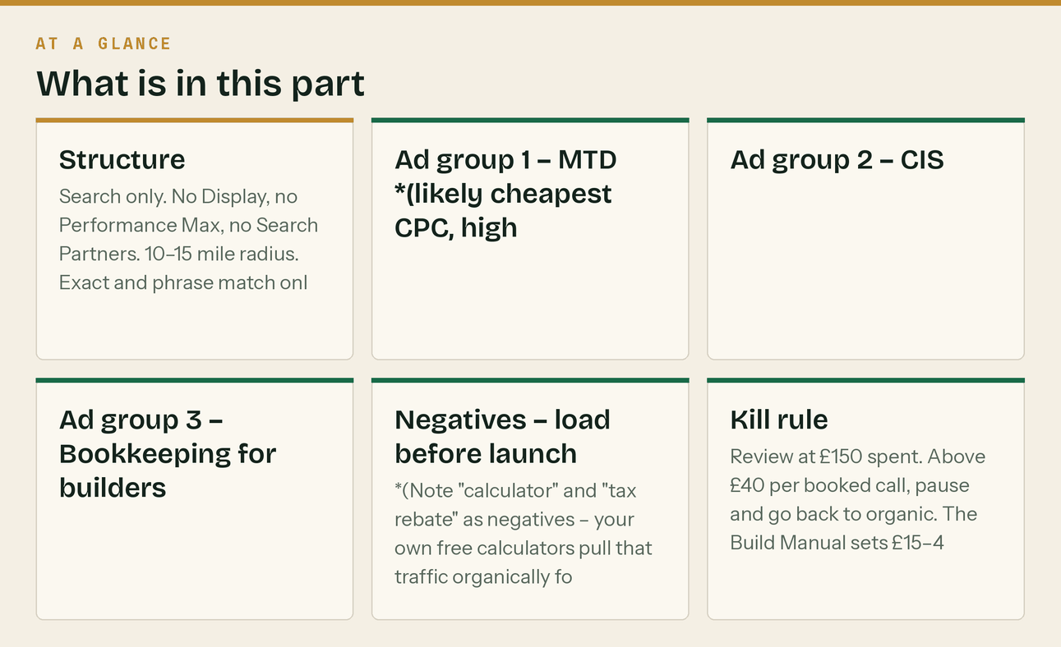

5. Local press release — send when AML lands


Local business editors will run this for free. It's a real story with a date on it.
FOR IMMEDIATE RELEASE
New [TOWN] firm targets the tax change catching out local builders
[TOWN], [DATE] — Thousands of self-employed builders and subcontractors across [COUNTY] are now
required to report to HMRC four times a year instead of once, under Making Tax Digital for Income
Tax — and many do not yet realise it applies to them.
The rules took effect in April 2026 for sole traders and landlords with qualifying income above
£50,000. The threshold falls to £30,000 in April 2027 and £20,000 in April 2028, bringing the
majority of working subcontractors into scope.
A new [TOWN]-based firm, Klyara, has been set up specifically to handle the change for construction
businesses.
"The part that catches people out is that HMRC measures your gross invoices, not what lands in your
bank," said Craig [SURNAME], founder of Klyara. "If you're a subcontractor with twenty per cent taken
off at source, your bank balance is telling you you're under the threshold when your invoices say
you're over it. In my experience most subcontractors assume they are out of scope because they look at what reached their bank rather than what they invoiced, and
weren't."
Klyara provides bookkeeping, CIS returns, VAT reverse charge coding, payroll and quarterly MTD filing
for construction firms on a fixed monthly fee, starting at £59 plus VAT.
The firm has published a free fifteen-page guide to the changes, together with a set of free
calculators covering CIS deductions, job margins and VAT, at klyara.com. Neither requires
registration.
"There's a lot of noise about this and not much plain English," said [SURNAME]. "We'd rather people
worked out where they stand for free than paid someone to be told they were fine."
ENDS
Notes to editors:
Klyara provides back-office services to construction businesses across [COUNTY].
Contact: [NAME], [EMAIL], 020 8058 1496
High-resolution logo and images available on request.
Send to: the local paper's business desk, the county business magazine, the local chamber newsletter, regional BBC/ITV business email, and any local business podcast. Email the editor directly by name, subject line Story: tax change hitting [county] builders from April.
The line that matters
Send to: the local paper's business desk, the county business magazine, the local chamber newsletter, regional BBC/ITV business email, and any local business podcast.

6. Podcast pitch — 40 words, sent 20 times

UK construction and trades podcasts need guests constantly. Craig's angle is genuinely differentiated. This template gets replies because it leads with the guest's audience, not with Klyara.
Subject: Guest idea — the tax change most of your listeners don't know applies to them
Hi [NAME],
HMRC now wants quarterly updates from any sole trader over £50k — and it's measured on gross
invoices, before CIS. Most subbies think they're out and aren't. Threshold drops to £30k next April.
I do the books for building firms and I could do 20 minutes on who's caught, what it actually
involves, and the three things to do before April. No pitch.
Craig — klyara.com
Pitch list to build: search "UK construction podcast", "trades podcast UK", "builders podcast", "self employed UK podcast" on Spotify and Apple Podcasts. Target twenty. Expect three replies and one booking — that's a normal, good result, and one episode is worth more than a month of posting.
The line that matters
Pitch list to build: search "UK construction podcast", "trades podcast UK", "builders podcast", "self employed UK podcast" on Spotify and Apple Podcasts.


Also worth knowing
Expect three replies and one booking — that's a normal, good result, and one episode is worth more than a month of posting.

7. Accountant partnership outreach — the highest-value channel here

The Build Manual's Layer D. This is the fastest route to clients 1–5 and it also solves the continuity-cover requirement. Send twenty of these.
Subject: Monthly bookkeeping for your construction clients
Hi [NAME],
Quick one, and it's a partnership question rather than a pitch.
I do monthly bookkeeping, CIS and MTD filing for construction firms — that's all I do. No year-end
accounts, no corporation tax, no self-assessment. I deliberately stop where you start.
If you've got building clients whose monthly bookkeeping is more trouble than it's worth to you — the
CIS returns, the reverse charge coding, the receipts that arrive in February — I'd take them on and
hand you clean books at year end.
Two-way referral, 10–15%, and I'd be glad to discuss a mutual continuity arrangement, which I gather
we both need on file.
Worth twenty minutes?
Craig
klyara.com | 020 8058 1496
Why this works: it opens by removing the threat. Accountants ignore firms that look like competitors and engage with firms that make their difficult clients easier. "I stop where you start" is the whole pitch.
The line that matters
Accountants ignore firms that look like competitors and engage with firms that make their difficult clients easier.

Also worth knowing
This is the fastest route to clients 1–5 and it also solves the continuity-cover requirement.

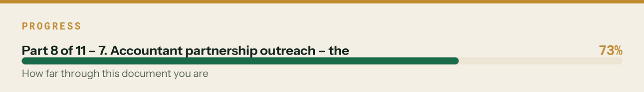

8. Merchant trade counter campaign — £40, highest local ROI on this list

The A5 card is rendered at 300dpi in assets/print/merchant-card-A5-300dpi.png.
Run: 250 cards, roughly £30–45 online. Add a QR code to the file pointing at the UTM'd URL before printing.
Placement: Travis Perkins, Jewson, Selco, MKM, Buildbase, Howdens, and every independent merchant within 15 miles. Ask the counter manager — most say yes to a bookkeeping card because it isn't competing with anything they sell.
The better move while you're there: ask the counter manager which local firms are growing. They know, because they see the account volumes. That conversation is worth more than the cards.
Track it: the QR's UTM tells you if it worked. Without it, don't bother printing them.
The line that matters
Placement: Travis Perkins, Jewson, Selco, MKM, Buildbase, Howdens, and every independent merchant within 15 miles.

Also worth knowing
Ask the counter manager — most say yes to a bookkeeping card because it isn't competing with anything they sell.

9. The review engine

Reviews are the highest-converting asset a local service business has, and Klyara has none. Fix it deliberately, from client one.
- Ask at handover of the first month's reports, not at signing. That's when the value has just
landed.
- Text the link, on the spot. An ask without a link is homework.
- Google first, always. Trustpilot second. Nothing else.
- Target: 2/month, forever, until you pass 20. BrightLocal data says 47% of consumers won't use
a business with fewer than 20 reviews, and 31% require a 4.5-star minimum — up from 17% a year earlier. Ten is not "credible", it is halfway. Twenty-five is established, and after that recency beats volume.
- Six reviews get read before someone books a tradesperson (Checkatrade), and only 24% of
completed trades jobs get reviewed at all — which is why you have to ask every time.
- Never offer anything in return, write them yourself, or buy them. For a firm holding clients'
financial data, a faked review is not a small problem.
- Reply to every one, including any bad one, within 24 hours. 65% of consumers cite
review-related reasons for rejecting a business, so one unanswered bad review is expensive. Prospects read the replies more carefully than the reviews.
Pre-client alternative: you cannot review a bookkeeping service you haven't used, and you must not fake it. But you *can* ethically publish: the partner accountant's written endorsement of Craig's CIS work, testimonials from previous employers or clients about Craig personally (clearly labelled as such), and Craig's certifications. Use those until real reviews exist.
The line that matters
Pre-client alternative: you cannot review a bookkeeping service you haven't used, and you must not fake it.


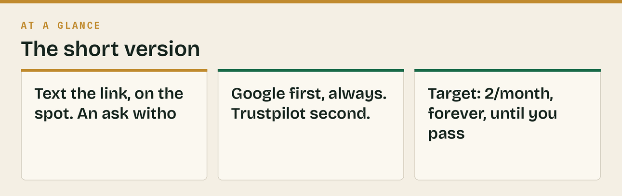

10. Things you didn't ask for, that you're missing

Ordered by what they'd cost you to keep missing.
- A crisis line in every piece of content. You're publishing tax guidance publicly as an unsupervised firm. Every post, video and email needs the "general information, not advice for your circumstances, rules change" line. It's in the templates — don't strip it out because it's ugly.
- A written content approval step. One person writes, the other reads before it goes out. A wrong CIS rate published under a bookkeeper's name is a professional problem, not a typo.
- The tryklyara.com outreach domain isn't bought yet (Manual Part 0 #9). Buy it this week — cold outreach starts before you'll remember.
- You have no lead magnet for contractors, only subcontractors. The MTD guide and Launch Kit both speak to solo operators. Your highest-value client — the 5–15-person firm — has no magnet aimed at them. Build one: *"The Contractor's CIS Compliance Pack"* — verification checklist, deduction statement template, monthly return calendar, gross status application checklist. That's a half-day's work and it targets the £199–£329 tier instead of the £59 one.
- No case study format. Your first three clients are worth more as written case studies than as revenue. Agree it at onboarding: "In three months, can I write up what we found?" Structure: the situation, what we found in the first month, what changed, the number. Anonymise if needed.
- Nobody owns social. Two founders means it's nobody's job by default. Name one owner for the two-hour weekly rhythm and put it in the founders' heads of terms alongside everything else.
- No brand safety plan for a bad comment. At some point someone will post that HMRC disagrees with something you wrote, or that an accountant did them wrong. Decide now: correct factual errors publicly and promptly, take specific complaints to DM, never argue, never delete unless it's abuse.
- The calculators aren't being marketed as the asset they are. Twelve free calculators is a genuinely strong SEO and link-building asset and you're treating it as a footnote. Each one should be its own indexed page with its own title tag ("CIS Deduction Calculator — Klyara"), and each is independently linkable from forums and Reddit, where a *tool* is welcome in places a *service* would be removed. This is the single best organic-link opportunity you have.
- No email capture on the calculator pages. People using a CIS calculator are your exact buyer at the exact moment of pain. One optional field — "want the deadline reminders emailed?" — after they get the result, never before.
- A LinkedIn newsletter. Free, and LinkedIn notifies every one of your connections when you publish an issue. Mirror the fortnightly newsletter there once the list is running. It's the highest-leverage free distribution on the platform and almost nobody in this sector uses it.
- You should be recording the discovery calls (with consent). Six calls in, you'll have the exact language your buyers use for their own problems — which is what the next thirty days of content should be written in, rather than in the language I've guessed at here.
- No plan for what happens when it works. The Manual puts Craig's ceiling at 20–25 full-service clients and the hire trigger at 15. Marketing that works will hit that faster than the hiring will. Decide the waitlist policy *before* you need it — it is much better to have a founding-rate waitlist than to take on client 26 badly.


