KLYARA the back office for building firms

Klyara — SEO & Schema Pack
Copy-paste JSON-LD, title tags and the calculator SEO plan

How to use this
Every block below goes in the <head> of the named page, inside <script type="application/ld+json"> tags. Replace anything in [SQUARE BRACKETS] with your real values before publishing — especially the address and the founding date. Schema with invented data is worse than no schema.
These are paths on klyara.com, not files in this pack — upload them to your site first, from the pack — the schema references them: assets/logo/klyara-mark-disc-512.png → /assets/klyara-mark-disc-512.png, and any 1200×630 crop of assets/banners/x-header-1500x500.png → /assets/og/klyara-og.png.
Validate every page after pasting at search.google.com/test/rich-results. It takes ten seconds per page and it catches typos that silently kill the whole block.
Do not add the AggregateRating or Review schema types until you have real reviews. Marking up reviews you don't have is the machine-readable version of the testimonial problem in docs/07, and Google issues manual actions for it.
The line that matters
Marking up reviews you don't have is the machine-readable version of the testimonial problem in docs/07, and Google issues manual actions for it.

In this part
Copy-paste JSON-LD, title tags and the calculator SEO plan · How to use this


Read top to bottom. The bar is just how far through the part you are.

1. Organization + LocalBusiness — goes on EVERY page

This is the foundation. It tells Google what Klyara is, where it operates and how to contact you. Put it site-wide in the template head.
<script type="application/ld+json">
{
"@context": "https://schema.org",
"@type": "AccountingService",
"@id": "https://klyara.com/#organization",
"name": "Klyara",
"alternateName": "Klyara — Construction Back Office",
"description": "Bookkeeping, VAT coding, payroll and Making Tax Digital quarterly filing for UK construction firms and subcontractors.",
"url": "https://klyara.com",
"logo": {
"@type": "ImageObject",
"url": "https://klyara.com/assets/klyara-mark-disc-512.png",
"width": 512,
"height": 512
},
"image": "https://klyara.com/assets/og/klyara-og.png",
"telephone": "+442080581496",
"email": "hello@klyara.com",
"foundingDate": "[YYYY-MM-DD]",
"priceRange": "££",
"currenciesAccepted": "GBP",
"paymentAccepted": "Direct Debit, Bank Transfer",
"address": {
"@type": "PostalAddress",
"streetAddress": "[STREET]",
"addressLocality": "[TOWN]",
"addressRegion": "[COUNTY]",
"postalCode": "[POSTCODE]",
"addressCountry": "GB"
},
"areaServed": [
{ "@type": "Country", "name": "United Kingdom" },
{ "@type": "City", "name": "[TOWN 1]" },
{ "@type": "City", "name": "[TOWN 2]" },
{ "@type": "City", "name": "[TOWN 3]" }
],
"openingHoursSpecification": [{
"@type": "OpeningHoursSpecification",
"dayOfWeek": ["Monday","Tuesday","Wednesday","Thursday","Friday"],
"opens": "08:00",
"closes": "18:00"
}],
"knowsAbout": [
"Construction Industry Scheme",
"CIS returns",
"Making Tax Digital for Income Tax",
"VAT domestic reverse charge",
"Construction payroll",
"Subcontractor verification",
"Gross payment status",
"Construction bookkeeping"
],
"sameAs": [
"https://www.linkedin.com/company/[HANDLE]",
"https://www.facebook.com/[HANDLE]",
"https://x.com/[HANDLE]",
"https://www.instagram.com/[HANDLE]",
"https://www.youtube.com/@[HANDLE]"
],
"hasOfferCatalog": {
"@type": "OfferCatalog",
"name": "Klyara plans",
"itemListElement": [
{ "@type": "Offer", "name": "Klyara Solo", "price": "59", "priceCurrency": "GBP",
"description": "MTD quarterly filing, receipt app, CIS tracking for sole-trader subcontractors",
"eligibleCustomerType": "Business" },
{ "@type": "Offer", "name": "Klyara Start", "price": "99", "priceCurrency": "GBP",
"description": "Monthly bookkeeping and P&L for micro limited companies" },
{ "@type": "Offer", "name": "Klyara Trade", "price": "199", "priceCurrency": "GBP",
"description": "Bookkeeping, VAT, CIS, payroll and invoice chasing for 5-15 person firms" },
Note on AccountingService: it's a subtype of LocalBusiness and ProfessionalService, so you inherit all the local-business properties. It's more specific than LocalBusiness and more accurate than FinancialService, which implies regulated activity you deliberately don't do.
The line that matters
It's more specific than LocalBusiness and more accurate than FinancialService, which implies regulated activity you deliberately don't do.

Also worth knowing
Note on AccountingService: it's a subtype of LocalBusiness and ProfessionalService, so you inherit all the local-business properties.



2. WebSite + Sitelinks Search — homepage only

<script type="application/ld+json">
{
"@context": "https://schema.org",
"@type": "WebSite",
"@id": "https://klyara.com/#website",
"url": "https://klyara.com",
"name": "Klyara",
"publisher": { "@id": "https://klyara.com/#organization" },
"inLanguage": "en-GB"
}
</script>


3. FAQPage — the MTD page ⭐ biggest single win


Your MTD page has sixteen questions and no markup. This block makes them eligible for expanded results. Answers must match the on-page text — Google checks, and mismatched answers get the markup ignored.
I've written the first six out in full using your actual questions. Replicate the pattern for the remaining ten, pasting your real on-page answers in.
<script type="application/ld+json">
{
"@context": "https://schema.org",
"@type": "FAQPage",
"@id": "https://klyara.com/making-tax-digital.html#faq",
"mainEntity": [
{
"@type": "Question",
"name": "Does CIS money count towards the MTD threshold?",
"acceptedAnswer": {
"@type": "Answer",
"text": "Yes. HMRC measures qualifying income as the amount before expenses — your turnover, taken from the tax return you filed the previous year. CIS deductions do not reduce turnover; they are recorded separately as tax already paid. So if you invoice £55,000 and 20% CIS is deducted, you bank £44,000 but the turnover box on your return still says £55,000, which puts you over the £50,000 threshold."
}
},
{
"@type": "Question",
"name": "I run a limited company. Does MTD for Income Tax apply to me?",
"acceptedAnswer": {
"@type": "Answer",
"text": "[PASTE YOUR ON-PAGE ANSWER VERBATIM]"
}
},
{
"@type": "Question",
"name": "What happens if I just ignore Making Tax Digital?",
"acceptedAnswer": {
"@type": "Answer",
"text": "[PASTE YOUR ON-PAGE ANSWER VERBATIM]"
}
},
{
"@type": "Question",
"name": "Can I just use a spreadsheet like always?",
"acceptedAnswer": {
"@type": "Answer",
"text": "[PASTE YOUR ON-PAGE ANSWER VERBATIM]"
}
},
{
"@type": "Question",
"name": "I have property income too. Does that count towards the threshold?",
"acceptedAnswer": {
"@type": "Answer",
"text": "[PASTE YOUR ON-PAGE ANSWER VERBATIM]"
}
},
{
"@type": "Question",
"name": "When should I actually start preparing for MTD?",
"acceptedAnswer": {
"@type": "Answer",
"text": "[PASTE YOUR ON-PAGE ANSWER VERBATIM]"
}
}
]
}
</script>
Rules that stop this backfiring:
- Every question in the markup must be visibly on the page
- Every answer must match the visible text (paraphrasing is fine, contradicting is not)
- No promotional links inside answer text
- One FAQPage block per page, never two
The line that matters
Answers must match the on-page text — Google checks, and mismatched answers get the markup ignored.

4. Service schema — one per service page

Template. Duplicate and adjust for Bookkeeping & CIS, MTD, Payroll, Invoice Chasing, AI Receptionist, Websites, Local Search.
<script type="application/ld+json">
{
"@context": "https://schema.org",
"@type": "Service",
"serviceType": "CIS returns and construction bookkeeping",
"name": "Bookkeeping and CIS for construction firms",
"description": "Monthly bookkeeping, CIS returns filed by the 19th, subcontractor verification, VAT reverse charge coding and management reports for UK building firms.",
"provider": { "@id": "https://klyara.com/#organization" },
"areaServed": { "@type": "Country", "name": "United Kingdom" },
"audience": {
"@type": "BusinessAudience",
"name": "UK construction firms and subcontractors"
},
"offers": {
"@type": "Offer",
"price": "199",
"priceCurrency": "GBP",
"priceSpecification": {
"@type": "UnitPriceSpecification",
"price": "199",
"priceCurrency": "GBP",
"unitCode": "MON",
"valueAddedTaxIncluded": false
}
}
}
</script>
The line that matters
Duplicate and adjust for Bookkeeping & CIS, MTD, Payroll, Invoice Chasing, AI Receptionist, Websites, Local Search.



5. BreadcrumbList — every page below the homepage

<script type="application/ld+json">
{
"@context": "https://schema.org",
"@type": "BreadcrumbList",
"itemListElement": [
{ "@type": "ListItem", "position": 1, "name": "Home", "item": "https://klyara.com" },
{ "@type": "ListItem", "position": 2, "name": "Services", "item": "https://klyara.com/services/" },
{ "@type": "ListItem", "position": 3, "name": "Bookkeeping and CIS" }
]
}
</script>
*The last item has no item URL — that's correct, it's the current page.*


6. SoftwareApplication — every calculator ⭐ the sleeper win


This is the most under-exploited asset you own. Twelve working, ungated calculators on their own URLs. Marked up properly, each becomes independently discoverable, independently linkable, and independently rankable for its own long-tail query.
Paste one of these on each calculator page:
<script type="application/ld+json">
{
"@context": "https://schema.org",
"@type": "SoftwareApplication",
"name": "CIS Deduction Calculator",
"description": "Work out CIS deductions at 20% or 30%, in both directions, with the materials split excluded. Free, no signup.",
"url": "https://klyara.com/tools/cis-deduction-calculator.html (your URL, not a file in this pack)",
"applicationCategory": "FinanceApplication",
"operatingSystem": "Any",
"browserRequirements": "Requires JavaScript",
"inLanguage": "en-GB",
"isAccessibleForFree": true,
"offers": { "@type": "Offer", "price": "0", "priceCurrency": "GBP" },
"publisher": { "@id": "https://klyara.com/#organization" }
}
</script>
Title tags and meta descriptions for all twelve
Each calculator needs its own. These are written to the query, not to the brand.
Calculator | Title tag | Meta description
CIS deduction | `CIS Deduction Calculator — 20% and 30% \ | Klyara`
VAT + reverse charge | `VAT Reverse Charge Calculator for Construction \ | Klyara`
Job margin | `Job Margin Calculator for Builders \ | Klyara`
Day rate builder | `Day Rate Calculator — What Should You Charge? \ | Klyara`
Late payment interest | `Late Payment Interest Calculator — UK B2B \ | Klyara`
Retention tracker | `Construction Retention Tracker — Free Template \ | Klyara`
VAT threshold tracker | `VAT Registration Threshold Tracker \ | Klyara`
Flat rate vs standard | `Flat Rate vs Standard VAT Calculator \ | Klyara`
Deadline calendar | `UK Tax Deadline Calendar — CIS, VAT, MTD \ | Klyara`
Subbie take-home | `Subcontractor Take-Home Calculator — After CIS \ | Klyara`
True employee cost | `True Cost of an Employee Calculator — UK \ | Klyara`
Name + domain finder | `Construction Business Name and Domain Generator \ | Klyara`

Why this matters more than it looks: a *tool* is welcome in places a *service* gets removed. You can post "here's a free CIS calculator, no signup" in a subreddit or a trade forum where "here's my bookkeeping firm" would be deleted on sight. Twelve tools is twelve legitimate, rule-compliant reasons to participate in communities. That is the entire Reddit and forum strategy in docs/01, and the calculators are what makes it work.
The line that matters
You can post "here's a free CIS calculator, no signup" in a subreddit or a trade forum where "here's my bookkeeping firm" would be deleted on sight.

In this part
Title tags and meta descriptions for all twelve

7. HowTo — for the quarter-end and verification guides

When you publish the quarter-end checklist as a page:
<script type="application/ld+json">
{
"@context": "https://schema.org",
"@type": "HowTo",
"name": "Quarter-end checklist for builders under Making Tax Digital",
"description": "Seven jobs, each under twenty minutes, to close an MTD quarter properly.",
"totalTime": "PT1H",
"step": [
{ "@type": "HowToStep", "position": 1, "name": "Connect the bank feed",
"text": "Connect every business bank account to your software so transactions feed automatically rather than being exported and typed in." },
{ "@type": "HowToStep", "position": 2, "name": "Get the receipts in",
"text": "Enter every receipt not already covered by the bank feed — fuel, parking, tools, trade counter purchases on personal cards, PPE." },
{ "@type": "HowToStep", "position": 3, "name": "Handle mixed-use costs",
"text": "Apply a consistent, defensible split for van, phone, home office and workwear, and record why you chose it." },
{ "@type": "HowToStep", "position": 4, "name": "Reconcile",
"text": "Match every transaction. Zero unmatched is the standard. Watch for payments in you never matched to an invoice." },
{ "@type": "HowToStep", "position": 5, "name": "Reconcile CIS",
"text": "Chase every missing payment and deduction statement while the contractor still remembers the job. Unevidenced deductions are tax paid twice." },
{ "@type": "HowToStep", "position": 6, "name": "Check the reverse charge",
"text": "Take your last ten sales invoices and check the five reverse charge tests on each. Two minutes." },
{ "@type": "HowToStep", "position": 7, "name": "Look at the number",
"text": "Gross margin by job, what you're owed by age, retentions outstanding, and bank balance against the next thirty days." }
]
}
</script>


8. Keyword clusters — what to build content against

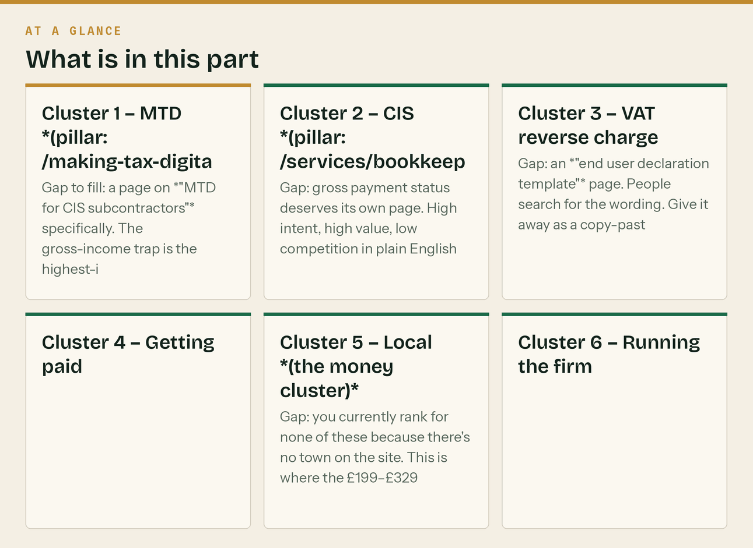
Six clusters. Each maps to one pillar page plus supporting pieces. This is your next six months of SEO.
Cluster 1 — MTD *(pillar: /making-tax-digital.html — already your best page)*
mtd for income tax · making tax digital sole trader · mtd threshold 2027 · mtd for subcontractors
mtd quarterly update deadline · do i need to do making tax digital · mtd £30,000 threshold
making tax digital for builders · mtd income tax cis · qualifying income mtd
Gap to fill: a page on *"MTD for CIS subcontractors"* specifically. The gross-income trap is the highest-intent query in this whole cluster and nobody else is answering it in plain English.
Cluster 2 — CIS *(pillar: /services/bookkeeping-cis)*
cis deduction calculator · cis returns deadline · cis 20 or 30 percent · verify subcontractor cis
cis gross payment status · cis materials deduction · nil cis return · cis penalties
cis monthly return · deemed contractor cis · cis payment and deduction statement
Gap: gross payment status deserves its own page. High intent, high value, low competition in plain English. The content is already written in assets/lead-magnets/.
Cluster 3 — VAT reverse charge
domestic reverse charge construction · vat reverse charge calculator · reverse charge end user
reverse charge invoice wording · cis reverse charge · construction vat monthly returns
Gap: an *"end user declaration template"* page. People search for the wording. Give it away as a copy-paste block and it earns links.
Cluster 4 — Getting paid
late payment interest calculator uk · retention construction · statutory interest commercial debt
how to chase unpaid invoices builder · construction retention release
Cluster 5 — Local *(the money cluster)*
bookkeeper for builders [town] · cis accountant [town] · construction accountant [town]
bookkeeper near me construction · accountant for subcontractors [town]
Gap: you currently rank for none of these because there's no town on the site. This is where the £199–£329 clients come from. One local page plus the Google Business Profile does most of it.
Cluster 6 — Running the firm
true cost of an employee uk · day rate calculator construction · job margin construction
first employee builder · construction cash flow
The line that matters
The gross-income trap is the highest-intent query in this whole cluster and nobody else is answering it in plain English.

In this part
Cluster 1 — MTD *(pillar: /making-tax-digital.html — already your best page)* · Cluster 2 — CIS *(pillar: /services/bookkeeping-cis)* · Cluster 3 — VAT reverse charge · Cluster 4 — Getting paid · Cluster 5 — Local *(the money cluster)* · Cluster 6 — Running the firm

9. Ten pages to build next, in priority order


# | Page | Cluster | Why
1 | Construction bookkeeping in [town] | Local | The only cluster with buying intent. Nothing else beats it.
2 | MTD for CIS subcontractors | MTD | Highest-intent long tail; the gross-income trap
3 | Gross payment status: the three tests | CIS | Content already written in the CIS pack
4 | End user declaration — free template | VAT | Template pages earn links passively
5 | CIS penalties explained | CIS | Fear-driven search, high urgency
6 | Switching bookkeepers mid-year | Trust | Removes the biggest objection to changing
7 | Nil CIS returns | CIS | Tiny query, near-zero competition, easy win
8 | Quarter-end checklist | MTD | HowTo schema, already written in docs/03
9 | Retentions: how to get them back | Getting paid | The post that got most engagement in the calendar
10 | What a bookkeeper actually does | Trust | Top-of-funnel; catches people who don't know they need you

All ten are now built — plus two that were not on the list
web/tools.html (four working calculators) and web/pricing.html (the four tiers, published) were added after this list was written. The pricing page exists because of a specific research finding: of eleven firms surveyed in and around Guildford, one published a full price list and it was the London one. See docs/22.
Two more built after the list, targeting queries with genuine intent and almost no competition:
web/cis-payment-and-deduction-statement.html How to read one. The verification number that
silently means you are on 30% rather than 20%.
web/late-payment-interest-construction.html 8% over base plus £40/£70/£100, worked example,
and the day-by-day chase sequence that uses it.
Both are the kind of query somebody types once, urgently, and remembers who answered.
One correction to the keyword plan, from real search data. Do not target "CIS calculator" or "free CIS deduction calculator" — at least eight established free calculators rank for those and several are good. Target the queries with no tool behind them instead: *do I charge VAT on this invoice construction*, *how much are my late CIS returns costing*, *am I in Making Tax Digital CIS subcontractor*, and the local qualifier *CIS calculator Guildford*. Full analysis in docs/22 PART 6.
The original five, built first
Not briefs — production HTML, same tokens and fonts, each with Article + FAQPage + BreadcrumbList schema and 1,300–1,800 words of genuinely useful content:
web/mtd-for-cis-subcontractors.html 1,772 words the gross-income trap, in full
web/cis-gross-payment-status.html 1,430 words the three tests, and re-applying
web/vat-reverse-charge-end-user-declaration.html 1,543 words free declaration wording — link bait
web/cis-penalties-explained.html 1,401 words why four missed months isn't £400
web/cis-materials-deduction.html 1,350 words the £240-per-invoice arithmetic
All five render clean in Chromium with no horizontal overflow and all JSON-LD validated.
Publish order: MTD for CIS subcontractors first (highest intent), then the end user declaration (template pages earn links passively), then the other three.
Link them properly. Each should link to the Guildford page, the MTD page, the tools page and each other. An orphan page ranks for nothing, and internal linking is the cheapest ranking factor there is.
The remaining five briefs — switching bookkeepers, nil returns, quarter-end checklist, retentions, what a bookkeeper does — have their full text in the calendar, the newsletters and the CIS lead magnet. Copy-and-reformat, not a writing job.
The line that matters
One correction to the keyword plan, from real search data.

In this part
All ten are now built — plus two that were not on the list · The original five, built first

10. The technical basics, in one list

☐ Google Search Console — verify domain, submit sitemap
☐ Google Analytics 4 — install, set "book a call" and "download guide" as conversions
☐ Bing Webmaster Tools — import from GSC, two minutes
☐ Meta Pixel — install now, zero spend
☐ LinkedIn Insight Tag — install now
☐ robots.txt — confirm nothing important is blocked
☐ XML sitemap — confirm every calculator URL is in it
☐ Canonical tags on every page
☐ Per-page og:image (use assets/posts/*.png)
☐ Every image has alt text — currently unchecked
☐ Core Web Vitals — run PageSpeed Insights on homepage, MTD page and one calculator
☐ Mobile check — most of this audience is on a phone, on site, in daylight
☐ HTTPS + HSTS
☐ 404 page that routes to the tools and the guide rather than dead-ending


11. The sitemap, robots.txt, and the guide index

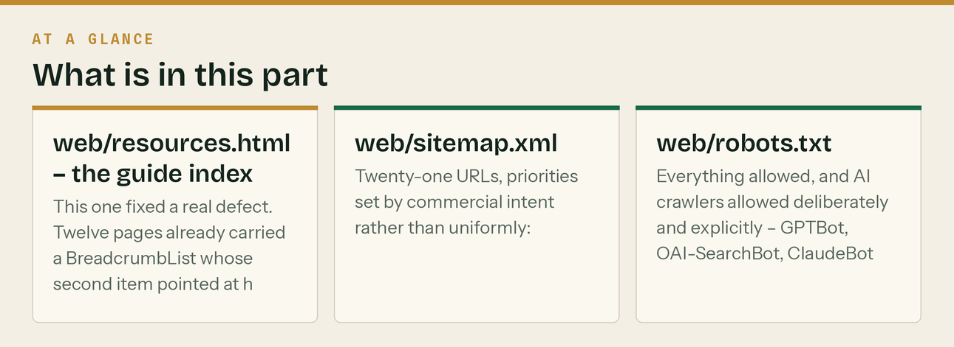
*Three small files added 26 August 2026. All three are generated by brand/gen_sitemap.py and brand/gen_resources_page.py — re-run either after adding a page.*
web/resources.html — the guide index
This one fixed a real defect. Twelve pages already carried a BreadcrumbList whose second item pointed at https://klyara.com/resources/ — a URL that did not exist. A breadcrumb pointing at a 404 is worse than no breadcrumb, because it is a claim about site structure that the crawler can check.
The page now exists, the breadcrumbs point at resources.html, and it does real work besides: fourteen guides and four tools grouped into six clusters — CIS, VAT and the reverse charge, Making Tax Digital, getting paid, choosing a bookkeeper, and where we work — with CollectionPage and a twenty-item ItemList. Nineteen pages link to it from the footer.
It is also the page to link from anywhere off-site. A single link to a good index passes value to everything under it, which is not true of a link to one guide.
web/sitemap.xml
Twenty-one URLs, priorities set by commercial intent rather than uniformly:
Priority | Pages
1.0 | Home, and the Guildford landing page
0.9 | Pricing, tools
0.8 | The four other local pages
0.7 | The guide index
0.6 | Every guide

changefreq is monthly on pricing, tools and the index, and yearly on the guides — which is honest, and honest is the point. Submit it in Search Console on the day the site goes live, then again after any batch of new pages.
web/robots.txt
Everything allowed, and AI crawlers allowed deliberately and explicitly — GPTBot, OAI-SearchBot, ClaudeBot, PerplexityBot and Google-Extended are each named with Allow.
That is a decision, not a default, and the reasoning is in docs/19: being the source an assistant cites is a channel worth having, not a leak worth blocking. The comment in the file says so, so that whoever reads it in a year knows it was chosen. The reference to the sitemap is at the bottom, which is where crawlers look for it.
The line that matters
Everything allowed, and AI crawlers allowed deliberately and explicitly — GPTBot, OAI-SearchBot, ClaudeBot, PerplexityBot and Google-Extended are each named with Allow.

In this part
web/resources.html — the guide index · web/sitemap.xml · web/robots.txt

12. Two corrections to this document, 26 August 2026

FAQPage and HowTo no longer produce rich results
This document repeatedly calls FAQPage schema "the biggest single win". That was true when the approach was written and it is not true now.
- FAQ rich results stopped appearing in Google Search on 7 May 2026, and support was removed the
following month. Before that, eligibility had already been narrowed to well-known government and health sites. Source: Google Search Central, structured data documentation for FAQPage.
- HowTo rich results were retired in September 2023, on both desktop and mobile. Source: the same
documentation for HowTo.
What to do about it. Keep the FAQ *content* — it is the best-performing thing on these pages, it is what AI assistants extract, and it answers the question a visitor actually arrived with. Keep the markup too; it costs nothing and it is still read by things other than Google. But stop treating it as the priority, and move the "forty minutes of copy-paste" to AccountingService, Organization, BreadcrumbList and Service, which still produce results.
The HowTo block earlier in this document can be deleted. The seven steps stay on the page.
Twelve calculators, or four?
Both, and the pack has never said which is which. Stating it once, here:
- klyara.com already has twelve individual calculators, each on its own URL. That is what
docs/07 audited and what §6 of this document refers to.
- web/tools.html is a new consolidated page with four tools — the CIS deduction calculator, the
reverse charge decision tool, the late-return penalty estimator and the MTD date checker. Three of those four do not exist anywhere else on the site, and the reverse-charge and MTD tools are the two the August 2026 search research identified as genuinely winnable.
Do not add SoftwareApplication schema to all twelve and to the four. You would be telling Google there are sixteen tools where a visitor experiences one toolset plus a set of single-purpose pages. Mark up the four on tools.html, mark up the twelve individually, and make tools.html link to the individual ones so the relationship is visible. Wherever the pack says "twelve free calculators", it means the individual pages; wherever it says "four tools", it means tools.html.
The line that matters
Do not add SoftwareApplication schema to all twelve and to the four.

In this part
FAQPage and HowTo no longer produce rich results · Twelve calculators, or four?


Read top to bottom. The bar is just how far through the part you are.

