KLYARA the back office for building firms

Klyara — Sales Pack
Discovery call script, qualification, objection handling, follow-up

*The Build Manual lists the discovery script, proposal template and outbound copy as deliverables. They hadn't been produced. This is them.*
Everything in this pack converts marketing into revenue. It is the highest-value document here — the other eight get people to the call; this one is the call.
The line that matters
Everything in this pack converts marketing into revenue. It is the highest-value document here — the other eight get people to the call; this one is the call.

In this part
Discovery call script, qualification, objection handling, follow-up

PART 1 — Before the call

The 90-second prep
Never take a discovery call cold. Ninety seconds of prep changes the entire tone, because you open knowing something about them.
☐ Google the firm name — website? Google Business Profile? reviews?
☐ Companies House — limited or sole trader? Incorporated when? Accounts overdue?
☐ Their website — do they list the trades they do? Any sign of size?
☐ Checkatrade / MyBuilder / Rated People — reviews tell you how busy they are
☐ Whatever they typed in the booking form
What you're looking for: rough size, whether they're limited, whether they look busy, and whether their online presence is weak — because that's the digital upsell later.
The frame — read this before every call for the first month
You are not selling. You are diagnosing, out loud, and telling them the truth about what they need.
This isn't a soft technique. It's what actually works with this audience, for a specific reason: builders get sold to constantly — by merchants, by lead-gen sites, by energy brokers, by anyone with a phone. They have excellent defences against a pitch and almost none against someone who just tells them how CIS works and then says "you probably don't need me."
So: if they don't need you, say so. You will lose about one in eight deals doing this and win considerably more than that back in referrals, because the person you told the truth to tells everyone.
The line that matters
It's what actually works with this audience, for a specific reason: builders get sold to constantly — by merchants, by lead-gen sites, by energy brokers, by anyone with a phone.

In this part
The 90-second prep · The frame — read this before every call for the first month

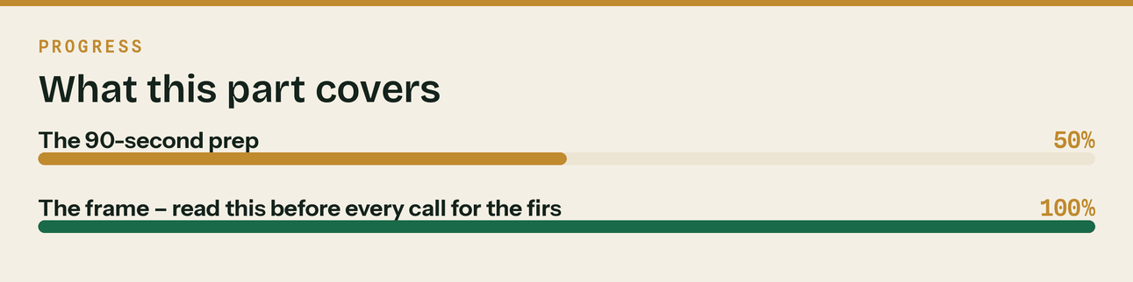
Read top to bottom. The bar is just how far through the part you are.

PART 2 — The discovery call script

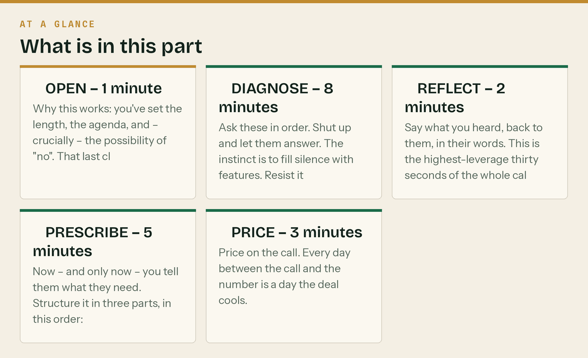
Twenty minutes. Five parts. Do not exceed twenty minutes — this audience prices its own time and a call that overruns reads as a firm that doesn't respect it.
① OPEN — 1 minute
"Craig from Klyara — thanks for booking in. Have you got twenty minute
Right. So this'll take about fifteen. What I want to do is understand how you're set up at the moment, tell you honestly what I think you actually need, and if that's us, I'll price it on the call so you're not waiting on a quote. And if it's not us I'll tell you that too. Sound alright?"

Why this works: you've set the length, the agenda, and — crucially — the possibility of "no". That last clause does more for the close rate than anything else in the script.
② DIAGNOSE — 8 minutes
Ask these in order. Shut up and let them answer. The instinct is to fill silence with features. Resist it — the diagnosis is the product.
The seven questions
1. "Tell me about the business — what do you do and how many are you?" Open question, lets them talk. You're listening for: trade, size, and whether they say "we" or "I".
2. "Are you a limited company or sole trader?" Determines: MTD ITSA scope, CT600 need, payroll complexity, which tier.
3. "Who does the books at the moment?" Listen very carefully to this answer. It's usually one of:
- *"My wife/partner does it"* → most delicate call you'll take. You are proposing to take a job
off someone in the family. Never disparage it. "She'll have better things to do with her Sundays" works. Making her feel replaced does not.
- *"An accountant does it once a year"* → you're not replacing them, you're the monthly layer
underneath. Say so explicitly, and mean it — that accountant is a referral partner.
- *"I do it"* → the easiest sale on this list. Ask when. The answer is always "evenings" or
"weekends" and that's the whole pitch.
- *"Nobody, really"* → they have a problem they haven't priced yet.
4. "Roughly what did you turn over last year — and is that gross, before CIS?" The single most important question on the call. It gives you: MTD scope, tier, and — if they're a subbie — the gross-income trap conversation, which is the moment they realise you know something they don't.
5. "Is CIS deducted from you, do you deduct from others, or both?" Determines complexity and tier. "Both" means Trade minimum.
6. "VAT registered? And how are you handling the reverse charge?" Ask the second half even if you're confident. Roughly half will give an answer that reveals they're doing it wrong, and that's your highest-value moment on the call — not because you catch them out, but because you can fix it.
7. "What's the bit that annoys you most?" The closing diagnostic. Whatever they say here is what you sell against for the rest of the call. It's almost never "tax". It's usually chasing money, or evenings, or not knowing where they stand.
Two more if it's flowing
8. "How do people find you at the moment?" → the digital upsell, later. Don't sell it now.
9. "Anyone missing your calls when you're on site?" → the receptionist. Same rule: don't sell it now.
③ REFLECT — 2 minutes
Say what you heard, back to them, in their words. This is the highest-leverage thirty seconds of the whole call and almost nobody does it.
"So — twelve on site, limited company, VAT registered, CIS both ways,
books on a Sunday afternoon. The bit that's actually getting to you is chasing Hendersons for money you earned in June. Have I got that right?"

Then stop talking until they respond. They will say "yes, exactly" and correct one detail, and that correction is worth more than another ten minutes of questions.
At this point you have done something almost no one who calls them does: you listened, and you played it back accurately.
④ PRESCRIBE — 5 minutes
Now — and only now — you tell them what they need. Structure it in three parts, in this order:
a) What's urgent
"Right. Two things are urgent and one isn't.
Urgent one: you're a limited company, so Making Tax Digital for Income Tax isn't yours to worry about — that one's sole traders and landlords. What is yours is the monthly CIS. You've got subbies going out and CIS coming off you, both, and that's the 19th every month with statements out the same day. When did the last return go in?"

Lead with the thing that has a date on it. Not the thing with the biggest fee.
And get the regime right. MTD for Income Tax applies to sole traders and landlords, not to limited companies. Saying "you're in MTD" to a company director is the kind of error that ends a call, because it is the one thing they may already have checked. If they are a sole trader over the threshold, then yes — lead with it.
b) What's costing them money quietly
"The one nobody's told you about: you said you're charging VAT to Hend
contractor invoicing your work onward, they're not an end user and that should be reverse charged. Two things follow from that — you'll want it fixed before the next VAT return, and if most of your sales go reverse charge you're probably in a repayment position, in which case you should be on monthly VAT returns, not quarterly. That's your money back twelve times a year instead of four."

This is the moment the call is won or lost. You've just told them something worth real money that they didn't know, before asking for anything.
c) What they don't need
"What you don't need is the AI receptionist. You've got an office and
it."

Never skip this part. Removing something from the sale is the single most credible thing you can do, and it makes everything else you said believable.
⑤ PRICE — 3 minutes
Price on the call. Every day between the call and the number is a day the deal cools.
"So that's Trade — £199 a month plus VAT. That's the bookkeeping, the
the reverse charge coding, CIS both ways filed by the 19th, payroll for the twelve, invoice chasing running automatically, and a monthly P&L. There's a one-off onboarding fee of £350. That's for cleaning up the catch-up — you've got four months of records to bring in and a reverse charge issue to unwind. I'd rather charge that once than pretend it's free and rush it. Thirty days' notice, no contract. If it's not working you tell me and we stop. How does that sit?"

The three rules of pricing on the call
- Say the number and stop. The silence after a price is uncomfortable and you must not fill it. Whoever speaks first loses. Count to ten in your head.
- Never discount on the call. If they push, add value or reduce scope — never cut the number. Discounting in the first conversation tells them the price was invented.
- Always give the onboarding fee its reason in the same breath as the number. It's the most objected-to figure and the objection disappears entirely when it's explained.
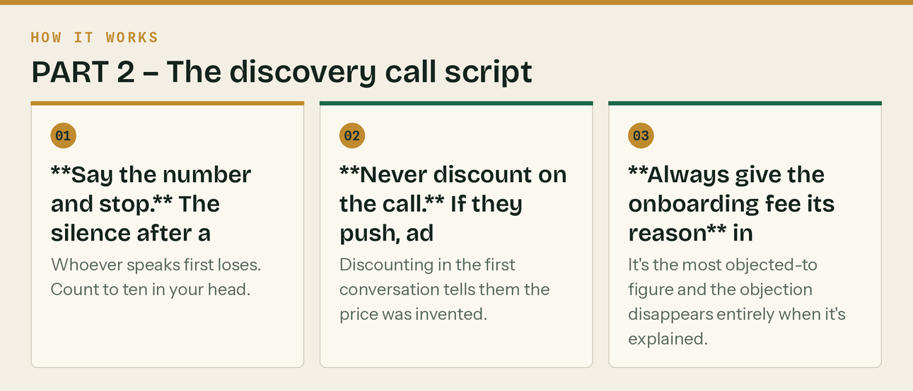
The same steps, in order.

PART 3 — Objection handling


Everything below is a real objection this audience raises. Never argue. Acknowledge, reframe, ask.
"That's more than my accountant charges"
"It probably is, and it should be — he does one job a year, we do twel
return. Ours is that your books are right every month, the CIS goes in on the 19th, and you know by the 10th what last month made. Genuinely though — if all you need is the annual return, keep him and don't pay us. That's a real answer, not a negotiating position."

"My wife does the books"
"Then she's saving you a fortune and I'm not going to tell you to chan
The only thing I'd say — MTD means four filings a year instead of one now, and it goes to £30,000 next April, so it'll catch more of what you do. If that turns her Sunday afternoon into a bad Sunday afternoon, come back to me. Happy to just answer questions in the meantime, no charge."

*This one you often lose, and you should. You'll get the referral, and about a third come back within a year.*
"I'll think about it"
"Course. What's the bit you want to think about — is it the money, or
"Course. What's the bit you want to think about — is it the money, or whether it's the right time?"

*Then be quiet.* "Think about it" is never the real objection; it's the polite version of one of those two. Find out which and you can actually answer it.
"Can you do it cheaper?"
"I can do you less for less. If we drop the payroll and you keep runni
Start at £99 rather than Trade at £199. Same quality of work, smaller scope. What I won't do is the same job for less, because then I'd be cutting corners on your figures and you'd never know which corner."

"I've been burned by an accountant before"
"What happened?"
"What happened?"

*Just that. Then listen properly.* This objection is trust, not price, and the only thing that answers it is being the person who asked and actually listened. Afterwards:
"Fair enough. Two things I'd say — thirty days' notice, so you're neve
have my mobile, not a general inbox. If that's not enough, don't sign, and I mean that."

"What if I want to leave?"
"Thirty days' notice, and your data's yours. It's your QuickBooks file
out with it. We don't hold books hostage — some firms do and it's why people are nervous."

"Do I have to move to QuickBooks?"
"No. If you're on Xero we'll work in Xero. If you're on QuickBooks, gr
I'll put you on QuickBooks because that's what I'll set up fastest and cheapest."

"Are you actually qualified?"
"[Current honest answer — membership, supervision, certifications, and
"[Current honest answer — membership, supervision, certifications, and Craig's years in the trade.]"

Say only what's true today. If the practice licence hasn't landed, say when it's expected and what you can and can't do until it does. Getting caught out on this is unrecoverable in a small local market.
"I'll wait until the new tax year"
"You can. Two things to weigh: your quarterly updates keep falling due
catch-up gets bigger the longer we leave it — which means the onboarding fee gets bigger too. Starting now means the year-end is clean rather than a reconstruction."

"Can I start today?" — pre-AML answer
"Almost. We're finishing our supervision registration, which is the bi
agent — that lands [timeframe]. What I can do now is put you on the founding list, hold the rate for twelve months from the day you start, and get the setup done so we're filing from day one rather than starting from scratch. No payment until we're live. If it drags on you walk away and you've lost nothing."

Never take money for bookkeeping work you're not yet supervised to do. Waitlist, no deposit, until it's confirmed.

PART 4 — Qualify out. Deliberately.

The Build Manual is right: qualify out sub-£20k hobbyists, anyone wanting credit, and anyone who won't do direct debit. Add these.
Walk away when | Why
Turnover under about £20,000 with no growth | Can't carry the fee, and won't stay
Wants to pay by invoice, in arrears | Direct debit is not negotiable. This is the strongest predictor of a bad debt.
Books more than two years behind with no urgency | The catch-up will exceed the annual fee and they'll resent it
Asks you to "be creative" with figures | End the call politely. This is your licence.
Won't do CDD / ID verification | You legally can't act. Not a preference.
Three or more prior bookkeepers in two years | You'll be number four for the same reason
Talks over you for the whole call | They will do that every month, forever
Won't say what they turn over | They don't trust you, and it won't improve

How to walk away well:
"I don't think we're the right fit, and I'd rather say so now than tak
you. What you probably want is [specific alternative]. Happy to point you at someone if that helps."

They remember this. It's how you get referrals from people who never became clients.
The line that matters
The Build Manual is right: qualify out sub-£20k hobbyists, anyone wanting credit, and anyone who won't do direct debit.

PART 5 — After the call


Within one hour — the proposal email
This is a rule, not a preference
BrightLocal's research on local buying behaviour: 75% of people decide within 30 minutes of starting to look, and 28% decide within five minutes. 72% evaluate three or fewer businesses before choosing.
That reframes the whole follow-up. You are not competing on being the best answer — you are competing on being an answer *while they are still deciding*. A perfect proposal on Thursday loses to an adequate one on Tuesday, every time.
The standard: acknowledge within the hour, always. Even if it is one line — *"Good to talk, full proposal with you by 5."* That single message keeps you in the consideration set.
*Source: Trades marketing statistics 2026, citing BrightLocal*
Speed is the whole thing. A proposal that arrives within an hour of the call converts far better than the identical proposal sent the next morning, because you're still in the conversation.
Subject: Klyara — Trade plan for [FIRM NAME]
Hi [NAME],
Good to talk. As promised, in writing:
WHAT YOU NEED
• VAT quarterly and the year-end corporation tax return, next update due 7 November
• VAT reverse charge on the Hendersons work fixed, and a switch to monthly returns
• CIS both directions, filed by the 19th
• Payroll for the twelve
• Invoice chasing running automatically
• Monthly P&L by the 10th
WHAT IT COSTS
Klyara Trade — £199/month + VAT
One-off onboarding — £350 + VAT (four months of catch-up and unwinding the reverse charge)
30 days' notice. No contract. Your data stays yours.
WHAT YOU DON'T NEED
The AI receptionist. You've got someone answering. Don't buy it.
WHAT HAPPENS NEXT
1. You say yes to this email
2. I send the engagement letter to e-sign and a direct debit link — five minutes
3. ID check (regulatory, quick)
4. We get authorised with HMRC as your agent — allow a week for their post
5. Portal login, and I'll show you the receipt app on your phone in two minutes
6. Live within five working days of signing, bar HMRC's post
One-page summary attached.
Any questions, ring me — 020 8058 1496.
Craig
Attach the one-page proposal PDF — template in assets/sales/. A one-page PDF alongside the email materially raises the close rate for a reason worth knowing: it's the thing they show someone else. Almost every deal in this market gets discussed with a partner, a co-director or an accountant. Give them something to forward.
The follow-up cadence — three touches, then stop
When | Channel | Message
Day 3 | Email | "Just checking that landed — any questions on it?" One line.
Day 7 | Phone | "Thought I'd ring rather than email again. Where's your head at?"
Day 14 | Email | The close-the-loop message below
Then | — | Stop. Move them to the newsletter.

Day 14, and this one works disproportionately well:
Hi [NAME],
I'll stop chasing — you've clearly got enough people doing that.
If the timing's wrong, that's completely fine. I'll leave the quote open at the same price
whenever you want it.
One thing regardless, because it's got a date on it: your MTD update for the quarter ending
5 October is due on 7 November. Worth diarising whoever ends up doing it.
Craig
Giving them the deadline for free, while withdrawing the pressure, is the highest-converting follow-up message in this whole pack. About one in five come back off it.
The line that matters
75% of people decide within 30 minutes of starting to look, and 28% decide within five minutes.

In this part
Within one hour — the proposal email · This is a rule, not a preference · The follow-up cadence — three touches, then stop

PART 6 — The numbers to watch


Metric | Healthy | If it's off
Booked calls → held calls | 80%+ | Reminder email isn't going out, or booking too far ahead
Held calls → proposals sent | 90%+ | You're not pricing on the call. Fix this first.
Proposals → closed | 30–40% | Below 25%, the problem is the diagnosis, not the price
Time from call to proposal | Under 1 hour | Every hour costs you
Time from signed to live | 5 working days | Onboarding checklist isn't being followed
Add-ons per client by month 3 | 1.5+ | You're not asking at the 90-day review

If close rate is under 25%, do not cut prices. Record three calls (with consent) and listen to whether you're actually diagnosing or just describing the tiers. It is almost always that.

PART 7 — The 90-day review (where the add-on revenue is)


Diarise this at onboarding for every client. It's twenty minutes and it's where the £199 client becomes the £366 client from the Build Manual's worked example.
"Right — ninety days in. Three things.
One, here's what your figures actually say now we've got three clean months. [The real value — lead with it.] Two, is anything not working? Genuinely, tell me now. Three, you mentioned on our first call that you're missing calls when you're on site. Still happening? Because that's a fixable thing and it's £79 a month."

You earned the right to sell the add-on by delivering three months first. This is the only place in the whole system where you push, and it works precisely because it's the only place.

