KLYARA the back office for building firms

Klyara — Brand Guidelines
Extracted from klyara.com, not invented. Hand this to anyone who touches the brand.

*Every value below is taken directly from the site's own CSS custom properties and its embedded font files. Where an earlier version of this pack said navy and safety orange, that was wrong and has been corrected throughout.*
The line that matters
*Every value below is taken directly from the site's own CSS custom properties and its embedded font files.

In this part
Extracted from klyara.com, not invented. Hand this to anyone who touches the brand.

1. Colour

These are the site's :root tokens, verbatim. Use the token name in conversation, not the hex.
--paper #F4EFE4 Warm bone. The page ground. Also called --bone.
--paper2 #ECE5D4 Deeper cream. Alternate rows, subtle blocks.
--card #FBF8F0 Warm white. Cards and surfaces sitting on paper.
--ink #14231C Green-black. Primary text on paper.
--ink2 #22392E Secondary dark.
--mute #57685C Muted sage. Body text that steps back, on paper.
--dim #87947F Dimmer sage. Muted text on pine.
--pine #16352A Deep green. Dark sections, covers, video, van livery.
--pine2 #1D4534 Lighter pine. Cards on pine, ghost numerals.
--em #196A48 Emerald. Positive, "done", data bars, row labels.
--em2 #135237 Deeper emerald.
--brass #C08A2E THE accent. Rules, kickers, CTAs, numerals.
--warn #A6592E Terracotta. Warnings and negative data only.
Hairlines — the site uses translucent ink/bone. Flattened equivalents for print and images:
On paper: #D6D0C2 (16%) #B4AE9E (32%)
On pine: #2A4A3C (16%) #3E5D4E (32%)
How the colours actually behave
There are two grounds, and you pick one per asset. Paper (cream) or pine (deep green). Never a gradient between them, never a third ground.
Brass is the accent and it is used sparingly. The top rule, the kicker text, the numerals, the one thing you want clicked. It is not a background for body text and it is not a headline colour on paper — brass on cream fails contrast at small sizes.
Emerald is not a second accent. It means *positive, correct, complete*. Row labels in tables, "filed", data bars going the right way, the page number in the footer. If it is decorating rather than meaning something, it is wrong.
Terracotta is for bad news only. Penalties, missed deadlines, the losing side of a comparison chart. Never for emphasis.
Contrast, checked
Text | On | Verdict
--paper | --pine | Strong. The main dark combination.
--dim | --pine | Body text on pine
--ink | --paper / --card | Strong. The main light combination.
--mute | --paper | Body text on paper
--brass | --pine | Kickers, numerals, small bold
--em2 | --paper | Table row labels, section leads
--brass | --paper | Large and bold only. Never body text, never small caps.
--pine2 | --pine | Ghost numerals only — deliberately low contrast, decorative, never carries meaning
--em | --pine | ❌ Too close. Use brass or paper on pine.

The line that matters
It is not a background for body text and it is not a headline colour on paper — brass on cream fails contrast at small sizes.

In this part
How the colours actually behave · Contrast, checked

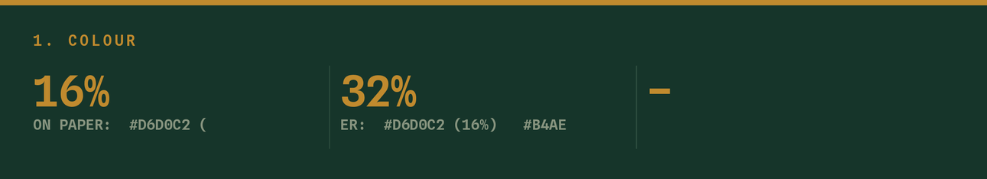

2. Typography

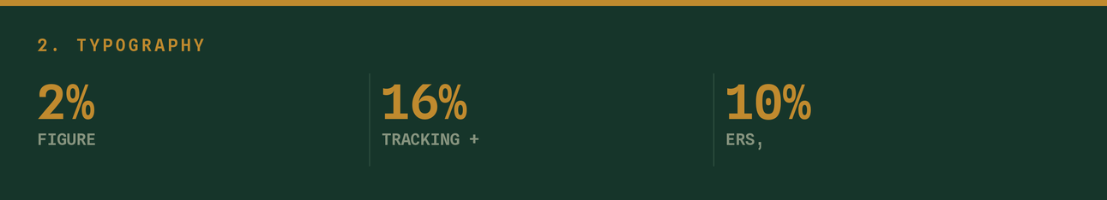
Three faces, three jobs. All three are embedded in the site and included in this pack as static TTF instances at brand/fonts/.
Bricolage Grotesque Display. Headlines, the wordmark, big numerals.
Weights used: 800 (display), 700, 600 (headings).
Tracking: -1.2% on headings. Optical size axis matters — the
600 cut is set at opsz 18, the display 800 at opsz 40.
Instrument Sans Body. Everything you read in sentences.
Weights: 400 body, 500 emphasis, 650/700 labels.
Line height 1.66 on the web, ~1.5 in print.
Spline Sans Mono Utility. Kickers, eyebrows, tags, chips, footers, dates,
page numbers, data labels.
Weight 500. ALWAYS uppercase. Tracking +16% on kickers,
+8–10% on footers and tags.
The kicker is the brand's signature
More than any colour, the thing that makes a piece of Klyara material recognisable is the small uppercase brass mono label sitting above a large Bricolage headline.
CHAPTER 02 ————
Are you a contractor?
Get that pairing right and almost everything else follows.
Headline rules
Headlines end with a full stop. "Run the jobs. We run the rest." "Are you in?" "MTD readiness checklist." "Verification." This is consistent across the whole site and all four PDFs. It is not optional styling — it is the voice.
Sentence case, never title case, never all caps. The only all-caps in the system are mono kickers and the KLYARA wordmark in print headers.
Scale — pick from the site's own clamps:
hero 2.7 → 5.6rem h1 2.0 → 3.5rem h2 1.45 → 2.05rem
h3 1.06 → 1.26rem body 1.0 → 1.08rem lede 1.1 → 1.3rem
Measure: the site sets .lede { max-width: 58ch }. Keep running text at 58–65 characters.
The font subset constraint — read this before making anything
The fonts embedded in the site are subsets of 108 glyphs. These characters do not exist and will render as blank gaps:
— (em dash) ✓ ✔ (ticks) ✗ ✘ (crosses) ⚠ (warning) ₤
→ (arrow — absent from Spline Mono; present in the others)
Use instead: en dash –, the mid dot ·, drawn tick marks, and the word "and". Every generator in this pack routes text through a safe() function that substitutes automatically — if you write copy by hand into a design tool, do the substitution yourself.
The · mid dot is the brand's natural separator and it is present in all three faces. Use it.
The line that matters
Every generator in this pack routes text through a safe() function that substitutes automatically — if you write copy by hand into a design tool, do the substitution yourself.

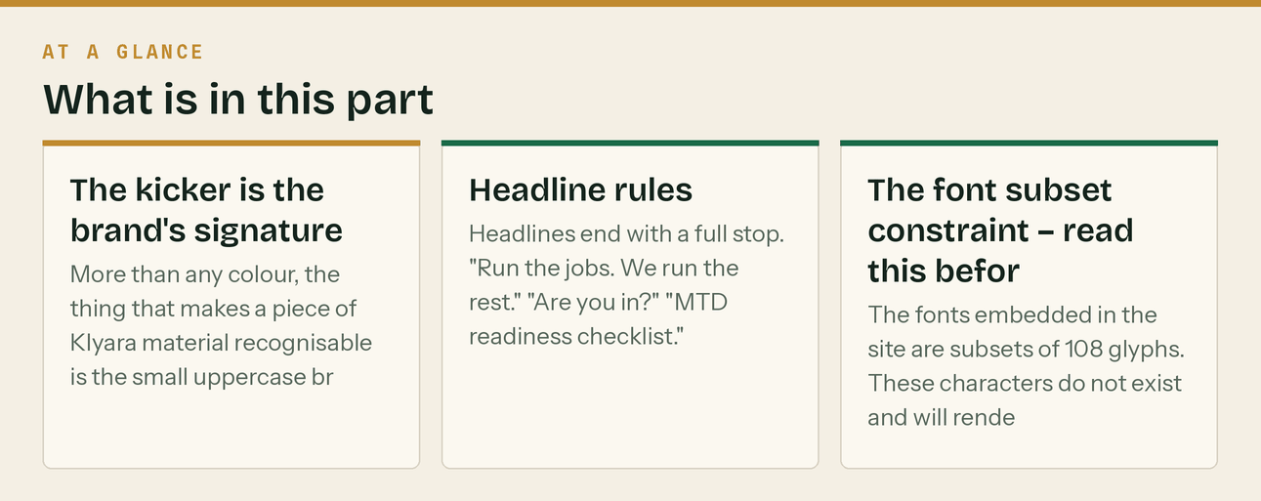

3. The mark

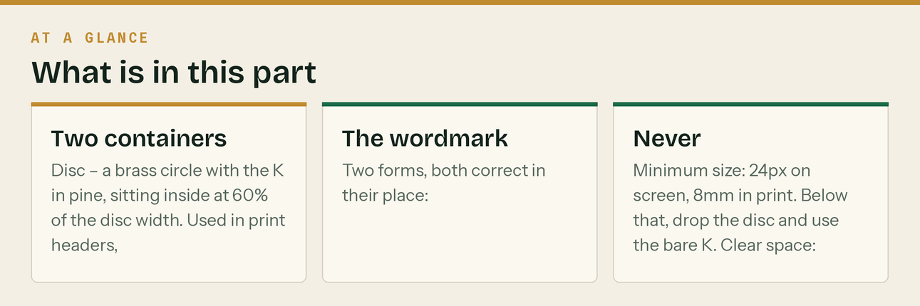
An angular K drawn as a single polygon, not a typeset letter. The exact coordinates, in an 88 × 88 box:
20,16 35,16 35,40 57,16 76,16 47.5,46 76,72 56,72 35,52 35,72 20,72
That polygon is the mark. Do not substitute a K from any typeface, including Bricolage.
Two containers
Disc — a brass circle with the K in pine, sitting inside at 60% of the disc width. Used in print headers, avatars, and anywhere the mark needs to hold its own.
Plain — the bare K in bone, no container. Used in the site header, where it sits on pine.
The wordmark
Two forms, both correct in their place:
- Klyara — sentence case, Bricolage 600. The web header, and anywhere the brand appears
conversationally.
- KLYARA — all caps, Bricolage 800. Print headers and document covers only.
Mark-to-wordmark gap: 42% of the mark's height.
Never
- Retype the K in another font
- Recolour the disc away from brass
- Add a gradient, shadow, glow or outline
- Rotate, skew or stretch it
- Put it on a photograph without a solid ground behind it
- Write "KLYARA" in sentence-case contexts, or "Klyara" on a print cover
Minimum size: 24px on screen, 8mm in print. Below that, drop the disc and use the bare K. Clear space: 30% of the mark's width on all four sides.
The line that matters
Disc — a brass circle with the K in pine, sitting inside at 60% of the disc width.

In this part
Two containers · The wordmark · Never

4. Layout

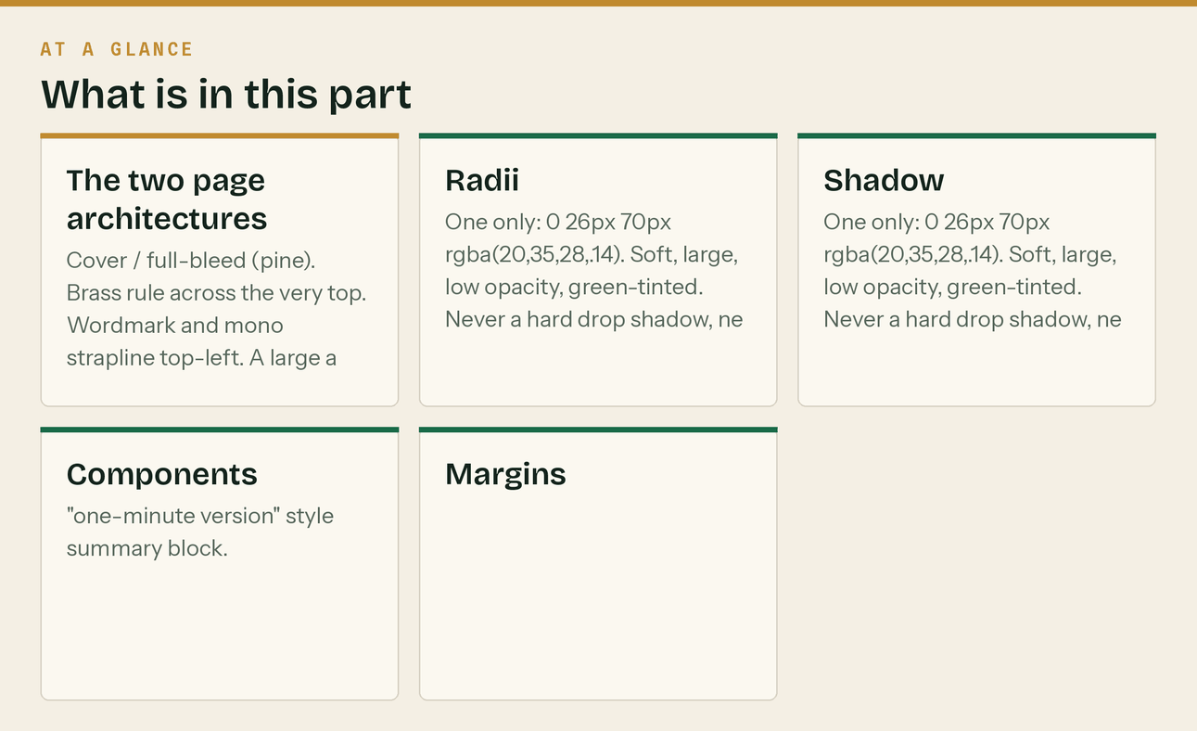
The two page architectures
Cover / full-bleed (pine). Brass rule across the very top. Wordmark and mono strapline top-left. A large amount of empty pine. Headline low on the page, roughly two-thirds down. Sub-headline in brass. Body in paper. Mono fine print at the bottom.
Interior (paper). A pine header band across the top, roughly 40mm on A4 or 17% of a social graphic. Inside the band: a mono brass kicker with a short brass dash rule, then the heading in paper, and a very large ghosted numeral in --pine2 bleeding off the right edge. A brass rule closes the band. Body sits on paper below. Mono footer, with the page number in emerald.
That ghosted numeral is doing a lot of work. Keep it.
Radii
--r 16px cards, callouts, tables
--r-lg 24px large panels
99px pills, tags, chips
Shadow
One only: 0 26px 70px rgba(20,35,28,.14). Soft, large, low opacity, green-tinted. Never a hard drop shadow, never black.
Components
- Pine callout — deep green box, brass mono label, brass bullet dots, paper text. For the
"one-minute version" style summary block.
- Quote box — card ground, emerald left bar 3px, brass mono label. For the aside that matters.
- Brass box — solid brass, ink text, for the single call to action at the end of a document.
- Section head — a 2.6px brass vertical bar to the left of a Bricolage 600 heading.
- Table — mono brass column headers, hairline under the header, hairlines between rows, emerald
row labels in the first column. No vertical rules, no filled header block.
Margins
Social graphic 7.5% of width
A4 print 19mm
Web --pad: clamp(20px, 4vw, 44px)
Max width 1240px
The line that matters
Inside the band: a mono brass kicker with a short brass dash rule, then the heading in paper, and a very large ghosted numeral in --pine2 bleeding off the right edge.

In this part
The two page architectures · Radii · Shadow · Components · Margins

5. Voice

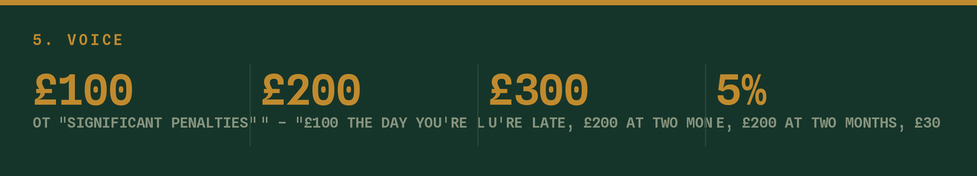
Short sentences. Then a shorter one.
Headlines end with a full stop.
Specific over general. Not "significant penalties" — "£100 the day you're late, £200 at two months, £300 or 5% at six."
Second person. "You are in MTD." Not "clients in this position are within scope."
Say the uncomfortable thing. "You don't need the receptionist." "We're new and we're not going to pretend otherwise." "It is not fixable on 6 November." This is the most distinctive thing about how Klyara sounds and it is why it is trusted.
Lead with the reader's problem, never with Klyara.
Words to use
straight · sorted · handled · filed · on time · what it actually costs
the bit that catches people · gross means gross · plain English
Words never to use
solution · synergy · leverage (verb) · best-in-class · seamless · world-class
revolutionise · empower · "we're passionate about" · "unlock your potential"
Also banned: exclamation marks in marketing copy, emoji in email subject lines, and any sentence beginning "In today's fast-paced business environment".
Emoji
Functional and rare. 📅 for dates, 📌 for a deadline. Never decorative, never in a headline, never in a subject line. The site itself uses almost none — follow it.
The disclaimer — non-negotiable
Every piece of public tax content carries a version of the site's own line:
General guidance, not tax advice. Rules move — check gov.uk or ask us
General guidance, not tax advice. Rules move — check gov.uk or ask us before acting.

Keep it. You are publishing tax guidance under a bookkeeping firm's name.
The line that matters
"You don't need the receptionist." "We're new and we're not going to pretend otherwise." "It is not fixable on 6 November." This is the most distinctive thing about how Klyara sounds and it is why it is trusted.

6. Photography

Real over stock, always. The site's own imagery is real construction. A slightly badly-lit photo of an actual Guildford site beats a perfect stock image of models in clean hi-vis, and this audience can tell instantly.
Shoot: Craig at a desk with real paperwork. A phone photographing a crumpled receipt on a van dashboard. An actual site. Hands, tools, muddy boots, a laptop on a workbench.
Never: handshakes in front of glass buildings, diverse teams laughing at a whiteboard, rising-graph stock, immaculate unworn PPE.
Treatment: if a photo carries text, put a pine overlay at 70–85% behind the text block rather than dropping text onto the image.
The line that matters
A slightly badly-lit photo of an actual Guildford site beats a perfect stock image of models in clean hi-vis, and this audience can tell instantly.

Also worth knowing
Never: handshakes in front of glass buildings, diverse teams laughing at a whiteboard, rising-graph stock, immaculate unworn PPE.

7. Making new assets

Everything in this pack is generated from Python, and the generators ship with it. Use them rather than rebuilding by hand — it guarantees the tokens and the fonts are right.
brand/klyara_brand.py Tokens, fonts, the K polygon, layout helpers, safe().
Change a colour here and every image rebuilds consistently.
brand/klyara_pdf.py The print system for ReportLab — pine boxes, quote boxes,
brass boxes, tables, section heads, the mark.
brand/gen_identity.py Logos, avatars, banners.
brand/gen_posts.py Social posts, carousels, story covers, the deadline card.
brand/gen_video.py Kinetic typography videos.
brand/gen_leadmagnet.py The multi-page branded A4 guide.
brand/gen_proposal.py Client proposals — edit the CLIENT dict, re-run.
brand/fonts/ The site's own fonts, converted to static TTF.
New social post: open gen_posts.py, copy a post(...) line, change the text, re-run. New client proposal: open gen_proposal.py, edit CLIENT, re-run. It names the file itself.
The line that matters
Use them rather than rebuilding by hand — it guarantees the tokens and the fonts are right.

Also worth knowing
New social post: open gen_posts.py, copy a post(...) line, change the text, re-run.

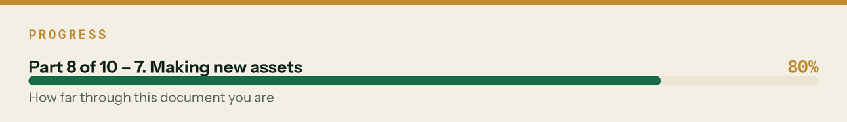

8. Asset sizes

Where | Size | Folder
X header | 1500×500 | banners/
LinkedIn company | 1128×191 | banners/
LinkedIn personal | 1584×396 | banners/
Facebook cover | 1640×856 | banners/
YouTube channel | 2560×1440 | banners/
Reddit banner | 1920×384 | banners/
Google Business cover | 1200×900 | banners/klyara-banner-gbp.png
Email header | 1200×260 | banners/
Avatars | 400 / 512 / 1024 | avatars/
Square post | 1080×1080 | posts/
Carousel slide | 1080×1350 | carousel/
Story / highlight | 1080×1920 | stories/
Vertical video | 1080×1920 | video/
A5 print | 1748×2480 @300dpi | print/

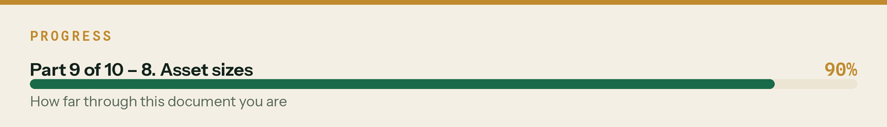

9. The test

Before anything goes out:
- Is the ground paper or pine? Not both, not something else.
- Is brass used once, on the thing that matters?
- Is there a mono kicker above the headline?
- Does the headline end with a full stop?
- Would a builder read it and think "that's straight"?
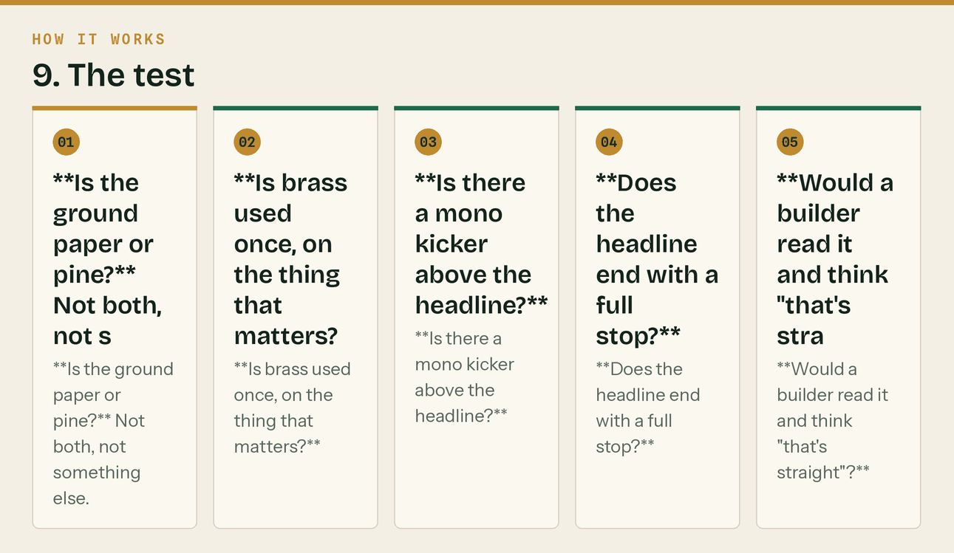
The same steps, in order.
If all five are yes, it's Klyara.


