KLYARA the back office for building firms

Klyara — Guildford & Surrey Local Pack
The town page, the GBP setup, the keywords, the merchants, the partners

*Local search intent is the only channel on this list where someone is actively looking to hire you today. Everything else builds awareness. This builds pipeline.*
The line that matters
*Local search intent is the only channel on this list where someone is actively looking to hire you today.

In this part
The town page, the GBP setup, the keywords, the merchants, the partners

1. Why Guildford is a good place to launch this

Not flattery — these are the things that actually change the plan.
The work is high-value domestic. Guildford, Godalming, Farnham and the villages between them are expensive housing stock: period property, conservation areas, and a large slice of the Surrey Hills National Landscape where planning is tight. That produces extensions, loft conversions, basements, barn conversions and full refurbishments rather than volume newbuild. Firms doing that work are the 5–15 person outfits Klyara is built for, and they invoice enough to be caught by MTD.
High-value domestic work means end users. Which means the VAT reverse charge question comes up constantly and is answered wrongly constantly — a domestic client is an end user, the reverse charge does not apply, and firms who work on both domestic and main-contractor jobs get this wrong in both directions. That is a genuinely differentiating conversation to be able to have on a first call.
Retentions bite hard here. The commercial work in Guildford town, the university, the hospital and the industrial estates runs on applications, certificates and retention. Your retention content will land harder in Surrey than almost anywhere.
There is real competition, and it isn't specialist. Guildford has plenty of accountants. It has very few construction-only bookkeepers. "We only do building firms" is a genuinely unusual claim in this market, which is exactly why it works.
Slyfield is the trade centre of gravity. Selco is on Slyfield Industrial Estate, and Slyfield is where the vans go. That concentrates your entire offline campaign into a couple of square miles.
One caution, stated once: Surrey is expensive, and £59–£329/month is going to read as cheap rather than as a bargain to some of this market. Do not apologise for the price or discount it. The value story is the specialism, not the saving.
The line that matters
Guildford, Godalming, Farnham and the villages between them are expensive housing stock: period property, conservation areas, and a large slice of the Surrey Hills National Landscape where planning is tight.


Also worth knowing
The commercial work in Guildford town, the university, the hospital and the industrial estates runs on applications, certificates and retention.

2. The service area — use this exact list everywhere

Primary (inside 10 miles, name these on the page and in GBP):
Guildford · Woking · Godalming · Farnham · Cranleigh · Ash · Normandy · Worplesdon
Merrow · Burpham · Shalford · Bramley · Wonersh · Chilworth · Send · Ripley
Secondary (10–20 miles, name in the ads and the town pages):
Camberley · Farnborough · Aldershot · Haslemere · Dorking · Leatherhead · Bookham
Effingham · Horsley · Byfleet · West Byfleet · Chertsey · Addlestone · Weybridge
Do not claim "London and the South East" or "nationwide". A construction bookkeeper who covers everywhere covers nowhere, and Google's local algorithm punishes over-broad service areas.
Postcodes: GU1–GU12, GU21–GU24, plus KT21–KT24 for the Leatherhead/Bookham edge.
The line that matters
A construction bookkeeper who covers everywhere covers nowhere, and Google's local algorithm punishes over-broad service areas.

Also worth knowing
Postcodes: GU1–GU12, GU21–GU24, plus KT21–KT24 for the Leatherhead/Bookham edge.

3. The local landing page — full copy, ready to publish


URL: klyara.com/construction-bookkeeping-guildford.html Title tag (58 chars): Construction Bookkeeper Guildford | CIS & MTD | Klyara Meta description (152 chars): Bookkeeping, CIS returns and Making Tax Digital for building firms in Guildford, Woking, Godalming and Farnham. Construction only. From £59/mo + VAT.
[H1]
The back office for Guildford building firms.
[LEDE]
Bookkeeping, VAT coding, payroll and Making Tax Digital
quarterly filing — for building firms across Guildford, Woking, Godalming and Farnham.
Construction only. Fixed monthly fee from £59 + VAT.
[PRIMARY CTA] Book a free 20-minute call
[SECONDARY] Check your MTD date in ten seconds
──────────────────────────────────────────────
[H2] Your accountant has a few building clients. We only have building clients.
Most Guildford accountants are perfectly good accountants. They also have a dentist, two
letting agents, a marketing consultancy and you. CIS is the awkward bit at the end of
their month.
Here it's the whole job. Gross payment status, 20% and 30% deductions, subcontractor
verification, materials splits, retentions, the domestic reverse charge and the monthly
19th — that's the everyday work, not the exception.
That difference shows up in specific places:
• You get asked for your subbies' UTRs before the job starts, not in February
• Your retentions go on a list with release dates, and someone asks on the day
• Your reverse charge gets coded right the first time, because we knew to ask whether
your customer was an end user
• Your CIS returns are filed by the 19th whether or not you were three men down that week
──────────────────────────────────────────────
[H2] The reverse charge question Surrey firms get wrong both ways.
A lot of Guildford work is high-value domestic — extensions, lofts, basements, full
refurbishments on period property. A homeowner is an end user, so the reverse charge does
not apply and you charge VAT as normal.
Then the same firm picks up a job for a main contractor who'll invoice the work onward.
That one is reverse charged, and no VAT should be on the invoice.
Firms that do both — which in this area is most of them — get it wrong in both directions,
and only find out at the VAT return. It's twenty minutes to fix and it's the first thing
we look at.
[TOOL CTA] Free VAT reverse charge checker →
──────────────────────────────────────────────
[H2] Making Tax Digital has already caught more Surrey subbies than they realise.
MTD for Income Tax started in April 2026 for anyone with qualifying income over £50,000.
It drops to £30,000 in April 2027 and £20,000 in April 2028.
Qualifying income is measured GROSS — before expenses and before CIS deductions. Invoice
£55,000, lose £11,000 to CIS, bank £44,000, and HMRC still counts the £55,000.
Day rates in Surrey being what they are, a full-time subcontractor around here clears the
£30,000 gross line without trying. Most of the trade is in the April 2027 wave and doesn't
know it yet.
[TOOL CTA] Check your MTD date in ten seconds →
──────────────────────────────────────────────
[H2] Where we work.
Guildford, Woking, Godalming, Farnham, Cranleigh, Ash, Normandy, Worplesdon, Merrow,
Burpham, Shalford, Bramley, Wonersh, Chilworth, Send and Ripley — plus Camberley,
Internal links to add on this page: Making Tax Digital page · Bookkeeping & CIS service page · Tools page · the VAT reverse charge calculator · the CIS calculator · Pricing.
Schema for this page: AccountingService with areaServed set to the primary town list, plus FAQPage for the six questions above. Blocks are in docs/08.
The line that matters
Schema for this page: AccountingService with areaServed set to the primary town list, plus FAQPage for the six questions above.

4. Google Business Profile — the Guildford specifics


Everything in docs/02 applies. These are the local overrides.
Business name: Klyara — nothing else. Do not use "Klyara Construction Bookkeeping Guildford". Google suspends listings for keyword-stuffed names and reinstatement takes weeks.
Service area, not address, if home-based. Set these as the named service areas:
Guildford · Woking · Godalming · Farnham · Cranleigh · Ash · Send · Ripley
Shalford · Bramley · Wonersh · Merrow · Worplesdon · Normandy
Primary category: Bookkeeping service Secondary: Accountant · Tax preparation service · Payroll service
Description — 748 chars, Guildford-specific, ready to paste:
Klyara is the back office for building firms across Guildford, Woking, Godalming and Farnham.
We handle bookkeeping, CIS returns, VAT reverse charge coding, payroll and Making Tax Digital
quarterly filing for one fixed monthly fee, so builders can get on with the work.
Construction only. CIS deductions, gross payment status, subcontractor verification, retentions and
the domestic reverse charge are the everyday job here, not the awkward bit at the end of the month.
Making Tax Digital for Income Tax began in April 2026 for gross income over £50,000 and drops to
£30,000 in April 2027. Qualifying income is measured before CIS comes off, so it catches more Surrey
subcontractors than expected.
Plans from £59 + VAT. Free MTD guide and 12 calculators at klyara.com.
Products: add all four tiers with prices. Services: Bookkeeping · CIS returns · Making Tax Digital filing · VAT returns · Payroll · Self assessment · Management reports · Invoice chasing. Photos: real ones. Craig, a Guildford site, a phone photographing a receipt on a van dash, a laptop showing the portal. Geotagged photos are not a ranking factor, but *real* photos convert.
The weekly GBP post is the highest-value five minutes in this pack. Posts expire after seven days. The 30-day calendar has one every week — just add a Surrey reference to each.
The line that matters
The weekly GBP post is the highest-value five minutes in this pack.

5. Local keyword clusters

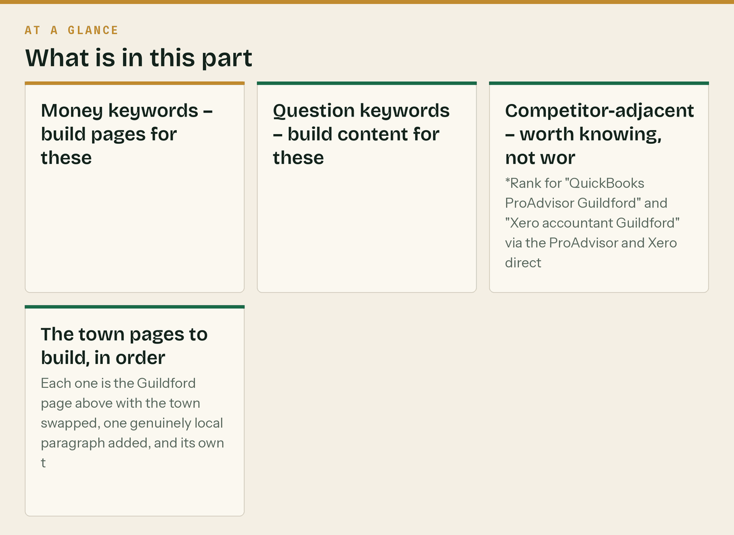
Money keywords — build pages for these
construction bookkeeper guildford cis accountant guildford
bookkeeper for builders guildford cis returns guildford
construction accountant surrey accountant for subcontractors guildford
bookkeeper for tradesmen guildford cis accountant woking
construction bookkeeper woking construction bookkeeper godalming
cis accountant farnham builders accountant surrey
Question keywords — build content for these
do i need mtd guildford vat reverse charge domestic customer
cis 20 or 30 percent gross payment status how to apply
how much does a bookkeeper cost surrey what does a construction accountant do
Competitor-adjacent — worth knowing, not worth chasing
[local accountancy firm names] + reviews
xero accountant guildford / quickbooks accountant guildford
*Rank for "QuickBooks ProAdvisor Guildford" and "Xero accountant Guildford" via the ProAdvisor and Xero directories rather than by building pages — those directories already outrank you and the listing is free.*
The town pages to build, in order
Each one is the Guildford page above with the town swapped, one genuinely local paragraph added, and its own title tag. Do not spin them — thin doorway pages get filtered and can drag the whole site down. Fewer, better pages win.
# | URL slug | Local angle to write about
1 | construction-bookkeeping-guildford | Slyfield trade estate, high-value domestic, conservation areas
2 | construction-bookkeeping-woking | Larger commercial base, more main-contractor work, retentions
3 | construction-bookkeeping-godalming | Period property, Waverley conservation, small firms
4 | construction-bookkeeping-farnham | Georgian stock, listed-building work, VAT on listed property
5 | cis-accountant-surrey | County-level catch-all, targets the CIS keyword directly
6 | construction-bookkeeping-cranleigh | Rural, Surrey Hills National Landscape planning constraints
7 | construction-bookkeeping-camberley | Blackwater Valley, more commercial and MoD-adjacent work

Build 1–5 first. Do not build 6 and 7 until 1–5 are indexed and getting impressions.
The line that matters
Build 1–5 first. Do not build 6 and 7 until 1–5 are indexed and getting impressions.

In this part
Money keywords — build pages for these · Question keywords — build content for these · Competitor-adjacent — worth knowing, not worth chasing · The town pages to build, in order

6. Local citations — the Surrey-specific list

NAP consistency matters more than volume. Same string everywhere, exactly.
Tier 1 — do these
Google Business Profile Bing Places Apple Business Connect
Yell.com FreeIndex Thomson Local
192.com Cylex UK Hotfrog
Scoot Trustpilot Nextdoor (Guildford)
Tier 2 — Surrey / local
Surrey Chambers of Commerce — member directory (paid, but the directory plus the events is
the real product; Guildford & Waverley Business Question Time is a genuine room to be in)
Business Surrey — the county business support directory
thebestof Guildford — local business guide, long-established, ranks locally
Guildford Borough Council business directory — check current availability
Surrey Live / Surrey Advertiser business listings
Tier 3 — professional (once supervised)
QuickBooks Find-a-ProAdvisor — set the location to Guildford
Xero Advisor Directory — same
FreeAgent Practice Directory
ICB or AAT "find a bookkeeper" — filter by GU postcode
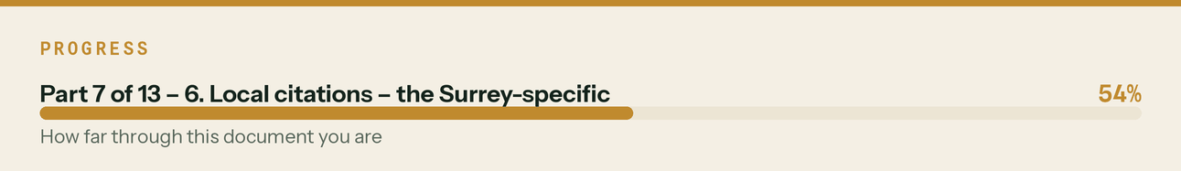

7. The offline campaign — this is where Guildford is unusually easy

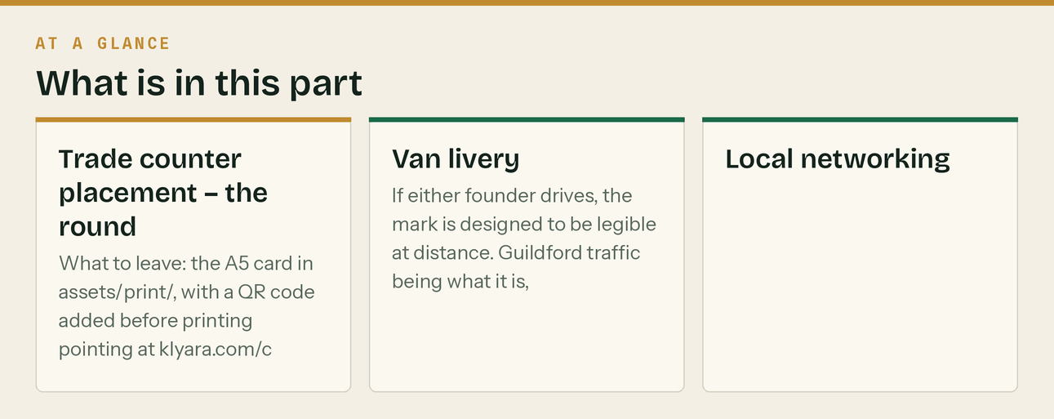
Slyfield concentrates the trade. A single morning covers most of your target market.
Trade counter placement — the round
Where | Why
Selco, Slyfield Industrial Estate, Guildford | The main one. Trade-only, high footfall, vans all morning.
Travis Perkins, Guildford | Account customers — bigger firms, your Trade and Pro tiers
Jewson, Guildford / Woking | Same logic
Howdens, Guildford | Kitchen fitters and joiners — Solo and Start tier
Independent merchants across Slyfield | Often more willing to take a card, and the counter staff talk
Woking, Godalming, Farnham, Cranleigh, Camberley branches | The second lap, once the first works

What to leave: the A5 card in assets/print/, with a QR code added before printing pointing at klyara.com/construction-bookkeeping-guildford.html?utm_source=merchant&utm_medium=qr&utm_campaign=slyfield
250 cards is roughly £30–45. Without the UTM you will never know whether it worked, so add it.
The better move while you're there: ask the counter manager which local firms are growing. They see the account volumes and they know. That conversation is worth more than the cards, and it costs a coffee.
Van livery
If either founder drives, the mark is designed to be legible at distance. Guildford traffic being what it is, a liveried van parked at Slyfield or on the A3 is permanent free local advertising to exactly the right audience.
Local networking
Surrey Chambers of Commerce — events and directory
Guildford & Waverley Business Question Time — free, and the room is right
BNI Guildford chapters — one seat, if the fit is right, can outperform every digital channel here
for a local B2B service. Expensive in time. Judge after three visits.
4Networking / local breakfast groups — cheaper way to test the same thing
The line that matters
Guildford traffic being what it is, a liveried van parked at Slyfield or on the A3 is permanent free local advertising to exactly the right audience.

In this part
Trade counter placement — the round · Van livery · Local networking

8. Local partnerships — the fastest route to clients 1–5

Target: twenty Guildford and Surrey accountancy firms. Use the outreach email in docs/06 §7, with this local opener swapped in:
Subject: Monthly bookkeeping for your Guildford construction clients
Hi [NAME],
Quick one, and it's a partnership question rather than a pitch.
I do monthly bookkeeping, CIS and MTD filing for building firms across Guildford and Surrey.
That's all I do — no year-end accounts, no corporation tax, no self assessment. I
deliberately stop where you start.
If you've got building clients whose monthly bookkeeping is more trouble than it's worth —
the CIS returns, the reverse charge coding on domestic versus main-contractor work, the
receipts that arrive in February — I'd take them on and hand you clean books at year end.
Two-way referral, 10–15%, and I'd be glad to discuss a mutual continuity arrangement, which
I gather we both need on file.
Worth twenty minutes? I'm in Guildford.
Craig
klyara.com | 020 8058 1496
How to build the list: search "accountants Guildford", "accountants Woking", "accountants Godalming", "accountants Farnham" and take the first two pages of each. Prioritise two-to-six partner firms — big enough to have construction clients they find annoying, small enough that the partner reads their own email.
Other local partners worth an email each:
- Two commercial insurance brokers (the Layer D introducer relationship)
- One construction-finance broker
- Two architects or architectural technologists doing Surrey domestic work — they know every good
builder in the county and they see the ones who are growing
- A local employment/HR consultant, for when clients hire
The line that matters
How to build the list: search "accountants Guildford", "accountants Woking", "accountants Godalming", "accountants Farnham" and take the first two pages of each.


Also worth knowing
Prioritise two-to-six partner firms — big enough to have construction clients they find annoying, small enough that the partner reads their own email.

9. Local press and media

Outlet | Angle
Surrey Advertiser / SurreyLive | Business desk. "Tax change hitting Surrey builders from April" — run the press release in docs/06 §5 with Surrey figures in it.
Surrey Chambers of Commerce newsletter | Member news slot. Free once you're a member.
Eagle Radio / Greatest Hits Radio Surrey | Local business segments do exist. Long shot, cheap to try.
Guildford Dragon / local news sites | Hyperlocal, and they publish business stories.
Local Facebook groups (Guildford community, Surrey trades) | Not for promotion. For answering questions.

Send it the week AML supervision lands, not before — the story is stronger when you can say you're taking clients.
The line that matters
Send it the week AML supervision lands, not before — the story is stronger when you can say you're taking clients.

10. Google Ads — Guildford targeting HOLD until supervised

Everything in docs/06 §4 applies, with these local settings:
Location targeting: Guildford + 12 mile radius
"Presence: people in or regularly in your targeted locations"
NOT "presence or interest" — that wastes budget on people
merely reading about Guildford
Exclude: Central London (you'll get expensive irrelevant clicks otherwise)
Ad schedule: 07:00–09:00 and 16:00–20:00 weekdays, all day Saturday.
Builders search before the day starts and after they've packed up.
Devices: Mobile bid +20%. This audience is on a phone.
Local ad copy:
H1: CIS Accountant In Guildford
H2: Construction Firms Only
H3: Fixed Fee From £59/Month
D1: CIS returns filed by the 19th, VAT reverse charge coded right, MTD quarterly filing handled.
D2: Guildford, Woking, Godalming, Farnham. Free 20-minute call. No hourly billing.
→ klyara.com/construction-bookkeeping-guildford.html
Local negatives to add on top of the main list:
university, surrey university, jobs, vacancies, apprenticeship, college, course,
cathedral, spectrum, castle, tourist
*("Guildford" pulls a lot of university and tourism traffic. Without these you'll pay for it.)*
The line that matters
*("Guildford" pulls a lot of university and tourism traffic.


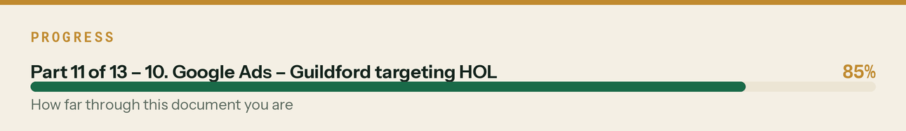

11. First 30 days in Guildford — the local sequence

Week | Do
1 | GBP created and verification requested. Local landing page live with schema. Tier 1 citations.
2 | Slyfield merchant round — Selco, Travis Perkins, Jewson, Howdens. Cards out, counter managers asked who's growing. 20 accountant emails sent.
3 | Woking / Godalming / Farnham town pages live. Surrey Chambers enquiry. Second merchant lap.
4 | Follow up every accountant who didn't reply, once. First Surrey-specific content published. Press release drafted and held.

The one number: booked discovery calls from a Guildford postcode. If the local page, GBP and merchant round produce fewer than four in the first month, the problem is almost certainly GBP verification not being live yet — check that before changing anything else.
The line that matters
If the local page, GBP and merchant round produce fewer than four in the first month, the problem is almost certainly GBP verification not being live yet — check that before changing anything else.

12. Guildford content — the local week, full copy

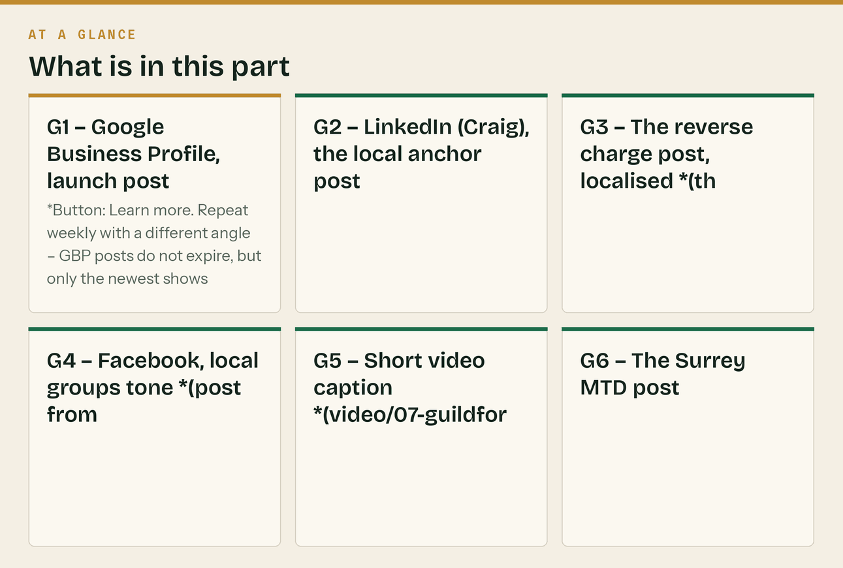
Slot this in as Week 1 of the 30-day calendar, or run it alongside. Local content does a different job from the national content: it is not trying to be shared, it is trying to be found and to signal "we are actually here."
Assets: assets/posts/post-guildford.png · video/07-guildford.mp4 · assets/stories/highlight-guildford.png
G1 — Google Business Profile, launch post
Klyara is open — the back office for building firms across Guildford, Woking, Godalming and
Farnham.
Bookkeeping, VAT coding, payroll and Making Tax Digital quarterly
filing, for one fixed monthly fee from £59 + VAT.
Construction only. Not general accountants who happen to have a few building clients.
Free MTD guide and twelve calculators at klyara.com.
*Button: Learn more. Repeat weekly with a different angle — GBP posts do not expire, but only the newest shows prominently.*
G2 — LinkedIn (Craig), the local anchor post
I've started something in Guildford.
Eleven years doing the books for building firms, and the thing I kept running into was this:
almost every builder I met had an accountant, and almost none of them had someone who
actually knew construction.
That sounds like a small distinction. It isn't.
Here's what it looks like in practice, and these are all real conversations from the last
month:
A firm in Godalming charging VAT on work for a main contractor who'd invoice it onward. That
should have been reverse charged. Two years of it.
A subbie near Cranleigh who'd never applied for gross payment status, was comfortably passing
all three tests, and had roughly twenty-four grand sitting with HMRC that could have been in
his account.
A roofing firm in Guildford with £11,000 of retentions on jobs that finished in 2024. Defects
period long over. Nobody had ever asked for it back, because nobody had the list.
None of that is exotic. It's just what happens when construction is the awkward ten per cent
of someone's client book rather than the whole thing.
So — Klyara. Bookkeeping, CIS, VAT reverse charge, payroll and the new MTD quarterly filing,
for building firms across Guildford, Woking, Godalming and Farnham. Fixed monthly fee. You run
the jobs, we run the rest.
Over the next month I'm going to post everything I know about CIS, the reverse charge and MTD.
Free, no gate, no email capture. If it's useful, follow along.
And if you're a Surrey builder wondering whether MTD has caught you — message me. Two minutes,
I'll tell you straight, and there's no pitch on the end of it.
#Construction #CIS #Guildford #Surrey #MakingTaxDigital
G3 — The reverse charge post, localised *(this is the one that will get replies)*
A Surrey-specific problem that costs building firms real money.
Round here most firms run two kinds of work at once: high-value domestic — extensions, lofts,
basements, refurbs on period property — and jobs for main contractors.
Those two are treated completely differently for VAT, and firms get them wrong in both
directions.
DOMESTIC CLIENT
A homeowner is an end user. The reverse charge does NOT apply. You charge VAT as normal.
MAIN CONTRACTOR WHO'LL INVOICE YOUR WORK ONWARD
Not an end user. The reverse charge DOES apply. No VAT on the invoice.
Get the first one wrong and you've not charged VAT you should have — and you'll owe it to HMRC
out of your own pocket unless you can go back and charge it.
Get the second one wrong and you've collected VAT that isn't yours, which you'll be handing
over anyway, having overcharged a customer you'd like to work for again.
The bit almost nobody does: the customer has to tell you in writing that they're an end user.
It's their declaration, not your guess. Get it in an email at the start of the job and keep it.
Free reverse charge checker, no email needed: klyara.com/tools.html
#VAT #ReverseCharge #Construction #Surrey
G4 — Facebook, local groups tone *(post from Craig's profile, not the page)*
Guildford and Surrey builders — a free thing, no catch, and I'm not selling anything in this
post.
I do the books for building firms and I've put twelve calculators on our site. No email wall,
no signup, no "enter your details to see your result." They just work.
The ones people actually use:
• CIS deduction — 20% or 30%, both directions, with the materials split taken out properly
• VAT reverse charge — whether it applies to this job, and what goes on the invoice
• Job margin — put price, costs and days in, get your real day rate out
• Retention tracker — the one that finds people money
klyara.com/tools.html
For context so I'm not being sneaky about it: this is my day job, and yes I'd like your
business eventually. But the tools are free whether you ever ring me or not, and I'd rather be
the bloke who gave you a working calculator than the bloke who gated it.
Any CIS or VAT question, stick it in the comments and I'll answer it properly.
G5 — Short video caption *(video/07-guildford.mp4)*
Your bookkeeper should know what CIS is.
Most local accountants have a handful of building clients. We only have building clients.
Gross payment status, 20 and 30 per cent, retentions, the reverse charge on domestic versus
main-contractor work — that's the everyday job here, not the awkward bit at month end.
Guildford, Woking, Godalming, Farnham, Cranleigh.
#guildford #surrey #ukbuilders #cis #tradesmen
G6 — The Surrey MTD post
A number worth checking if you're a Surrey subbie.
Making Tax Digital drops to £30,000 in April 2027. That's measured on GROSS invoices, before
CIS comes off.
Day rates being what they are round here, a full-time subcontractor in Surrey clears £30,000
gross without trying. Most of the trade is in the April 2027 wave and doesn't know it yet.
Check the turnover box on your last tax return. Not your bank statement — your bank statement
is about twenty per cent lower than the number HMRC uses.
Free MTD checker: klyara.com
#MakingTaxDigital #CIS #Surrey #Guildford
G7 — The merchant-round post *(after you've done the Slyfield lap — real, local, human)*
Spent the morning at Slyfield.
If you're a Guildford builder you'll know it — Selco, the merchants, half the vans in the
borough by nine o'clock.
Left some cards on a few trade counters, which is the boring bit. The useful bit was asking
the counter managers which local firms are busy at the moment. They know, because they see the
account volumes, and they were happy to talk about it.
General mood, for what it's worth: domestic extensions steady, commercial slower, everyone
grumbling about how long they're waiting to get paid.
That last one's fixable, and it's mostly not about chasing harder. It's four boring things:
invoice the day the work's done, invoice a named person rather than "accounts", ask the
payment run date in week one rather than week nine, and chase on a schedule instead of when
you remember.
If you want the retention tracker we use — the one that finds people four to fifteen grand
they'd written off — it's free on the site. klyara.com/tools.html
#Guildford #Surrey #Construction
*Only post this if you actually did the round. It works because it's true.*
Local posting notes
- Post the local content to LinkedIn, Facebook and GBP. Skip X and TikTok for local — the
audience there isn't geographically targeted and the local angle wastes the slot.
- Tag the town, not the county, in the first line. "Guildford" outperforms "Surrey" for local
discovery; "Surrey" is better for the wider posts.
- Never use a location hashtag as the only local signal — put the town in the body text where
Google can read it.
- The merchant post is the highest-performing local format in this sector, because it's the only
one that proves you actually left the office.
The line that matters
audience there isn't geographically targeted and the local angle wastes the slot.

In this part
G1 — Google Business Profile, launch post · G2 — LinkedIn (Craig), the local anchor post · G3 — The reverse charge post, localised *(this is the one that will get replies)* · G4 — Facebook, local groups tone *(post from Craig's profile, not the page)* · G5 — Short video caption *(video/07-guildford.mp4)* · G6 — The Surrey MTD post

