KLYARA the back office for building firms

Klyara — Client Onboarding Pack
Signed to live in five working days. The runbook, the emails, the first 90 days.

*Build Manual §6.5 calls for an onboarding runbook "before client 1". This is it, plus the client-facing emails that go with each step.*
Why this matters more than it looks: onboarding is the only part of the service the client experiences before they have anything to judge you on. A firm that goes from "yes" to "live" in five days with no chasing has already proved the thing it sells. A firm that takes three weeks and asks for the same document twice has also already proved something.
The line that matters
Why this matters more than it looks: onboarding is the only part of the service the client experiences before they have anything to judge you on.

In this part
Signed to live in five working days. The runbook, the emails, the first 90 days.

PART 1 — The five-day runbook

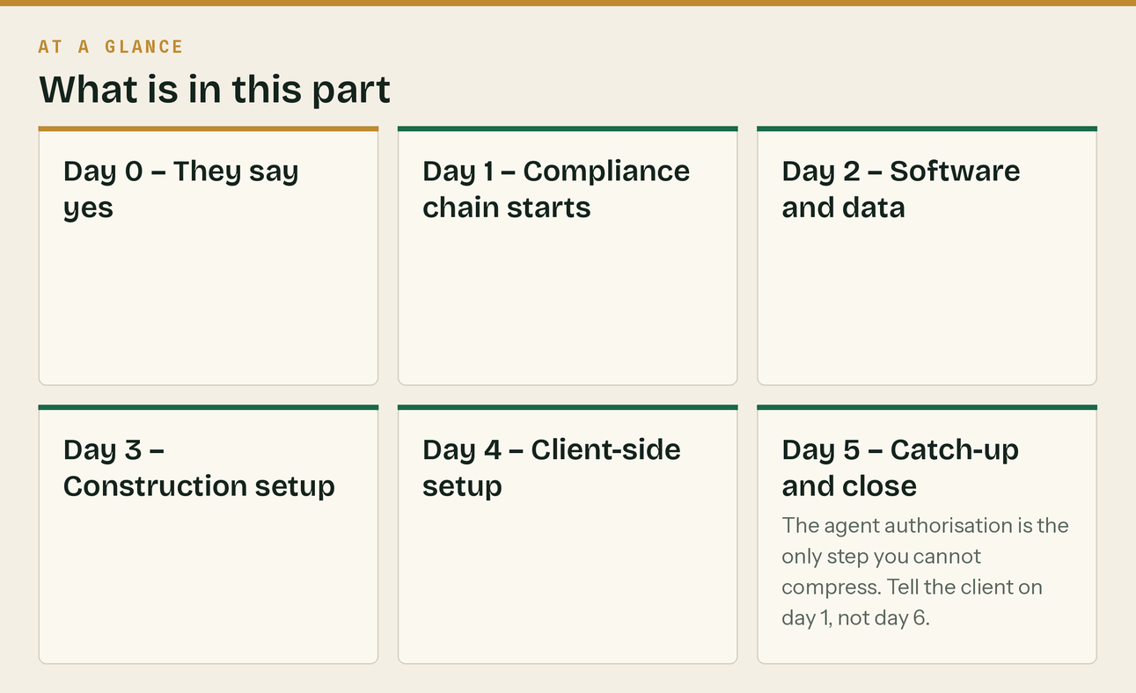
Every step has an owner, a trigger and a client-facing artefact. Nothing waits on Craig remembering.
Day 0 — They say yes
☐ | Step | Notes
☐ | Log the deal | Name, tier, monthly, onboarding fee, source, town
☐ | Send Email 1 — Welcome & what happens next | Within one hour. Speed is the whole impression.
☐ | Send engagement letter for e-signature | Klyara-branded, scope, price-review clause, late-records surcharge, 30-day notice
☐ | Send GoCardless direct debit link | In the same email. Not later.
☐ | Create the client folder and portal record

Day 1 — Compliance chain starts
☐ | Step | Notes
☐ | CDD / ID verification on every director or the sole trader | MLR 2017. Non-negotiable and it is not a formality. Use the professional body's tool or Credas/SmartSearch tier.
☐ | Client risk assessment recorded | Written, per client, per your firm-wide AML policy
☐ | PEP and sanctions check | Part of the same tool
☐ | Engagement letter signature chased if not back | One message. Polite.
☐ | Agent authorisation submitted — VAT, CIS, ITSA as applicable | This is the long pole. HMRC's post takes about a week. Submit today.
☐ | Send Email 2 — ID check and HMRC authorisation | Sets the expectation about HMRC's post *before* it becomes a delay

Day 2 — Software and data
☐ | Step | Notes
☐ | QBO subscription added under bill-my-firm (or Xero if inbound) | Time it to an Intuit promo where one is running
☐ | Chart of accounts set to the construction template | CIS control, retentions held, retentions receivable, materials, subsistence, plant hire
☐ | Bank feeds connected | Every business account and card. This is the single highest-value step.
☐ | Opening balances agreed with the previous bookkeeper or accountant | If none exist, say so now rather than discovering it in month three
☐ | Prior year figures obtained

Day 3 — Construction setup
☐ | Step | Notes
☐ | CIS: contractor scheme, subcontractor list, verification records loaded
☐ | Every existing subbie's verification status confirmed | If they cannot evidence a verification, treat as unverified until re-verified
☐ | VAT scheme confirmed, and reverse charge review on the last ten sales invoices | This is where you find the first thing worth finding
☐ | End-user declarations collected or requested for live jobs | In writing
☐ | Retention register built — job, amount, release date | Almost always finds money. See the 90-day review.
☐ | Payroll data loaded if applicable

Day 4 — Client-side setup
☐ | Step | Notes
☐ | Portal login issued
☐ | Receipt app demoed on their actual phone, on a real receipt | Not a link to a help doc. Two minutes on the phone with them. This determines whether the whole service works.
☐ | Records deadline agreed and diarised — the 10th | Say the late-records surcharge out loud, once, kindly
☐ | The monthly rhythm explained: records by the 10th, CIS by the 19th, reports by month end
☐ | Send Email 3 — You're live

Day 5 — Catch-up and close
☐ | Step | Notes
☐ | Catch-up work scoped and scheduled
☐ | Onboarding fee invoiced
☐ | First month's work started
☐ | Diarise the 90-day review | The single most commonly skipped step, and where add-on revenue lives
☐ | Diarise the annual price review | Per the engagement letter
☐ | Ask: "Is there anyone else you'd want us to talk to?" | Only if the week went well. Ask once.

Blocked-by-HMRC protocol
The agent authorisation is the only step you cannot compress. Tell the client on day 1, not day 6.
"Everything's set up our end. The one thing we're waiting on is HMRC —
code and it takes about a week. Nothing for you to do; I'll chase it. We'll be filing from the moment it lands."

A delay you predicted is competence. The same delay unannounced is incompetence.

PART 2 — The client onboarding emails

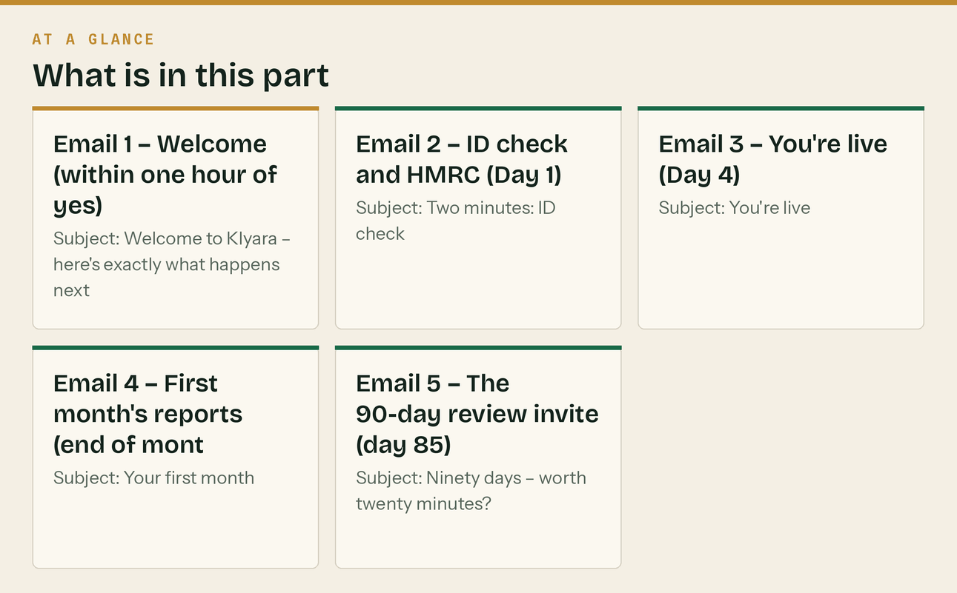
Email 1 — Welcome (within one hour of yes)
Subject: Welcome to Klyara — here's exactly what happens next
Hi {{FIRSTNAME}},
Good news. Here's what happens now, in order, so nothing's a surprise.
TODAY — two things from you, both under five minutes
1. Engagement letter to e-sign — link below
2. Direct debit mandate — link below
That's genuinely it for now.
THIS WEEK — things from us
• ID check (regulatory, we all have to do it, it's quick)
• We register as your agent with HMRC
• Your books get set up and your bank feeds connected
• Portal login, and I'll show you the receipt app on your phone
ONE THING WORTH KNOWING NOW
The HMRC agent authorisation is the only bit we can't speed up. They post a code and it takes
about a week. Nothing for you to do — I'll chase it. Everything else will be ready before it
lands.
Live within five working days of signing, bar HMRC's post.
[Sign the engagement letter →]
[Set up the direct debit →]
Anything at all, ring me. 020 8058 1496.
Craig
Klyara
Email 2 — ID check and HMRC (Day 1)
Subject: Two minutes: ID check
Hi {{FIRSTNAME}},
One regulatory job. Bookkeepers have to verify the identity of everyone we act for — it's
anti-money-laundering rules and there's no way round it, for anyone.
It's a link, a photo of your driving licence or passport, and a selfie. Two minutes on your
phone.
[Complete the ID check →]
Also done today: your HMRC agent authorisation has gone in. HMRC will post you a code —
when it arrives, send me a photo of it and we're away. Usually about a week.
If a letter turns up from HMRC that looks like it's about an agent, that's the one. Don't
bin it.
Craig
Email 3 — You're live (Day 4)
Subject: You're live
Hi {{FIRSTNAME}},
Set up and running.
YOUR LOGIN
{{PORTAL_URL}} — bank position, reports, receipt upload, documents.
THE RHYTHM, so you know what to expect
• Records to us by the 10th
• CIS filed by the 19th
• Reports in the portal by month end
THE ONE HABIT THAT MAKES ALL OF THIS WORK
Snap the receipt the moment you get it. Ten seconds at the counter. Don't collect them, don't
sort them, don't put them in the glovebox with good intentions. Just snap and forget.
That single habit is the difference between this being easy and this being a monthly argument.
WHAT WE FOUND WHILE SETTING UP
{{FINDINGS — always include something. The reverse charge coding, the retention register,
the unverified subbie, the duplicate subscription. There is always something, and telling them
in week one is worth more than telling them in month six.}}
Anything at all, ring me. 020 8058 1496.
Craig
Email 4 — First month's reports (end of month 1)
Subject: Your first month
Hi {{FIRSTNAME}},
First set of figures is in the portal.
THE HEADLINES
• Turnover: {{X}}
• Gross margin: {{X}}
• Owed to you: {{X}} — of which {{X}} is over 60 days
• Retentions outstanding: {{X}}
• Bank vs the next 30 days: {{X}}
{{ONE OBSERVATION — the single most useful thing in the numbers, in one sentence.}}
Nothing needed from you. If you want to talk it through, ring me — twenty minutes and you'll
know your numbers better than most people who've been in business twenty years.
Craig
Email 5 — The 90-day review invite (day 85)
Subject: Ninety days — worth twenty minutes?
Hi {{FIRSTNAME}},
Ninety days in, and we've now got three clean months, which is the first point where the
figures actually tell you something.
Worth twenty minutes on the phone? Three things:
1. What your numbers actually say now there's a trend
2. Anything that isn't working — genuinely, tell me
3. One thing I think you should change
[Book twenty minutes →]
Craig
In this part
Email 1 — Welcome (within one hour of yes) · Email 2 — ID check and HMRC (Day 1) · Email 3 — You're live (Day 4) · Email 4 — First month's reports (end of month 1) · Email 5 — The 90-day review invite (day 85)

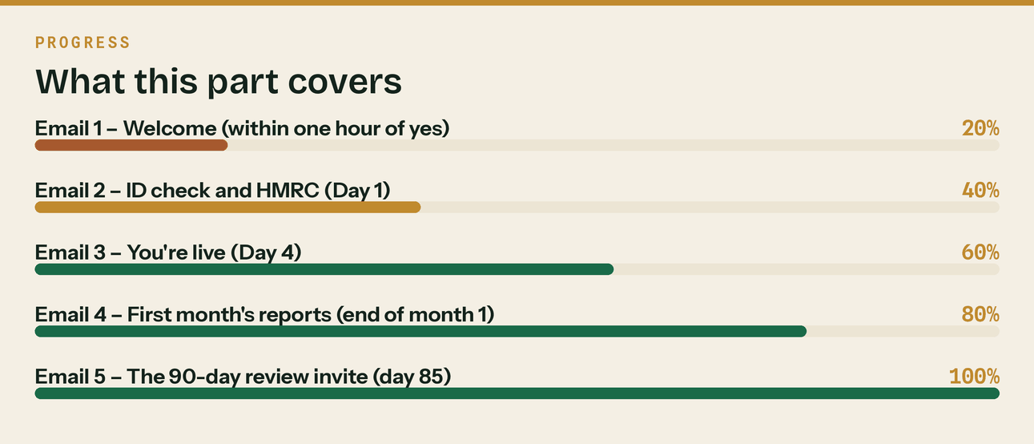
Read top to bottom. The bar is just how far through the part you are.

PART 3 — What to look for in the first month


Every new client has at least one of these. Find it in week one and say so — it is the cheapest trust you will ever buy.
Look at | What you usually find
Last ten sales invoices | Reverse charge coded wrong in one direction or the other
Retentions | £4,000–£15,000 nobody has asked for. Build the register on day 3.
CIS deduction statements | Missing ones. Every unevidenced pound is tax paid twice.
Subcontractor verifications | At least one they cannot evidence — a 30% exposure sitting with the contractor
Aged debtors | An invoice already paid but never matched, which they were about to chase
Subscriptions | Two accounting products, or a Dext they stopped using but still pay for
VAT position | If most sales are reverse charged, they may be owed money quarterly and should be on monthly returns
Gross payment status | They would pass the three tests and have never applied
Van, phone, home office | Claimed at nothing, or claimed at 100% — both are wrong

PART 4 — The client rhythm, after onboarding

By the 10th Records in. Late-records surcharge applies after this. It only works if you apply it.
By the 19th CIS filed. Statements to subbies inside 14 days of the tax month end.
Month end P&L, balance sheet, aged debtors, retentions, cash position in the portal.
Quarterly VAT return. MTD update for Solo clients.
Day 90 The review. Then every six months.
Annually Price review per the engagement letter. Not a surprise, it's in the letter.
The late-records surcharge. £25 after the 10th. Everyone hates charging it and everyone who doesn't charge it ends up doing three clients' books in the last four days of the month, forever. Charge it once, kindly, with a warning first. It almost never needs charging twice.
The line that matters
Everyone hates charging it and everyone who doesn't charge it ends up doing three clients' books in the last four days of the month, forever.



PART 5 — Offboarding, because you should decide this now

A firm that offboards gracefully gets referrals from clients who left. A firm that holds data hostage gets a review that costs it ten clients.
☐ 30 days' notice, either way, no argument and no retention attempt beyond one honest conversation
☐ Books handed over in full — it is their QuickBooks or Xero file, in their name, and they take it
☐ Agent authorisation removed from HMRC promptly
☐ Final reconciliation and a clean trial balance to whoever is taking over
☐ Direct debit cancelled the day notice ends, not a month later
☐ One email, four weeks after: "Anything you need, ring me." No pitch.
Never hold books, delay a handover, or make leaving expensive. In a town the size of Guildford, one story about a bookkeeper who made it difficult reaches every builder within a year.
The line that matters
In a town the size of Guildford, one story about a bookkeeper who made it difficult reaches every builder within a year.

Also worth knowing
A firm that holds data hostage gets a review that costs it ten clients.



PART 6 — The onboarding checklist as a one-pager

Print this. One per client, in the folder.
CLIENT ______________________ TIER ________ SIGNED ____/____/____
DAY 0 ☐ Welcome email ☐ Engagement letter sent ☐ DD link sent ☐ Folder created
DAY 1 ☐ ID check done ☐ Risk assessment ☐ PEP/sanctions
☐ Agent auth submitted: ☐ VAT ☐ CIS ☐ ITSA ☐ Email 2 sent
DAY 2 ☐ Software live ☐ Chart of accounts ☐ Bank feeds connected
☐ Opening balances ☐ Prior year figures
DAY 3 ☐ CIS scheme set ☐ Subbies verified ☐ Reverse charge reviewed
☐ End-user declarations ☐ Retention register built ☐ Payroll loaded
DAY 4 ☐ Portal login ☐ Receipt app demoed on their phone
☐ 10th deadline agreed ☐ Email 3 sent
DAY 5 ☐ Catch-up scoped ☐ Onboarding fee invoiced ☐ 90-day review diarised
☐ Price review diarised ☐ Referral asked (if the week went well)
WHAT WE FOUND: _______________________________________________________
_____________________________________________________________________
BLOCKED ON HMRC? ☐ Yes, client told on day ____ ☐ No
LIVE DATE ____/____/____ DAYS FROM SIGNING: ____
Track "days from signing" for every client. Target is five. If it drifts past ten, the runbook isn't being followed, and onboarding speed is one of the KPIs in Build Manual §9.3 for a reason.
The line that matters
If it drifts past ten, the runbook isn't being followed, and onboarding speed is one of the KPIs in Build Manual §9.3 for a reason.



