KLYARA the back office for building firms

26 — The review engine
The only missing input. Every word you need, written out.

### Read this before using anything below
Klyara cannot trade as a bookkeeper by way of business until AML supervision is in place (docs/01, docs/06 §5). Everything in this document that offers, prices or sells the service is written for the day supervision lands. Before then, run the education-first and waitlist variants in docs/03 — the content, the guides and the free tools are all fine to publish now; the "we do your books for £X a month" half is not. Ask a client for a review only after you have lawfully done work for them. Delete this box on the day the licence arrives, and not before.

Why this document exists
docs/19 reached a specific conclusion: on the AI-discovery channel, Klyara is already unusually well positioned on everything except one input, and that input is reviews. docs/06 §9 sets the policy. This document is the words.
Everything below is written to be sent as it is. Nothing needs adapting except the brackets.
The target is 20+, at two a month, forever. BrightLocal's data says 47% of consumers will not use a business with fewer than 20 reviews. Ten is not "getting there" — it is halfway. And only 24% of completed trades jobs get reviewed at all, which is why the ask has to be systematic rather than occasional.
The line that matters
docs/19 reached a specific conclusion: on the AI-discovery channel, Klyara is already unusually well positioned on everything except one input, and that input is reviews.

In this part
The only missing input. Every word you need, written out. · Why this document exists

PART 1 — When to ask

There are exactly three moments. Do not invent a fourth.
Moment | When | Why then
The first report | Handover of the first month's reports, roughly day 35 | The value has just landed and is visible on a page in front of them
A specific win | The day something good happens — a refund lands, gross payment status is granted, a retention is released, a penalty is cancelled | Emotion is the whole thing. Ask within 24 hours or not at all
The 90-day review | At the end of the call, if it went well | They have just told you it is working. That is the moment

Never ask at signing. They have not received anything yet, and a review written at signing says nothing useful, which readers can tell.
Never ask twice in the same quarter. If they said yes and did not do it, use the nudge in PART 5 once, and then leave it. A client who feels chased about a review is worse off than no review.
The line that matters
They have not received anything yet, and a review written at signing says nothing useful, which readers can tell.

Also worth knowing
If they said yes and did not do it, use the nudge in PART 5 once, and then leave it.

PART 2 — The ask

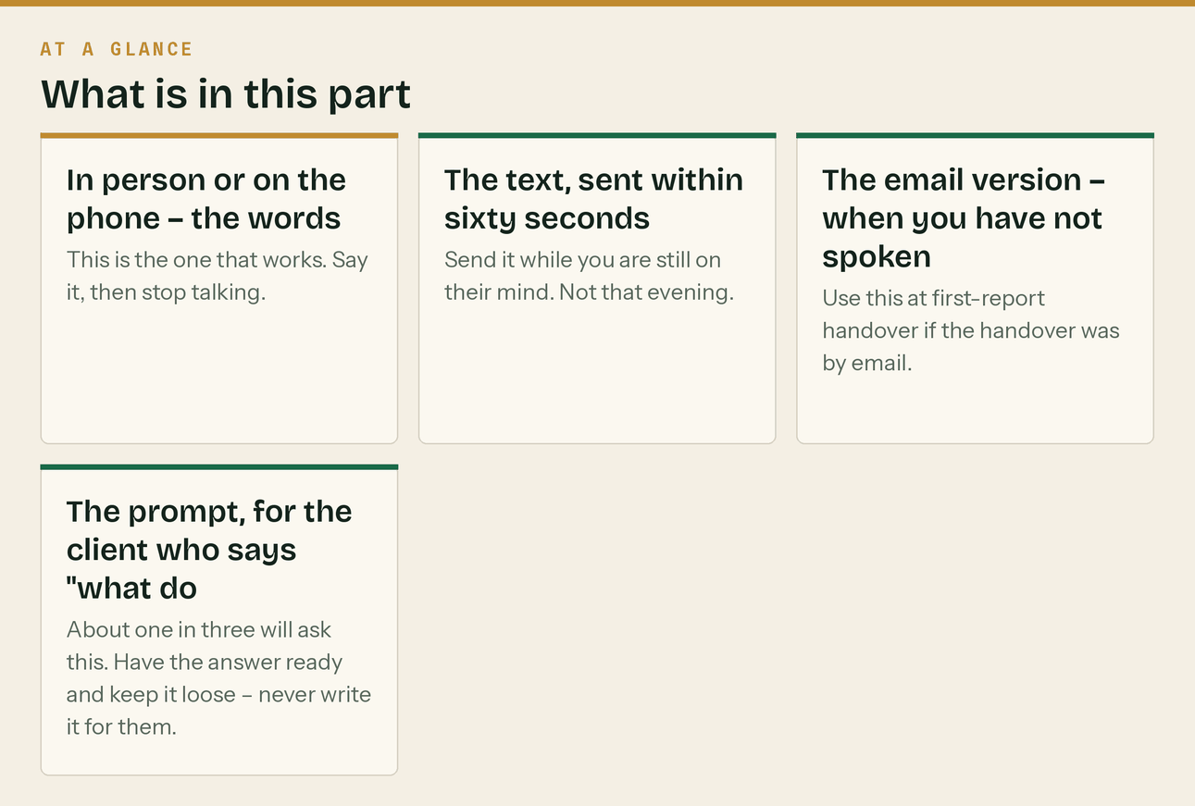
In person or on the phone — the words
This is the one that works. Say it, then stop talking.
"Can I ask you a favour, and say no if it's awkward.
We're new, and the thing that decides whether builders take a chance on us is Google reviews. If you've been happy with how this month's gone, would you leave one? It takes about ninety seconds. I'll text you the link the second we hang up so you don't have to go looking for it. And if you're not happy about something, tell me that instead — that's more useful to me than a review."

Three things make this work and all three are deliberate.
"Say no if it's awkward" removes the pressure, which is exactly what makes people say yes. "I'll text you the link" removes the work — an ask without a link is homework and homework does not get done. "If you're not happy, tell me instead" is not a filter to keep bad reviews off Google; it is a genuine offer to fix something, and it is the reason you will almost never get a bad one.
The text, sent within sixty seconds
Send it while you are still on their mind. Not that evening.
Thanks [Name] — here's that link: [GOOGLE_REVIEW_LINK]
Ninety seconds, and it genuinely makes a difference to a new firm. Cheers. [Name], Klyara

That is the whole message. No signature block, no logo, no "we value your feedback". It should read like a text from a person, because it is one.
The email version — when you have not spoken
Use this at first-report handover if the handover was by email.
**Subject: October's reports — and a small favour**
[Name] — October's summary is attached. Short version: [one line, the actual headline]. One favour, and no problem at all if you'd rather not. We're a new firm and Google reviews are pretty much the whole of how builders decide whether to take a chance on us. If this month's gone well, would you leave one? [GOOGLE_REVIEW_LINK] Takes about ninety seconds. And if there's anything you're not happy with, reply and tell me that instead — I'd rather fix it. [Name] Klyara · 020 8058 1496

The prompt, for the client who says "what do I even write?"
About one in three will ask this. Have the answer ready and keep it loose — never write it for them.
"Honestly, two lines is plenty. What you were struggling with before,
That's the bit other builders actually read."

Never send them suggested wording. A review you drafted is a review you wrote, and for a firm holding clients' financial records that is not a small problem — it is a banned practice under the DMCC Act 2024 and a conduct issue with your professional body.

PART 3 — Replying. Every one, within 24 hours.

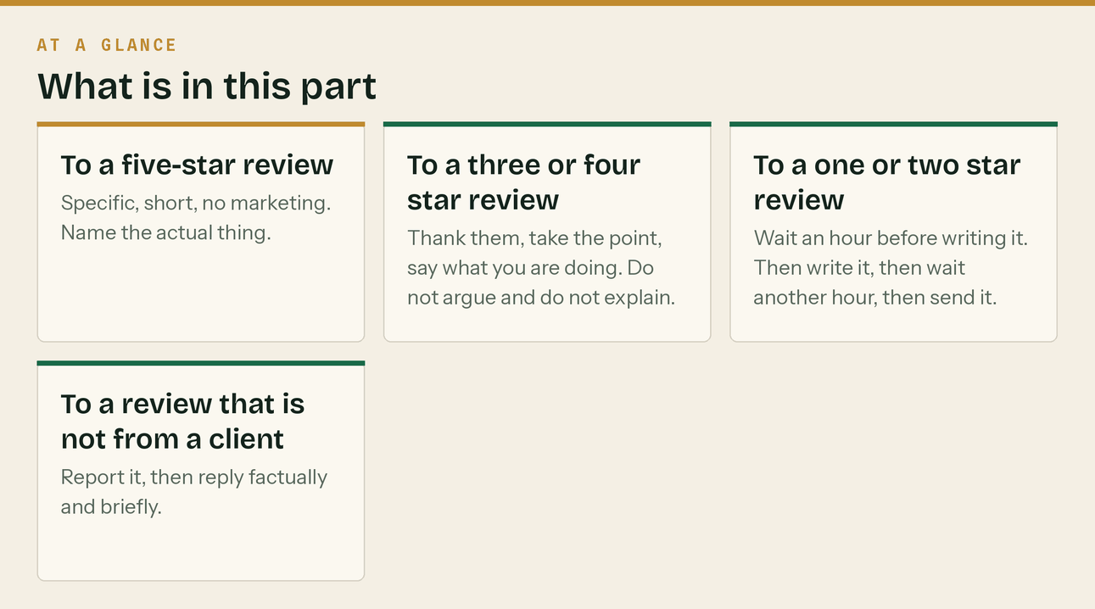
Prospects read the replies more carefully than the reviews. A wall of five-star reviews with no replies reads as bought; five reviews each with a specific human reply reads as real.
To a five-star review
Specific, short, no marketing. Name the actual thing.
Thanks [Name], that's good to hear. The CIS statements chasing was the
get straight and I'm glad it's off your plate. See you at the quarter end.

Never reply with "Thank you for your kind words! We pride ourselves on delivering exceptional service to all our valued clients." It is visibly generated and it devalues the review.
To a three or four star review
Thank them, take the point, say what you are doing. Do not argue and do not explain.
Thanks [Name] — and fair on the response times in January. That month
weren't the only one who noticed. I've moved the CIS work to the 12th so the 19th isn't a scramble any more. Anything else that's not right, ring me directly.

To a one or two star review
Wait an hour before writing it. Then write it, then wait another hour, then send it.
[Name] — I'm sorry. That's not the service we should have given you an
about the detail in public. I'll ring you today. If we've cost you money I'll put it right. [Name], Klyara, 020 8058 1496

Then ring them. Most bad reviews come from a communication failure rather than a technical one, and most are resolvable. A resolved one is often edited by the reviewer, and even where it is not, a prospect reading a calm reply to an angry review learns more about you than ten good ones.
Never: dispute facts publicly, mention a fee dispute, hint that the client was difficult, or reply the same minute you read it.
To a review that is not from a client
Report it, then reply factually and briefly.
We have no record of this person as a client and have asked Google to
got that wrong and you have dealt with us under another name, please ring me on 020 8058 1496.

PART 4 — Seeding the Google Business Profile Q&A

This is free, almost nobody does it, and it fills a panel on your profile that would otherwise be empty or — worse — answered by a stranger.
You can post a question on your own profile and answer it — Google supports this and documents it. Post and answer from the business account, and space them out over a fortnight rather than posting twelve in an afternoon.
Do not post them from a personal account and do not upvote your own answers. Both are engagement manipulation, and it would be a strange document that forbids review gating on one page and stages demand on another. Seeded as an honest FAQ from the business, this is fine. Dressed up as questions from the public, it is not.
Twelve to seed, in this order:
- *How much does it cost?* > Four fixed monthly plans: £59, £99, £199 and £329 plus VAT, depending on size and whether you > pay subcontractors. The accounting software is inside the fee on every plan, and monthly CIS > returns are included from the £199 plan upwards. Full breakdown at klyara.com/pricing.html.
- *Do you do CIS returns?* > Yes. If you pay subcontractors, monthly CIS returns are included from our £199 plan — filed on > the 12th rather than the 19th so there is a week of slack, including nil months, verification > before anyone is paid, and the statements out to your subcontractors. If CIS is only deducted > *from* you, the smaller plans handle the reclaim instead.
- *I already have an accountant. Is that a problem?* > Not at all, and it is common. We do the monthly work and your accountant keeps the year end. > Plenty of our clients arrived that way.
- *Do you only work with builders?* > Only. Construction and the trades, nothing else. It is the reason we are quick at CIS.
- *Can you help with Making Tax Digital?* > Yes — quarterly updates and the final declaration. There is a free checker at > klyara.com/tools.html that tells you which April you are caught by, which surprises a lot of > subcontractors because it is measured on gross invoices before CIS comes off.
- *Where are you based?* > Guildford, and we work across Surrey — Woking, Godalming, Farnham, Cranleigh and the villages > between.
- *Do I have to come to an office?* > No. Almost everything happens by phone, email and WhatsApp, and receipts are a photo on your > phone. We will come to you if you would rather.
- *What software do you use?* > Cloud accounting with a receipt-capture app, and the subscription is in your name rather than > ours. If you ever leave, your records go with you.
- *Is there a contract?* > No tie-in. Thirty days' notice either way, in writing.
- *Can you sort out books that are in a bad state?* > Yes. It is quoted separately after a look, at an hourly rate capped at the quote, so you know > the worst case before we start.
- *What is the VAT reverse charge and does it apply to me?* > It applies to most construction work between two VAT-registered, CIS-registered businesses > where your customer is not the end user. There is a four-question tool at > klyara.com/tools.html that gives you the answer and the exact invoice wording.
- *How quickly can you start?* > Live within five working days of signing, apart from HMRC's agent authorisation, which is a > code they post and takes about a week.
Post "How much does it cost?" first. It is the question people actually have, and the one your competitors make them fill in a form to answer.
The line that matters
Do not post them from a personal account and do not upvote your own answers.

Also worth knowing
This is free, almost nobody does it, and it fills a panel on your profile that would otherwise be empty or — worse — answered by a stranger.

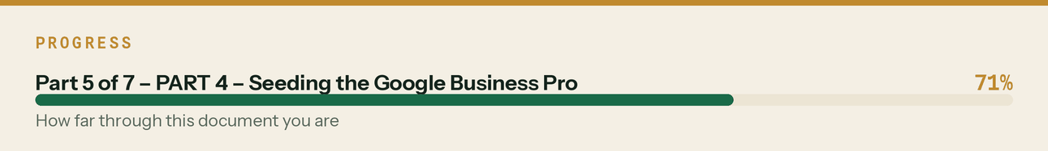

PART 5 — Running it

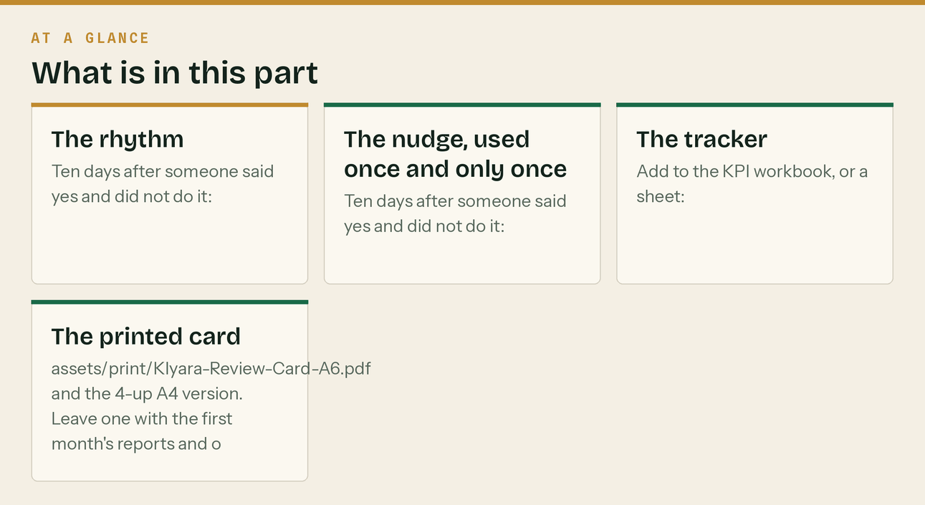
The rhythm
When | What | Time
Day 35 of every client | The first-report ask | 2 min
Same day as any win | The specific-win ask | 2 min
First Friday monthly | Check the count. Are you at two this month? | 5 min
Within 24h of any review | Reply | 5 min
First Friday monthly | One GBP Q&A seeded, until all twelve are up | 5 min

The nudge, used once and only once
Ten days after someone said yes and did not do it:
[Name] — no pressure at all, just in case it got buried: [GOOGLE_REVIE
Last time I'll mention it either way. Cheers.

"Last time I'll mention it" is the important half of that message. Say it and mean it.
The tracker
Add to the KPI workbook, or a sheet:
Client | Asked (date) | Method | Said yes? | Left (date) | Stars | Replied?

The number to watch is not the review count. It is the ask count. BrightLocal's survey found 83% of people who were asked went on to leave a review — so twenty reviews is roughly twenty-five asks, not eighty. (The 24% figure at the top of this document is a different thing: it is how many trades jobs get reviewed *without* anybody asking. The gap between 24% and 83% is the entire argument for asking.)
If the reviews are not arriving, the cause is almost always that the asking stopped, and the tracker is what shows you that.
The printed card
assets/print/Klyara-Review-Card-A6.pdf and the 4-up A4 version. Leave one with the first month's reports and one in the onboarding pack.
The QR on it currently points at klyara.com. Once the Google Business Profile is verified and you have the short review link, put it into brand/gen_reviewcard.py at the top and re-run — it takes about ten seconds and regenerates both files.
The line that matters
The number to watch is not the review count. It is the ask count.

PART 6 — The things that will get you in trouble

Stated once, plainly, because a bookkeeping practice has more to lose here than a builder does.
Never write a review yourself or have anyone write one for you. Fake reviews are a banned practice under the Digital Markets, Competition and Consumers Act 2024 and a conduct matter with ICB or AAT. For a firm holding clients' financial data it is a disproportionate risk for a disproportionately small gain.
Never offer anything in exchange. No discount, no free month, no entry into anything. Google prohibits it, the DMCC Act covers incentivised reviews that are not disclosed, and it changes what the review is worth to a reader anyway.
Never filter. Asking only your happy clients and quietly not asking the others is called review gating, and Google's policy prohibits it. Ask everyone at the same three moments. The "if you're not happy, tell me instead" line in PART 2 is an offer to fix a problem, made to everybody — it is not a diversion, and the difference is that you must genuinely accept the review if they want to leave one.
The homepage testimonials must come down before any of this starts. They are flagged in docs/07 and docs/20 as the highest-severity item in the whole pack. Running a review programme while invented testimonials sit on the homepage is the worst possible combination — it is the exact thing a complaint would point at.
Related
- docs/06 §9 — the policy this document implements, and the pre-client alternative
- docs/19 — why reviews are the one missing input for AI discovery
- docs/12 — onboarding, where the day-35 ask sits
- docs/25 — the first-report handover the ask is attached to
- docs/07 and docs/20 — the testimonials that have to go first
- assets/print/Klyara-Review-Card-A6.pdf — the printed card
The line that matters
The homepage testimonials must come down before any of this starts.

In this part
Related



