KLYARA the back office for building firms

Klyara — Market, Compliance & Competitor Intelligence
Real data, with sources. Researched 26 August 2026.

*Every figure is attributed, and there is a primary-source link wherever I had one. Section 2 is the exception: those market-size figures are attributed to their publishers but I could not get primary URLs for all of them in the time, and two rows are industry aggregate estimates rather than a named dataset. Treat section 2 as indicative and section 8 as verified. Where I could not verify something, it says so.*
The line that matters
*Every figure is attributed, and there is a primary-source link wherever I had one.

In this part
Real data, with sources. Researched 26 August 2026.

1. Verified compliance facts


These underpin every piece of content in the pack. I checked them at source rather than trusting the earlier drafts.
Making Tax Digital for Income Tax — verified
Threshold | Assessed on | Applies from
Over £50,000 | 2024–25 Self Assessment return | 6 April 2026
Over £30,000 | 2025–26 return | 6 April 2027
Over £20,000 | 2026–27 return | 6 April 2028

The critical one, quoted verbatim from HMRC: qualifying income is
"the amount before expenses (also known as turnover), based on the tax
previous tax year"

And it combines both income types — HMRC's own worked example: £25,000 rental + £27,000 self-employment = £52,000 qualifying income, so in scope.
*Source: Work out your qualifying income for MTD for Income Tax — GOV.UK and Find out if and when you need to use MTD for Income Tax — GOV.UK*
One precision fix to make across the pack
The pack repeatedly says qualifying income is measured "before CIS deductions". HMRC's guidance does not say that in terms — it says "before expenses (turnover)". The conclusion is still right, but the reasoning needs stating properly, because a builder who checks will not find those words:
Turnover on a self-employment return is the gross amount invoiced. CIS
reduction in turnover — they are recorded separately as tax already paid. So the turnover figure HMRC assesses is the pre-CIS number.

Say it that way from now on: *"HMRC looks at the turnover box on your return. CIS deductions don't reduce that box — they go in a different one, as tax you've already paid."* That is accurate, checkable, and it survives someone pushing back on it.
AML supervision — verified, and there is a much better route
This is the most financially useful finding in this document.
Route | Up front | Annual | Processing | AML included
ICB Practice Licence | £94 application | £206 + membership (£167–£200) | 28 days | Yes, at no extra cost
HMRC direct registration | £300 application | £400 per premises | up to 45 days | (it is the supervision)

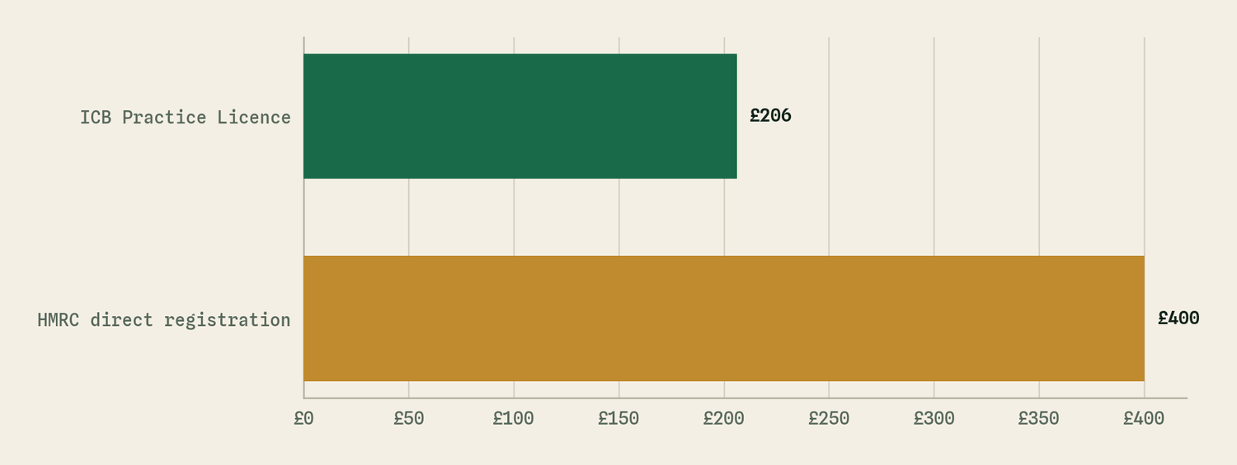
The same table as a picture. HMRC direct registration is the largest at £400.
HMRC also charges £40 per person for approval checks on beneficial owners, officers and managers in the accountancy sector, and £400 per premises again at annual declaration. There is a small business reduction — a £500 refund — but only where turnover is under £5,000, which will not apply to Klyara.
The ICB route is cheaper, faster, and comes with a professional body, a public directory listing, discounted PII, engagement letter templates and MLR guidance. The HMRC route gets you supervision and nothing else.
Recommendation: go ICB. Unless Craig's qualifications point at AAT, in which case AAT is also a statutory supervisor and the same logic applies.
*Sources: ICB Practice Licence · ICB fees · Money laundering supervision registration fees — GOV.UK · Register or renew your money laundering supervision — GOV.UK · AAT licensing*
Note the ICB licence also requires Professional Indemnity Insurance and annual renewal, and changes must be notified within 30 days.
Bank of England base rate — verified
3.75%, held on 30 July 2026. Next decision 17 September 2026.
So statutory late payment interest — 8% over base — is currently 11.75%.
Re-check this before quoting a number publicly, particularly after 17 September. The pack says "8% over base" rather than a fixed percentage everywhere for exactly this reason; keep it that way in evergreen content and only state 11.75% in dated posts.
*Source: Bank of England base rate — money.co.uk*
CIS — partially verified
The gov.uk overview page does not carry the operational detail (rates, penalty amounts, statement deadlines). The figures used throughout the pack — 0/20/30%, the 19th, £100/£200/£300-or-5%, 14 days for statements — are the long-standing published position and are consistent across the sector, but I could not pull them from a single authoritative page in this session.
Action: before publishing any CIS penalty figure, check it against the CIS guide for contractors and subcontractors (CIS340) on gov.uk. It is one link and it protects a bookkeeping firm's credibility on its own specialism.
*Source consulted: What is the Construction Industry Scheme — GOV.UK*

2. The market

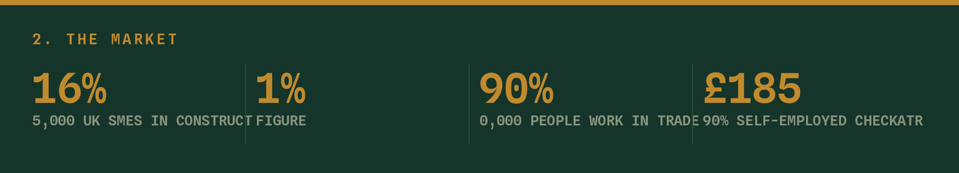
Size and shape
Figure | Source
885,000 UK SMEs in construction, 16% of all private sector businesses | Department for Business and Trade
385,000 VAT/PAYE registered construction businesses, 14.1% of UK enterprises | ONS
~343,000 construction businesses; 99.1% are SMEs | BEIS Business Population Estimates
~252,000 operate as sole traders or one-person companies | BEIS BPE
~900,000 people work in trades; ~90% self-employed | Checkatrade
£185bn construction output, 6.7% of UK GDP, 2.4m workers | ONS

What this means for Klyara: roughly a quarter of a million sole traders and one-person companies is the Solo tier addressable market, and the April 2027 £30,000 threshold catches a very large share of them. That is the single biggest demand event in the plan.
The pain is real and measurable
Figure | Source
43 days average payment time from invoice | Industry data
62% of SMEs report cash flow difficulties from slow payments | Industry data
~4,300 construction insolvencies in 2025 | Insolvency Service
Construction is ~17% of all UK business failures — consistently the highest of any sector | Insolvency Service
206,000 extra workers needed 2026–2030 | CITB
72% of firms report skills shortages affecting projects | FMB

Use the insolvency figure carefully. "Construction has the highest insolvency rate of any sector" is true, relevant and motivating. It is also frightening, and a bookkeeping firm leaning on it too hard reads as fear-selling. Once, in a cash flow piece, with the source named.
*Sources: UK Construction Industry Statistics 2026 — FORGE Command · Trades Marketing Statistics 2026 — Tom Riley SEO*
The line that matters
What this means for Klyara: roughly a quarter of a million sole traders and one-person companies is the Solo tier addressable market, and the April 2027 £30,000 threshold catches a very large share of them.

3. How your buyers actually decide — and what it changes


This is the most operationally useful data in the document.
Finding | Source | What it changes
75% decide within 30 minutes. 28% within 5 minutes. | BrightLocal | The speed-of-response advice in docs/09 is not a nicety. A quote sent in 24 hours vs 4 days is most of the decision.
72% evaluate three or fewer businesses | BrightLocal | You do not need to be the best in Surrey. You need to be in the first three found. That is a GBP and local-page problem, not a quality problem.
6 reviews read before booking a tradesperson | Checkatrade | Ten reviews is not "some social proof", it is the working minimum.
47% won't use a business with fewer than 20 reviews | BrightLocal (US) | The review target in docs/06 §9 should be 20+, not 10. Raising it.
31% require a 4.5-star minimum, up from 17% a year earlier | BrightLocal (US) | One bad review early is disproportionately damaging. Reply to every one within 24 hours.
65% cite review-related reasons for rejecting a business | BrightLocal | Reviews are a rejection filter more than a selection filter.
Only 24% of completed trades jobs get reviewed | Checkatrade | You have to ask. Every time, on the spot, with the link texted.
52% use Google Search first; 71% use it somewhere in the journey | BrightLocal (US) | GBP and local pages remain the priority. Nothing has displaced search.
Facebook/Messenger reaches 93% of UK adults (45.9m) | Ofcom | Facebook groups deserve the weight docs/01 gives them.
TikTok reaches 56% of UK adults (27.3m) | Ofcom | Bigger than its reputation with this demographic. Keep it.

Two changes I am making to the pack off the back of this:
- Review target raised from 10 to 20+. docs/06 §9 said ten reviews is "credible". The data says 47% filter out businesses below twenty. Two a month for ten months, starting with client one.
- Quote speed promoted from advice to a rule. With 28% deciding inside five minutes, "reply within the hour, even if only to acknowledge" belongs in the sales pack as a standard, not a tip.
*Sources: Trades Marketing Statistics 2026 — Tom Riley SEO, citing BrightLocal, Checkatrade and Ofcom*
The line that matters
This is the most operationally useful data in the document.

4. The new angle: AI discovery

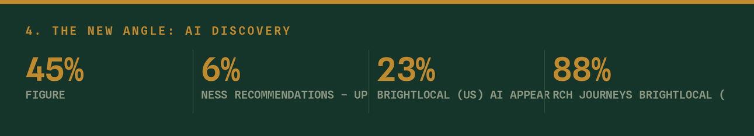
This is the most interesting thing I found and it is not in the pack yet.
Finding | Source
45% of consumers now use AI for local business recommendations — up from 6% a year earlier | BrightLocal (US)
AI appears in 23% of local search journeys | BrightLocal (US)
88% verify AI recommendations by checking the underlying sources | BrightLocal

A 6% → 45% shift in twelve months is the fastest change in local discovery since mobile. It is US data and the UK usually trails, but not by much and not for long.
What actually makes an AI recommend a local business
AI assistants do not have a ranking algorithm you can game. They assemble an answer from sources: business websites and service pages, Google Business Profile, directories and citations, reviews, professional credentials, social presence and news mentions. The consistent finding is that completeness and consistency beat optimisation — "AI performs better when information is complete".
The factors that come up repeatedly: information completeness, identical NAP everywhere, detailed individual service pages, explicit geographic service areas, FAQ content answering real questions, structured data, topical depth, and reviews.
*Source: How ChatGPT Recommends Local Businesses in 2026 — CMC SEO*
The genuinely good news
You have accidentally already built most of this. Look at the overlap:
What AI assistants reward | What the pack already does
Detailed individual service pages | Service pages exist; docs/08 §9 adds ten more
Explicit geographic service areas | Five local pages with named towns and areaServed schema
FAQ content answering real questions | 16 FAQs on the MTD page, 6 per local page, all schema-marked
Structured data | docs/08 — five schema types
Consistent NAP across sources | Canonical NAP string, 12+ citations in docs/02
Topical depth on a narrow subject | Construction-only, 55,000 words of CIS/MTD/VAT content
Professional credentials visible | ⏳ Once the ICB licence lands
Reviews | ❌ The gap

Klyara is unusually well positioned to be the answer when someone asks an AI "who does CIS bookkeeping near Guildford". Narrow specialism plus deep content plus explicit geography is exactly the shape these systems reward, and almost no local bookkeeper has it.
The four things to do about it
- Add an "About Klyara" fact block to the site — a short, plain, unambiguous paragraph stating what Klyara does, where, for whom, and from what price. AI systems extract these well. Put it in the footer or an About page, in plain text, not in an image.
- Get the reviews. It is the one input you have none of, and it is a named factor across every source on this.
- Publish the professional credentials the moment they exist. ICB membership number, supervision status, certifications — as text on the page, not a badge image.
- Test it monthly. Ask ChatGPT, Claude, Gemini and Perplexity: *"Who does CIS bookkeeping for builders near Guildford?"* Log what comes back. It costs five minutes and it is the only feedback loop that exists for this channel.
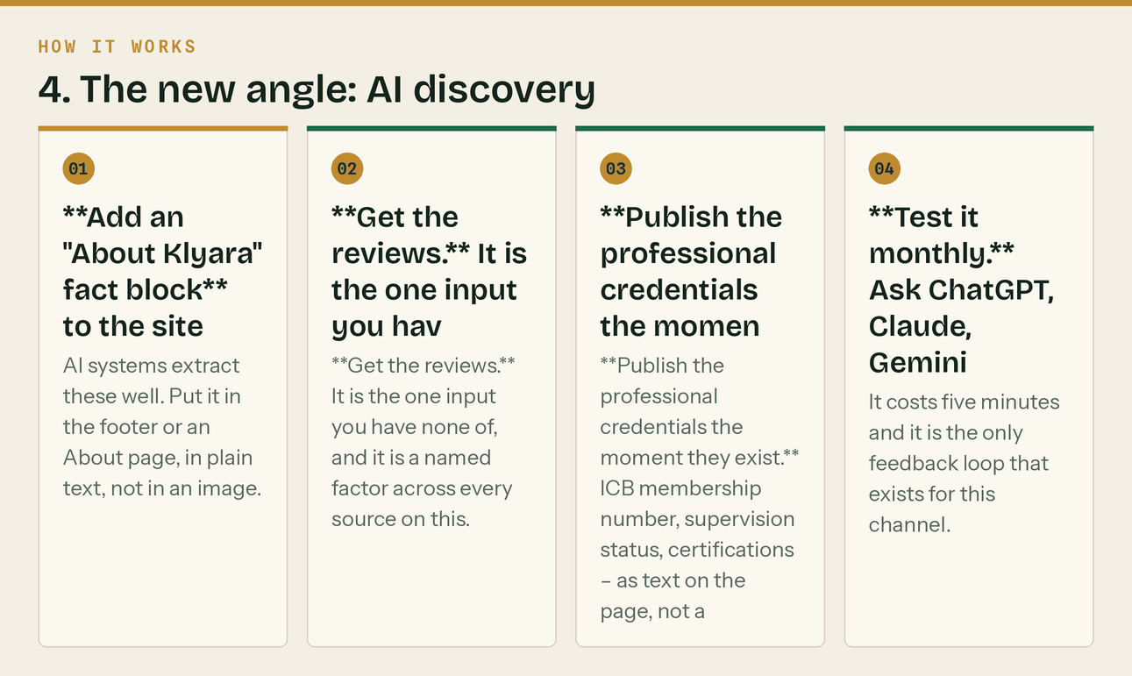
The same steps, in order.
Add that test to the Friday production hour from day 30.
The line that matters
Klyara is unusually well positioned to be the answer when someone asks an AI "who does CIS bookkeeping near Guildford".

5. The competitors


Who is actually in this market
Firm | Position | Notes
Accountant for Construction (Guildford page) | Construction-specialist, national with local pages | Closest direct competitor by positioning. Two testimonials with 5-star ratings. No pricing shown. CTA: "Get a Quote".
Guildford Accounting | General practice with a CIS service page | Targets "busy contractors". Claims "rapport with HMRC" and fast subbie refunds. No pricing shown. CTA: "Book A Consultation" / "arrange a friendly meeting".
David Howard | Construction, trades & property division | Established multi-office practice.
Sherwin Currid, Butt Miller, Treetops | General Guildford/Surrey accountants | Not construction-specialist.
dns accountants | National, low-cost, volume | Different game — price-led and remote.

*Sources: Accountant for Construction — Guildford · Guildford Accounting — CIS Accountants · David Howard — Construction, Trades & Property · Sherwin Currid · Butt Miller · Treetops*
The four gaps
1. Nobody publishes prices. Both construction-specialist competitors use "get a quote" or "book a consultation". Klyara publishing £59/£99/£199/£329 openly is a genuine, defensible differentiator in *this specific market* — and it filters out the people who were never going to proceed.
Do not let anyone talk you into hiding the pricing. It is your sharpest edge here.
2. Everyone sells relief, nobody sells competence. "Reducing your admin burden", "focus on your business", "friendly meeting". Klyara's angle — *we will tell you the thing you didn't know, on the first call* — is materially different and it is what the sales script in docs/09 is built on.
3. Nobody gives anything away ungated. Twelve working calculators with no email wall is unmatched locally and it is what makes the community strategy in docs/01 possible at all.
4. Nobody is construction-*only*. Even the specialists have construction as a division. "That is all we do" is a claim none of them can make.
Where they beat you, honestly
- Trading history and real reviews. They have them. You do not. This is the whole gap.
- Full-service. They do year-end, corporation tax and advisory. You deliberately do not, and some
prospects want one supplier. The answer is the accountant partnership channel, not scope creep.
- Established local relationships. Which is why 20 accountant emails and the Slyfield round matter
more than another social channel.
The line that matters
Klyara publishing £59/£99/£199/£329 openly is a genuine, defensible differentiator in *this specific market* — and it filters out the people who were never going to proceed.

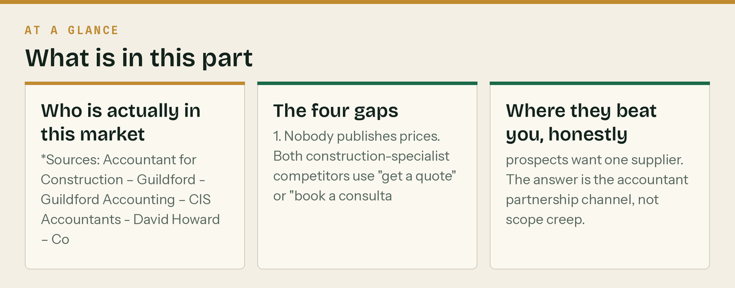

6. What I changed in the pack because of this research

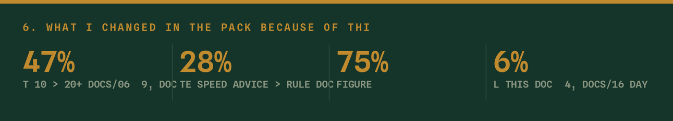
Change | Where | Why
Review target 10 → 20+ | docs/06 §9, docs/14 | 47% filter out businesses under 20 reviews
Quote speed advice → rule | docs/09 | 28% decide within five minutes
AML route: recommend ICB over HMRC | docs/14, docs/16, this doc | Cheaper, faster, includes supervision, adds a professional body
"Before CIS" → the turnover-box explanation | all content going forward | HMRC's wording is "before expenses"; the CIS point needs the mechanism stated
Base rate stated as 3.75% (30 Jul 2026) | this doc | So dated posts can quote 11.75% correctly
AI discovery added as a channel | this doc §4, docs/16 Day 30+ | 6% → 45% in a year is too big to ignore
Added the monthly AI visibility test | docs/16 Friday production hour | The only feedback loop this channel has

7. What I could not verify, and what you should check

Being explicit so nothing here is taken on trust.
- CIS penalty amounts and statement deadlines — CLOSED 26 August 2026. Verified directly against gov.uk. Figures and source in §8 below.
- Whether Craig's qualifications route to ICB or AAT — changes the licence application.
- PII insurance cost — quotes vary by turnover and cover level; ICB members get a discounted route.
- Current MTD-compatible software list — HMRC maintains it and it changes.
- Whether the £5,000 small business reduction could ever apply — almost certainly not, but worth thirty seconds before paying the £300 HMRC fee (if you go that route at all, which you shouldn't).
- Guildford competitor pricing — PARTIALLY CLOSED 26 August 2026. No local firm publishes, which is itself the finding. But a London construction specialist does publish in full, and two 2026 UK price guides give the market ranges. All of it is in docs/22 with sources, and it is enough to price against. A mystery-shop of the two Guildford firms is still worth doing once and is the only remaining gap.
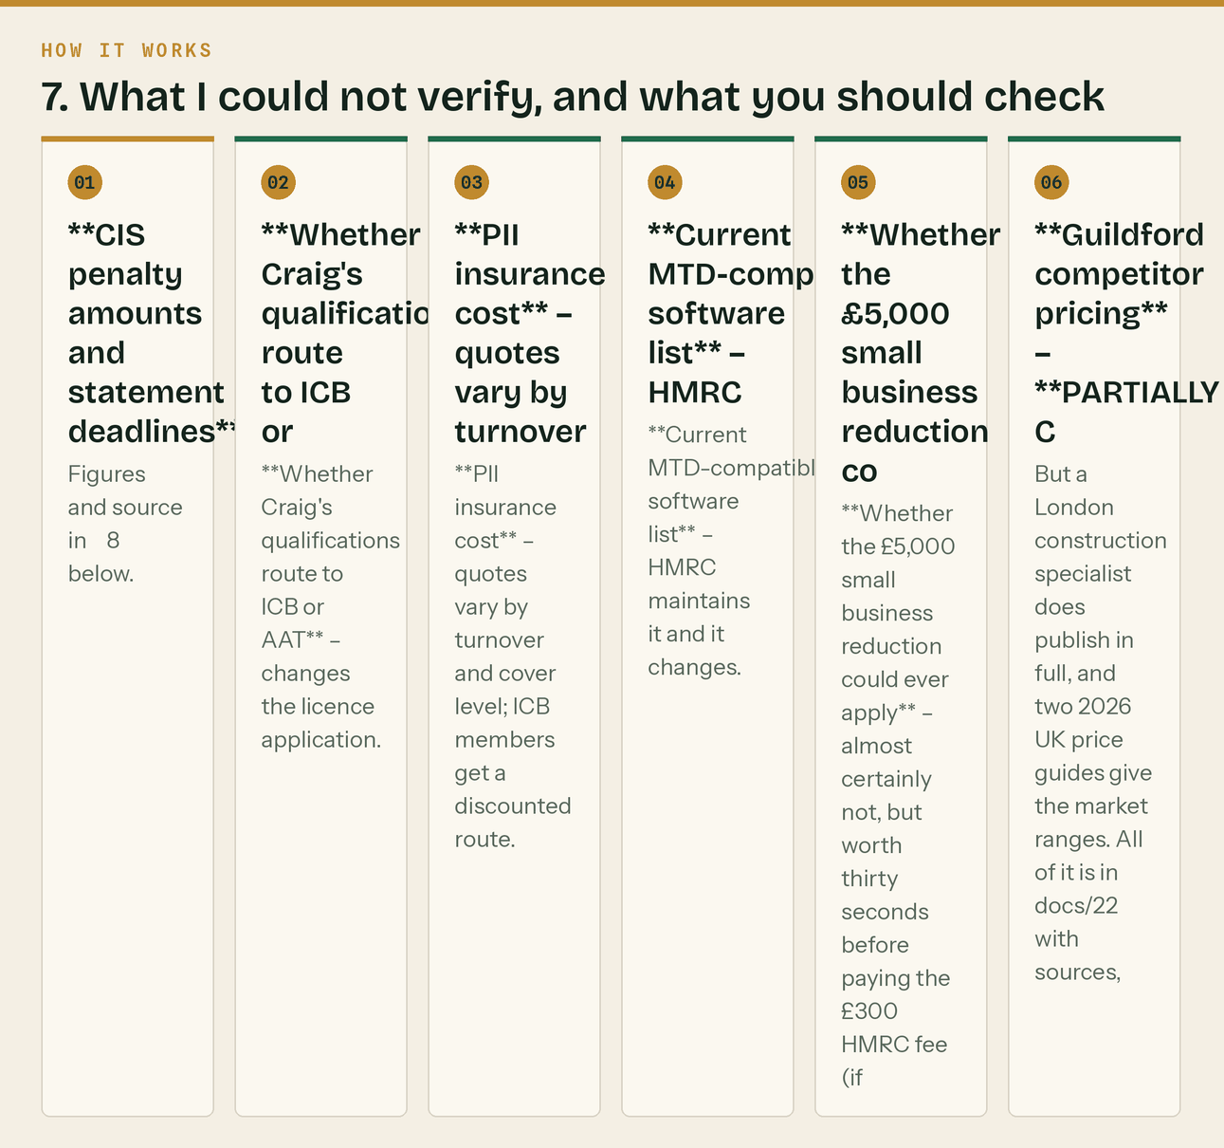
The same steps, in order.
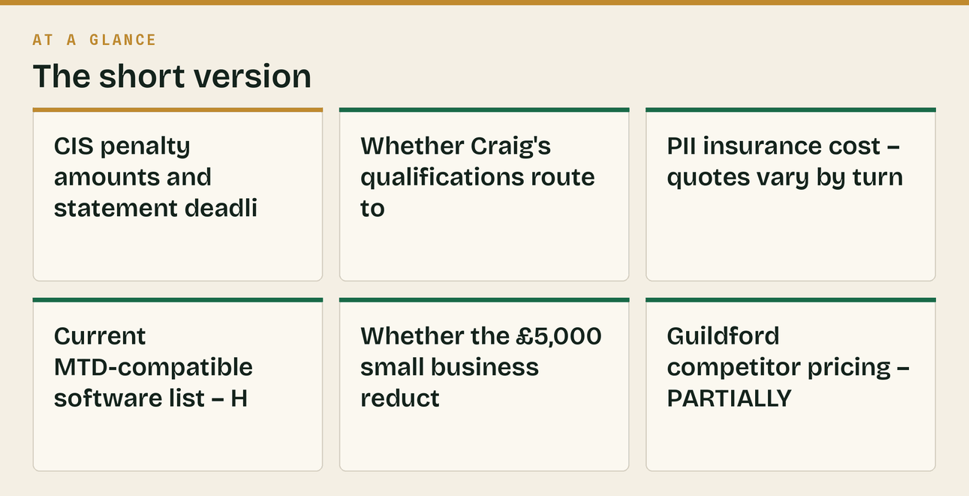
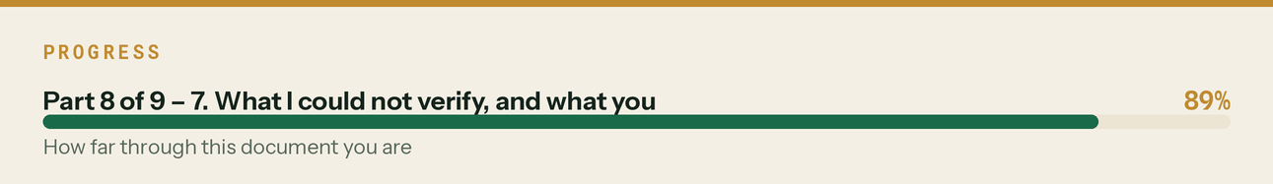

8. Verified compliance facts — checked 26 August 2026


*Every figure used anywhere in this pack, checked against the primary source on the same day. Where a number appears in a post, a PDF, a web page or a calculator, this is where it came from.*
CIS
Claim | Verified figure | Source
Monthly return deadline | "by the 19th of every month following the last tax month" | gov.uk — What you must do as a CIS contractor
Late return, 1 day | £100 | same
Late return, 2 months | £200 | same
Late return, 6 months | £300 or 5% of the CIS deductions, whichever is higher | same
Late return, 12 months | £300 or 5% of the CIS deductions, whichever is higher | same
Beyond 12 months | Up to £3,000 or 100% of the CIS deductions, whichever is higher | same
Nil months | File a nil return, or notify HMRC of temporary inactivity | same

What changed because of this check. The "beyond 12 months" band was missing from the penalty estimator on web/tools.html and from the copy in docs/03. Both now carry it. It matters: it is the band that turns a forgotten scheme into a genuinely serious number, and it is the reason "file the oldest one first" is the right advice.
Gross payment status
Claim | Verified figure | Source
Turnover test, per director or shareholder | £30,000 | HMRC CIS305 notes
Turnover test, company alternative | "at least £100,000" for the whole company | same
What counts | "gross income from construction work excluding VAT and the cost of materials" | same
Compliance test period | "during the 12 months to the date of the application" | same

Making Tax Digital for Income Tax
Claim | Verified figure | Source
£50,000 threshold | Mandatory from 6 April 2026, tested on the 2024–25 return | gov.uk — Check if you're eligible for MTD for Income Tax
£30,000 threshold | Mandatory from 6 April 2027, tested on the 2025–26 return | same
£20,000 threshold | Mandatory from 6 April 2028, tested on the 2026–27 return | same
Quarter ends | 5 July · 5 October · 5 January · 5 April | gov.uk — Send quarterly updates
Update deadlines | 7 August · 7 November · 7 February · 7 May | same
Updates are cumulative | "from the start of the tax year to the end of the update period, not just the previous three months" | same

What changed because of this check. The cumulative point was wrong in docs/24 — it described each update as covering its own quarter. It has been corrected in the calendar copy and added to the MTD checker on web/tools.html as an explicit flag. It is a genuinely useful thing to know, because it means a correction to an earlier quarter is picked up automatically rather than needing an amendment, and nobody explains it.
Employment
Claim | Verified figure | Source
Statutory holiday | 5.6 weeks; at least 28 days for a five-day week | gov.uk — Holiday entitlement
Bank holidays | An employer can choose to count them towards the 5.6 weeks | same
Employers' liability insurance | Minimum £5 million of cover | gov.uk — Employers' liability insurance
Penalty, uninsured | £2,500 for every day not properly insured | same
Penalty, certificate not available | £1,000 | same
Auto-enrolment, employer minimum | 3% | gov.uk — Workplace pensions
Auto-enrolment, employee | 5%, total 8% | same
Qualifying earnings band | £6,240 to £50,270 a year, before tax | same
Written statement | Principal statement on the first day; the wider written statement within 2 months | gov.uk — Written statement of employment particulars

What changed because of this check. Three things. The holiday line said "28 days including bank holidays", which overstates it — an employer *may* count them, and the copy now says so. The employers' liability line said "a fine per day" and can now say £2,500 and £1,000, which is far more persuasive. And the written statement line said "not within two months" — the principal statement is day one, but there genuinely is a second statement due within two months, so the original was half right in a way that would have been embarrassing if a client had checked.
Late commercial payment
Claim | Verified figure | Source
Statutory interest | 8% plus the Bank of England base rate, business to business | gov.uk — Late commercial payments
Fixed sum, debt up to £999.99 | £40 | gov.uk — Claim debt recovery costs
Fixed sum, £1,000 to £9,999.99 | £70 | same
Fixed sum, £10,000 or more | £100 | same
Charged | Once per payment | same

Confirms the figures already used in docs/03 week 3 and the getting-paid carousel. No change needed.
Sources, in full
All accessed 26 August 2026.
- What you must do as a CIS contractor — file your monthly returns — https://www.gov.uk/what-you-must-do-as-a-cis-contractor/file-your-monthly-returns
- HMRC CIS305 notes (company registration for gross payment status) — https://assets.publishing.service.gov.uk/media/66854e2bd9d35187868f43f2/CIS305_Notes.pdf
- Construction Industry Scheme: CIS 340 — https://www.gov.uk/government/publications/construction-industry-scheme-cis-340/construction-industry-scheme-a-guide-for-contractors-and-subcontractors-cis-340
- Check if you're eligible for Making Tax Digital for Income Tax — https://www.gov.uk/guidance/check-if-youre-eligible-for-making-tax-digital-for-income-tax
- Use Making Tax Digital for Income Tax: send quarterly updates — https://www.gov.uk/guidance/use-making-tax-digital-for-income-tax/send-quarterly-updates
- Holiday entitlement — https://www.gov.uk/holiday-entitlement-rights
- Employers' liability insurance — https://www.gov.uk/employers-liability-insurance
- Workplace pensions: what you, your employer and the government pay — https://www.gov.uk/workplace-pensions/what-you-your-employer-and-the-government-pay
- Written statement of employment particulars — https://www.gov.uk/employment-contracts-and-conditions/written-statement-of-employment-particulars
- Late commercial payments: charging interest — https://www.gov.uk/late-commercial-payments-interest-debt-recovery/charging-interest-commercial-debt
- Late commercial payments: claim debt recovery costs — https://www.gov.uk/late-commercial-payments-interest-debt-recovery/claim-debt-recovery-costs
The standing rule
Re-check this section every April, when rates and thresholds move, and before any print run. Three of the figures above (the qualifying earnings band, the base rate the 8% sits on top of, and the MTD thresholds) change on a schedule; the rest change without warning.
And never publish a figure that is not in this table. If a post needs a number that is not here, verify it first and add it. The whole positioning of this business is that Klyara knows this stuff properly, and one wrong figure in a LinkedIn post undoes a great deal of it.
The line that matters
It is a genuinely useful thing to know, because it means a correction to an earlier quarter is picked up automatically rather than needing an amendment, and nobody explains it.



