KLYARA the back office for building firms

Klyara — Risk Register
What actually kills this, ranked, with the early warning sign for each.

*A business partner's job includes saying the uncomfortable thing once, clearly, and then getting on with it. This is that.*
Scoring: Likelihood and Impact are 1–5. Score is the product. Anything 15+ needs a decision this month, not a note.
The line that matters
*A business partner's job includes saying the uncomfortable thing once, clearly, and then getting on with it.

In this part
What actually kills this, ranked, with the early warning sign for each.

The register

# | Risk | L | I | Score | Early warning sign
1 | Fabricated testimonials stay live | 4 | 5 | 20 | They're still there. That is the warning sign.
2 | AML supervision slips past November | 3 | 5 | 15 | No application submitted by mid-September
3 | Craig is the entire product | 3 | 5 | 15 | Any week where Craig is unavailable and nothing ships
4 | No founders' agreement | 3 | 5 | 15 | It still isn't signed
5 | Capacity arrives before hiring | 4 | 3 | 12 | 12+ clients and no recruitment started
6 | Marketing stops in week 4 | 4 | 3 | 12 | Two consecutive missed Wednesday community slots
7 | Zero reviews at day 90 | 4 | 3 | 12 | Three clients onboarded, no review asked for
8 | GBP never gets verified | 2 | 5 | 10 | No verification by day 14
9 | Reddit / forum accounts banned | 2 | 4 | 8 | Any post removed by a moderator
10 | A published tax figure is wrong | 2 | 4 | 8 | Anything published without checking gov.uk that week
11 | Cash runs out before revenue | 2 | 4 | 8 | Cumulative net still negative at month 4
12 | Client 1 has a bad onboarding | 3 | 3 | 9 | Days-from-signing-to-live over 10
13 | Ads burn budget with no calls | 3 | 2 | 6 | £150 spent, cost per call over £40
14 | A competitor copies the pricing play | 2 | 2 | 4 | A local firm publishes tiered pricing



The five that need a decision

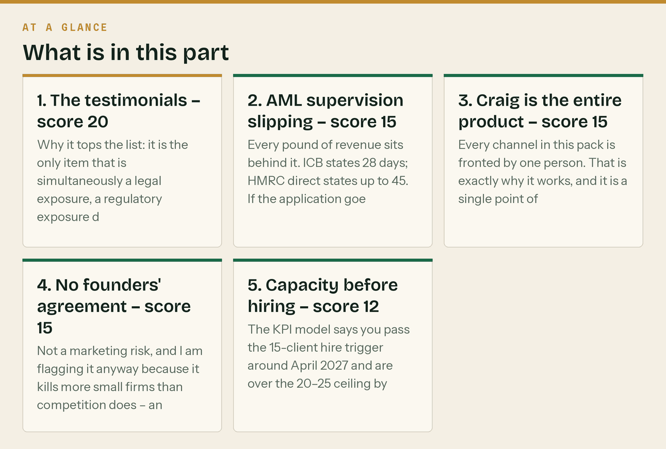
1. The testimonials — score 20
Why it tops the list: it is the only item that is simultaneously a legal exposure, a regulatory exposure during a licence application, and a direct contradiction of the thing you sell.
Fake reviews and testimonials are a banned practice under the Digital Markets, Competition and Consumers Act 2024, enforceable by the CMA. You are about to put a practice licence application in front of a professional body with conduct rules on honest marketing.
Mitigation: remove today. Replacement copy is in docs/07 §Option B. It takes ten minutes. Residual risk after mitigation: near zero. This is the cheapest risk on the register to close.
2. AML supervision slipping — score 15
Every pound of revenue sits behind it. ICB states 28 days; HMRC direct states up to 45. If the application goes in late September you are into November before you can trade, and the founding waitlist has to hold people for six weeks longer than they expected.
Mitigation: apply this week, via ICB (cheaper, faster, includes supervision — docs/17 §1). Write the application date on the wall. If it passes 28 days, chase weekly. Contingency: the waitlist keeps working. Keep publishing regardless — the pipeline is being built either way, and a founding rate held for longer is a stronger offer, not a weaker one.
3. Craig is the entire product — score 15
Every channel in this pack is fronted by one person. That is exactly why it works, and it is a single point of failure for both delivery and marketing.
Mitigation: the continuity arrangement is not paperwork, it is the answer to this risk. Get it agreed with a partner accountant (docs/11 §8). Separately, document the monthly client process so someone else could run it — docs/12 is the start of that. Watch for: the first week Craig is ill and nothing ships. That is the rehearsal.
4. No founders' agreement — score 15
Not a marketing risk, and I am flagging it anyway because it kills more small firms than competition does — and marketing that works makes it more urgent, not less. The moment there is revenue, clients and a brand with value, the cost of not having agreed who owns what goes up sharply.
Mitigation: heads of terms this month. It does not need to be elaborate; it needs to exist.
5. Capacity before hiring — score 12
The KPI model says you pass the 15-client hire trigger around April 2027 and are over the 20–25 ceiling by month 12 — on assumptions that are deliberately not aggressive.
Mitigation: decide the waitlist policy *before* you need it. Holding a founding-rate waitlist is a far better outcome than taking on client 26 badly and losing client 4. Start the recruitment conversation one month before the model says you cross 15.
The line that matters
Why it tops the list: it is the only item that is simultaneously a legal exposure, a regulatory exposure during a licence application, and a direct contradiction of the thing you sell.

In this part
1. The testimonials — score 20 · 2. AML supervision slipping — score 15 · 3. Craig is the entire product — score 15 · 4. No founders' agreement — score 15 · 5. Capacity before hiring — score 12

The ones that quietly do the damage

Marketing stops in week 4. This is the most common failure mode for a plan like this, and it never announces itself. The tell is two consecutive missed Wednesday community slots. docs/16 has a fallback plan naming exactly what to protect and what to drop — the whole point of it is to make "a bad week" survivable rather than terminal.
Zero reviews at day 90. Reviews are the biggest single gap in the AI-visibility analysis, the thing 65% of consumers use to reject businesses, and the thing 47% use as a hard filter below twenty. And they cost nothing but the asking. Three clients with no review request is a process failure, not a client failure.
A published tax figure is wrong. A bookkeeping firm that publishes an incorrect CIS penalty figure has a credibility problem that no amount of good content fixes. docs/17 §1 flags which figures I verified at source and which I could not — check CIS340 before publishing penalty amounts.
The line that matters
Reviews are the biggest single gap in the AI-visibility analysis, the thing 65% of consumers use to reject businesses, and the thing 47% use as a hard filter below twenty.


Also worth knowing
docs/16 has a fallback plan naming exactly what to protect and what to drop — the whole point of it is to make "a bad week" survivable rather than terminal.

What I'd worry about that isn't on the list

The pack is bigger than the business. Twenty documents, ten web pages, 109 assets and a 90-day plan is a lot of apparatus for a firm with no clients. There is a real risk of *doing the marketing* instead of *doing the business* — of a satisfying Tuesday spent scheduling posts while nobody has been rung.
The counterweight is in the plan: the two-hour steady state, the fallback list, and the fact that the single highest-return activity in the whole pack — twenty emails to local accountants — takes an afternoon and needs none of the rest of it.
If you are ever choosing between a post and a phone call, make the call.
The line that matters
If you are ever choosing between a post and a phone call, make the call.

Also worth knowing
There is a real risk of *doing the marketing* instead of *doing the business* — of a satisfying Tuesday spent scheduling posts while nobody has been rung.

Review cadence

Weekly (Friday) The four numbers. Any risk whose early warning sign has appeared?
Monthly Re-score anything that moved. Add anything new.
Day 90 Full re-score against what actually happened.
Keep it in the KPI workbook next to the numbers. A risk register nobody re-reads is decoration.
Correction, 26 August 2026 — read this with the document above
- FAQPage and HowTo schema no longer produce rich results. FAQ rich results stopped appearing in
Google Search on 7 May 2026; HowTo was retired in September 2023. Keep the FAQ content and the markup, but move the effort to AccountingService, Organization, BreadcrumbList and Service. Full note in docs/08 §12.
- Google Business Profile posts no longer expire. Google stopped that in January 2021. Post
weekly anyway — only the newest shows prominently and a stale profile reads as abandoned.
- The verified figures live in docs/17 §8, checked against gov.uk on 26 August 2026. Never
publish a figure that is not in that table.
- Current inventory: 27 documents, 20 web pages, 180+ assets, 12 PDFs, 14 videos, one workbook.
Anywhere this document quotes a smaller count, it predates the later passes.
- Twelve calculators vs four tools: the twelve are the individual calculator pages already on
klyara.com; the four are the consolidated web/tools.html. docs/08 §12 explains which schema goes where.
- ICB cost: £94 application, then £373–£406 a year (£206 licence plus £167–£200 membership).
Anywhere this document says "£206 a year", it is quoting the licence only.
The line that matters
Keep the FAQ content and the markup, but move the effort to AccountingService, Organization, BreadcrumbList and Service.

In this part
Correction, 26 August 2026 — read this with the document above

Also worth knowing
weekly anyway — only the newest shows prominently and a stale profile reads as abandoned.

