KLYARA the back office for building firms

Credit note
CRN-2026-0009 · a worked example, materials credited

Worked example — not a real job
Every name, number and date on this document is made up to show you how the form works. Klyara has no clients yet and this is not a record of any job. Replace the lot with your own.


The four numbers on this credit note.
From | Credit to
Hatcher Groundworks Ltd  Unit 4, Ladymead Yard  Guildford  Surrey GU1 1DB  VAT GB 412 8890 55  Company 09884412 | Pennistone Construction Ltd  Pennistone House, Chertsey Road  Woking  Surrey GU21 5BJ  For the attention of Marie Odell, Commercial

Credit note number | Date | Credits invoice | Invoice dated
CRN-2026-0009 | Friday 20 November 2026 | INV-2026-0184 | Friday 16 October 2026

Why this credit note was raised
Four 6 metre lengths of 110mm pipe were charged on INV-2026-0184 and never used. They went back to Guildford Building Supplies on 18 November 2026 and we have been credited for them, so we are crediting you.

What is being credited
Description | Type | Amount
110mm underground pipe, 6m lengths, 4 at £18.40, returned unused | Materials | £73.60
Total credited, excluding VAT |  | £73.60

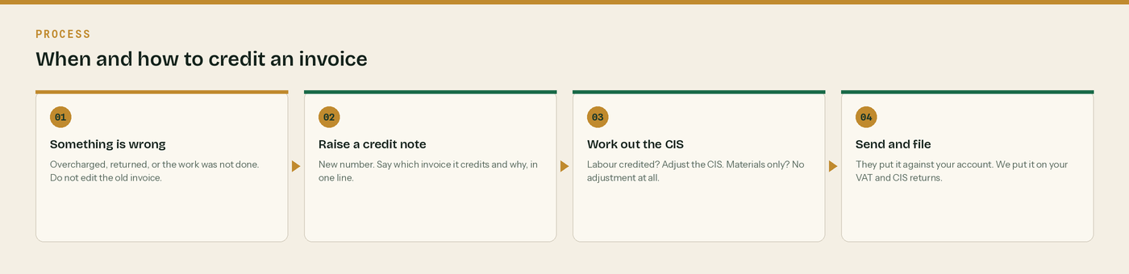
When and how to credit an invoice.
How the credit works through
Line | Working | Amount
Materials credited | 4 at £18.40 | £73.60
VAT | Reverse charge. 20% of £73.60 is £14.72, to reverse on your return. | £0.00
CIS adjustment | None. CIS is never deducted from materials. | £0.00
Less retention already withheld on this line | 5% of £73.60 | -£3.68
Credit to your account | We were only ever paid 95% of that line | £69.92
Retention you now hold on INV-2026-0184 | £147.35 less £3.68 | £143.67

VAT: Reverse charge: customer to pay the VAT to HMRC
The original invoice was reverse charged, so this credit note is too. The rate that would have applied is 20%, which on £73.60 is £14.72. Reverse that figure on your own return. Nothing is being refunded to you as VAT because none was charged.

CIS adjustment: £0.00 - and that is correct
This credit is materials only. CIS was never deducted from the £596.00 of materials on INV-2026-0184, so there is nothing to put back. The £383.80 already deducted from labour stands. If we had credited labour instead, 20% of it would move as well.

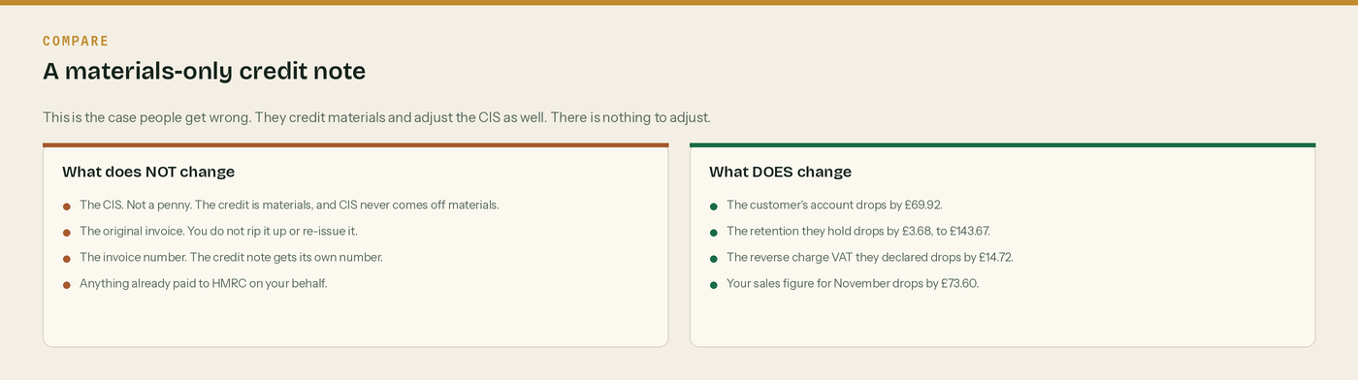
The case people get wrong is the one on the left.
The four numbers on this credit note, once more.

What changes, and what does not

Materials credited: nothing to adjust. Labour credited: the CIS moves.
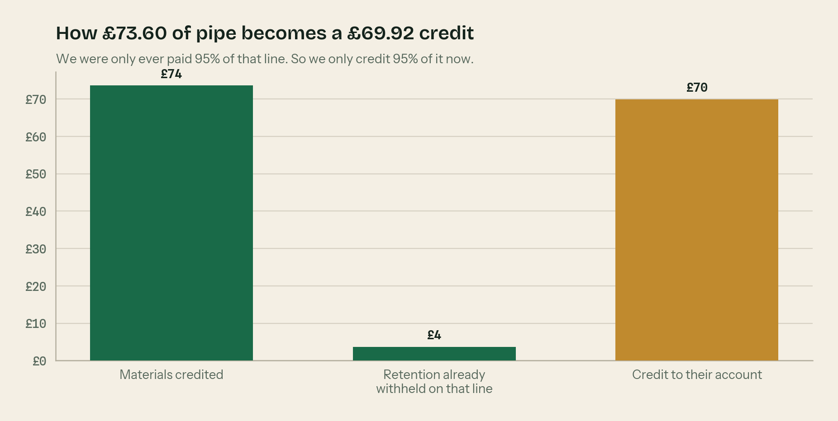
Why £73.60 credited is only £69.92 off the account.
And the four numbers again.

The rules behind this credit note

Never edit an invoice you have already sent
Once it has gone out and it is on a VAT return, it is a record. Correcting it by typing over the old one is how firms end up with two versions of the same invoice number and a very awkward VAT check. Raise a credit note instead.

Credit notes get their own number series
CRN, not INV. Same order, no gaps. A gap in the numbers is the first thing an inspector counts.

Say which invoice it credits, and why
One line. “Credits INV-2026-0184. Four lengths of 110mm pipe returned unused.” That single line is what stops the query email six months later.

Materials credited: no CIS. Labour credited: the CIS moves too.
CIS never came off materials, plant hired in or consumables, so there is nothing to put back. But if you credit £1,000 of labour that was paid under a 20% deduction, £200 of CIS goes back as well. Tell us in the same month so your return agrees with the contractor's.

Reverse charge credit notes carry the same wording
The credit note shows “Reverse charge: customer to pay the VAT to HMRC” and the rate that would have applied, exactly like the invoice did. The customer reverses that VAT on their own return.

WHERE THIS COMES FROM
Checked against gov.uk on Wednesday 26 August 2026. If a rate changes, the wording stays the same and only the number moves.
· What comes out before the CIS deduction (CIS 340) — https://www.gov.uk/government/publications/construction-industry-scheme-cis-340/construction-industry-scheme-a-guide-for-contractors-and-subcontractors-cis-340
· CIS deduction rates — https://www.gov.uk/what-you-must-do-as-a-cis-contractor/make-deductions-and-pay-subcontractors
· The wording HMRC accept on a reverse charge invoice (VATREVCON37100) — https://www.gov.uk/hmrc-internal-manuals/vat-reverse-charge-for-building-and-construction-services-manual/vatrevcon37100
· Retention payments and CIS (CISR15040) — https://www.gov.uk/hmrc-internal-manuals/construction-industry-scheme-reform/cisr15040

