KLYARA the back office for building firms

Purchase order
Blank template · raise one before you ring the merchant

Blank purchase order — ready to use
Type over anything in [square brackets]. Delete the rows you do not need. Everything on this page is real Word text, so you can change it, save it and re-use it.

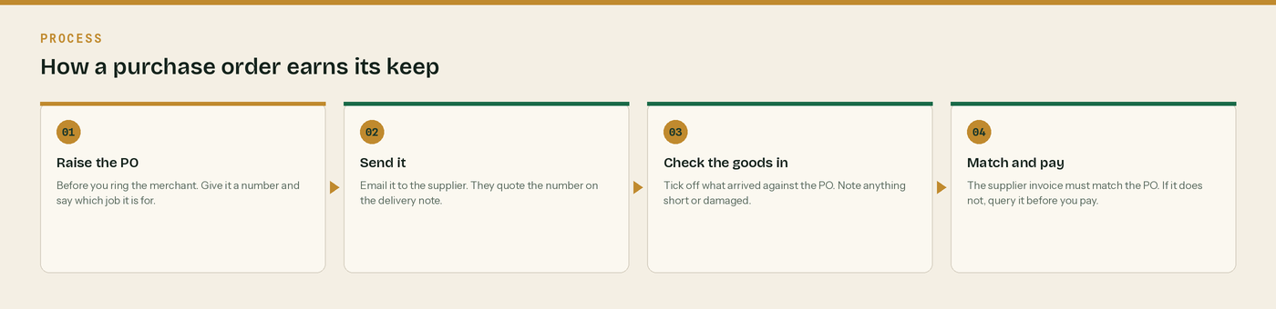
Four steps. The last one is where the money is saved.
Order from | Order placed by
[Supplier name]  [Address line 1]  [Town]  [County and postcode]  [Contact name]  Our account [number] | [Your business name]  [Address line 1]  [Town]  [County and postcode]  VAT [registration number]  Company [number]

Order number | Date ordered | Required on site by | Job reference
[PO-0000] | [date] | [date] | [job number and site]

Deliver to | Site contact | Access
[Plot and site name]  [Town and postcode] | [Name and mobile] | [Gate times, restrictions]

What we are ordering
Description | Quantity | Unit price | Amount
[Description] | [qty] | £0.00 | £0.00
[Description] | [qty] | £0.00 | £0.00
[Description] | [qty] | £0.00 | £0.00
[Description] | [qty] | £0.00 | £0.00
[Description] | [qty] | £0.00 | £0.00
[Description] | [qty] | £0.00 | £0.00

Line | Working | Amount
Net total | Goods only | £0.00
VAT at [20]% | Normal VAT on a supply of goods | £0.00
Order total | [Payment terms] | £0.00

Normal VAT, not reverse charge
A merchant supplying materials is supplying goods, so they charge VAT in the normal way and you reclaim it. The reverse charge is for construction work reported under CIS. Do not mix the two up.

Keep the delivery note with this order
Order, delivery note and supplier invoice all carrying the same PO number is what proves the materials were yours - and that is what keeps the CIS deduction off them.

Raised by | Authorised by | Date
[name] | [name and title] | [date]

Three things to check before you send it

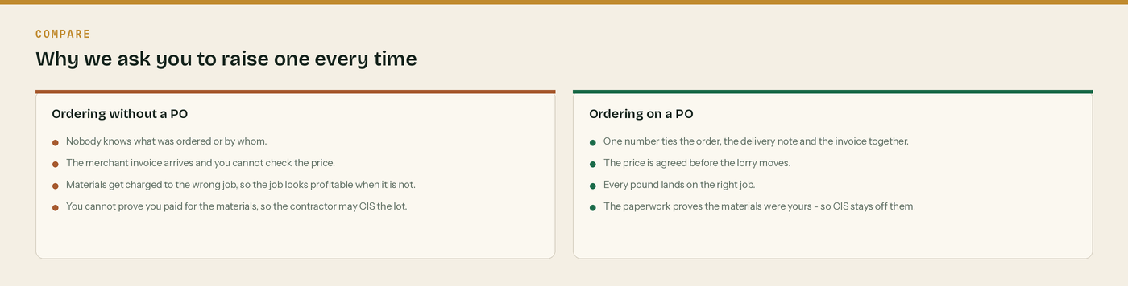
One. Does it have a number, a job reference and a price?
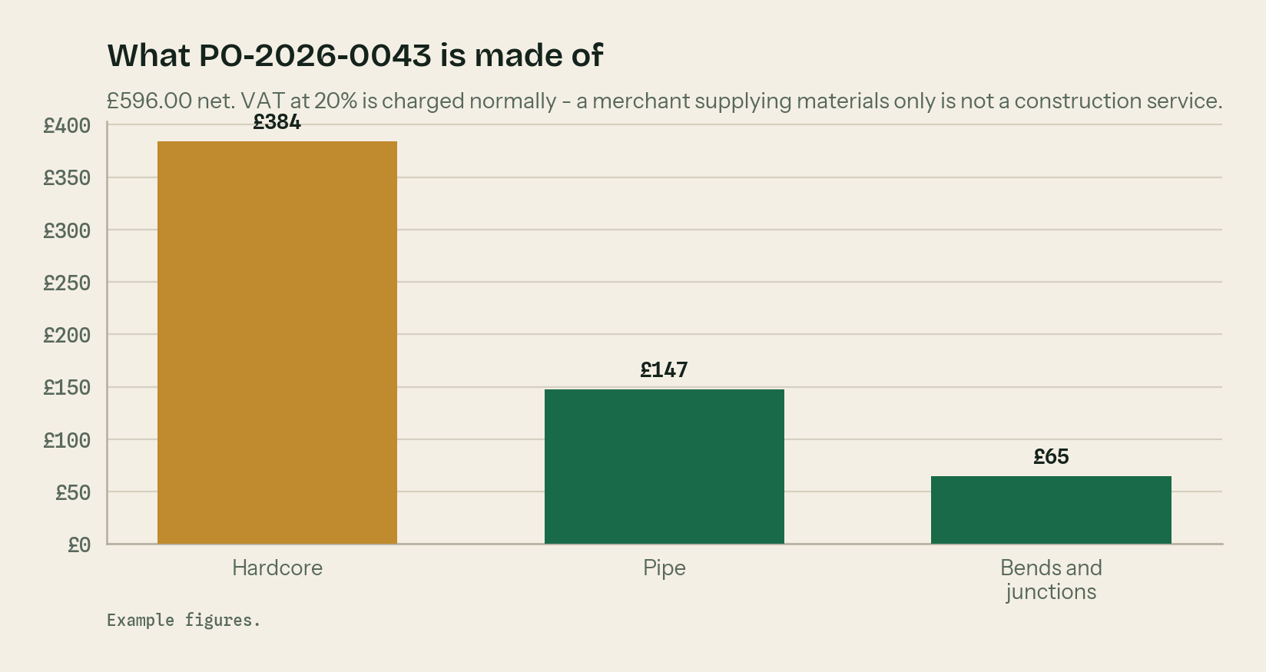
Two. Do the line amounts add to the net total?

Three. Is the VAT right for what is actually being supplied?
A materials-only order is not a construction service
A merchant selling you hardcore and pipe is supplying goods, not construction work. So the reverse charge does not apply and they charge you VAT at 20% in the normal way. Reverse charge is for construction work reported under CIS, not for the builders merchant.

The PO is what keeps CIS off your materials
To keep materials out of the CIS deduction you have to show you paid for them yourself. A purchase order, a delivery note and a supplier invoice that all carry the same number is the cleanest proof there is. No proof, and the contractor is entitled to deduct 20% off the lot.

One number ties three pieces of paper together
The order, the delivery note and the supplier invoice. Put the PO number on all three and the month-end takes minutes instead of an afternoon.

Check the goods in on the day
Count it against the order before the lorry leaves. Write short deliveries and damage on the delivery note and get the driver to initial it. After the lorry goes it is your word against theirs.

Put the job reference on it
Every order belongs to a job. Without the job reference the cost lands nowhere and the job looks more profitable than it was.

WHERE THIS COMES FROM
Checked against gov.uk on Wednesday 26 August 2026. If a rate changes, the wording stays the same and only the number moves.
· What comes out before the CIS deduction (CIS 340) — https://www.gov.uk/government/publications/construction-industry-scheme-cis-340/construction-industry-scheme-a-guide-for-contractors-and-subcontractors-cis-340
· CIS deduction rates — https://www.gov.uk/what-you-must-do-as-a-cis-contractor/make-deductions-and-pay-subcontractors
· When to use the VAT domestic reverse charge — https://www.gov.uk/guidance/vat-domestic-reverse-charge-for-building-and-construction-services

