KLYARA the back office for building firms

Quotation
QUO-2026-0117 · a worked example, groundworks package

Worked example — not a real job
Every name, number and date on this document is made up to show you how the form works. Klyara has no clients yet and this is not a record of any job. Replace the lot with your own.


The four numbers on this quote.
From | Quotation for
Hatcher Groundworks Ltd  Unit 4, Ladymead Yard  Guildford  Surrey GU1 1DB  01483 000 114  accounts@hatchergroundworks.co.uk  VAT GB 412 8890 55 | Pennistone Construction Ltd  Pennistone House, Chertsey Road  Woking  Surrey GU21 5BJ  For the attention of Marie Odell, Commercial

Quotation number | Date | Valid until | Priced from
QUO-2026-0117 | Monday 5 October 2026 | Wednesday 4 November 2026 | Drawing WM-06 rev C

Site | Start on site | Programme
Plot 6, Wey Meadow  Cranleigh  Surrey GU6 8TF | Two weeks from acceptance | Four weeks on site, weather permitting

What we will do, and what it costs
Description | Type | Amount
Site strip and dig to formation, 340 sq m | Labour | £2,180.00
Foundation dig and muck away, 46 cu m, to licensed tip | Labour | £2,760.00
Drainage runs and connections, 3 chambers | Labour | £1,640.00
Hardcore, blind and compact to slab base | Labour | £1,420.00
Plant hired in - 1.5t and 3t excavators, 6 days | Plant hired in | £570.00
Materials allowance - Type 1, pipe and fittings | Materials | £370.00
Total, excluding VAT |  | £8,940.00

What is included, and what is not
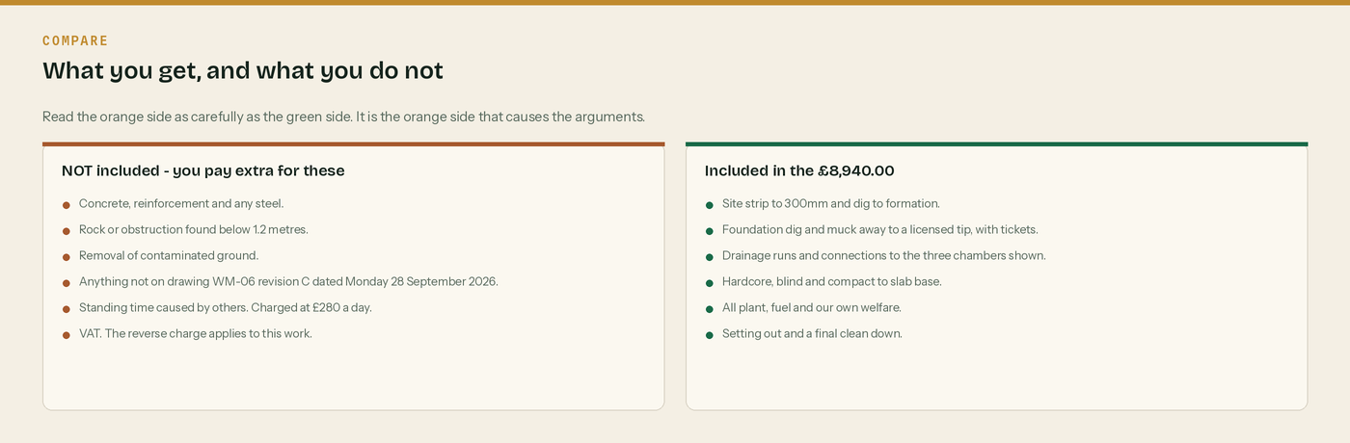
Read the orange side as carefully as the green side.
VAT: Reverse charge: customer to pay the VAT to HMRC
This work is standard rated construction work reported under CIS, between two VAT registered businesses, so the domestic reverse charge applies. The rate that would have applied is 20%, which on £8,940.00 is £1,788.00. We will not charge it. You account for it to HMRC. If you are an end user, send us a written declaration and we will charge VAT in the normal way.

CIS: £1,600.00 will be held from labour across the job
20% of the £8,000.00 of labour in this quote. Nothing is deducted from the £570.00 of plant hired in or the £370.00 of materials. Each invoice will show the split.

Payment terms | Retention | Validity
Applied for monthly on the last Friday.  30 days from the date of each invoice. | 5% held to practical completion. | This price holds until 4 November 2026.  After that we re-check it.

To accept this quotation
Sign below, write the date and your purchase order number, and email this page back to accounts@hatchergroundworks.co.uk. We will confirm the start date within two working days.
Signed | Print name | Position | Date | Your PO number

What happens, and by when


From quote to first payment.
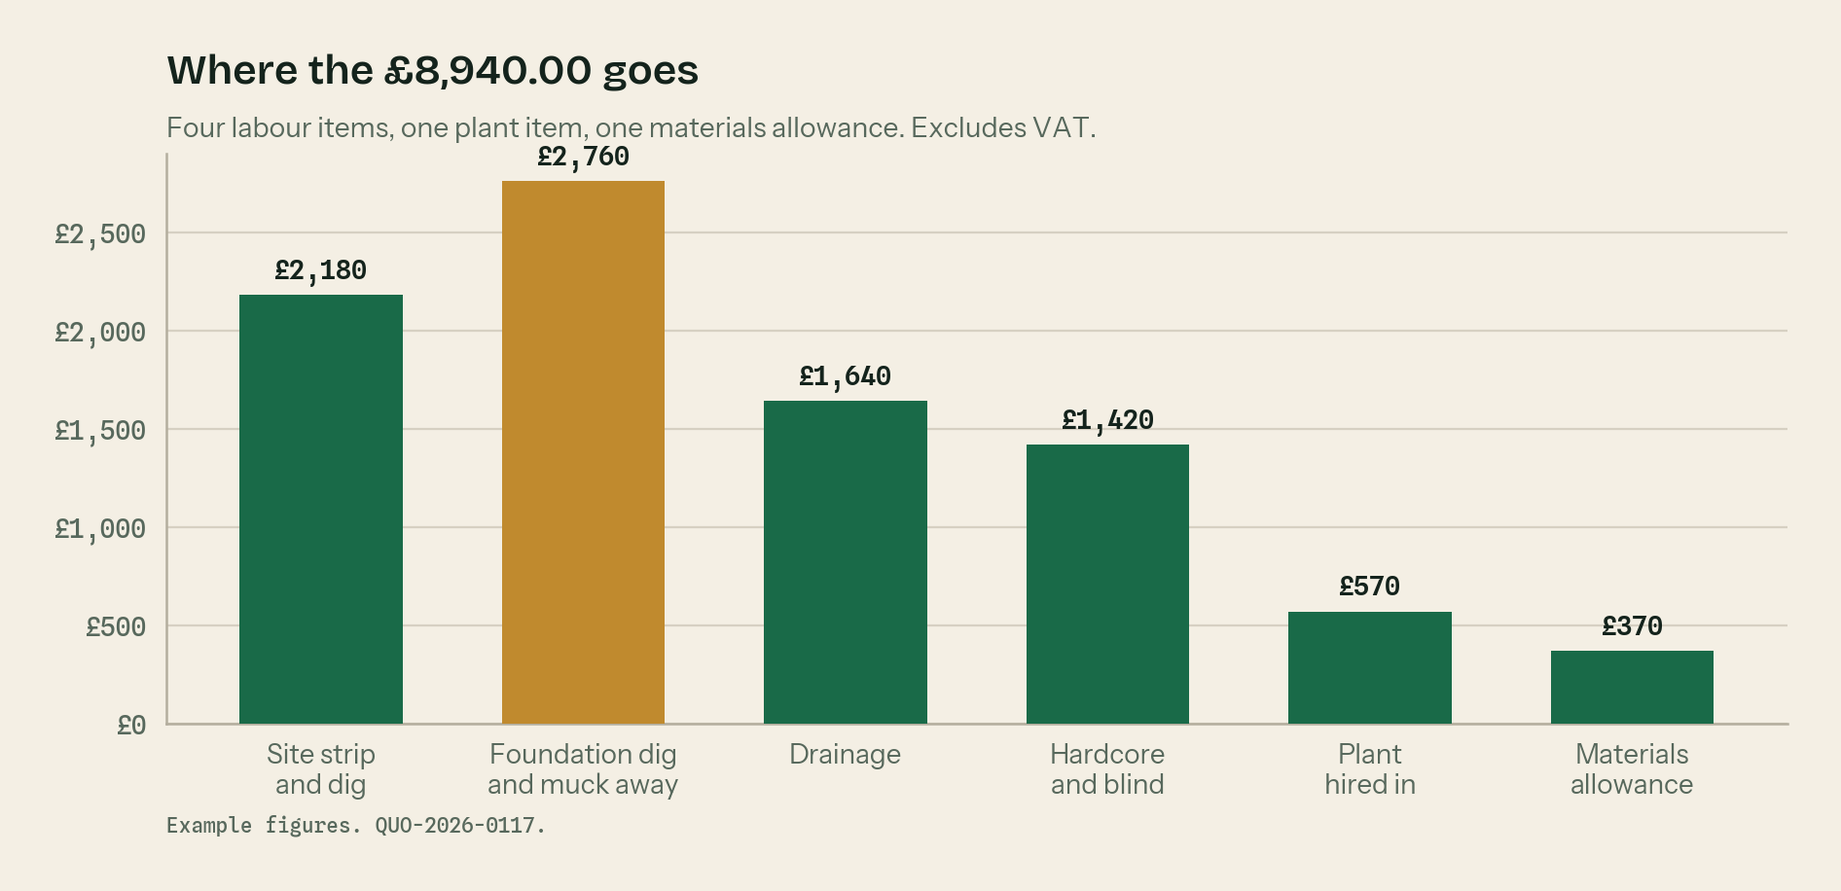
Where the £8,940.00 goes. The foundation dig is the biggest item.
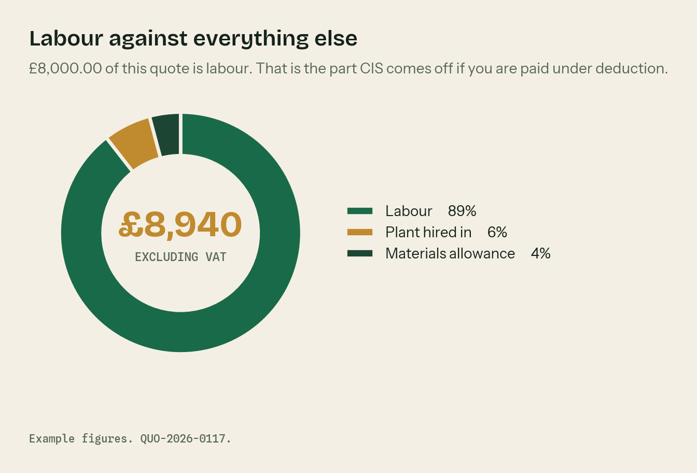
Labour against everything else. Labour is the part CIS comes off.

The rules behind this quotation

A quote is a fixed price. An estimate is a guess.
If you write quote at the top you are offering to do the job for that money. If the ground turns out worse than the drawing said, you carry it unless the exclusions cover you. If you are not sure of the scope, write estimate and say what it is based on.

Always put a validity date on it
Thirty days is normal. Materials and plant prices move. Without a date the customer can hold you to a price you gave last spring.

Exclusions are the whole game
Most arguments on site are about something nobody wrote down. The orange panel is not you being difficult. It is you being clear.

Say what the VAT does
Where the reverse charge applies, say so on the quote as well as the invoice. The customer needs to budget for cash, and reverse charge changes their cash. The wording is “Reverse charge: customer to pay the VAT to HMRC”.

Say what the CIS does
If the customer is a contractor and you are paid under deduction, they will hold 20% of the labour. On this quote that is £1,600.00 across the job. Say it now so nobody is surprised on the first payment.

WHERE THIS COMES FROM
Checked against gov.uk on Wednesday 26 August 2026. If a rate changes, the wording stays the same and only the number moves.
· When to use the VAT domestic reverse charge — https://www.gov.uk/guidance/vat-domestic-reverse-charge-for-building-and-construction-services
· The wording HMRC accept on a reverse charge invoice (VATREVCON37100) — https://www.gov.uk/hmrc-internal-manuals/vat-reverse-charge-for-building-and-construction-services-manual/vatrevcon37100
· End user and intermediary supplier declarations — https://www.gov.uk/guidance/vat-reverse-charge-technical-guide
· CIS deduction rates — https://www.gov.uk/what-you-must-do-as-a-cis-contractor/make-deductions-and-pay-subcontractors

