KLYARA the back office for building firms

Complaints Procedure
What to do if something goes wrong, how long each step takes, and who to go to if we do not put it right.

THE SHORT VERSION
Tell us. Ring 020 8058 1496 or email hello@klyara.com. Most things are sorted the same day and never become a complaint at all. If that does not work, there are two formal stages here, and after that there are two organisations outside Klyara you can go to.
Complaining does not affect your service
Nothing about your work changes because you have complained. Your returns still get filed, your deadlines are still met, and nobody here holds it against you. A firm that is difficult about complaints is telling you something about itself, and we would rather tell you something else.

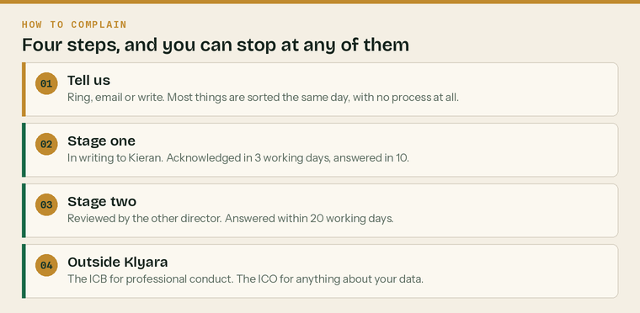
Four steps, and most people stop at the first one.
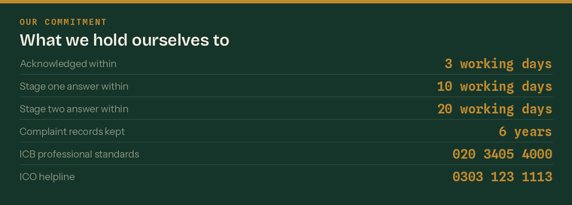
What we hold ourselves to. Working days, not calendar days.
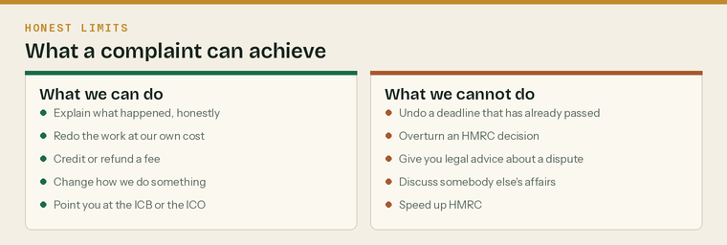
What a complaint can actually achieve, and what it cannot.
Four ways to raise it
 | Ring 020 8058 1496 |  | Email hello@klyara.com
 | Write to us at [address] |  | Fill in the Complaints Form

The stages

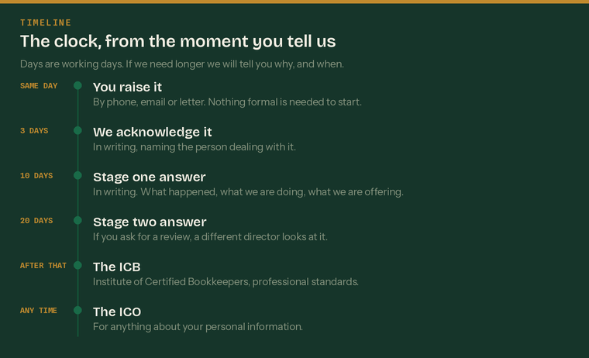
The clock, from the moment you tell us. If we need longer, we tell you why and when.
What we will ask you for
 | What happened, and roughly when | A rough date is fine
 | Who you dealt with, if you know | It is not about blaming anybody
 | What you would like us to do | The most useful question on the form
 | Anything you are relying on | Emails, invoices, letters

Before a complaint — just tell us
Ring, email, or send a WhatsApp message. Say what is wrong. There is no form to fill in and no particular words to use.
Most problems are a misunderstanding about scope, a deadline nobody explained, or an invoice that looks wrong. Almost all of them are fixed inside a day. If you would rather go straight to a formal complaint, that is your right and Stage 1 is below.
Stage 1 — Formal complaint
Step | Who | When
You put it in writing | You | Whenever you like
We acknowledge it in writing and say who is handling it | Kieran | 3 working days
We investigate — file, correspondence, and whoever was involved | Kieran | Straight away
We may ring you to check we have understood it | Kieran | During the investigation
We answer in writing | Kieran | 10 working days

What our answer will contain
 | What we found | Plainly, including where we were wrong
 | What we are doing about it | The specific action, with a date
 | What we are offering, if anything | A fee credit, redoing the work, or an apology
 | What has changed so it does not happen again | The process change, not a promise to be careful
 | How to take it further | Stage 2, and the two routes outside Klyara

Stage 2 — Review
If the Stage 1 answer does not satisfy you, ask for a review. Say so in writing within [20] working days of our answer and tell us which part of it you disagree with.
Step | Who | When
You ask for a review, in writing | You | Within 20 working days of the Stage 1 answer
We acknowledge it | Craig | 3 working days
A different director reviews the whole file | Craig | Straight away
We answer in writing | Craig | 20 working days

The Stage 2 answer is our final response. It will say so, and it will set out the routes outside Klyara.
If we cannot meet a deadline, we will tell you before it passes
Sometimes an investigation genuinely takes longer — a third party is slow, or the file is large. If that happens we will write to you before the deadline, tell you why, and give you a new date. What we will not do is let a deadline go past in silence.

Going outside Klyara

You can go to either of these at any point. You do not have to finish our process first, although both will normally ask whether you have raised it with us.
The Institute of Certified Bookkeepers
For anything about the professional conduct of an ICB member or practice — competence, honesty, how we behaved, whether we did what a bookkeeper should have done.
The ICB | Details
Professional standards | professional.standards@bookkeepers.org.uk
Telephone | 020 3405 4000
Post | Institute of Certified Bookkeepers, 122-126 Tooley Street, London, SE1 2TU
What it covers | Professional conduct of members and practices, under the Professional Conduct Regulations
What it does not cover | A fee dispute on its own, or a commercial disagreement

What ICB membership means in practice
An ICB Practice Licence requires the practice to hold professional indemnity insurance — not less than £50,000 — to comply with the Professional Conduct Regulations, and to hold AML supervision. Those are enforceable obligations with a disciplinary process behind them, and that is what a complaint to the ICB engages.

Confirm the exact ICB route on the day the Practice Licence is granted
The ICB publishes a Complaints Policy that deals with complaints about the ICB itself, and separate Professional Conduct Regulations that deal with the conduct of members. Complaints about a member's work go through professional standards, under the Conduct Regulations. Ring the ICB when the licence arrives, confirm the current address for a client complaint, and update this page. Do not publish a complaints procedure that sends a client to the wrong desk.

The Information Commissioner's Office
For anything about your personal information — a subject access request we did not answer, information we should not have shared, information we got wrong.
The ICO | Details
Helpline | 0303 123 1113
Website | ico.org.uk/make-a-complaint
Post | Information Commissioner's Office, Wycliffe House, Water Lane, Wilmslow, Cheshire, SK9 5AF
Cost | Free
Before you go | The ICO will ask whether you complained to us first, and for a copy of that complaint

And the courts
Nothing here takes away your right to take a claim to court, and nothing here is a condition of doing so. Using this procedure, or going to the ICB or the ICO, does not stop you.
How we run this internally

This section is for us. It is published because a complaints procedure that only describes what the client does is half a procedure.
The complaints register
Every complaint goes in the register the day it arrives, whether it is formal or not. The register records:
 | Date received and how it arrived |  | Who complained and about what
 | Who is handling it |  | Date acknowledged
 | What we found |  | Date answered
 | What we offered |  | What we changed as a result

The register is kept for six years. It is reviewed at every quarterly practice review, and it is the first thing a professional body inspection will ask to see.
What goes in the answer letter, every time
 | What we found |  | Where we were wrong, if we were
 | What we are doing about it, with a date |  | What we are offering, if anything
 | What has changed in the process |  | How to take it further

Root cause, not blame
Ask | Rather than
What in the process allowed this? | Who made the mistake?
What would have caught it? | Why did nobody notice?
What are we changing, and by when? | We will be more careful
Has this happened before? | This was a one-off

When to escalate immediately, without waiting for a stage
 | Anything alleging dishonesty | Straight to both directors and to the insurer
 | Anything that might be a claim | Tell the professional indemnity insurer the same day
 | A data breach | 72-hour clock to the ICO if it is reportable
 | Anything involving a missed statutory deadline | Fix the filing first, then handle the complaint
 | Anything from a professional body | Both directors, same day

Tell the insurer early, not late
Most professional indemnity policies require notification of a circumstance that might give rise to a claim, not just of a claim itself. Late notification is one of the commonest reasons cover is refused. If in doubt, notify. It costs nothing and it protects everything.

Review of this procedure
Version | 1.0 — draft, not yet issued
Written | Wednesday 26 August 2026
Owner | [name]
Next review | [one year from issue]

Sources
Every figure and deadline in this document was checked against the page listed beside it on Wednesday 26 August 2026. Re-check before each use — thresholds and penalties change.
What was checked | Source
ICB Professional Conduct Regulations — conduct, PII minimum, disciplinary process | https://www.bookkeepers.org.uk/out/262546/ICB-Professional-Conduct-Regulations.pdf
ICB Complaints Policy — address and telephone, acknowledgement and response times | https://www.bookkeepers.org.uk/out/189133/ICB-Complaints-Policy.pdf
ICB professional standards contact, from the Professional Conduct Regulations page | https://www.bookkeepers.org.uk/Membership/Ethics--Regulations/Professional-Conduct-Regulations
ICB Practice Licence and what it requires | https://www.bookkeepers.org.uk/Running-a-Practice/Regulation/Practice-Licence
Complaining to the ICO, and complaining to the organisation first | https://ico.org.uk/make-a-complaint/data-protection-complaints/
ICO head office postal address | https://ico.org.uk/about-the-ico/who-we-are/directions-head-office/

