KLYARA the back office for building firms

Employment Contract and Hire Pack
The written statement of employment particulars that meets the day-one requirement, and the checklist that goes with it.

Read this before you use this document
This is a working template. It has been drafted carefully and checked against the sources listed at the end, but it is not legal advice and it has not been settled by a solicitor. Have it reviewed by a solicitor, or by the Institute of Certified Bookkeepers, before you issue it to anybody. And it cannot be used to take on a bookkeeping client until Klyara's AML supervision is in place — an ICB Practice Licence includes AML supervision and takes about 28 days to process. Until that licence is granted, Klyara cannot lawfully carry on bookkeeping by way of business.

WHAT IS IN THIS PACK
Two things. Part 1 is the hire checklist — the four things that must be done before anybody gets paid, in the order the law expects them. Part 2 is the written statement of employment particulars itself, which by law has to be given on the first day of employment.
Employees and workers, not just employees
The day-one written statement is owed to employees and workers. If you take somebody on casually, on an as-and-when basis, they are very likely a worker and they are very likely entitled to this document. The safest habit is to issue it to everybody.

Use this pack when
 | Klyara takes on its first employee |  | A client asks how to hire properly
 | Someone casual becomes regular |  | An existing arrangement needs putting right

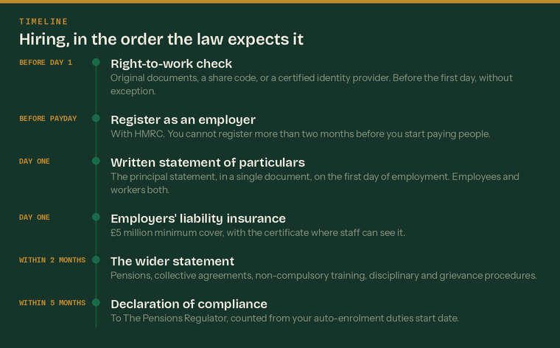
The order the law expects. Two of these have a penalty attached to being late.
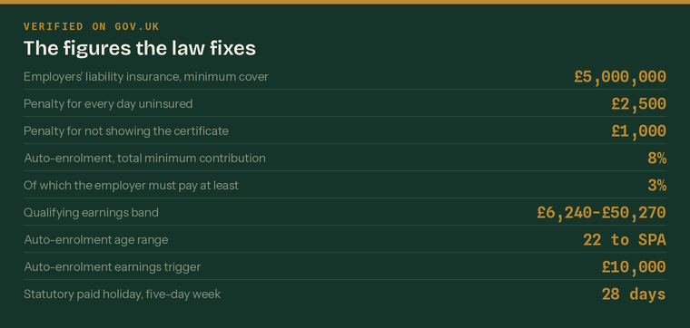
The figures the law fixes. Every one checked on gov.uk on Wednesday 26 August 2026.
Part 1 — The hire checklist

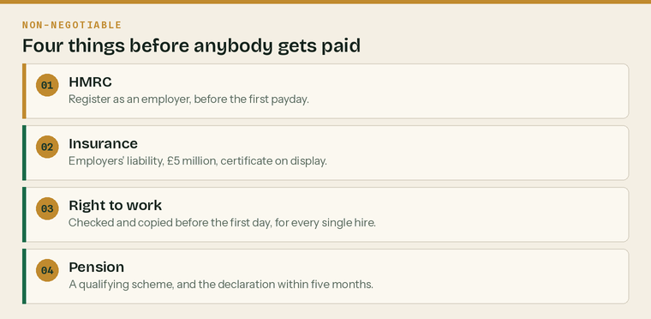
Four things, and none of them can wait until after the first payday.
1 — Register as an employer with HMRC
 | Register before the first payday | You cannot register more than two months before you start paying people
 | Get the PAYE reference and Accounts Office reference | Both come by post
 | Set up the payroll software or hand it to Klyara | RTI is filed on or before every payday
 | Decide the pay frequency and the pay date | Weekly, fortnightly, four-weekly or monthly
 | Check whether Employment Allowance applies | It reduces the employer's National Insurance bill

2 — Employers' liability insurance
£5 million, and £2,500 for every day you have not got it
Employers' liability insurance must cover you for at least £5 million. The penalty for not being properly insured is £2,500 for every day. The certificate has to be somewhere your staff can see it — the workplace, the website or the intranet — and not displaying it, or not producing it for an inspector, is a further £1,000.

 | Policy in place before the first day |  | Cover at least £5 million
 | Certificate displayed where staff can see it |  | Renewal date diarised

You do not need it if the only people you employ are close family — spouse, parents, grandparents, step-relations, siblings or half-siblings — or if they are based outside England, Scotland and Wales. Check this rather than assuming it, because it is narrower than most people think.
3 — Right to work
Check before employment starts, for everybody, without exception and without picking and choosing who gets checked. There are three lawful ways to do it.
Method | How it works | When to use it
Original documents | See the original, check it against the person, take a dated copy | British and Irish passport holders
Home Office online check | They give you a share code, you check it online | Anyone with a digital immigration status
Certified identity provider | An IDSP using identity document validation technology | British and Irish citizens, remotely

 | Check done before the first day | A check done afterwards gives you no statutory excuse
 | Copy taken and the date of the check recorded | The date is as important as the copy
 | Follow-up check diarised if the right to work is time-limited | Before it expires
 | Copy kept for the employment plus two years | Then destroyed

Up to £60,000, per worker
The civil penalty for employing somebody who does not have the right to work is up to £60,000 for each worker. Knowingly employing somebody, or having reasonable cause to believe they cannot work, is a criminal offence carrying up to five years' imprisonment and an unlimited fine. A correct check done before they start is a statutory excuse against the civil penalty.

4 — Pension auto-enrolment
Your duties start on the day your first member of staff begins work. That is your duties start date and everything counts from it.
Who must be enrolled | The test
Age | 22 or over, and under State Pension age
Earnings | £10,000 a year or more
Where they work | In the UK

Contributions | Minimum
Total minimum contribution | 8% of qualifying earnings
Employer must pay at least | 3%
Employee makes up the rest | 5%, including tax relief
Qualifying earnings band | £6,240 to £50,270 a year

 | A qualifying pension scheme chosen | Nest, The People's Pension, Smart Pension or similar
 | Staff assessed on the duties start date | And on every payday afterwards
 | Eligible staff enrolled and written to | Within six weeks of them becoming eligible
 | Declaration of compliance filed | Within five months of the duties start date
 | Re-enrolment diarised | Every three years

The declaration is a separate legal duty and it is the one people forget
Enrolling everybody correctly is not enough. You must also tell The Pensions Regulator you have done it, within five months of your duties start date, and you can be fined if you do not. Diary it on the day you take on your first employee.

Before the first day — the full list
 | Offer letter sent and accepted |  | Right-to-work check done and copied
 | Registered as an employer with HMRC |  | Employers' liability insurance in place
 | Certificate displayed |  | Pension scheme chosen
 | Payroll set up with the pay date |  | P45 or new starter checklist obtained
 | Written statement ready for day one |  | Somebody briefed to meet them

Part 2 — Written statement of employment particulars

This must be given on the first day of employment
Not within two months, not when it is convenient. The principal statement is a day-one document and it has to be in a single document. A separate, wider statement — pensions, collective agreements, non-compulsory training, disciplinary and grievance procedures — can follow within two months. Any change to any of it must be notified in writing within one month of the change.

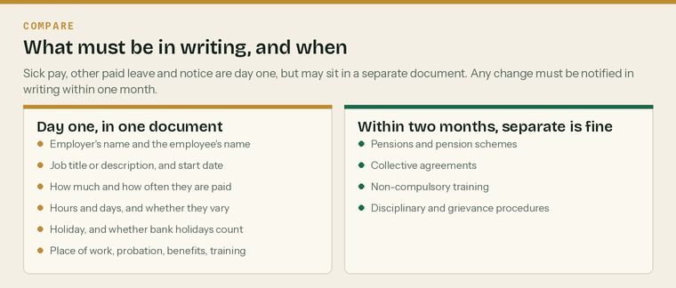
What goes in the day-one document, and what can wait two months.
The principal statement
Complete every line. A blank line is a missing particular and a missing particular is a claim.
1 — The parties
Employer's name | Klyara
Employer's address
Employee's name
Employee's address

2 — The job
Job title
Or a description of the work | if there is no single title
Start date of employment
Date continuous employment began | the same date, unless earlier service counts
Is this a fixed-term job? | yes or no
If fixed term, how long it is expected to last, and the end date

3 — Pay
Rate of pay | £ per year, per hour, or per week
How it is calculated | salary, hourly rate, piece rate
How often it is paid | weekly, fortnightly, four-weekly, monthly
Pay date
Method of payment | bank transfer
Any bonus or commission, and how it works

4 — Hours and days
Normal hours of work | per week
The days of the week required to work
Are the hours or days variable? | yes or no
If variable, how they vary and how they are decided
Overtime — is it required, and how is it paid?

5 — Holiday
Holiday entitlement | days or weeks a year
Does that include bank holidays? | yes or no
Holiday year runs from
How holiday pay is calculated
What happens to accrued holiday on leaving

The statutory minimum is 5.6 weeks a year, which is 28 days for somebody working five days a week. Bank holidays do not have to be given as paid leave, but they can count towards the 5.6 weeks if you say so. Statutory entitlement is capped at 28 days however many days a week somebody works.
6 — Place of work
Place of work
Or, if there is more than one, the places and the employer's address
Will they be required to work outside the UK for more than a month? | yes or no
If so, for how long, in what currency, and what the terms of return are

7 — Probation
Is there a probationary period? | yes or no
How long is it?
What are its conditions? | what is being assessed, and what happens at the end
Notice during probation

8 — Benefits and training
Other benefits | vehicle, tools, phone, lunch, childcare
Training the employee must do | and whether the employer pays for it
Any training the employer requires but does not pay for

9 — Sick pay, other leave and notice
These are day-one particulars, but they may be set out in a separate document referred to here rather than in the principal statement itself.
Sick pay entitlement and the procedure for reporting sickness
Other paid leave — maternity, paternity, adoption, shared parental, bereavement
Notice the employee must give
Notice the employer must give

Statutory minimum notice | The employer must give | The employee must give
One month to two years' service | One week | One week
Two to twelve years' service | One week for each complete year | One week
Twelve years or more | Twelve weeks | One week

These are minimums. A contract can give more, and often should. It cannot give less.
The wider statement — within two months
These can be in the same document or in a separate one, provided they are given within two months of the start of employment.
 | Pensions and pension schemes | Including the auto-enrolment position
 | Any collective agreements that affect the terms | State if there are none
 | Training the employer provides that is not compulsory | Or state there is none
 | Disciplinary rules and procedure | Or where to find them
 | Grievance procedure | Or where to find them
 | Who to appeal to, and how | Name the role, not the person

Other terms worth writing down
Not required by the day-one statement, but standard in a construction back office and much easier to agree at the start than later.
 | Confidentiality |  | Data protection and acceptable use
 | Client confidentiality and AML duties |  | Return of property on leaving
 | Deductions from pay, where lawfully agreed |  | Lay-off and short-time working, if relevant
 | Health and safety responsibilities |  | Company vehicle and driving licence checks

Anything you write here becomes a contractual term
That is the point of it, and it is also the risk. A generous sick pay scheme written into a statement is a contractual entitlement you cannot then withdraw. Decide what you actually mean before you write it, and have a solicitor read the finished statement before the first one is issued.

Signing
The employee does not have to sign a written statement for it to be valid — it is a statement of particulars, not a contract by itself. Getting a signature is still worth doing, because it records that it was given on the first day.
Signatures
The employee | [name]
Signed | Print name
Position | Date
Klyara | [name], for Klyara
Signed | Print name
Position | Date

Date the principal statement was given | must be the first day of employment
Date the wider statement was given | within two months
Given by

Sources
Every figure and deadline in this document was checked against the page listed beside it on Wednesday 26 August 2026. Re-check before each use — thresholds and penalties change.
What was checked | Source
Written statement of particulars — contents, day one, two months, one month for changes | https://www.gov.uk/employment-contracts-and-conditions/written-statement-of-employment-particulars
Employers' liability insurance — £5m, £2,500 a day, £1,000 certificate, exemptions | https://www.gov.uk/employers-liability-insurance
Displaying the certificate | https://www.gov.uk/employers-liability-insurance/certificates-and-records
Registering as an employer before the first payday, and the two-month limit | https://www.gov.uk/register-employer
Auto-enrolment — 22 to State Pension age, £10,000 trigger, duties start date | https://www.gov.uk/workplace-pensions-employers
Contributions — 8% total, 3% employer minimum, £6,240 to £50,270 band | https://www.gov.uk/workplace-pensions/what-you-your-employer-and-the-government-pay
Declaration of compliance within five months of the duties start date | https://www.thepensionsregulator.gov.uk/en/employers/new-employers/im-an-employer-who-has-to-provide-a-pension/declare-your-compliance
Holiday — 5.6 weeks, 28 days cap, bank holidays not automatically included | https://www.gov.uk/holiday-entitlement-rights
Statutory notice periods by length of service | https://www.gov.uk/redundancy-your-rights/notice-periods
Employee's statutory minimum notice of one week after one month | https://www.gov.uk/handing-in-your-notice/giving-notice
Right-to-work checks: three methods, before employment, 2-year retention | https://www.gov.uk/check-job-applicant-right-to-work
Civil penalty up to £60,000 per illegal worker; criminal penalty | https://www.gov.uk/penalties-for-employing-illegal-workers

