KLYARA the back office for building firms

Klyara — Account Setup Pack
Copy-paste-ready. Sign up, paste, upload, next.

*Every field is written to the platform's actual character limit. Counts shown are the limits, and all copy below is inside them.*
Before you start — 5 decisions, made
1. Handle. Use this order, take the first available, then use it *everywhere* for consistency:
klyara → klyarahq → klyara_uk → getklyara → klyaraback (last resort)
Whatever you land on, write it here and use it on every platform, even where a better one is free. Consistency beats perfection: @klyarahq everywhere is worth more than the perfect handle on three platforms and a mess on the rest.
2. Display name. Klyara on personal-style platforms. Klyara — Construction Back Office where the field allows more and search matters (LinkedIn, GBP, YouTube, directories).
3. Email for signups. Do not use hello@klyara.com — that's your public inbox and it will drown. Create social@klyara.com and use it for every platform registration. One inbox, all the password resets and verification codes in one place.
4. Password + 2FA. Every account into Bitwarden (already in the stack), 2FA on every single one. A hijacked social account for a firm that holds clients' financial data is a reputational event you cannot talk your way out of.
5. Who owns the account. Facebook Pages and LinkedIn Company Pages are owned by a *personal* profile, not by the business. Set both founders as admins from day one. Businesses lose their pages when the one admin leaves.
Canonical brand strings — use these verbatim everywhere
Business name: Klyara
Long name: Klyara — Construction Back Office
Tagline: Run the jobs. We run the rest.
Category: Bookkeeping service / Accountant
Website: https://klyara.com
Email (public): hello@klyara.com
Phone: 020 8058 1496
Hours: Mon–Fri 8:00–18:00 (24/7 call answering)
Founded: 2026
Serving: UK construction firms and subcontractors
One-line descriptor (use anywhere you need a single sentence):
Bookkeeping, CIS and Making Tax Digital for UK construction firms — so
Bookkeeping, CIS and Making Tax Digital for UK construction firms — so you can run the jobs.

Standard link set (in priority order — most profiles allow only one):
1. https://klyara.com ← default single link
2. https://klyara.com/making-tax-digital.html
3. https://klyara.com/guide.html ← free MTD guide (lead magnet)
4. https://klyara.com/tools.html ← 12 free calculators
5. https://klyara.com/pricing.html
The line that matters
Consistency beats perfection: @klyarahq everywhere is worth more than the perfect handle on three platforms and a mess on the rest.

In this part
Copy-paste-ready. Sign up, paste, upload, next. · Before you start — 5 decisions, made · Canonical brand strings — use these verbatim everywhere

1. Google Business Profile ★ START HERE — verification takes 5–14 days


Business name: Klyara *(Do not add keywords to the name — Google suspends listings for this and suspension is a fortnight of pain to reverse.)*
Primary category: Bookkeeping service Additional categories: Accountant · Tax preparation service · Payroll service
Service area: Set as a service-area business if home-based. Radius: 15 miles from your target town. Add the 6–8 named towns you actually want to serve.
Description (750 char limit — this is 727):
Klyara is the back office for small construction firms. We handle the bookkeeping, CIS returns, VAT
reverse charge coding, payroll and Making Tax Digital quarterly filing, so builders can get on with
the work.
Making Tax Digital for Income Tax started in April 2026 for sole traders earning over £50,000, and
the threshold drops to £30,000 in April 2027. If you are a subcontractor or a small builder, this
almost certainly affects you.
We are construction specialists, not general accountants. CIS deductions, gross payment status,
domestic reverse charge and retentions are the everyday work here, not the awkward bit at the end.
Fixed monthly pricing from £59. Free discovery call. Free MTD guide and 12 calculators at
klyara.com.
Services to add (each with its own short description in GBP): Bookkeeping · CIS returns · Making Tax Digital filing · VAT returns · Payroll · Self assessment · Management reports · Invoice chasing
Attributes to tick: Online appointments · Onsite services not required · LGBTQ+ friendly (if true) Products: Add the four tiers as Products with prices — Solo £59, Start £99, Trade £199, Pro £329. Photos: logo (klyara-avatar-google-business-512.png), cover (klyara-banner-gbp.png), plus 5+ real photos — Craig, a desk, a laptop showing the portal, a site visit. Real photos beat stock heavily here. Booking link: your Cal.com URL.
**Weekly GBP post is the highest-value 5 minutes in this whole pack.**
The 30-day calendar includes one every week.

The line that matters
Weekly GBP post is the highest-value 5 minutes in this whole pack.

2. LinkedIn — Company Page


Name: Klyara Tagline / slogan (120 char limit — this is 96):
Bookkeeping, CIS and Making Tax Digital for UK construction firms. Run the jobs. We run the rest.
Industry: Accounting Company size: 2-10 employees Company type: Privately Held Website: https://klyara.com Specialities (add all):
Construction bookkeeping, CIS returns, Making Tax Digital, MTD for Income Tax, VAT domestic reverse
charge, Construction payroll, Subcontractor verification, Management accounts, Cash flow reporting,
Invoice chasing, QuickBooks, Xero, FreeAgent
About (2,000 char limit — this is 1,842):
Klyara is the back office for small construction firms.
Bookkeeping, VAT coding, payroll and Making Tax Digital quarterly filing
— handled, monthly, for a fixed fee. You run the jobs. We run the rest.
WHY CONSTRUCTION ONLY
Most accountants have a handful of building clients and treat CIS as the awkward bit at the end of
the month. We do it all day. Gross payment status, 20% and 30% deductions, the domestic reverse
charge, retentions, materials splits, subcontractor verification, monthly returns by the 19th — this
is the everyday work here, not the exception.
MAKING TAX DIGITAL CHANGED THE RULES
Since April 2026, sole traders and landlords with qualifying income over £50,000 must keep digital
records and send HMRC a quarterly update. The threshold falls to £30,000 in April 2027 and £20,000 in
April 2028. Qualifying income is gross — before CIS deductions — so a subcontractor invoicing £55,000
and taking home £44,000 after deductions is already in scope.
Annual shoebox bookkeeping stops working the moment HMRC wants four updates a year. We built Klyara
for that.
WHAT YOU GET
- A named construction bookkeeping specialist, not a call centre
- Receipts snapped on your phone, straight into the books
- CIS returns filed by the 19th, every month
- A monthly P&L you can actually read
- Quarterly MTD updates handled and filed
- A client portal showing where the business stands, in real time
- Fixed monthly pricing from £59 + VAT. No hourly billing, no surprise invoices.
WHO WE WORK WITH
Sole trader subcontractors through to fifteen-person building firms with a PAYE and CIS mix. If you
are VAT-registered, running CIS, and losing evenings to paperwork, that is exactly who this is for.
Free MTD guide, free Digital Launch Kit and 12 free calculators — job margin, CIS, VAT, day rate,
deadlines — at klyara.com.
Book a free discovery call: klyara.com
Assets: Logo → klyara-avatar-linkedin-512.png · Cover → linkedin-company-1128x191.png Also do: create a LinkedIn Showcase Page later for "Klyara MTD" if MTD content outgrows the main page. Not at launch.
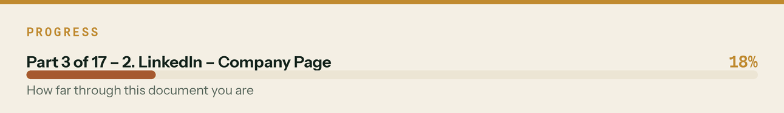

3. LinkedIn — Craig's personal profile *(this one does the actual work)*

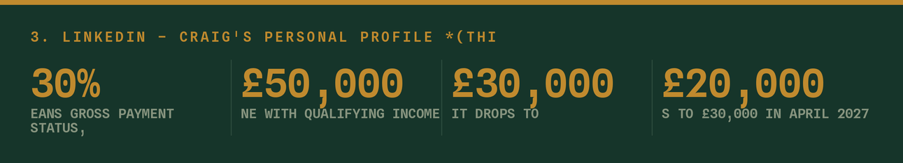
Headline (220 char limit — this is 148):
Construction bookkeeping & CIS specialist | Making Tax Digital for builders and subcontractors |
Founder at Klyara — run the jobs, we run the rest
About (2,600 char limit — this is 1,394):
I do the back office for building firms.
CIS returns, VAT reverse charge, payroll, bookkeeping and now Making Tax Digital quarterly filing.
The paperwork that piles up on the passenger seat and gets dealt with at eleven at night.
Most accountants have a few building clients. I only have building clients. That means gross payment
status, 20/30% deductions, retentions, materials splits and subcontractor verification are the normal
day here — not the bit everyone dreads at month end.
Why now: Making Tax Digital for Income Tax went live in April 2026 for anyone with qualifying income
over £50,000. It drops to £30,000 in April 2027 and £20,000 in April 2028. Qualifying income is
measured gross, before CIS is taken off — which catches a lot of subbies who assume they are under
the line. Once HMRC wants four updates a year instead of one return, the shoebox stops working.
I started Klyara so a builder can snap a receipt on site, forget about it, and get a P&L at the end of
the month that actually makes sense. Fixed monthly fee. No hourly billing.
If you run a building firm, or you are a subbie wondering whether MTD has caught you, message me —
I will tell you straight whether you are in scope. No pitch.
Free MTD guide and 12 calculators at klyara.com.
Profile setup:
- Photo: real headshot of Craig, on site or in hi-vis if possible. Not a logo. Not a suit.
- Banner: linkedin-personal-1584x396.png
- Featured section: pin the MTD guide, the calculators page, and the MTD landing page
- Custom URL: linkedin.com/in/craig-klyara or similar — set it, don't leave the number string
- Skills: Construction Accounting, CIS, Making Tax Digital, VAT, Bookkeeping, QuickBooks, Xero,
Payroll, Cash Flow Management
- Open to: Providing services → Bookkeeping, Tax Preparation, Financial Accounting
- Creator mode: ON. Hashtags: #CIS #MakingTaxDigital #UKConstruction #Bookkeeping #Subcontractors
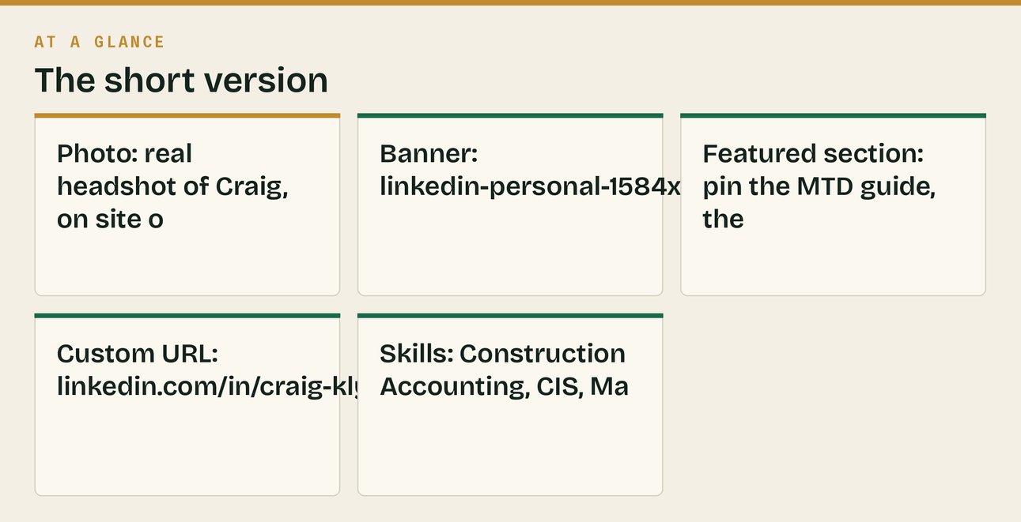

4. Facebook Page


Page name: Klyara Username: @klyara (or your chosen handle) Category: Accountant → secondary Bookkeeping Service, Business Service
Short description (255 char limit — this is 148):
Bookkeeping, CIS returns and Making Tax Digital for UK construction firms. Fixed monthly pricing from
£59 + VAT. Run the jobs — we run the rest.
About / long description:
Klyara is the back office for small construction firms.
We do the bookkeeping, the CIS returns, the VAT reverse charge coding, the payroll and the Making Tax
Digital quarterly updates — for one fixed monthly fee. You get on with the work.
Construction only. CIS deductions, gross payment status, reverse charge and retentions are the
everyday job here, not the awkward bit at the end of the month.
Making Tax Digital for Income Tax started in April 2026 for anyone with qualifying income over
£50,000. It drops to £30,000 in April 2027. Qualifying income is gross — before CIS is taken off — so
it catches more subbies than people expect.
Plans from £59 + VAT a month. Free discovery call, free MTD guide and 12 free calculators at
klyara.com.
📞 020 8058 1496 (Mon–Fri 8–6, 24/7 answering)
✉️ hello@klyara.com
Fields: Website https://klyara.com · Phone 020 8058 1496 · Email hello@klyara.com · Hours Mon–Fri 08:00–18:00 · Price range ££ Button: Book Now → Cal.com link (or Learn More → klyara.com pre-AML) Assets: Profile → klyara-avatar-facebook-400.png · Cover → facebook-cover-1640x856.png Also: install the Meta Pixel on klyara.com now, even with no ad spend planned. It builds the retargeting audience from day one, and an audience you didn't collect is gone forever.
The line that matters
It builds the retargeting audience from day one, and an audience you didn't collect is gone forever.

5. X / Twitter

Display name (50 char limit): Klyara — Construction Back Office Handle: @klyara / your chosen handle
Bio (160 char limit — this is 157):
The back office for small building firms. Bookkeeping, CIS, VAT reverse charge & Making Tax Digital.
Run the jobs — we run the rest. Free MTD guide below ↓
Location: United Kingdom (or your town — better for local discovery) Website: https://klyara.com/guide.html Assets: Avatar → klyara-avatar-x-400.png · Header → x-header-1500x500.png Pinned post: Day 1 launch post from the content calendar.
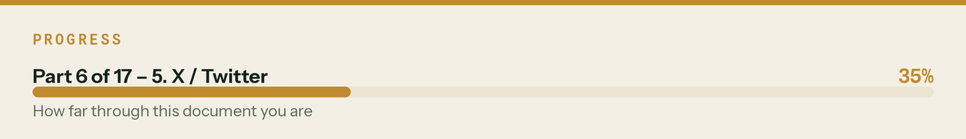

6. Instagram (Professional / Business account)

Username: your chosen handle Name field (30 char — this is 28, and it IS searchable, so use keywords):
Klyara | CIS & MTD for trades
Bio (150 char limit — this is 149):
Bookkeeping, CIS & Making Tax Digital for UK builders 🧱
Fixed monthly fee from £59+VAT
Free MTD guide + 12 calculators ↓
Category: Accountant Contact: email + phone buttons on Link: https://klyara.com/guide.html
Story Highlights to create (covers included in the asset pack): MTD · CIS · Pricing · Free Tools · Reviews · About
Assets: Avatar → klyara-avatar-instagram-400.png Convert to a Professional account — you lose nothing and gain insights, scheduling and the contact buttons.
The line that matters
Assets: Avatar → klyara-avatar-instagram-400.png Convert to a Professional account — you lose nothing and gain insights, scheduling and the contact buttons.

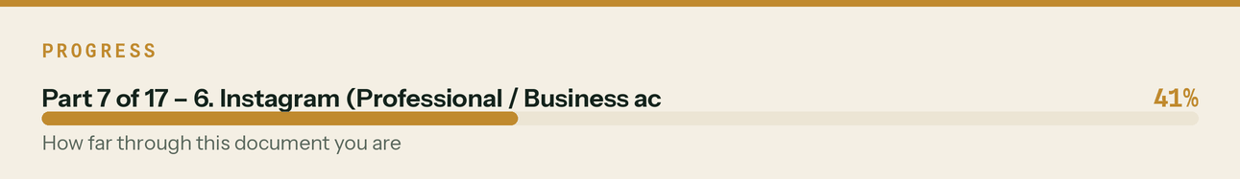

7. TikTok

Username: your chosen handle Name (30 char): Klyara | CIS & tax for trades Bio (80 char limit — this is 79):
CIS, VAT & Making Tax Digital, explained straight. UK builders 🧱 Free guide ↓
Link: https://klyara.com/guide.html *(requires 1,000 followers on some accounts — put it in the bio text until then)* Category: Finance / Education Assets: Avatar → klyara-avatar-tiktok-400.png Switch to a Business account for analytics and the commercial sound library — using a copyrighted trending sound on a business account gets videos muted.
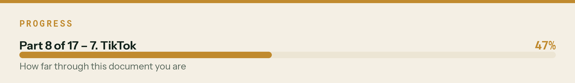

8. YouTube

Channel name: Klyara — Construction Back Office Handle: @klyara / chosen handle
Description (1,000 char limit — this is 693):
Straight answers on CIS, VAT reverse charge, Making Tax Digital and getting paid — for UK builders
and subcontractors.
No jargon, no ten-minute intros. Just the bit you actually needed to know.
Klyara is the back office for small construction firms: bookkeeping, CIS returns, payroll and MTD
quarterly filing for a fixed monthly fee, so you can run the jobs.
New videos weekly.
📘 Free MTD guide: klyara.com/guide.html
🧮 12 free calculators — job margin, CIS, VAT, day rate: klyara.com/tools.html
📞 020 8058 1496
🌐 klyara.com
Nothing on this channel is tax advice for your specific situation. Rules change — always check the
current HMRC position or ask us directly.
Assets: Avatar → klyara-avatar-youtube-512.png · Banner → youtube-channel-2560x1440.png Links (shown on channel): Website · Free MTD Guide · Free Calculators · LinkedIn Playlists to create on day 1: CIS Explained · Making Tax Digital · VAT for Builders · Getting Paid · Klyara Shorts
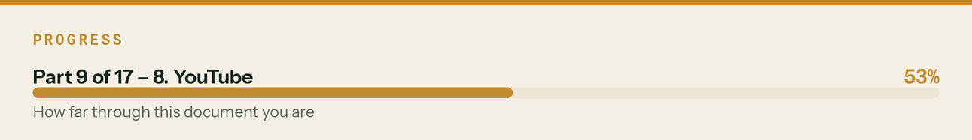

9. Reddit

Two accounts, deliberately:
a) Craig's personal account — the one that does the work. Username: something human, e.g. craig_does_cis or CIS_Craig. Not KlyaraOfficial. Bio (200 char): Construction bookkeeper. CIS, VAT reverse charge, MTD. UK. I answer tax questions for builders because nobody else will do it in plain English. No link for the first 30 days.
b) Brand account — holds the name, posts almost nothing. Username: klyara / chosen handle Display name: Klyara Bio: The back office for small UK construction firms. Bookkeeping, CIS and Making Tax Digital. Banner: reddit-banner-1920x384.png · Avatar: klyara-avatar-reddit-400.png
Follow the Reddit Protocol in the Channel Map. It is not optional advice — it is the difference between a channel and a ban.
The line that matters
Follow the Reddit Protocol in the Channel Map. It is not optional advice — it is the difference between a channel and a ban.

Also worth knowing
Username: klyara / chosen handle Display name: Klyara Bio: The back office for small UK construction firms.

10. Threads

Auto-created from the Instagram account. Bio mirrors Instagram (150 char):
Bookkeeping, CIS & Making Tax Digital for UK builders. Fixed monthly fee. Straight answers, no jargon.
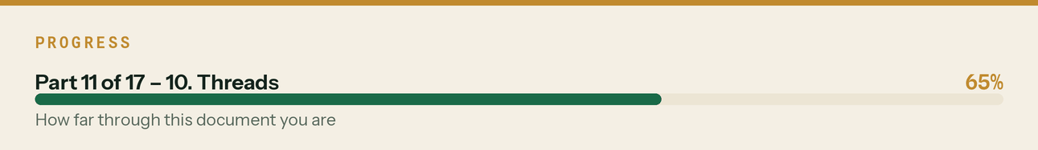

11. Bluesky

Handle: chosen handle · Display name: Klyara Description (256 char — this is 178):
The back office for small UK construction firms. Bookkeeping, CIS returns, VAT reverse charge and
Making Tax Digital — so builders can run the jobs. Free MTD guide at klyara.com
Do this: verify the domain — set your Bluesky handle to @klyara.com via the DNS TXT method. Free, takes 10 minutes, and it's a genuine trust signal.
The line that matters
Do this: verify the domain — set your Bluesky handle to @klyara.com via the DNS TXT method.

Also worth knowing
Free, takes 10 minutes, and it's a genuine trust signal.

12. Pinterest (Business)

Name: Klyara — Construction Back Office About (500 char — this is 268):
Bookkeeping, CIS and Making Tax Digital for UK construction firms. Free calculators, deadline
checklists and plain-English guides for builders and subcontractors. Run the jobs — we run the rest.
klyara.com
Claim the website (meta tag or DNS). Boards: CIS Explained · Making Tax Digital · Builder Cash Flow · Free Calculators · Tax Deadlines UK
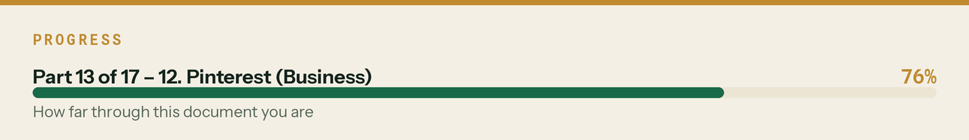

13. Snapchat *(handle protection only — see Channel Map §Tier 5)*

Display name: Klyara · Bio: Bookkeeping, CIS & MTD for UK builders. klyara.com Avatar: klyara-avatar-snapchat-400.png. Claim it, then leave it. No content budget.
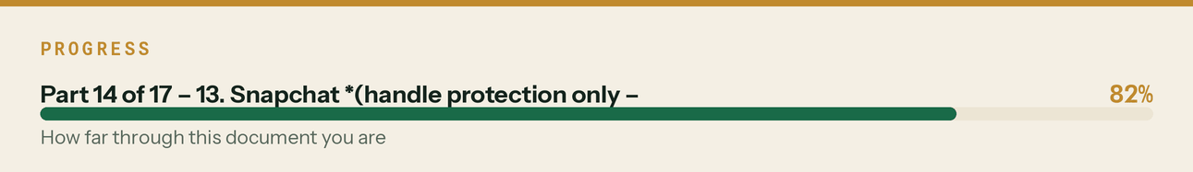

14. Nextdoor Business

Name Klyara · Category Accountant · Description: Bookkeeping, CIS returns and Making Tax Digital for local building firms and subcontractors. Fixed monthly pricing from £59 + VAT. Free discovery call.
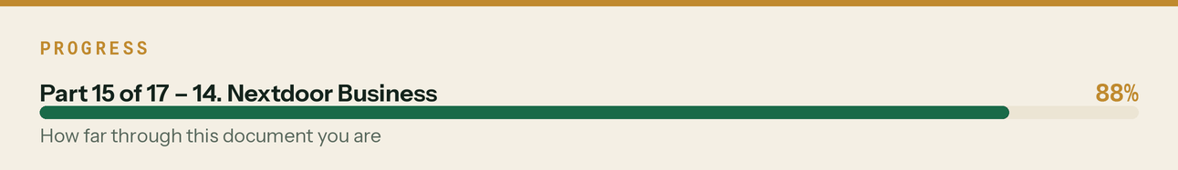

Directory listings — one paste for all of them


Most directories want the same four fields. Use these:
Short (150 char):
Bookkeeping, CIS returns and Making Tax Digital for UK construction firms. Fixed monthly pricing from
£59 + VAT.
Medium (300 char):
Klyara is the back office for small construction firms — bookkeeping, CIS returns, VAT reverse charge
coding, payroll and Making Tax Digital quarterly filing, for one fixed monthly fee. Construction
specialists, not general accountants. Plans from £59 + VAT. Free discovery call.
Long (600 char):
Klyara is the back office for small construction firms. We handle bookkeeping, CIS returns, VAT
domestic reverse charge coding, payroll and Making Tax Digital quarterly filing for one fixed monthly
fee, so builders can get on with the work.
We work with construction only — gross payment status, 20% and 30% CIS deductions, retentions,
materials splits and subcontractor verification are the everyday job here.
Making Tax Digital for Income Tax began in April 2026 at £50,000 qualifying income and drops to
£30,000 in April 2027. Plans from £59 + VAT. Free MTD guide and 12 calculators at klyara.com.
Keywords for directory tag fields:
bookkeeper for builders, construction bookkeeping, CIS returns, CIS accountant, subcontractor
accountant, Making Tax Digital, MTD for income tax, VAT reverse charge, construction payroll,
builders accountant, small business bookkeeping, [your town] bookkeeper
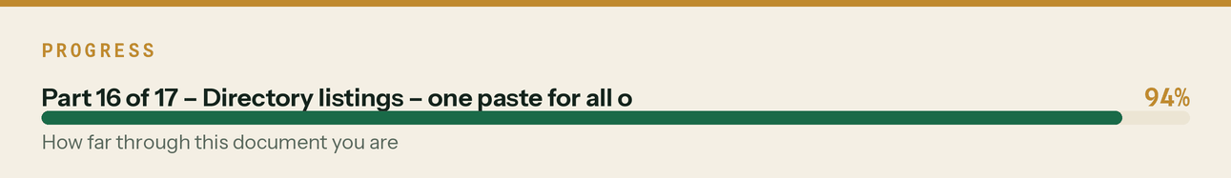

Setup order and time budget

# | Task | Time | Blocking?
1 | Create social@klyara.com, add to Bitwarden | 10 min | Blocks everything
2 | Google Business Profile + request verification | 30 min | 5–14 day wait — do first
3 | LinkedIn Company Page | 20 min
4 | Craig's LinkedIn rebuild | 30 min | Needs headshot
5 | Facebook Page + Meta Pixel on site | 25 min
6 | Instagram (Professional) → auto-create Threads | 20 min
7 | X | 10 min
8 | YouTube + playlists | 20 min
9 | TikTok (Business) | 10 min
10 | Reddit ×2 | 15 min | Then *wait* — read only
11 | Bluesky (+ domain verify), Pinterest, Snapchat, Nextdoor | 30 min
12 | Trustpilot, Yell, FreeIndex, Bing Places, Apple Business Connect | 45 min
13 | Cylex, Scoot, Thomson Local, Hotfrog, 192.com | 30 min
14 | Forum registrations (Screwfix, UKBF, BookaBuilder, ContractorsTalk, plumbers, electricians) | 40 min | Profiles only — no signature yet
15 | Facebook groups — request to join 12–15 | 30 min | Approval can take days
 | Total | ≈ 6 hours | Split over two sittings

Do steps 1–2 today. GBP verification is the long pole and everything local-SEO depends on it.
The line that matters
GBP verification is the long pole and everything local-SEO depends on it.

