KLYARA the back office for building firms

23 — Outreach and partners
The first fifty conversations. Scripts you can read off the screen.

### Read this before using anything below
Klyara cannot trade as a bookkeeper by way of business until AML supervision is in place (docs/01, docs/06 §5). Everything in this document that offers, prices or sells the service is written for the day supervision lands. Before then, run the education-first and waitlist variants in docs/03 — the content, the guides and the free tools are all fine to publish now; the "we do your books for £X a month" half is not. Ask a client for a review only after you have lawfully done work for them. Delete this box on the day the licence arrives, and not before.

Why this document exists
Content and SEO work. They work in month four. The 90-day plan (docs/16) needs clients in month one, and the only thing that produces clients in month one is talking to people.
This is the outbound half of the business, written out in full. Nothing in here is a strategy; it is all sentences you can send today. Where a script has a bracket, fill the bracket. Where it does not, do not improve it — every one of these is written short on purpose, because short gets read.
One rule before anything else. Outbound in this trade works because you are useful before you are commercial. Every sequence below leads with something the recipient can use whether or not they ever speak to you. That is not a tactic, it is the reason it works — the guides and the three free tools on the site exist so that outbound has something to give away.
The line that matters
That is not a tactic, it is the reason it works — the guides and the three free tools on the site exist so that outbound has something to give away.

In this part
The first fifty conversations. Scripts you can read off the screen. · Why this document exists

PART 1 — Who to talk to, in priority order

Rank | Who | Why them | How many are reachable in 90 days
1 | Sole-trader subbies you already know | Warm, quick, cheap to serve, gives you reviews fast | 10–30
2 | Small contractors paying 2–8 subbies | The Trade tier. Where the money is. | 40–80
3 | General accountants without a construction desk | Referrals, repeatable, no fee competition | 15–25 firms
4 | Builders merchants and tool hire counters | Physical footfall of exactly your client | 8–12 branches
5 | Quantity surveyors and small architects | Adjacent professionals, same client, no overlap | 10–15
6 | Local Facebook trade groups | Free, high volume, low conversion, high visibility | 6–10 groups
7 | Bookkeepers who do not do CIS | Overflow work, and they exist in numbers | 10–20

Work the list top down. Rank 1 and 2 produce clients. Ranks 3–5 produce a pipeline that still delivers in month nine, which is why they cannot wait until month nine to start.
The line that matters
Ranks 3–5 produce a pipeline that still delivers in month nine, which is why they cannot wait until month nine to start.

PART 2 — LinkedIn

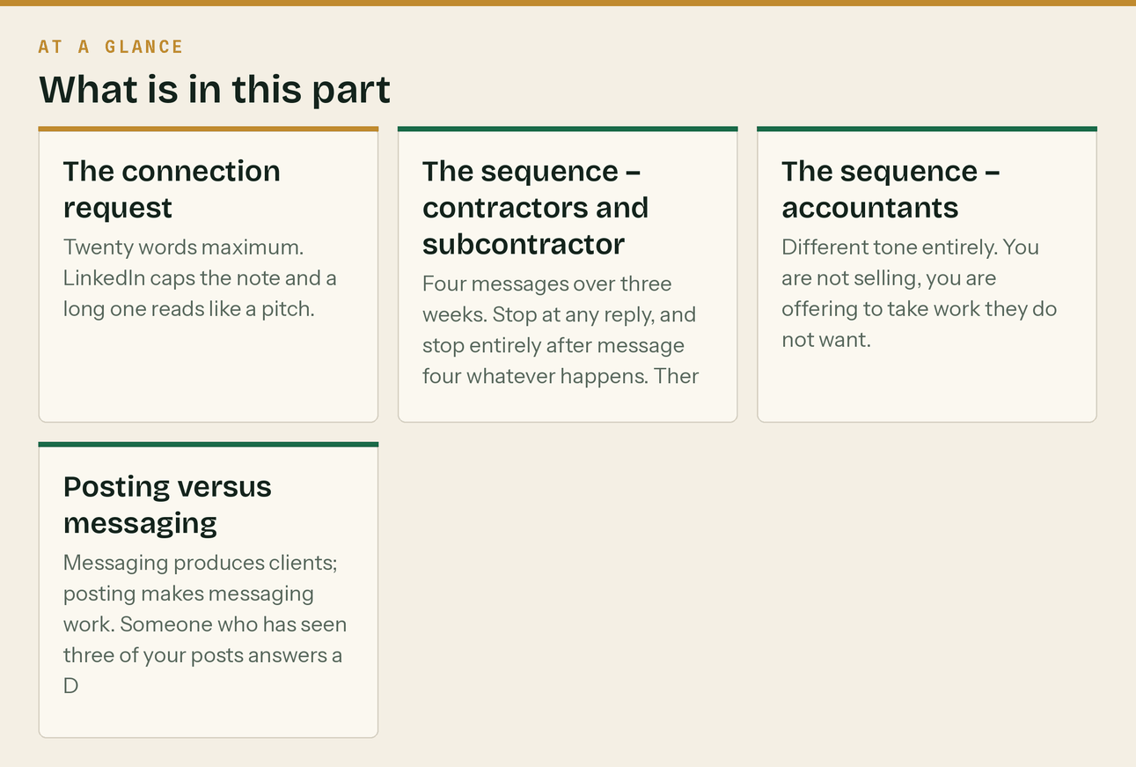
The connection request
Twenty words maximum. LinkedIn caps the note and a long one reads like a pitch.
To a contractor or subcontractor
Hi [Name] — Guildford based, I do the back office for construction fir
local trades.

To an accountant
Hi [Name] — I run a construction-only bookkeeping practice in Guildfor
all day. Worth connecting.

To a QS or architect
Hi [Name] — Guildford, construction bookkeeping. We see the same firms
Happy to connect.

Never send a connection request with a pitch in it. The note buys the connection; the connection buys the right to send a message later.
The sequence — contractors and subcontractors
Four messages over three weeks. Stop at any reply, and stop entirely after message four whatever happens. There is no message five.
Day 0 — accepted, no pitch
Thanks for connecting, [Name]. No pitch — I just like knowing who's do
What sort of work are you mostly on at the moment?

Day 4 — give something
[Name], this might be useful either way. We put a CIS calculator on ou
and materials in and it shows what should actually land in your bank, and flags the 20/30% thing if it applies. Free, no sign-up: klyara.com/tools.html Most people find out they're on 30% when they see the money, which is about two months too late.

Day 11 — the specific question
Quick one, [Name] — do you file monthly CIS returns yourself, or does
Asking because we're seeing a lot of firms where the accountant does the year end and nobody really owns the monthly, so the 19th is a scramble. If that's not you, ignore me.

Day 20 — the close, and the exit
Last one from me, [Name]. If the monthly CIS and VAT side is ever more
we do it as a fixed monthly fee — construction only, nothing else. For a firm your size that is £199 a month plus VAT, with the CIS returns and the software in it. Free twenty-minute call, no pitch, and if you're fine as you are I'll say so. If it's not relevant, no problem at all — I'll leave you be. Good luck with the [job/season].

That last line matters more than the rest. A clean exit is why people come back four months later, and about one in six of them do.
The sequence — accountants
Different tone entirely. You are not selling, you are offering to take work they do not want.
Day 0
Thanks for connecting, [Name]. I run a construction-only bookkeeping p
CIS, reverse charge, retentions, the monthly grind. We work alongside accountants rather than competing; year end stays with you.

Day 6
[Name] — genuine question rather than a pitch. How many construction c
books, and is the monthly CIS side something you actively want or something you inherited? The reason I ask: most general practices I speak to have four or five builders, and the CIS returns are twenty per cent of the hassle for two per cent of the fee.

Day 15 — the offer, made concrete
[Name], here's the shape of it if it's ever useful.
We take the monthly bookkeeping, CIS returns and VAT for your construction clients. You keep the year end, the CT600 and the relationship — we never sell them anything you do, and it's in writing. You get a clean set of books in April instead of a shoebox, and they get someone who knows what a reverse charge is. Ten per cent of the monthly fee back to you for anyone you send, for as long as they stay. Worth twenty minutes? Coffee in Guildford or a call, whichever.

Day 30 — the useful exit
[Name] — I'll stop chasing. One thing that might be worth having regar
reverse charge end user rules and the gross payment status tests properly, because nobody else seems to have. klyara.com/vat-reverse-charge-end-user-declaration.html Send it to whichever client keeps asking. Door's open if the outsourcing idea ever comes round.

Posting versus messaging
Messaging produces clients; posting makes messaging work. Someone who has seen three of your posts answers a DM at roughly three times the rate of a cold one. The content calendar (docs/03) covers what to post. The rule for outbound is simply: do not start a LinkedIn sequence in a week where you have posted nothing.

PART 3 — Cold email

Cold email to businesses is lawful in the UK under PECR when it is business-to-business and the recipient can opt out easily — but be careful: a sole trader and an unincorporated partnership count as individual subscribers, so consent rules bite. In practice that means:
- Limited companies and LLPs: legitimate interest, fine, include an opt-out.
- Sole traders: do not cold email. Use LinkedIn, phone, or in person.
- Every email carries a real postal address and a one-line unsubscribe.
- Keep a suppression list and honour it forever.
Ten to fifteen emails a session, on the two email days in PART 7 — twenty a week, not a hundred. Sent one at a time from your normal mailbox. Not a platform, not a merge field that can misfire, and never a BCC list.
Sequence A — contractors, three emails
Email 1 · Subject: the 19th
[Name],
Are your CIS returns something you think about on the 18th? I ask because we file ours on the 12th, every month, for around [x] construction firms in Surrey, and the difference between the 12th and the 18th is the whole quality of the month. We're Klyara — bookkeeping and CIS for construction firms only. Fixed monthly fee. Based in Guildford. Not asking for anything. If it's ever a headache, the number's below. [Name] · Klyara · 020 8058 1496 · klyara.com [postal address] · Reply "no thanks" and I won't email again.

Email 2 · four days later · Subject: materials
[Name] — one thing worth checking whether or not you ever call us.
CIS comes off labour. It does not come off materials, plant hire or consumables. If your subcontractors' invoices don't show the split, the deduction usually goes on the whole thing, and that's their money and your paperwork. We wrote it up properly here: klyara.com/cis-materials-deduction.html Takes three minutes to read and it's the single most common thing we fix. [signature + opt-out]

Email 3 · nine days later · Subject: last one
[Name] — I'll leave it there.
If the monthly side ever gets away from you — CIS, VAT, the reverse charge, chasing statements — we do it as a fixed fee and we only do construction. For a firm paying subcontractors that is £199 a month plus VAT, returns and software included; for a sole trader it starts at £59. Twenty-minute call, no pitch, and if you're fine as you are I'll tell you. Otherwise good luck with the year. I won't email again. [signature + opt-out]

Sequence B — accountants, two emails
Email 1 · Subject: your construction clients
[Name],
How many builders are on your books, and is the monthly CIS side something you want? We're a construction-only bookkeeping practice in Guildford. We take the monthly work — bookkeeping, CIS returns, VAT with the reverse charge applied properly — and the year end stays entirely with you. In writing: we don't offer year-end accounts to a client you introduce. Ten per cent of the monthly fee, ongoing, for anyone you send our way. Worth a coffee? [signature + opt-out]

Email 2 · seven days later · Subject: re: your construction clients
[Name] — following up once, then I'll stop.
The specific problem we solve for practices: a builder arrives in April with twelve months of CIS that was never reconciled to the statements, and somebody junior spends two days on it for a fee that was quoted for half a day. If that happens to you more than twice a year, the arrangement pays for itself. Either way — here's the gross payment status write-up, which is the thing your construction clients ask about most: klyara.com/cis-gross-payment-status.html [signature + opt-out]

PART 4 — The phone

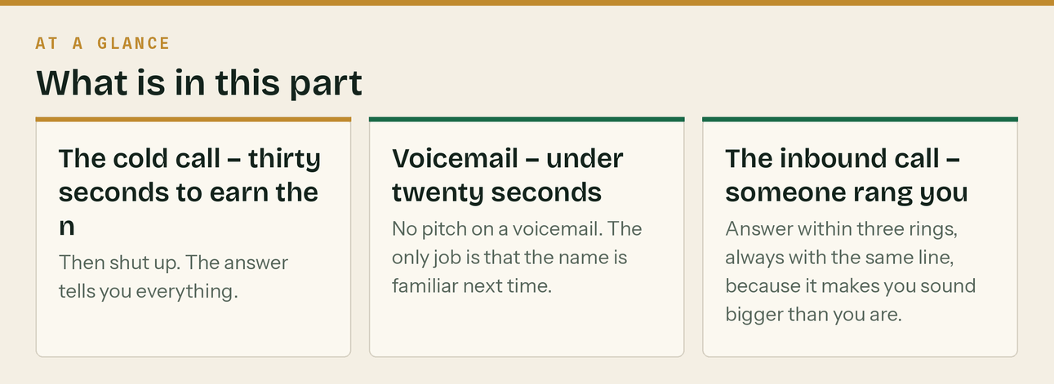
The phone converts better than everything else on this page combined and almost nobody does it. Ten calls a block, on the two call mornings in PART 7 — twenty a week. Between 7:30 and 8:30am, or 4:30 and 6pm. Builders answer early and late; they do not answer at 11am because they are on a roof.
The cold call — thirty seconds to earn the next ninety
"Morning — is that [Name]? [Name] here from Klyara, we're a bookkeepin
Have I caught you at a bad time?" *(If bad: "No problem — better time later in the week?" and get one. Then go.)* "It'll take thirty seconds. We do the books and the CIS for construction firms — that's all we do, no other trades. I'm ringing round local firms because I'd rather know who's who than post on LinkedIn about it. Can I ask you one thing? Who does your monthly CIS returns at the moment?"

Then shut up. The answer tells you everything.
They say | You say
"My accountant" | "Fair enough — and do they chase the statements and check the materials split, or just file it?"
"I do them myself" | "Most people do. How long does the 19th take you, honestly?"
"My wife does them" | "That's the most common answer I get. Does she want to?"
"We don't have subbies" | "Then you don't need me for CIS. Are you VAT registered? The reverse charge is the other one that catches people."
"Not interested" | "No problem at all. Can I send you one link? It's a CIS calculator, it's free, no sign-up. Then I'll leave you alone."

The ask, if it is going well
"Look — I'm not going to sell you anything on the phone. Twenty minute
come to you, and I'll tell you what your setup actually needs. If that's nothing, I'll say so and that's a genuinely useful twenty minutes for you. Any good?"

Voicemail — under twenty seconds
"[Name], it's [Name] at Klyara in Guildford — we do bookkeeping and CI
Ringing round local trades, nothing urgent. 020 8058 1496 if you want it, otherwise I'll try you another time. Cheers."

No pitch on a voicemail. The only job is that the name is familiar next time.
The inbound call — someone rang you
Answer within three rings, always with the same line, because it makes you sound bigger than you are.
"Klyara, [Name] speaking."
"Klyara, [Name] speaking."

Then, in order:
- Get the name and the number first. "Before we get into it — can I take a number in case we get cut off?" Do this in the first thirty seconds. Calls drop, and an anonymous lost enquiry is the most expensive thing that happens all week.
- Ask what prompted the call. Not "how can I help" — "what's made you pick up the phone today?" The answer is the whole diagnosis.
- Do not quote a price in the first four minutes. docs/09 has the full script.
- Book the call before you hang up. "I'll send you a link now while we're on the phone."
- Send the follow-up within one hour. Non-negotiable — the data says most enquiries go to whoever replies first, and the gap between five minutes and an hour is enormous.
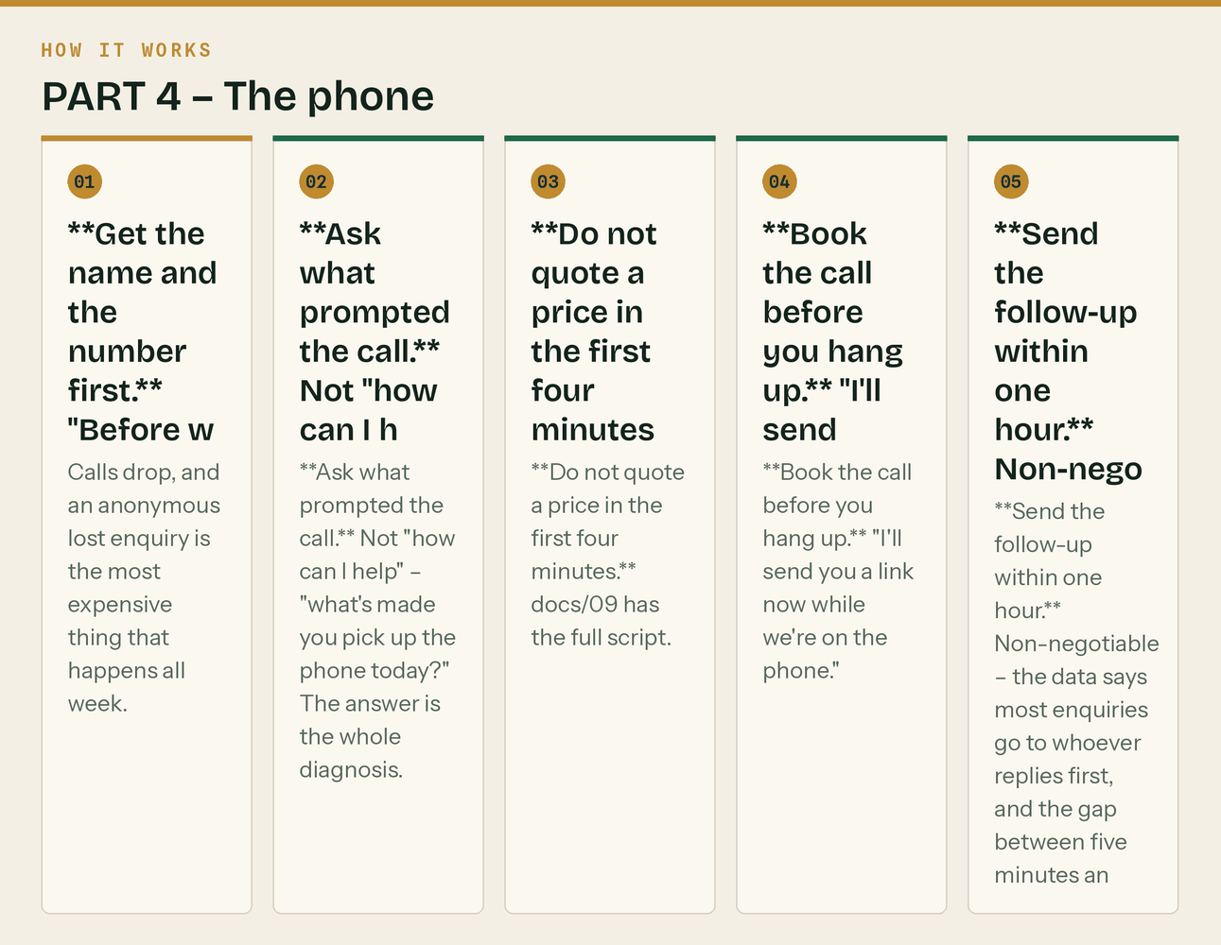
The same steps, in order.

PART 5 — The partner programme


The offer, in one paragraph
You send us a construction client. We do their monthly bookkeeping, CI
year end and the relationship. We pay you 10% of their monthly fee, every month, for as long as they stay with us — not a one-off finder's fee. And we will not offer them any service you already provide, which is a term of our agreement, not a promise.

Why 10% ongoing rather than a lump sum
A one-off payment gets you one referral. A revenue share gets you a partner who thinks about you in October. On a Trade client at £199, 10% is £19.90 a month — £239 a year, every year. For an accountant with four builders on the books, sending all four is roughly £950 a year for work they did not want, plus books they can actually close.
The maths on your side: you give up 10% of the fee to acquire a client at zero cost, with a warm introduction, and a retention rate materially higher than cold acquisition. It is the cheapest client you will ever get.
Who to sign up, and what to say
General accountants — the primary target
Fifteen to twenty-five firms within twenty miles. The pitch is in PART 2 and PART 3. Get to a coffee, and bring a one-pager (assets/sales/Klyara-For-Accountants-Partnership.pdf).
The objection you will get, and the answer
"How do I know you won't take the year end off me?"
"Because it's in the agreement, in writing, and because I don't want it. I don't do CT600s, I'm not set up for them, and the day I start doing them is the day this whole arrangement stops working for me. My business model is thirty monthly fees, not four annual ones."

Builders merchants and tool hire
Travis Perkins, Jewson, Selco, Howdens, local independents, and the tool hire counters. The trade counter at 7am is standing in front of your entire client list.
The offer to them: a stack of A5 cards by the till, and a note on their trade account welcome pack. In return, offer something real — a free CIS health check for their account customers, or fifteen minutes at whatever trade morning they run.
What to say to the branch manager
"I'm not selling you anything. I do the books for building firms — CIS
your trade account customers get the CIS bit wrong and it costs them money. Can I leave a few cards, and would a free session for your account holders be any use to you? You'd be giving your customers something, and I'd be meeting some builders."

Track which branch each enquiry came from — different phone number or a different card per branch — or you will never know which one works.
Quantity surveyors and small architects
Ten to fifteen locally. Same client, zero overlap, and they hear about cash flow problems before anybody else does. No revenue share needed here as a rule — a reciprocal referral relationship works better, because you will meet firms who need a QS long before they need an architect.
Bookkeepers who do not do CIS
There are more of these than you would think, and they are the least competitive partner of the lot. A general bookkeeper with one building client is usually looking for a way to hand it over without losing face.
"If you've got a construction client that's more trouble than it's wor
you 10% of the fee for as long as they're with me. You keep everything else they might send you."

The partner terms — put these in writing
- 10% of the net monthly fee, paid monthly, for the life of the client relationship.
- Paid by bank transfer on the 15th, against a self-billing statement we send you.
- Klyara will not offer year-end accounts, CT600, or personal tax to an introduced client where the partner provides those services.
- Either side can end the arrangement with thirty days' notice; commission on existing introduced clients continues while those clients remain.
- The client is told there is a referral arrangement. Always. It is a professional conduct requirement and it costs nothing.
- No commission on a client who was already in conversation with Klyara — checked against the CRM at the point of introduction, in good faith, and the benefit of any doubt goes to the partner.
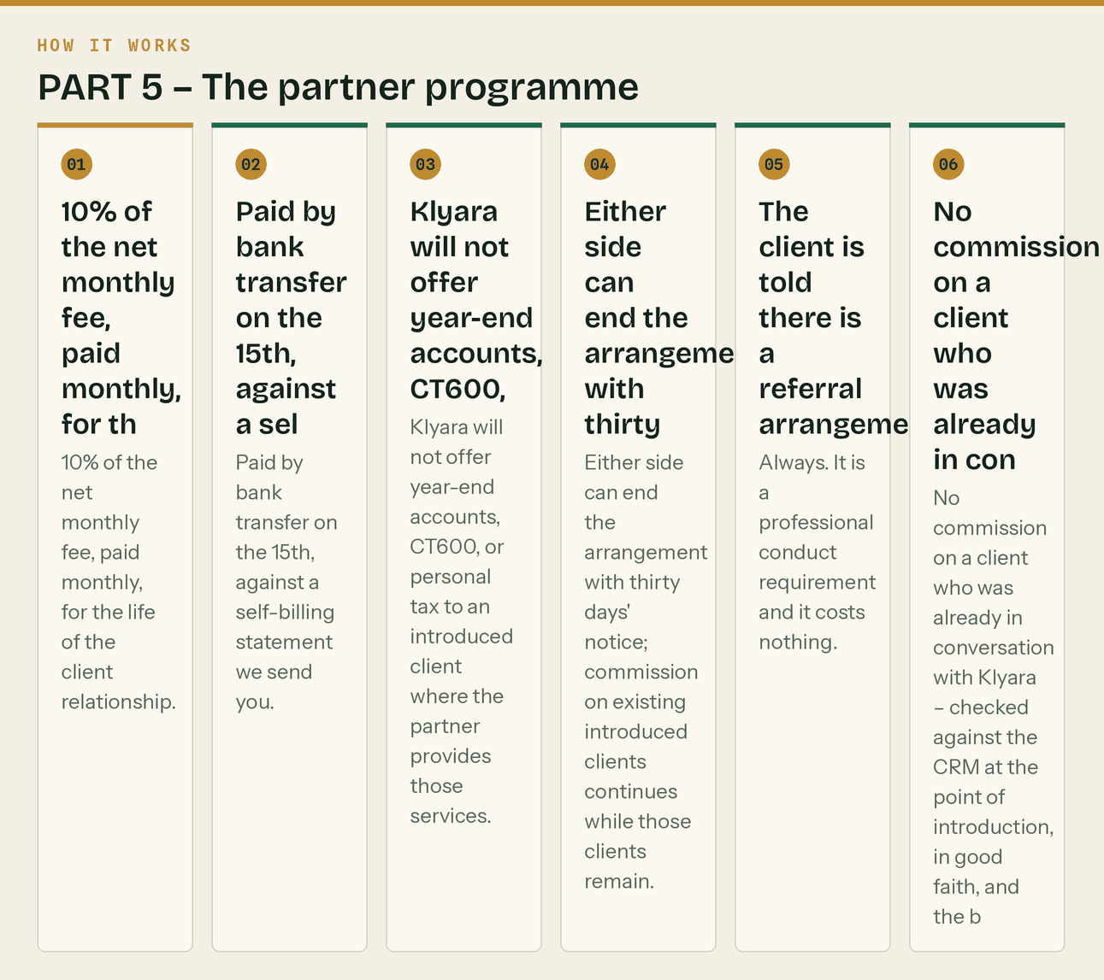
The same steps, in order.
The partner tracker
Add a tab to the KPI workbook, or a simple sheet:
Partner | Type | First contact | Status | Introductions | Live clients | Monthly commission | Last contact

Rule: no partner goes more than eight weeks without contact. A dormant partner is worth nothing, and the reactivation email is two lines.
"[Name] — nothing needed, just keeping in touch. We've taken on [x] co
spoke, and the [reverse charge / MTD] thing is coming up fast for anyone with builders on the books. Shout if any of yours get stuck."

PART 6 — Facebook groups and forums

Six to ten local and trade groups. Guildford and Surrey community groups, Surrey trades groups, UK-wide builder and subcontractor groups.
The rules, in order of how badly people get them wrong
- Read the group rules before posting anything. Most ban promotion outright. That is fine — the value is in answering questions, not posting.
- Never post an advert. Ever. One promotional post gets you removed and you cannot get back in.
- Answer CIS and VAT questions properly and completely, with no call to action. Your profile says who you are. That is the advert.
- Never give specific tax advice to a named person's specific situation in public. General principle, then "worth checking with whoever does your books — happy to point you at the guidance either way."
- If someone asks for a recommendation, let someone else name you. If nobody does, comment once, plainly: "We do this — Klyara, Guildford, construction only. Happy to answer it here for free either way."
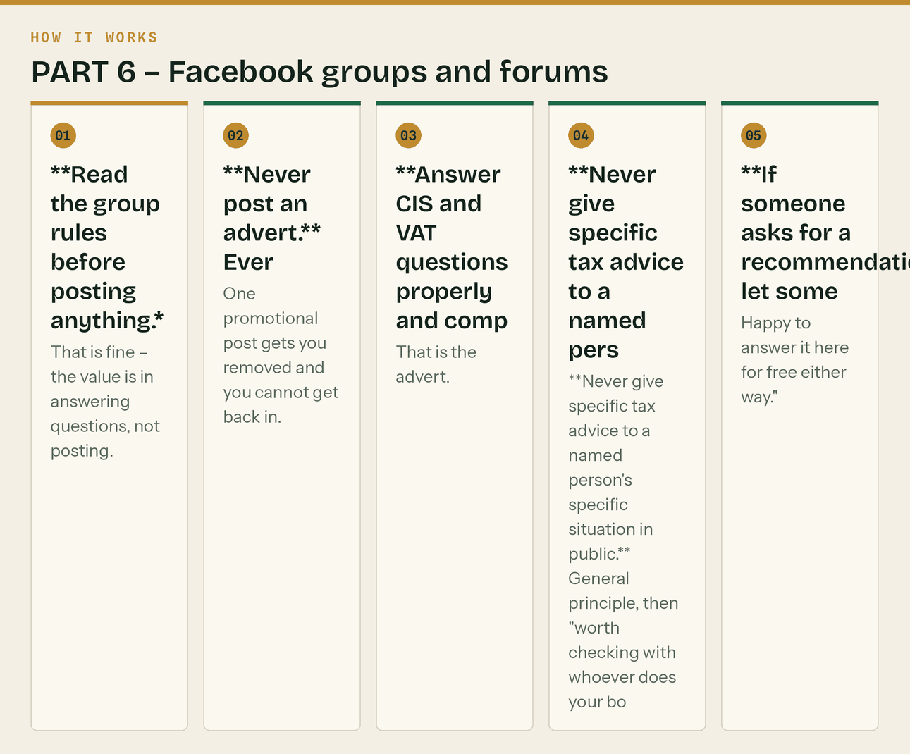
The same steps, in order.
Time budget: twenty minutes a day, four days a week. It is genuinely one of the highest-yield twenty minutes available in month one, and it is worth nothing at all in month one if you have not been doing it since week one.
The line that matters
It is genuinely one of the highest-yield twenty minutes available in month one, and it is worth nothing at all in month one if you have not been doing it since week one.

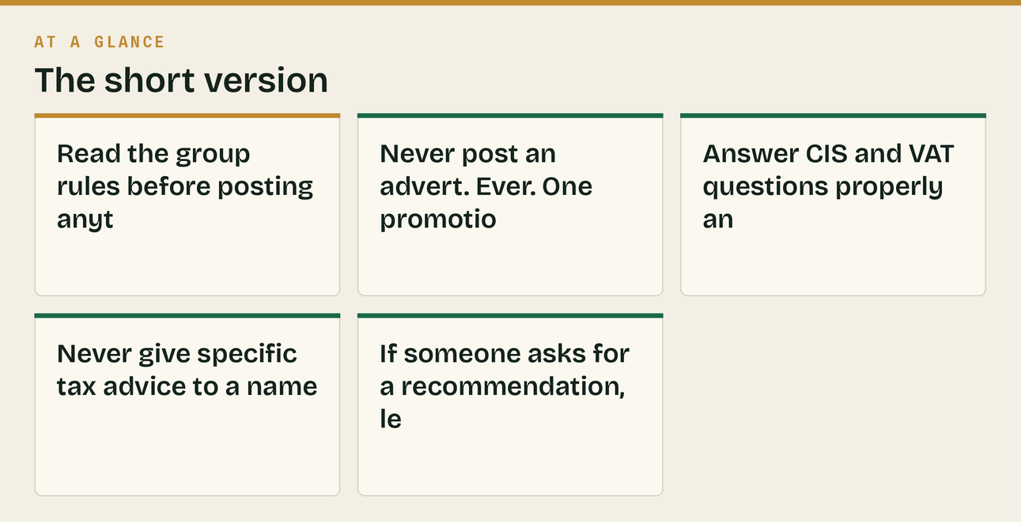

PART 7 — The weekly outbound rhythm

Book it in the diary as a recurring block or it will not happen.
Day | Block | What
Mon | 07:30–08:30 | 10 cold calls
Mon | 16:30–17:00 | LinkedIn: 15 connection requests, work the sequence
Tue | 07:30–08:00 | 10 cold emails (limited companies only)
Tue | 20 min | Facebook groups
Wed | 07:30–08:30 | 10 cold calls
Wed | 16:00–17:00 | One partner meeting or coffee
Thu | 07:30–08:00 | 10 cold emails, follow-ups
Thu | 20 min | Facebook groups
Fri | 07:30–08:30 | Follow up everyone who half-answered this week
Fri | 16:00–16:30 | Update the tracker. Count the numbers below.

The weekly numbers
Metric | Weekly target
Cold calls made | 20
Conversations of over a minute | 6
Cold emails sent | 20
LinkedIn connections sent | 15
LinkedIn conversations started | 4
Partner meetings | 1
Discovery calls booked | 2
Group answers posted | 8

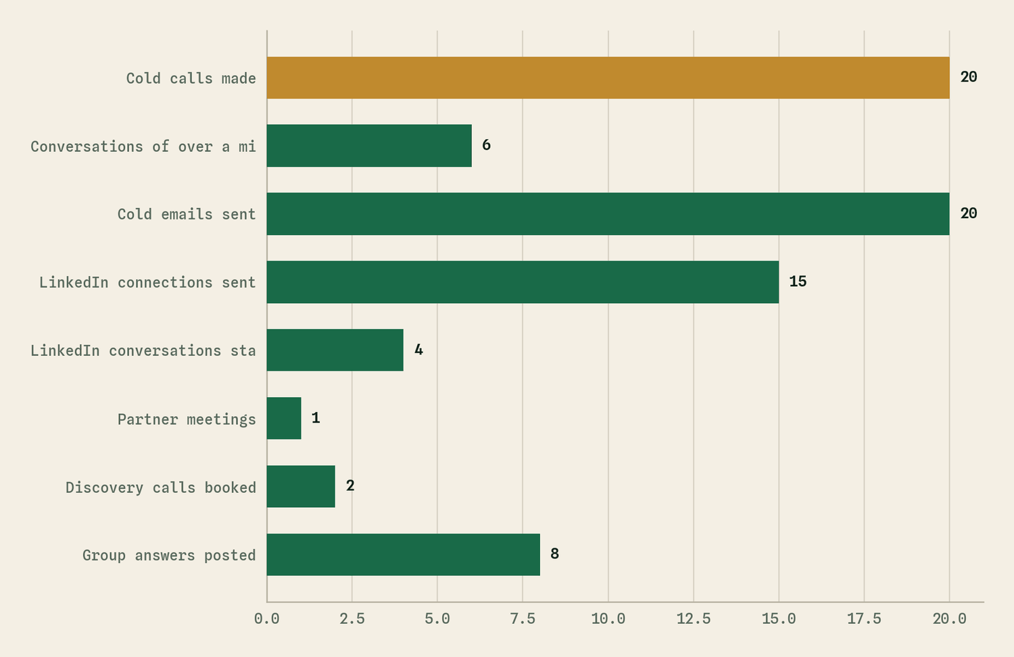
The same table as a picture. Cold calls made is the largest at 20.
Two discovery calls a week is roughly one new client a fortnight at a normal close rate, which is 26 clients a year from outbound alone — comfortably past the point where the content starts carrying it. It is not a big number. It just has to happen every week, including the bad ones.
Related
- docs/09 — what happens once they agree to the call
- docs/21 — what you quote them, and what is in scope
- docs/22 — who else they are ringing, and what those firms charge
- docs/16 — where these blocks sit in the day-by-day plan
- docs/11 — the Guildford-specific version of ranks 4 and 6
- assets/sales/Klyara-For-Accountants-Partnership.pdf — leave-behind for PART 5
- assets/sales/Klyara-Discovery-Call-Card.pdf — beside you on every call in PART 4
The line that matters
Two discovery calls a week is roughly one new client a fortnight at a normal close rate, which is 26 clients a year from outbound alone — comfortably past the point where the content starts carrying it.

In this part
The weekly numbers · Related

