KLYARA the back office for building firms

24 — Content calendar, month 2
Days 31–60, Wednesday 7 October to Thursday 5 November 2026. Full copy, not themes.

### Read this before using anything below
Klyara cannot trade as a bookkeeper by way of business until AML supervision is in place (docs/01, docs/06 §5). Everything in this document that offers, prices or sells the service is written for the day supervision lands. Before then, run the education-first and waitlist variants in docs/03 — the content, the guides and the free tools are all fine to publish now; the "we do your books for £X a month" half is not. Ask a client for a review only after you have lawfully done work for them. Delete this box on the day the licence arrives, and not before.

How this follows on
docs/03 covers days 1–30 and then hands over to a table of themes. This document turns that table into the same thing days 1–30 got: written posts you can copy out.
The rhythm is unchanged. Monday anchor · Tuesday short video · Wednesday carousel · Thursday long video · Friday practical · Saturday human or off · Sunday week ahead.
Two hard dates land inside these thirty days:
- Monday 19 October — CIS return for the tax month to 5 October. It falls on a Monday, which
means the practical realistic deadline for getting information in is Friday 16 October.
- Saturday 7 November — the MTD for Income Tax quarterly update for the quarter to 5 October.
Because it is a Saturday, work to Friday 6 November. This is the first MTD deadline that a meaningful number of your audience has ever had to meet, and it is the biggest content peg in the whole of month two. Days 50–60 are built around it.
What changed since docs/03 was written. There is now a /tools.html page with four working calculators and a /pricing.html page with the actual numbers on it. Both are unusual in this market and both are linked repeatedly below — pushing people to a tool converts better than pushing them to a call, and the tool page is the thing that makes the call happen a week later.
The line that matters
Both are unusual in this market and both are linked repeatedly below — pushing people to a tool converts better than pushing them to a call, and the tool page is the thing that makes the call happen a week later.

In this part
Days 31–60, Wednesday 7 October to Thursday 5 November 2026. Full copy, not themes. · How this follows on

WEEK 5 — "Gross payment status: the three tests"


Wed 7 – Sun 11 October
*The single highest-value thing you can tell a subcontractor. docs/15 puts the cash-flow value at around £24,000 a year for a firm turning over £120,000, and most of them have never applied.*
DAY 31 — Wednesday 14 October · ANCHOR
🔷 LinkedIn + Facebook
There is a form that stops HMRC taking 20% of every payment you receive.
Most subcontractors who qualify for it have never applied.
It is called gross payment status. If you have it, contractors pay you in full and you settle your
tax through your own return, in your own time. If you do not, 20% of your labour goes to HMRC before
it ever reaches your bank, and you wait until the year end to get the excess back.
On £120,000 of labour that is £24,000 sitting with HMRC instead of in your account.
There are three tests and you have to pass all of them.
THE BUSINESS TEST
You are in construction, in the UK, and your business runs through a bank account.
Nearly everyone passes this one.
THE TURNOVER TEST
£30,000 of construction turnover in the last twelve months, excluding VAT and excluding materials.
Labour only. For a partnership it is £30,000 each or £100,000 for the whole firm; for a company it
is £30,000 per director or £100,000 for the company. If you are a full-time subbie in Surrey you
almost certainly pass this without thinking about it.
THE COMPLIANCE TEST
This is the one that fails people. Over the last twelve months: every return filed on time, every
payment made on time, everything HMRC asked for provided. There is limited tolerance built in, but
it is limited, and a pattern of late CIS returns will end it.
Here is the part nobody says out loud: the compliance test is the reason to get your monthly filing
in order NOW, even if you are not applying yet. It looks backwards twelve months. Whatever you do
today does not count until next October.
If you think you might qualify, the application is free and it takes about twenty minutes.
Full write-up, no email required: klyara.com/cis-gross-payment-status.html
#CIS #Construction #Subcontractor #UKConstruction
🔷 X thread
1/ There's a form that stops HMRC taking 20% of every payment you receive.
Most subcontractors who qualify have never applied for it.
2/ It's gross payment status. Contractors pay you in full. You settle the tax through your own
return, in your own time.
3/ On £120,000 of labour, that's £24,000 that sits in your account instead of HMRC's until January.
4/ Three tests. You need all three.
5/ Business test: construction, UK, run through a bank account. Almost everyone passes.
6/ Turnover test: £30,000 of construction turnover in 12 months. Excluding VAT. Excluding materials.
Labour only.
7/ Compliance test: 12 months of returns filed on time and payments made on time. This is the one
that fails people.
8/ The compliance test looks BACKWARDS twelve months. Getting your filing right today doesn't help
you until next October.
9/ Which is the actual reason to sort it now.
10/ Free write-up, no email: klyara.com/cis-gross-payment-status.html
🔷 GBP post
Gross payment status: three tests, and roughly £24,000 of cash flow for a subcontractor turning over
£120,000 of labour.
Most subcontractors who qualify have never applied. The application is free.
Full guide at klyara.com/cis-gross-payment-status.html — no email required.
Klyara: bookkeeping and CIS for construction firms in Guildford and across Surrey.
🔷 Instagram
Asset: assets/carousel/gross-status-6slides/
20% of every payment, gone before it reaches you.
There is a form that stops it. Three tests, free to apply, and most subbies who qualify have never
done it.
Swipe for all three tests →
Full guide in bio. No email required.
#CIS #construction #subcontractor #selfemployed #buildersofinstagram #surreybuilders
DAY 32 — Thursday 15 October · LONG VIDEO + TOOL PUSH
🔷 YouTube — "Gross payment status explained in 6 minutes"
Use the script in docs/04 §Long-form scripts. Description:
Gross payment status stops CIS being deducted from your payments. Three tests, how to apply, and
what happens if you fail.
00:00 What it actually is
00:48 What it's worth — the £24,000 arithmetic
02:10 Test one: the business test
02:55 Test two: the turnover test
04:05 Test three: the compliance test (the one that fails people)
05:20 How to apply, and what happens if you're refused
Free CIS calculator — see what you're losing to deductions right now:
klyara.com/tools.html
Full written guide: klyara.com/cis-gross-payment-status.html
Klyara is the back office for small construction firms. Bookkeeping, CIS, VAT and payroll, fixed
monthly fee. Guildford and across Surrey. klyara.com
General guidance, not tax advice. Check gov.uk or ask us before acting.
🔷 LinkedIn
"How much is CIS actually costing me?"
I got asked this three times last week and it is a good question, because the answer is not the
deduction — it is the deduction multiplied by how long you wait for it.
So there is now a calculator on the site that shows it. Put your labour and materials in, pick your
rate, and it tells you what should land in your bank and what is sitting with HMRC.
It also flags the two things that quietly cost people money:
→ If you are on 30%, it shows you what one phone call from your contractor is worth
→ If your materials are higher than your labour, it reminds you to keep the receipts, because a
contractor who cannot see the split usually deducts on the whole invoice
No sign-up. Nothing emailed to you. Nothing stored — it runs in your browser.
klyara.com/tools.html
DAY 33 — Friday 16 October · PRACTICAL
🔷 LinkedIn + Facebook
If you are going to apply for gross payment status, do this first. It takes ten minutes and it is
the difference between a yes and a refusal.
CHECK YOUR OWN COMPLIANCE RECORD BEFORE HMRC DOES.
Log into your HMRC account and go through the last twelve months:
□ Every CIS return filed by the 19th? Including the nil months?
□ Every VAT return filed and paid on time?
□ Self Assessment filed by 31 January and paid by 31 January?
□ Any PAYE submitted on time, every month?
□ Corporation tax paid within nine months and a day, if you are a company?
Any late ones — write down the date and how late.
There is some tolerance in the test, but it is narrow, and "I did not know nil returns counted" is
not one of the accepted reasons.
If the record is clean, apply. It is free and it takes twenty minutes.
If it is not clean, do not apply yet. Fix the filing, run twelve clean months, and apply next
October. A refusal is not the end of the world but you cannot reapply immediately, and the twelve
months start again anyway.
The version of this that costs people money is applying too early, getting refused, and never trying
again.
klyara.com/cis-gross-payment-status.html
🔷 GBP post
Applying for gross payment status? Check your own compliance record first.
Twelve months of CIS returns, VAT returns, Self Assessment and PAYE — all filed and paid on time.
Nil returns count.
A refusal is avoidable and applying too early is the most common reason for one.
klyara.com/cis-gross-payment-status.html
DAY 34 — Saturday 17 October · HUMAN
🔷 Instagram + Facebook
Saturday thought.
The thing about a bookkeeper is that most of the value is in the boring bit, and the boring bit is
invisible when it is done properly.
Nobody notices a CIS return filed on the 12th. Nobody notices a subcontractor verified before he was
paid rather than after. Nobody notices the reverse charge being right on an invoice.
You notice all three the moment one of them goes wrong.
Have a good weekend.
DAY 35 — Sunday 18 October · WEEK AHEAD
🔷 LinkedIn + Facebook + X
Week ahead for anyone in construction.
MONDAY 19 OCTOBER — CIS return due for the tax month to 5 October.
It is a Monday, which means the realistic cut-off for getting your subcontractor invoices to
whoever files it is Friday 16 October. Nobody wants to be reconciling statements on a Sunday night.
If you paid nobody in that month you still file. Nil return, two minutes, £100 if you do not.
Also due by the 19th: the payment and deduction statements to every subcontractor you paid. Those
are their evidence for their own tax return, and issuing them late is the most common reason a
subbie cannot prove what was taken off him.
Next week we are on pricing and quoting — what a job actually costs you once you have counted
everything.
The line that matters
*The single highest-value thing you can tell a subcontractor.

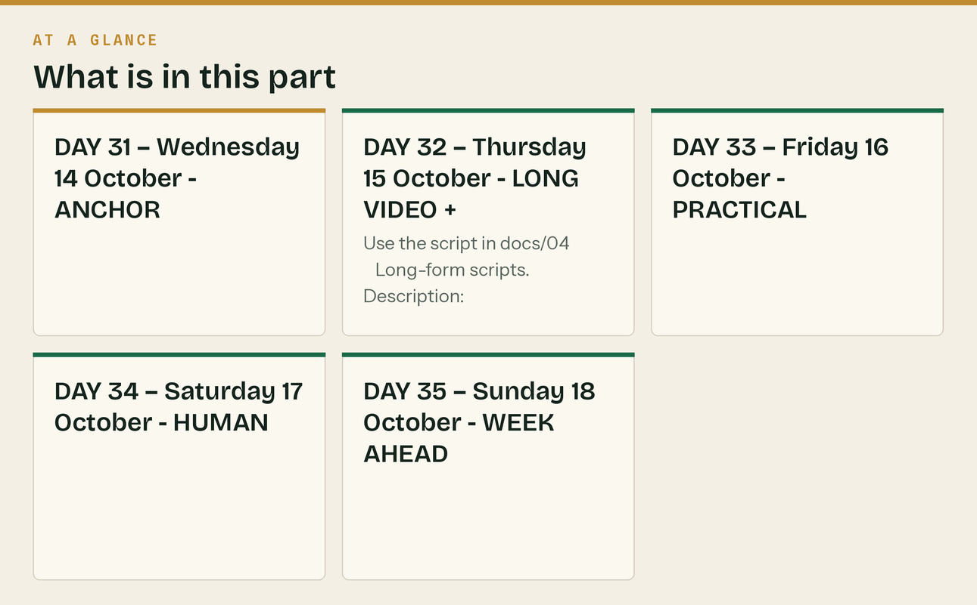

WEEK 6 — "Pricing and quoting"


Mon 12 – Sun 18 October
*The most requested topic and the one with the least good content online. It also sells your own service without ever mentioning it, because a firm that cannot price a job cannot see its own numbers.*
DAY 36 — Monday 19 October · ANCHOR
🔷 LinkedIn + Facebook
Most small building firms are not underpricing. They are undercounting.
There is a difference, and it matters, because underpricing is a decision and undercounting is an
accident.
Here is what gets left out of a quote, in the order I see it left out:
1. THE UNBILLED HOURS
The site visit to quote it. The two phone calls. The trip to the merchant because something was
wrong. The half hour on the phone to a client who wanted reassurance. None of that is on the
invoice. All of it is your week.
2. THE VAN
Fuel, insurance, tax, servicing, tyres, the finance payment. Divide the annual cost by the number
of chargeable days you actually work — not 365, and not 250 either. Most sole traders bill about
190 days. That is £35 to £50 a day before you turn the key.
3. THE TOOLS THAT WEAR OUT
Blades, bits, discs, sealant, screws, tape, bags. Small, constant, and almost never in a quote.
4. THE MONEY YOU ARE LENDING
If you buy the materials and get paid in six weeks, you have lent the job that money. On a £4,000
materials bill at six weeks, that is real cash you cannot use elsewhere.
5. THE RETENTION
If 5% is held for twelve months, your margin on the job is not what the invoice says. It is what
the invoice says minus the bit you may have to chase in a year.
6. THE JOBS YOU QUOTED AND DIDN'T GET
If you win one in three, the two you lost are a cost of winning the one you got.
Add those six up honestly and the day rate you need is usually 20-30% above the one you have been
charging.
That is not a pricing problem. It is a counting problem, and it is fixable this week.
#Construction #Trades #UKConstruction #SmallBusiness
🔷 GBP post
Most small building firms are not underpricing. They are undercounting.
The six costs that get left out of a quote: unbilled hours, the van, consumables, the cash you lend
the job in materials, the retention, and the jobs you quoted and did not win.
Add those honestly and the day rate is usually 20–30% higher than the one being charged.
Klyara: bookkeeping and CIS for construction firms across Surrey. klyara.com
DAY 37 — Tuesday 20 October · SHORT VIDEO
Asset: video/12-what-a-bookkeeper-does.mp4
🔷 TikTok / Reels / Shorts caption
"What does a bookkeeper actually do?"
Fair question. It is not the same job as your accountant, and it happens in a different month.
Full answer, no sales pitch: link in bio
#construction #cis #bookkeeping #ukbusiness #trades #selfemployed
🔷 LinkedIn (native upload)
The most common question I get asked is not about CIS. It is "what does a bookkeeper actually do?"
It is a completely fair question and the honest answer is that most people meet an accountant once a
year and have never met a bookkeeper at all.
Short version: your accountant reports on the year that has finished. A bookkeeper runs the month
that is happening. Different work, different timing, and the second one is what makes the first one
cheap.
Longer version, written out properly: klyara.com/what-a-bookkeeper-actually-does.html
DAY 38 — Wednesday 21 October · CAROUSEL
Asset: build from the day 36 anchor — six slides, one per hidden cost.
🔷 Instagram + LinkedIn carousel
Slide 1: Six costs that are not in your quote
Slide 2: The unbilled hours. Quoting, phone calls, merchant runs.
Slide 3: The van. £35–£50 a day before you turn the key.
Slide 4: Consumables. Blades, discs, sealant, screws. Constant.
Slide 5: The cash you lend the job. £4,000 of materials at six weeks is a loan.
Slide 6: The retention. 5% for twelve months is not margin, it is a hope.
Slide 7: The jobs you didn't win. One in three means two are a cost of the one.
Slide 8: Count all six. The rate you need is usually 20–30% above the one you charge.
Caption:
Undercounting, not underpricing. There is a difference and one of them is fixable this week.
#construction #trades #pricing #selfemployed #ukconstruction #buildersofinstagram
DAY 39 — Thursday 22 October · LONG VIDEO
🔷 YouTube — "How to price a job so you actually make money"
The six costs that never make it into a quote, and how to build a day rate that covers them.
00:00 Underpricing vs undercounting
01:05 The unbilled hours nobody counts
02:20 What your van actually costs per chargeable day
03:30 Consumables — small, constant, invisible
04:25 The cash you lend a job in materials
05:40 Retentions are not margin
06:35 The jobs you quoted and lost
07:30 Building the number, with an example
Free CIS calculator: klyara.com/tools.html
What we charge, published, because nobody else does: klyara.com/pricing.html
Klyara is the back office for small construction firms. Guildford and across Surrey. klyara.com
General guidance, not tax advice.
DAY 40 — Friday 23 October · PRACTICAL CIS CUT-OFF TODAY
🔷 LinkedIn + Facebook + X + GBP
⚠️ If somebody else files your CIS return, they need everything TODAY.
The return for the tax month to 5 October is due Monday 19 October. Nobody should be reconciling
subcontractor statements on a Sunday evening.
What is needed:
□ Every subcontractor invoice for payments made between 6 September and 5 October
□ The labour / materials split on each one
□ Confirmation that everyone paid was verified BEFORE they were paid
□ Any new subcontractor's UTR, name exactly as HMRC holds it, and NI number or company UTR
And the bit that gets forgotten: the payment and deduction statements go out to every subcontractor
by the 19th as well. That is their evidence. Late statements are the reason a subbie cannot prove
what was taken off him.
No payments in that month? You still file. Nil return, two minutes, £100 if you do not.
klyara.com/nil-cis-returns.html
DAY 41 — Saturday 24 October · LIGHT
🔷 Instagram story / Facebook
Reminder for Monday: CIS return for the month to 5 October.
Statements out to your subbies as well. Same date.
DAY 42 — Sunday 25 October · WEEK AHEAD
🔷 LinkedIn + Facebook
Week ahead.
MONDAY 19 OCTOBER — CIS return for the tax month to 5 October. Statements to subcontractors the
same day.
If you have not started it, it is still a twenty minute job for most firms. Start it tonight rather
than at seven tomorrow morning.
Next week: taking on your first employee. What it actually costs, what you have to do before their
first day, and the two things that catch everybody.
The line that matters
*The most requested topic and the one with the least good content online.

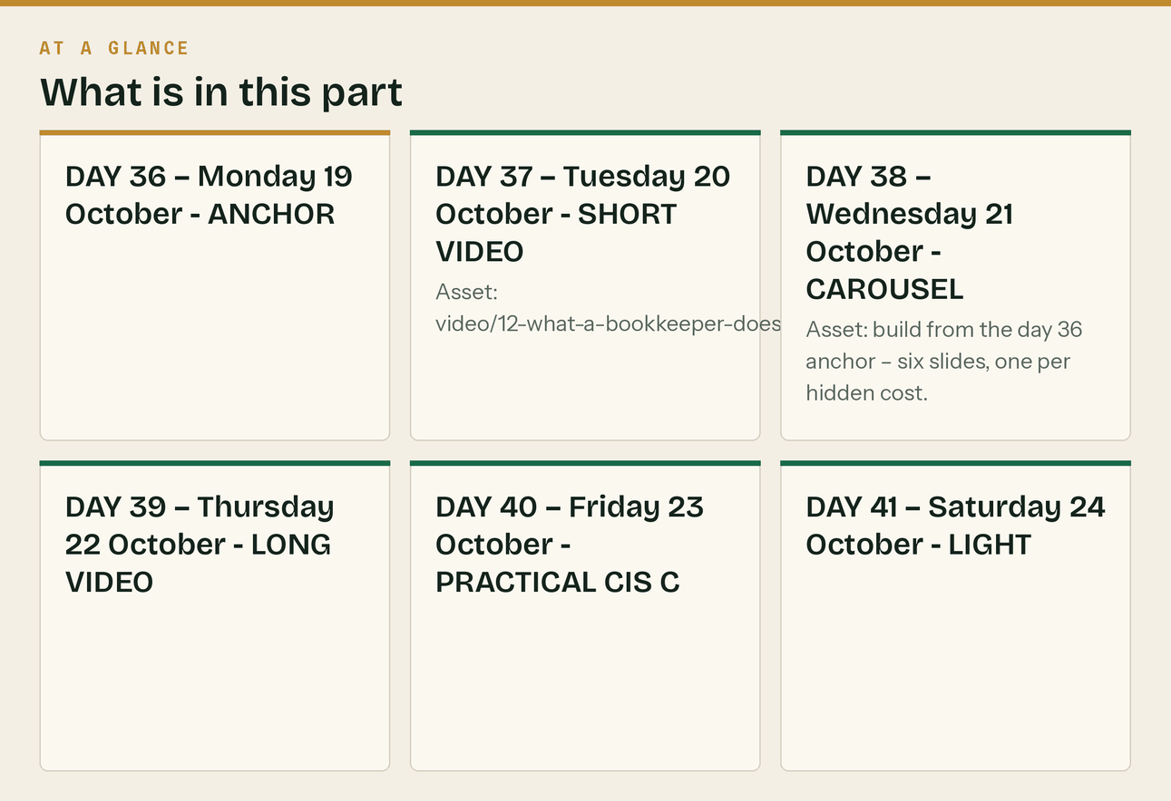

WEEK 7 — "Your first employee"


Mon 19 – Sun 25 October
*Evergreen, high intent, and it is the moment a Solo client becomes a Trade client. This week sells your service more directly than any other week in month two, so keep the tone useful rather than promotional and let the arithmetic do the work.*
DAY 43 — Monday 26 October · ANCHOR CIS DUE TODAY
🔷 LinkedIn + Facebook
⚠️ CIS return due today for the month to 5 October. Statements to subcontractors today as well.
—
This week: your first employee, and what it actually costs.
Somebody has been helping you for six months. He is on your jobs, you tell him what to do and when
to turn up, he uses your tools and your van. You have been paying him as a subcontractor because
that is what everybody does.
Two problems with that, and they are both yours rather than his.
PROBLEM ONE — HE MIGHT NOT BE A SUBCONTRACTOR
Employment status is decided by how the working relationship actually runs, not by what you call it
or what he invoices you. Control, whether he has to do the work himself, whether there is an
obligation on both sides — those are the questions. If HMRC decides he was an employee, the PAYE,
the National Insurance and the penalties come to you, not to him.
PROBLEM TWO — WHAT IT ACTUALLY COSTS
Say you agree £180 a day. As an employee that is not £180.
→ Employer's National Insurance on top — but read the next paragraph before you panic about this one
→ Employer pension contribution, minimum 3% of qualifying earnings
→ Holiday: 5.6 weeks a year, which is 28 days for a five-day week — you can choose to count bank
holidays towards that, but you cannot go below it
→ Employer's liability insurance — legally required, and it is a fine per day without it
→ Sick pay, and the days he is not on site but is still paid
One piece of good news that nobody tells you at this point: the Employment Allowance reduces most
employers' National Insurance bill by up to £10,500 a year. On a single employee at £180 a day, the
employer's NI is comfortably inside that — so in practice it is often nil. Check you are eligible and
claim it; it is a tick box in your payroll software, not an application.
Rule of thumb even so: an employee costs 20-25% more than the headline rate once you count the
pension, the holiday, the insurance and the days nobody is on site.
That is not a reason not to hire. It is a reason to price the hire properly before you make the
offer, because "£180 a day" said out loud becomes a promise very quickly.
Tomorrow: the five things that have to be done before their first day.
#Construction #Employment #UKConstruction #SmallBusiness
🔷 GBP post
Taking on your first employee? An employee costs 25–30% more than the day rate you agreed, once
you count employer's NI, the pension, 28 days' holiday, employer's liability insurance and sick pay.
Price the hire before you make the offer.
Klyara: bookkeeping, CIS and payroll for construction firms across Surrey. klyara.com
DAY 44 — Tuesday 27 October · SHORT VIDEO + PRACTICAL
🔷 LinkedIn + Facebook
Five things that have to happen before your first employee's first day. In order.
1. REGISTER AS AN EMPLOYER WITH HMRC
Do this before the first payday, not after. It can take a few days to come back and you cannot run
payroll without the reference.
2. GET EMPLOYERS' LIABILITY INSURANCE
Legally required from day one, minimum £5 million of cover. The penalty for not being properly
insured is £2,500 for every day you are not, and a further £1,000 if the certificate is not
available to your employees or to an inspector who asks for it.
3. WRITTEN STATEMENT OF EMPLOYMENT PARTICULARS
The principal statement is due on the first day of employment — not "within a couple of months",
day one. Name, job title, start date, pay and how often, hours and days, holiday entitlement and
whether it includes public holidays, place of work, how long the job is expected to last, and any
probation period. A second, wider written statement follows within two months.
4. CHECK THEIR RIGHT TO WORK
Before they start. Keep a copy with the date you checked it. This one has a civil penalty attached
and "he seemed fine" is not a defence.
5. SET UP PAYROLL AND THE PENSION
RTI submission on or before every payday. Auto-enrolment assessment from their first pay period —
you have duties even if they opt out, and the declaration of compliance has a deadline.
None of this is hard. All of it is easier before the first day than after it, and every item on the
list has a penalty attached to getting it wrong.
If you want it done for you, payroll is inside the monthly fee from our Trade plan rather than on
top — that is the plan for anyone paying subcontractors or running a payroll:
klyara.com/pricing.html
DAY 45 — Wednesday 28 October · CAROUSEL
🔷 Instagram + LinkedIn carousel
Slide 1: "£180 a day" is not £180 a day
Slide 2: + Employer's National Insurance
Slide 3: + Pension, minimum 3% of qualifying earnings
Slide 4: + 28 days' holiday, paid
Slide 5: + Employer's liability insurance, legally required
Slide 6: + Sick pay, and the days nobody is on site
Slide 7: Real cost: 25–30% above the headline rate
Slide 8: Price the hire before you make the offer.
Caption:
Taking someone on is the right move for a lot of firms. Saying a number before you have counted it
is not.
#construction #employment #trades #smallbusiness #ukconstruction
DAY 46 — Thursday 29 October · LONG VIDEO
🔷 YouTube — "Subcontractor or employee? The question that costs builders money"
How employment status is actually decided, why calling someone a subcontractor does not make them
one, and what it costs if HMRC disagrees.
00:00 The situation almost every growing firm ends up in
01:10 What actually decides status — control, substitution, mutuality
03:00 Why "he invoices me" is not the answer
04:15 What happens when HMRC disagrees, and who pays
05:30 What an employee really costs
07:00 The five things to do before day one
Published prices, including payroll: klyara.com/pricing.html
Free CIS and VAT tools: klyara.com/tools.html
Klyara is the back office for small construction firms. Guildford and across Surrey.
General guidance, not tax advice. Employment status is fact-specific — get advice on your own
situation.
DAY 47 — Friday 30 October · PRACTICAL
🔷 LinkedIn + Facebook
The three-question test for whether the man on your site is a subcontractor.
None of these is the whole answer — status is decided on the overall picture — but if you answer
these three honestly you will know which way it leans.
1. CONTROL. Do you tell him what to do, when to turn up, and how to do it? Or does he decide?
A subcontractor is engaged to deliver a result. An employee is directed.
2. SUBSTITUTION. If he could not make it Tuesday, could he send someone else in his place, at his
own cost, without asking you? If the answer is "no, I need him specifically" — that points hard
at employment.
3. MUTUALITY. Are you obliged to offer him work, and is he obliged to take it? A rolling expectation
that he turns up every Monday is not the same relationship as a job at a time.
Other things that count: whose tools, whose van, whether he can profit from working more efficiently,
whether he carries any financial risk, whether he works for anyone else.
If you have read that and felt uncomfortable, that discomfort is the useful part. Get it looked at
now, while it is a decision, rather than in two years when it is an assessment.
CIS registration does not settle it. Neither does an invoice, a UTR, or a contract that says
"self-employed" at the top. Only the reality of how the work is done settles it.
DAY 48 — Saturday 31 October · HUMAN
🔷 Instagram + Facebook
Saturday.
The best thing about doing books for building firms is that everyone is straight with you. Nobody
in this trade dresses anything up. If the month was bad, they tell you it was bad.
It makes the job easy. It is also, I think, why the trade looks after its own.
Have a good weekend.
DAY 49 — Sunday 1 November · WEEK AHEAD MTD COUNTDOWN STARTS
🔷 LinkedIn + Facebook + X
Week ahead, and it is a big one for anyone in Making Tax Digital.
FRIDAY 6 NOVEMBER — your MTD quarterly update is due.
The deadline is technically Saturday 7 November. Do not work to a Saturday. Work to Friday 6th.
This covers the quarter to 5 October, and for most people reading this it is either the first or the
second update they have ever had to send. It is not a tax return. It is a summary of income and
expenses sent from your software — and note that each update is **cumulative**: it covers from the
start of the tax year to the end of the update period, not just the three months since the last one.
If you are over £50,000 of qualifying income, you are in this. Qualifying income is gross — what you
invoiced, before expenses and before CIS. That is the bit that catches subbies out, because the
number in the bank is roughly 20% smaller than the number HMRC counts.
Not sure whether you are in it? There is a checker on the site that takes ten seconds:
klyara.com/tools.html
Every day this week: one thing to get ready. Follow along and Friday will be quiet.
The line that matters
*Evergreen, high intent, and it is the moment a Solo client becomes a Trade client.

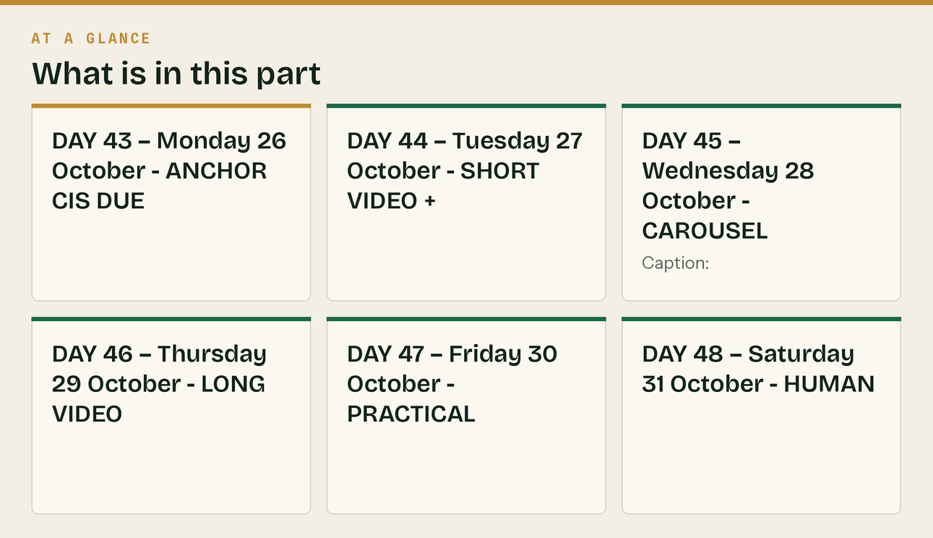

WEEK 8 — "MTD countdown"


Mon 26 Oct – Sun 1 Nov
*The strongest peg in month two. Run it as a daily countdown — the format worked in week 4 of docs/03 and there is no reason to change it. One task a day, ten minutes each.*
DAY 50 — Monday 2 November · COUNTDOWN 1 OF 10
🔷 LinkedIn + Facebook + GBP
MTD quarterly update due Friday 6 November. Ten days, ten jobs, ten minutes each.
DAY 1: Know whether you are actually in it.
Qualifying income is your self-employment turnover plus any property income. Gross. Before expenses
and before CIS.
→ More than £50,000: you have been in MTD since 6 April 2026. This update is yours.
→ £30,001 to £50,000: you start 6 April 2027. Not this one, but next year is closer than it looks.
→ £20,001 to £30,000: you start 6 April 2028.
→ £20,000 or less: nothing announced yet.
It is measured on more than the threshold, so exactly £50,000 is not caught. And it is tested on a
specific year's return, not on this year's figures: April 2026 was tested on 2024/25, April 2027 on
2025/26, April 2028 on 2026/27.
The trap for subcontractors: you invoice £55,000, CIS takes £11,000, you bank £44,000. HMRC counts
the £55,000. Your bank balance says you are out of scope. You are not.
Ten-second checker, no sign-up: klyara.com/tools.html
Tomorrow: the invoices.
DAY 51 — Tuesday 3 November · COUNTDOWN 2 OF 10
🔷 LinkedIn + Facebook
MTD countdown, day 2 of 10. Ten minutes.
TODAY: every sale in the quarter is invoiced.
The quarter ran 6 July to 5 October. Go and find the work you did in it that has not been invoiced
yet.
The usual places:
□ The job you finished but "will sort the paperwork on" — check the van dashboard
□ The extra you agreed on site and never wrote down
□ The one you invoiced by text message and never put in the software
□ Anything you quoted, did, and got paid in cash for
An update built on incomplete income is wrong, and correcting it later is more work than doing it
now.
Tomorrow: the purchases.
DAY 52 — Wednesday 4 November · COUNTDOWN 3 OF 10 + CAROUSEL
🔷 LinkedIn + Facebook
MTD countdown, day 3 of 10.
TODAY: every purchase is in.
Fuel, merchants, tool hire, subcontractors, parking, congestion charge, phone, insurance,
subscriptions, protective gear, the drill you bought in August.
Two places people lose money every single quarter:
1. The personal card. If you paid for something for the job on your own card and never claimed it,
it is not in the accounts and you paid tax on money you spent on the business.
2. The glovebox. Fuel receipts, merchant docket copies, and the pay-and-display from the job in
town.
Empty the glovebox today. It is genuinely worth doing and it takes four minutes.
Tomorrow: the reverse charge, both ways.
🔷 Instagram carousel
Asset: assets/carousel/quarter-end/ (from docs/03)
DAY 53 — Thursday 5 November · COUNTDOWN 4 OF 10
🔷 LinkedIn + Facebook
MTD countdown, day 4 of 10. This is the one people get wrong.
TODAY: the reverse charge, checked in BOTH directions.
On what you sold: if the work is within CIS, you are both VAT registered, your customer is a CIS
contractor, and they have not given you a written end user declaration — you should have charged no
VAT, and the invoice should say the customer accounts for it.
On what you bought: the same test applied to your subcontractors' invoices. If one of them charged
you VAT when they should not have, you cannot reclaim it. That is not HMRC's problem and it is not
theirs — it is yours, and you have to go back to them for a credit note.
Four questions, ninety seconds, on the site:
klyara.com/tools.html
And if you are missing an end user declaration from a customer, email them for it today. It is their
declaration to make, not your guess, and it is the first thing asked for on a check.
Tomorrow: retentions.
DAY 54 — Friday 6 November · COUNTDOWN 5 OF 10
🔷 LinkedIn + Facebook
MTD countdown, day 5 of 10.
TODAY: separate your retentions from your turnover.
If a main contractor holds 5% for twelve months, that 5% is not money you have. Treated as normal
turnover it makes the quarter look better than it was and it disappears from view entirely — which
is exactly how retentions end up unclaimed.
Ten minutes:
□ List every job with a retention held
□ Note the amount, the percentage, and the release date
□ Diarise the release date — not "sometime next year", an actual date
□ Anything already past its release date: chase it on Monday
Most builders I speak to have between £2,000 and £15,000 out there and no list of it.
klyara.com/construction-retentions-guide.html
Have a good weekend. Monday: CIS suffered.
DAY 55 — Saturday 7 November · LIGHT
🔷 Instagram story
MTD update due Friday 6 November.
Five down, five to go. Back Monday.
DAY 56 — Sunday 8 November · COUNTDOWN 6 OF 10
🔷 LinkedIn + Facebook
MTD countdown, day 6 of 10. Five days left.
TODAY: match your CIS suffered to the statements, line by line.
Every contractor who deducted CIS from you should have sent you a payment and deduction statement
within 14 days of the tax month end. Get them all out and tick them off against what actually hit
your bank.
What you are looking for:
□ A payment with no statement — chase it, you need it
□ A deduction at 30% when you are registered — that is 10% of your labour. One call from the
contractor to HMRC fixes the rate going forward; the money already taken comes back through your
own tax return at the year end, not from the contractor
□ A deduction taken on materials — CIS comes off labour only
□ Amounts that do not match what landed
This is money. It is not admin. Every pound of CIS you cannot evidence is a pound you may not get
back, and the year end is the wrong time to discover the statement never came.
Tomorrow: the bank.
The line that matters
Run it as a daily countdown — the format worked in week 4 of docs/03 and there is no reason to change it.

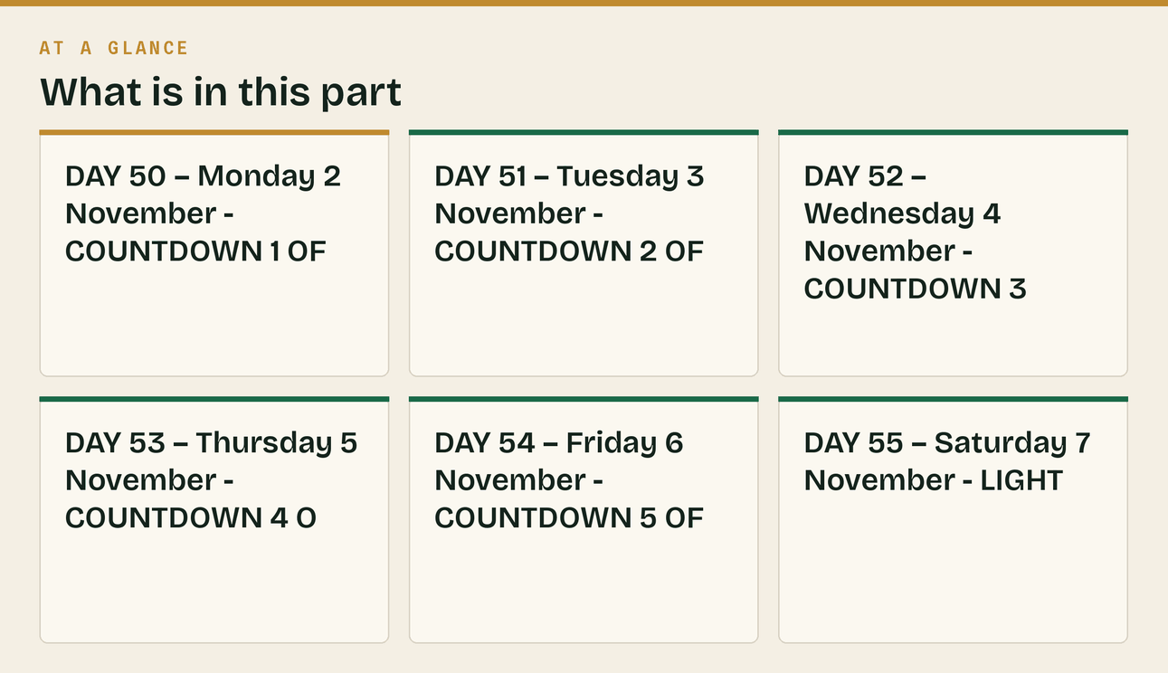

WEEK 9 — "MTD deadline week"

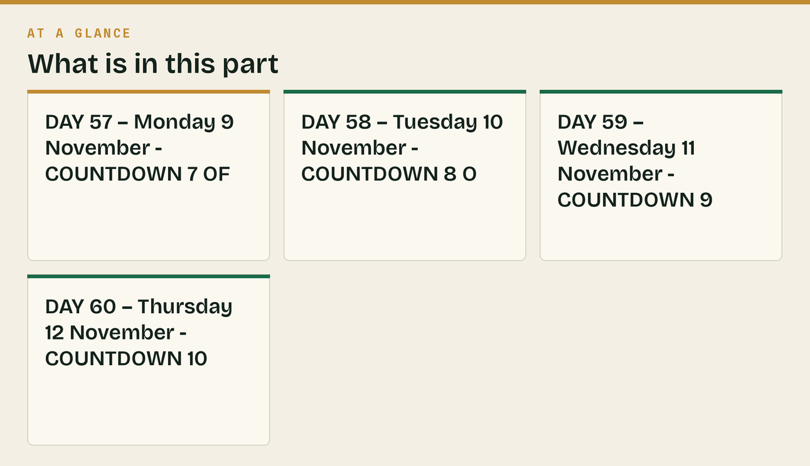
Mon 2 – Thu 5 November
DAY 57 — Monday 9 November · COUNTDOWN 7 OF 10
🔷 LinkedIn + Facebook + GBP
MTD countdown, day 7 of 10. Four days.
TODAY: reconcile the bank to zero difference.
Not "roughly right". Zero.
If the software's balance does not match the actual balance on the statement, something is missing —
and it is almost always income, because expenses get chased and income gets assumed.
Common causes:
□ A payment received into a personal account
□ A transfer between your own accounts entered as income
□ A card payment that never came through the feed
□ A cash job
If it does not tie, do not send the update until it does. A quarter built on a bank that does not
reconcile will need correcting.
Tomorrow: the actual submission.
DAY 58 — Tuesday 10 November · COUNTDOWN 8 OF 10
🔷 LinkedIn + Facebook
MTD countdown, day 8 of 10. Three days.
TODAY: send it.
Yes, three days early. Here is why.
Filing early is free. It costs you nothing and it removes every possible thing that goes wrong on
the day — the software update, the connection, the password you cannot find, the job that overruns,
the child who is ill.
And there is nothing to pay. A quarterly update is a submission, not a bill — the tax is settled
through the final declaration and the payment dates on 31 January and 31 July, exactly as before.
If anybody tells you a quarterly update has a payment attached to it, they are wrong.
What actually happens: it is a summary of income and expenses sent from your software. Not a tax
return. There is nothing to calculate, no tax to work out, and no final declaration until
31 January.
One thing worth knowing, because it confuses people the first time: each update is cumulative. It
covers from the start of the tax year to the end of the update period, not just the last three
months. If you corrected something from the July quarter, the correction is picked up here.
If it is your first one, it will take longer to worry about it than to do it.
Thursday: what happens next.
DAY 59 — Wednesday 11 November · COUNTDOWN 9 OF 10
🔷 LinkedIn + Facebook + X + GBP
⚠️ MTD quarterly update due Friday 6 November. Two days.
The deadline is Saturday 7 November. Nobody should be doing this on a Saturday. Friday.
If you have not started, it is not too late — for most sole traders it is under an hour if the
bookkeeping is up to date, and an evening if it is not.
The short version of everything this week:
□ Every sale invoiced
□ Every purchase in
□ Reverse charge checked on sales and purchases
□ Retentions separated out
□ CIS suffered matched to the statements
□ Bank reconciled to zero
□ Send it
If you are stuck tonight, ring us. 020 8058 1496. We will tell you whether it is a five-minute
problem or a real one, and if it is five minutes we will just tell you how to fix it.
DAY 60 — Thursday 12 November · COUNTDOWN 10 OF 10 + FORWARD
🔷 LinkedIn + Facebook
MTD update due tomorrow, Friday 6 November. Last call.
—
And then it starts again. That is the part nobody explains properly when they talk about MTD, so
here is the year, in full, once:
QUARTERS END: 5 July · 5 October · 5 January · 5 April
UPDATES DUE: 7 August · 7 November · 7 February · 7 May
FINAL DECLARATION: 31 January, as before
Four updates and one declaration, every year, instead of one return.
The firms that find this easy are not the organised ones. They are the ones who stopped treating
bookkeeping as a thing you do at the end and started treating it as a thing that happens as you go.
Ten minutes a week beats a lost weekend every quarter, and the difference is entirely habit.
If the last two weeks have shown you that the ten-minutes-a-week version does not exist in your
business, that is what we do. Fixed monthly fee, published, from £59 + VAT — and unlike everyone
else round here you can see the prices without giving anyone your phone number.
klyara.com/pricing.html
Next month: year-end planning, vans and capital allowances before 5 April, and the January hole.
#MakingTaxDigital #CIS #Construction #UKConstruction
🔷 GBP post
MTD quarterly update due Friday 6 November for the quarter to 5 October.
Then: quarters end 5 Jan, 5 Apr, 5 Jul, 5 Oct. Updates due 7 Feb, 7 May, 7 Aug, 7 Nov. Final
declaration 31 January.
Free MTD date checker and CIS calculator at klyara.com/tools.html — no sign-up.
Klyara: bookkeeping, CIS and MTD filing for construction firms in Guildford and across Surrey.
Fixed monthly fee from £59 + VAT, published at klyara.com/pricing.html.
In this part
Mon 2 – Thu 5 November · DAY 57 — Monday 9 November · COUNTDOWN 7 OF 10 · 🔷 LinkedIn + Facebook + GBP · DAY 58 — Tuesday 10 November · COUNTDOWN 8 OF 10 · 🔷 LinkedIn + Facebook · DAY 59 — Wednesday 11 November · COUNTDOWN 9 OF 10

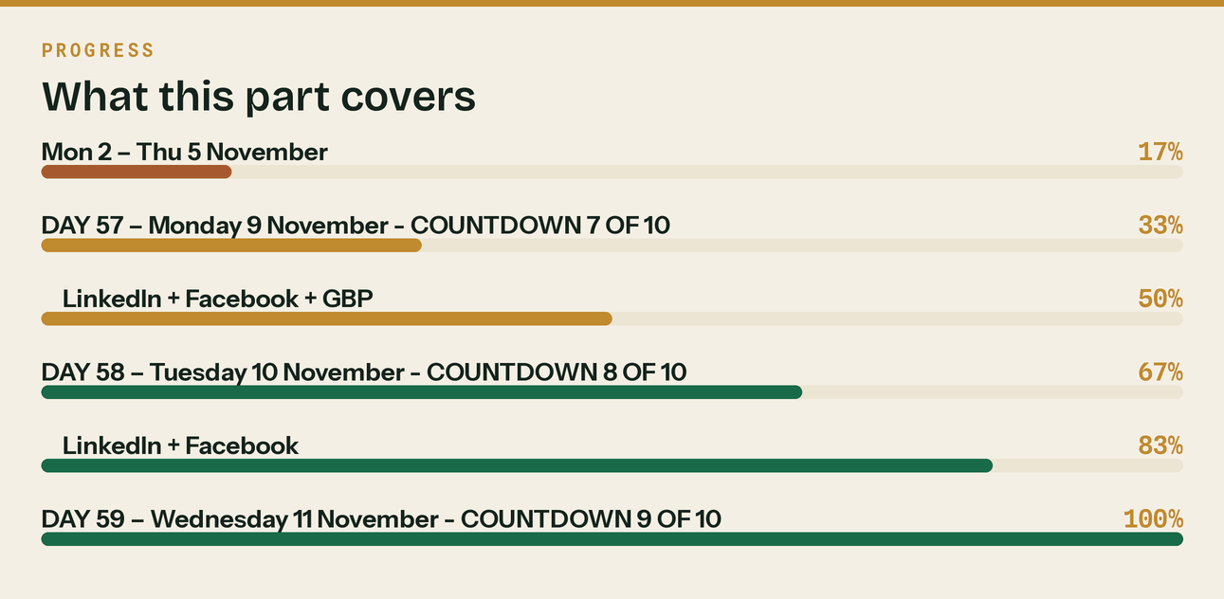
Read top to bottom. The bar is just how far through the part you are.

What to do on day 61

Month three is already themed in docs/03 — year-end planning, vans and capital allowances, the Christmas shutdown, and the start of the 31 January countdown. docs/05 newsletters 5 to 9 carry the source material for all four weeks and docs/13 has the Google Business Profile posts already dated.
Three things worth carrying forward from month two:
- The daily countdown format works. It produced the best engagement in month one and it will do the same in December against 31 January. Ten days, one task, ten minutes. Reuse it verbatim.
- Point at the tools, not the call. Every post above that offers a calculator instead of a conversation will outperform the ones that offer a conversation. The call comes a week later, and it comes warm.
- Publishing the prices is a weapon. Nobody else local does it. Say so, once a fortnight, without being smug about it — "you can see the prices without giving anyone your phone number" is the whole line, and it is worth repeating because it is true.
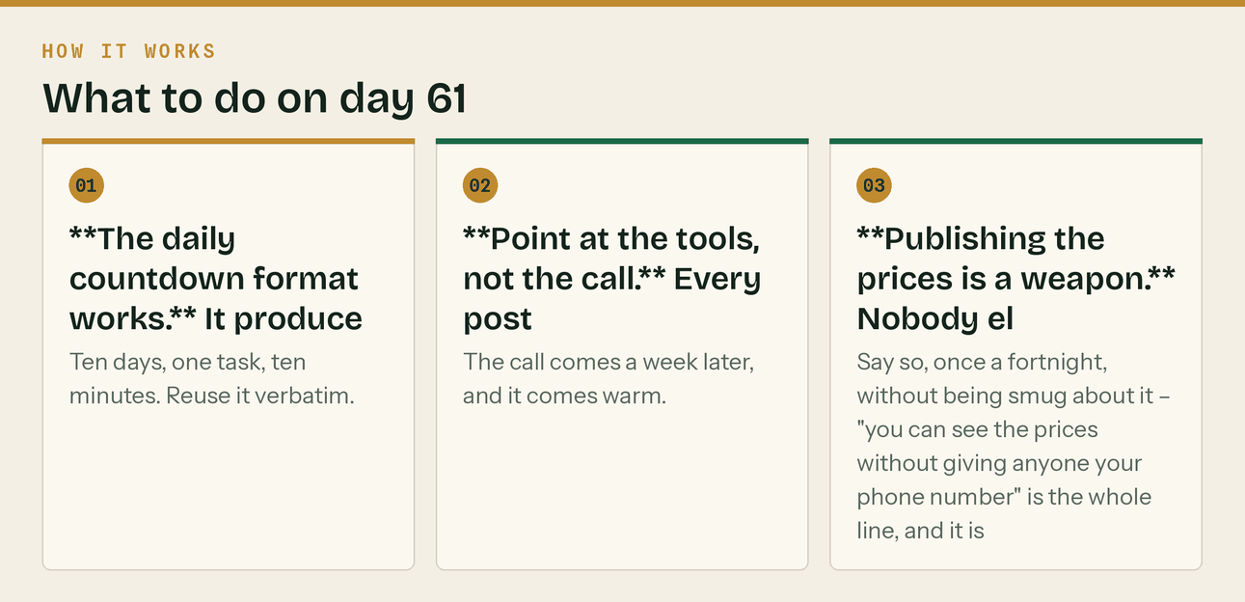
The same steps, in order.
Related
- docs/03 — days 1–30 in full, and the months 3–6 themes
- docs/13 — the Google Business Profile posts, already dated for the same period
- docs/05 — newsletters, which share the source material for weeks 5 to 9
- docs/23 — the outbound rhythm that runs alongside this
- docs/22 — where the "published prices" line comes from, with sources
The line that matters
Month three is already themed in docs/03 — year-end planning, vans and capital allowances, the Christmas shutdown, and the start of the 31 January countdown.

In this part
Related

