**What are the top 5 airlines in terms of ontime departure percentage? ontime arrival percentage? average departure lateness? average arrival lateness?**

Top 5 airlines in terms of ontime departure percentage:

CARRIER

HA 74.193105

AS 74.035108

OO 71.439801

EV 69.596006

DL 65.959413

dtype: float64

Top 5 airlines in terms of ontime arrival percentage:

CARRIER

DL 69.547686

UA 67.984728

AS 66.918849

HA 65.224557

EV 64.476153

dtype: float64

Top 5 airlines in terms of average departure lateness:

CARRIER

EV 61.148131

B6 57.858820

OO 56.353297

UA 50.895549

NK 49.118061

Name: DEP_DELAY, dtype: float64

Top 5 airlines in terms of average arrival lateness:

CARRIER

B6 59.657081

EV 54.201635

UA 52.944740

F9 48.677506

NK 47.653699

Name: ARR_DELAY, dtype: float64

**What are the relative percentages of flights that leave and arrive on time vs. leave on time and arrive late vs. leave late and arrive on time, and leave and arrive late?**

Relative percentage of flights that leave and arrive on time:

51.81152704784567

Relative percentage of flights that leave on time and arrive late:

9.121909123702814

Relative percentage of flights that leave late and arrive on time:

9.745116679521445

Relative percentage of flights that leave and arrive late:

29.321447148930062

**Do states in the northeast (Pennsylvania, Maryland, New Jersey, Delaware, New York, Connecticut, Rhode Island, Massachusetts, Vermont, New Hampshire, and Maine) have worse time performance than the rest of the country based on average departure lateness?**

Time performance of the states in northeast based on average departure lateness:

49.88400868306802

Time performance of the states in rest of the country based on average departure lateness:

39.29047986696757

Yes, states in the northeast have worse time performance than the rest of the country based on average departure lateness.

**What are the top 5 airports in terms of ontime departure percentage? ontime arrival percentage? average departure lateness? average arrival lateness?**

Top 5 airports in terms of ontime departure percentage:

ORIGIN

GUC 100.000000

LWS 94.117647

HLN 93.197279

CLL 92.771084

EGE 92.500000

dtype: float64

Top 5 airports in terms of ontime arrival percentage:

DEST

DLG 96.774194

INL 94.444444

PPG 92.307692

LWS 89.411765

ADK 88.888889

dtype: float64

Top 5 airports in terms of average departure lateness:

ORIGIN

HIB 175.571429

TOL 151.888889

LWS 135.400000

EAU 127.071429

MEI 118.441860

Name: DEP_DELAY, dtype: float64

Top 5 airports in terms of average arrival lateness:

DEST

UST 137.000000

MEI 120.170213

CIU 112.588235

ABR 103.777778

PAH 86.304348

Name: ARR_DELAY, dtype: float64

**For each of five major airports - LAX, JFK, DFW, ORD and ATL - what are the top 5 airlines in terms of the longest taxi out and taxi in times?**

Top 5 airlines in terms of longest taxi out for five major airports:

ORIGIN CARRIER

ATL AA 144.0

B6 131.0

UA 128.0

DL 122.0

EV 95.0

DFW AA 172.0

UA 141.0

OO 139.0

EV 127.0

F9 105.0

JFK AA 176.0

DL 169.0

B6 167.0

VX 124.0

AS 44.0

LAX AA 171.0

WN 138.0

UA 136.0

OO 82.0

VX 76.0

ORD AA 174.0

OO 169.0

F9 164.0

UA 155.0

B6 124.0

Name: TAXI_OUT, dtype: float64

Top 5 airlines in terms of longest taxi in for five major airports:

DEST CARRIER

ATL NK 105.0

UA 86.0

DL 65.0

AA 62.0

OO 57.0

DFW AA 131.0

UA 113.0

OO 91.0

EV 53.0

NK 49.0

JFK B6 146.0

VX 100.0

AA 94.0

DL 87.0

HA 14.0

LAX AA 139.0

F9 122.0

UA 86.0

VX 83.0

NK 80.0

ORD OO 134.0

B6 124.0

DL 119.0

AS 117.0

AA 114.0

Name: TAXI_IN, dtype: float64

**What are the relative percentages of flight time in terms of taxi out time, actual flying time, and taxi in time?**

Relative percentage of flight time in terms of taxi out time:

11.948793945097835

Relative percentage of flight time in terms of actual flying time:

82.54124003838884

Relative percentage of flight time in terms of taxi in time:

5.5099660165133315

**What are the top 5 airlines in terms of actual flight speed?**

Top 5 airlines in terms of actual flight speed (in mph):

CARRIER

F9 450.670580

VX 448.089373

UA 446.827920

NK 442.572101

AS 441.455626

Name: SPEED, dtype: float64

**Do flights that depart late fly faster than those that do not? (compare flying times of the same routes when they are late and not)**

Average speed of flights that depart late on same routes:

420.25289876880413

Average speed of flights that depart on time on same routes:

419.7959525875255

Yes, the flights that depart late fly faster than those that do not.

**Do longer flights arrive late more often than shorter flights? (plot percentage arrival lateness vs flight length)**

DISTANCE_GROUP PER_ARR_LATE

0 500 38.598805

1 1000 38.842297

2 1500 39.267418

3 2000 36.809473

4 2500 36.733275

5 3000 35.787626

6 3500 25.129534

7 4000 36.161616

8 4500 23.611111

9 5000 23.577236

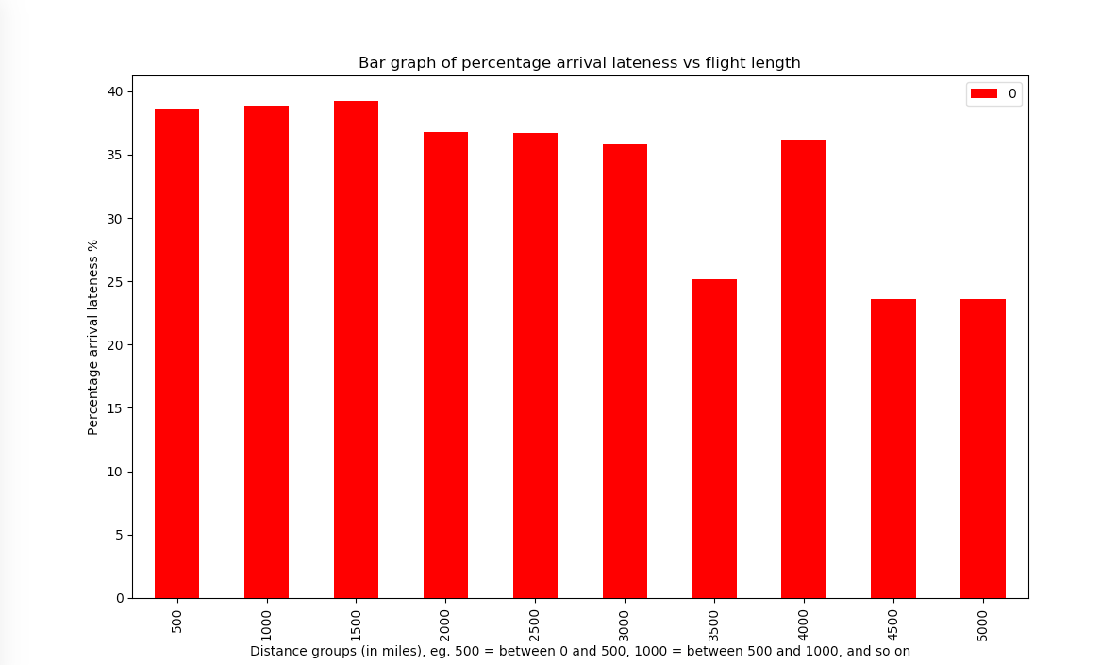

**Which flights (morning: before noon, afternoon: 12 - 6, evening: 6-12), have a greater on time departure percentage?  on time arrival percentage?**

On time departure percentage for morning flights:

73.28049141080302

On time departure percentage for noon flights:

54.544172402121184

On time departure percentage for evening flights:

48.24895268122316

Morning flights have a greater on time departure percentage.

On time arrival percentage for morning flights:

70.91907409380661

On time arrival percentage for noon flights:

62.51984934561652

On time arrival percentage for evening flights:

51.65247140583744

Morning flights have a greater on time arrival percentage.

**Which day in the month has a worse performance time based on departure lateness percentage - the holiday, the day before, or the day after?**

Departure lateness percentage on the major holiday:

19.602677299914554

Departure lateness percentage on the day before major holiday:

23.40810923784311

Departure lateness percentage on the day after major holiday:

33.262660528228736

Day after major holiday has a worse performance time based on departure lateness percentage.

**Do flights on the weekend have a worse performance than those on weekdays in terms of arrival lateness percentage?**

Arrival lateness percentage on weekend:

35.53329981915401

Arrival lateness percentage on weekdays:

39.72202300697094

No, flights on the weekend do not have a worse performance than those on weekdays in terms of arrival lateness percentage.

**Think up three other interesting questions and determine the answers.**

* **the top 5 airlines based on average departure lateness in Connecticut**
* **the top 5 airlines based on average arrival lateness in Connecticut**
* **the top 5 airports based on on time departure percentage in Northeast**
* **the top 5 airports based on on time arrival percentage in Northeast**

Top 5 airlines based on average departure lateness in Connecticut:

CARRIER

EV 136.500000

OO 90.941176

B6 51.908397

DL 51.409524

UA 44.732143

Name: DEP_DELAY, dtype: float64

Top 5 airlines based on average arrival lateness in Connecticut:

CARRIER

B6 61.862745

DL 50.827273

NK 48.952381

UA 48.800000

OO 46.891304

Name: ARR_DELAY, dtype: float64

Top 5 best airports based on on time departure percentage in Northeast:

ORIGIN

ITH 84.705882

ERI 81.294964

BGM 78.823529

SCE 77.241379

ABE 75.520833

dtype: float64

Top 5 best airports based on on time arrival percentage in Northeast:

DEST

ITH 82.352941

SCE 71.428571

PBG 71.052632

ERI 67.153285

BGM 67.058824

dtype: float64