**Eco industrielle – Reinforcement learning :**

**Problem IV : Getting confidence in market equilibriums – an agent based perspective :**

**Case 1: Traditional Cournot equilibriums:**

* For all cases, the cost of productionis equal to 0.
* For each firm we can write the profit

***Monopoly:***

Let the quantity sold on the market by the monopolist: We have the following equations:

* = (

We know that the firm wants to maximize this profit leading to :

Hence:

For the monopoly, we have an equilibrium quantity .

The market price is equal to

***Duopoly:***

Let the quantity sold on the market by the firm 1.

Let the quantity sold on the market by the firm 2: We have the following equations:

* = (
* = (

Each firm wants to maximize its profit leading to:

We can solve the system:

*For the firm 1:*

*For the firm 2:*

We can write the system with a matrix to ease solving:

With the invert of

We have:

Finally, it gives us the following market price:

***Triopoly:***

Let the quantity sold on the market by the firm 1.

Let the quantity sold on the market by the firm 2.

Let the quantity sold on the market by the firm 3: We have the following equations:

* = (
* = (
* =

Each firm wants to maximize its profit leading to:

We can solve the system:

*For the firm 1:*

*For the firm 2:*

*For the firm 2:*

We can write the system with a matrix to ease solving:

With the invert of

We have:

With the invert of

Finally, it gives us the following market price:

**Synthesis:**

We can summarize these results in the following table:

|  |  |
| --- | --- |
| **Market structure** | **Price value [** |
| Monopoly | 300 |
| Duopoly | 200 |
| Triopoly | 150 |
| -opoly | With |

**Case 2: Roth & Erev, a Reinforcement learning process**

2 & 3. Studying convergence and plotting.

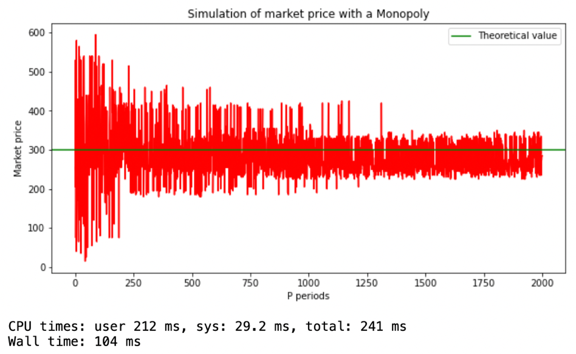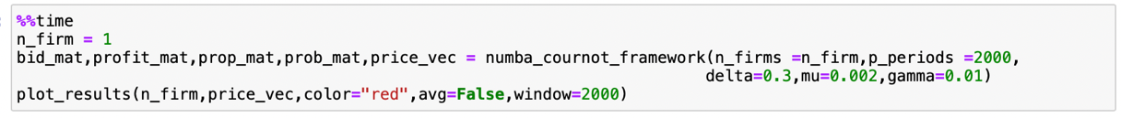*Monopoly:*

*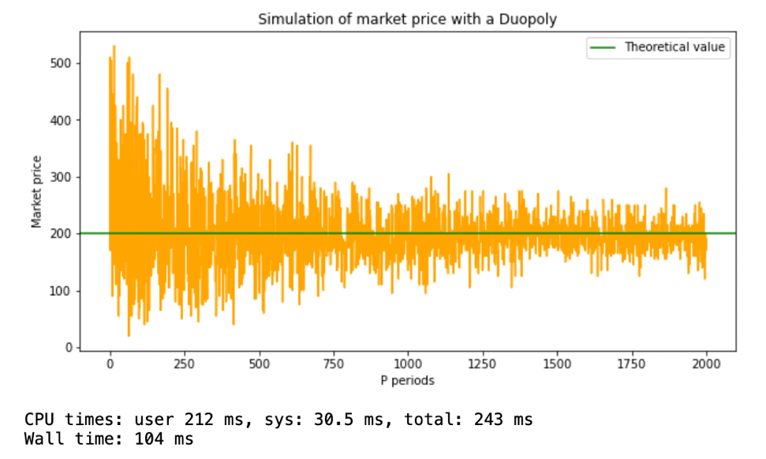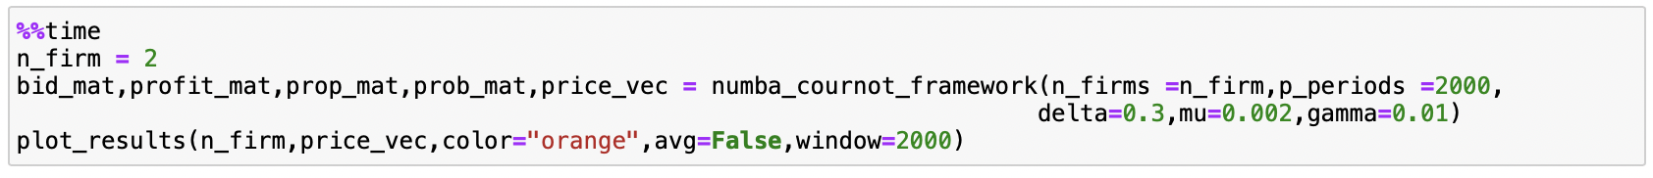Duopoly:*

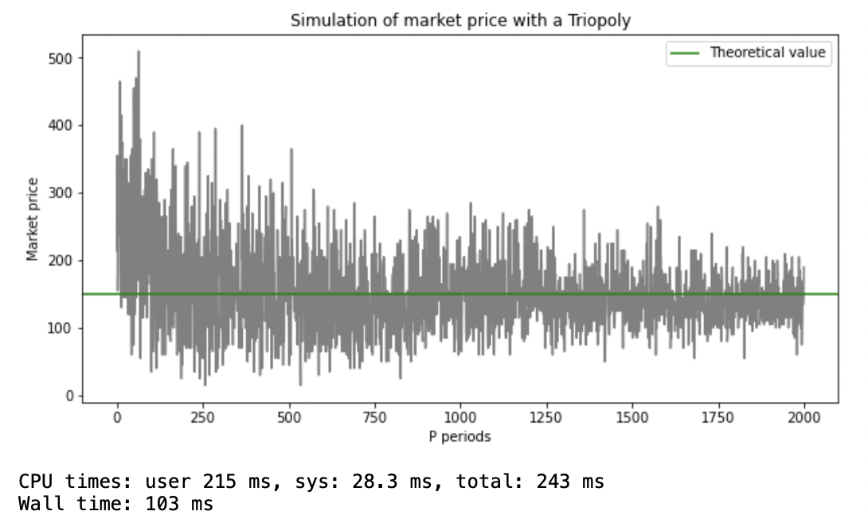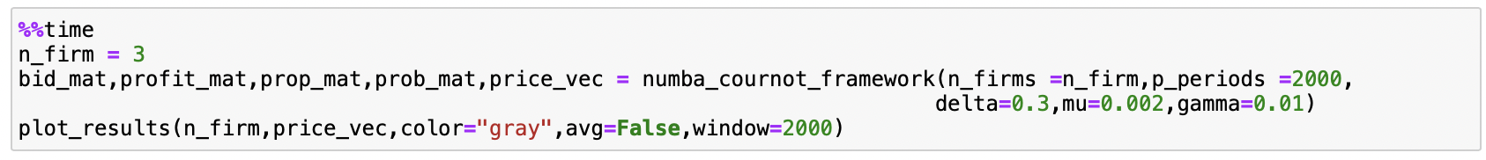*Triopoly:*

For each market structure, we can see that each simulation stabilizes around the theoretical value, after 1000 periods. Indeed, we have for each market structure the simulation and the theoretical value that we have computed before. Our framework seems to be reliable.

Besides regarding time performance, as we have used numpy library in our code (cf. appendix) and [numba](https://numba.pydata.org/) (a code compiler for python designed for numpy), we converge to a stationary state really quickly.

**4. Multiple simulation results:**

*As our framework can do a lot of simulations in a reduce amount of time, we have decided to run 10 000 samples to see what are the results. For each sample, we are looking at the 200 Moving Average.*

We can represent the moving average as following:

**Cournot framework – Python code.**

*Global framework*

@njit(parallel=False) # Using njit refers to numba, a compiler in python, which convert python to C equivalent.

# By compiling the functions with function we can increase dramatically the speed

def numba_cournot_framework(n_firms, p_periods,initial_propension=90000,delta=0.3,mu=0.002,gamma=0.01,total_demand=600):

"""Cournot framework - Simulate market situations

Args :

n_firms (int): Number of firms : n_firms>=1

p_periods (int): Number of simulation periods

initial_propension (float) : initial_propension for each value

mu (float) : extinction in finite time

gamma (float) : gradual forgetting

delta (float) : persistent local experimentation

total_demand (int): total demand of market

Returns :

bid_mat (np.matrix): Matrix of bid for each firm at each period

profit_mat (np.matrix): Matrix of profit for each firm at each period

prop_mat (np.matrix) : Propension matrix for each bid for each firm for each period

price_vec (np.array) : Market price for each period"""

s_discrete = int((120/n_firms)//1) #Max of allowable bids - Integer part of 120/n

bid_mat = np.zeros((p_periods,n_firms)) # Bid matrix : (p_periods,n_firms)

profit_mat = np.zeros((p_periods,n_firms)) # Profit matrix : (p_periods,n_firms)

prop_mat = np.zeros((s_discrete,n_firms,p_periods)) # Propensions matrix : (S,n_firms,p_periods)

prop_mat[:,:,0] = initial_propension # Initialize propension - setting up for first iteration

secrete_bids = np.arange(1,s_discrete+1) #Set of allowable bids

bid_possibilities = np.arange(1,s_discrete+1)*5 #Bids possibities (*5) [5,10 ...5*S]

price_vec = np.zeros(p_periods) # Price vector : (p_periods)

for period in range(p_periods):

#For each period we compute the propbability matrix based on propension vector

prob_mat = prop_mat[:,:,period]/np.sum(prop_mat[:,:,period],axis=0) #probability matrix

for firm in prange(n_firms):

### Across all firms

# We determine for each firm the bid

# rand_choice_nb(vec, prob) returns a value in array based on a probability vector

# prob[:,firm] : probability for each bid for a given firm

bid_pick = rand_choice_nb(bid_possibilities, prob=prob_mat[:,firm])

bid_mat[period,firm] = bid_pick # We set bid picked for the firm at this period

# Once bid are made we can compute price

market_price = total_demand-np.sum(bid_mat[period,:]) # P(Q)=600-SUM(Qi)

price_vec[period] = market_price # We save the price of this period

profit_mat[period,:] = market_price*bid_mat[period,:] # We compute the profit (no cost of prod.)

# Need to recompute propensions for next iterations

for firm in range(n_firms):

lambda_ = bid_mat[period,firm]/5 #Get lambda of the firm i.e the bid picked at this period

profit = profit_mat[period,firm] #Retrieve this associated profit

# For each allowable bid in 1..S

for s_bid in range(s_discrete):

# Loop bound reinforcement

######### Part 1 of reinforcement #######################:

# Current propension for this period

propension = prop_mat[s_bid,firm,period]

# Warning : s_bid+1 because python starts at 0

# We resort to a function that recalculates propension given multiple input

new_propension = propensions_reinforcement_part1(s_bid+1,propension,

profit,lambda_,delta,gamma)

# Set propension for next period

if period + 1 < p_periods:

## Do not outbound the number of periods

prop_mat[s_bid,firm,period+1] = new_propension # Set new propension

############## Part 2 : adjust regarding mu #################

if period + 1 < p_periods:

## Do not outbound the number of periods

propension_vec = prop_mat[:,firm,period+1] # Extract propension vector

# We look at the new propension for next period, and before going further

# we adjust propension regarding mu

propension_vec_mu_filter = (propension_vec/np.sum(propension_vec))>mu # rs/sum(rs)>mu

# By multipling like that we implement the indicator function

prop_mat[:,firm,period+1] = propension_vec*propension_vec_mu_filter # (0,1,0,0)*(propension)

# We can go to the next period !

return (bid_mat,profit_mat,prop_mat,prob_mat,price_vec)

Recompute propensions function:

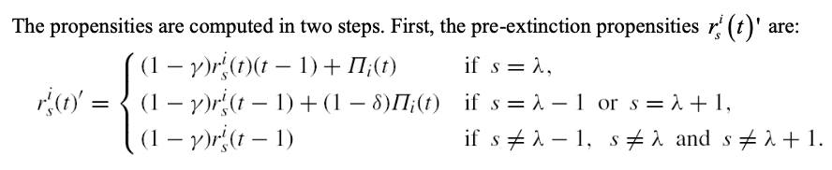

@njit #Numba decorator – enable use in Cournot framework

def propensions_reinforcement_part1(s_bid,propension,profit,lambda_,delta,gamma):

"""Reinforcing s_bid : s_bid in 1..S

Args :

s_bid (int): s_bid value

propension (float) : propension of s_bid

profit (float) : profit at period p

lambda_ (int) : s_bid picked at period p

gamma (float) : forget rate

delta (float) : propension increaser

Returns:

new_propension (float): reinforced propension

# First step : comparison between previously picked s_bid

# and current s_bid

if s_bid==lambda_:

new_propension = (1-gamma)*propension+profit

elif s_bid == lambda_-1 or s_bid == lambda_ +1:

new_propension = (1-gamma)*propension+profit*(1-delta)

else:

new_propension = (1-gamma)*propension

*Plotting simulation:*

def plot_results(n_firm,price_vec,color,avg=False,window=20):

"""Plot market price after a simulation fo a configuration. Can display simulate price

or a moving average of it"""

dic = {1:"Monopoly",2:"Duopoly",3:"Triopoly"}

if n_firm in dic:

t = dic[n_firm] #Retrieve label

else:

t = f'{n_firm}-opoly'

plt.figure(figsize=(10,5))

plt.xlabel("P periods")

plt.ylabel("Market price")

if avg:

price_vec = pd.Series(price_vec).rolling(window).mean()

plt.plot(range(len(price_vec)),price_vec,c=color)#Display price

plt.title(f"Simulation of market price with a {t} - {window} Moving Average")

else:

plt.plot(range(len(price_vec)),price_vec,c=color)

plt.title(f"Simulation of market price with a {t}")

plt.axhline(600/(n_firm+1),color="green",label="Theoretical value")

plt.legend()

plt.show()