**Practical:-1**

**1. Write a Python Program to Convert Celsius to Fahrenheit and vice –a-versa. 14/02/22.**

c=int(input("Enter Celsius "))

f=(9/5)*c+32

print("Celsius to Fahrenheit ",f)

f1=int(input("Enter Fahrenheit "))

c=(5/9)*(f1-32)

print("Fahrenheit to Celsius ",c)

**Output:-**

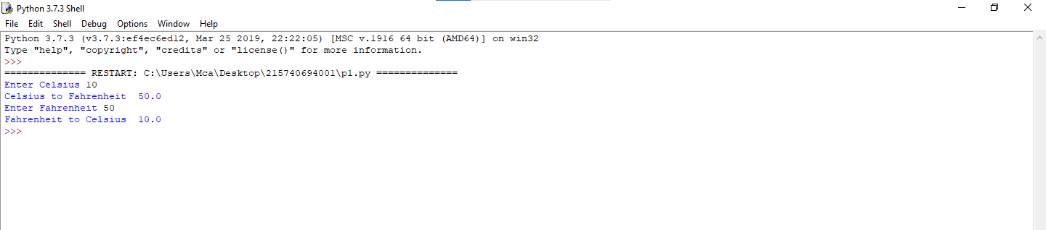

**Practical:-2**

**2 Write a program in python to swap two variables without using temporary variable. . 14/2/22**

a=int(input("Enter a "))

b=int(input("Enter b "))

print("-------------------")

print("Before swap")

print("-------------------")

print("A is ",a)

print("B is ",b)

print("-------------------")

a,b=b,a

print("After swap")

print("-------------------")

print("A is ",a)

print("B is ",b)

**Output:-**

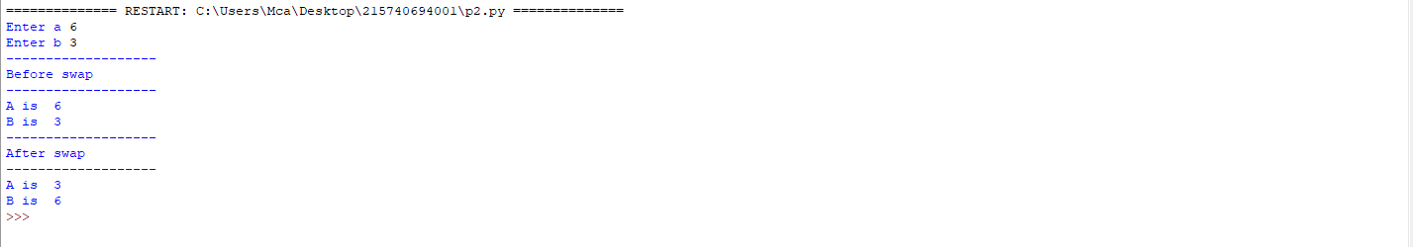

**Practical:-3**

**3. Write a Python Program to Convert Decimal to Binary, Octal and Hexadecimal. 14-2-22**

a=int(input("Enter Number "))

print("binary ",bin(a))

print("Octal ",oct(a))

print("Hexadecimal ",hex(a))

**Output:-**

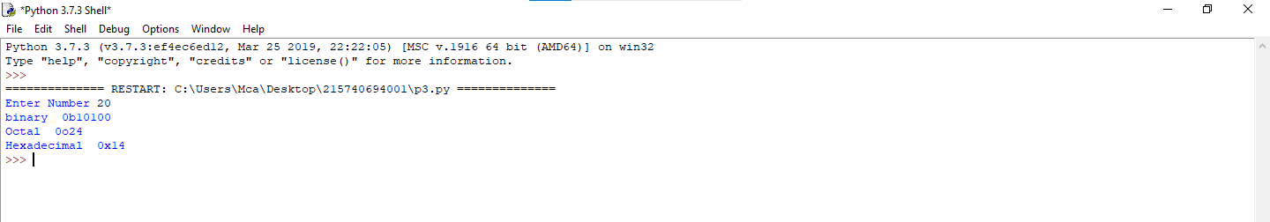

**Practical:-4**

**4 Write a program to make a simple calculator. 14/2/22**

**4.1**

a=int(input("Enter a "))

b=int(input("Enter b "))

c=a+b

print("sum is",c)

c=a-b

print("sub is",c)

c=a*b

print("mulis",c)

c=a/b

print("div is",c)

**Output:-**

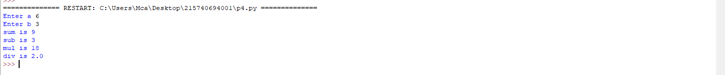

**4.2**

a=int(input("Enter Value 1: "))

b=int(input("Enter value 2: "))

print("")

print("1.Addition")

print("2.Substraction")

print("3.Multiplication")

print("4.division")

print(" ")

n=int(input("Enter Your Choice : "))

if n==1:

print("addition is ",a+b)

elif n==2:

print("substraction is ",a-b)

elif n==3:

print("Multiplication is ",a*b)

elif n==4:

print("Division is ",a/b)

else:

print("invalid Choice..!")

**Output:-**

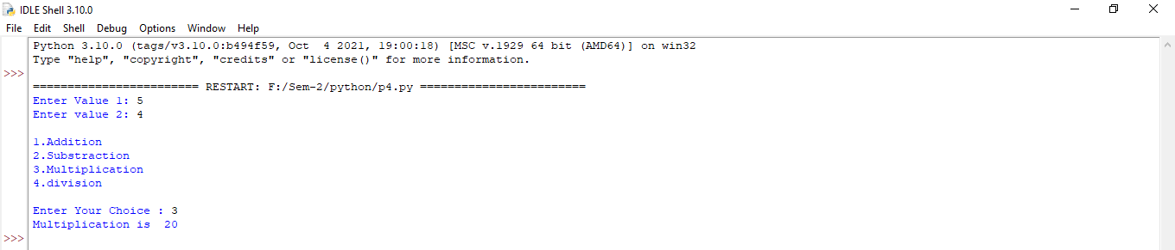

**4.3**

def add(a,b):

return a+b

def sub(a,b):

return a-b

def mul(a,b):

return a*b

def div(a,b):

return a//b

while("true"):

print(" ")

a=int(input("Enter Value 1: "))

b=int(input("Enter value 2: "))

print("-------------------------")

print("1.Addition")

print("2.Substraction")

print("3.Multiplication")

print("4.division")

print("-------------------------")

n=int(input("Enter Your Choice : "))

if n==1:

print("addition is ",add(a,b))

elif n==2:

print("substraction is ",sub(a,b))

elif n==3:

print("Multiplication is ",mul(a,b))

elif n==4:

print("Division is ",div(a,b))

else:

print("invalid Choice..!")

print(" ")

y=input("You want to leave..? press( y or Y ) Otherwise give Enter... ")

if y=='y' or y=='Y':

break

else:

continue

**Output:-**

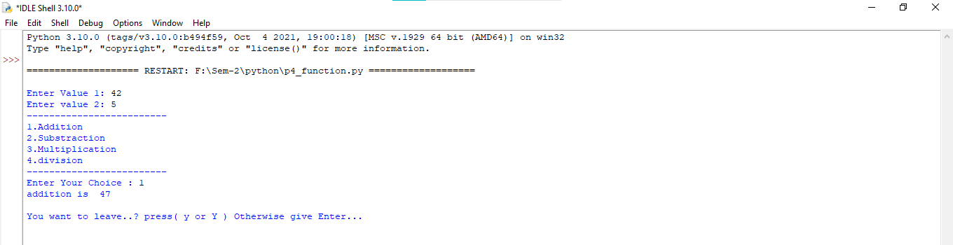

**Practical:-5**

**5 Write a program in python to find out maximum and minimum number out of three user entered number.**

def maxn(num1, num2, num3):

if (num1 > num2) and (num1 > num3):

maxn=num1

elif (num2 > num1) and (num2 > num3):

maxn=num2

else:

maxn = num3

print("The Max numbers is : ", maxn)

def minn(num1, num2, num3):

if (num1 < num2) and (num1 < num3):

minn = num1

elif (num2 < num1) and (num2 < num3):

minn=num2

else:

minn=num3

print("The Min numbers is : ", minn)

number1 = int(input('Enter First number : '))

number2 = int(input('Enter Second number : '))

number3 = int(input('Enter Third number : '))

maxn(number1, number2, number3)

minn(number1, number2, number3)

**Output:-**

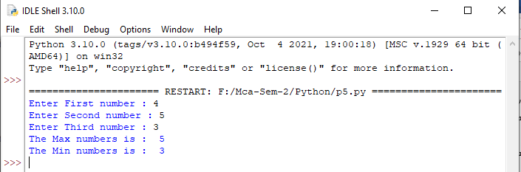

**Practical:-6**

**6 Write a program which will allow user to enter 10 numbers and display largest odd number from them. It will display appropriate message in case if no odd number is found. 14/03/2022**

print("Enter 10 Numbers : ")

modd=0

n=0

while n<10:

i=int(input("Enter no "))

if i%2!=0:

if i>modd:

modd = i

n=n+1

print("Larger odd Numbers is",modd)

**Output:-**

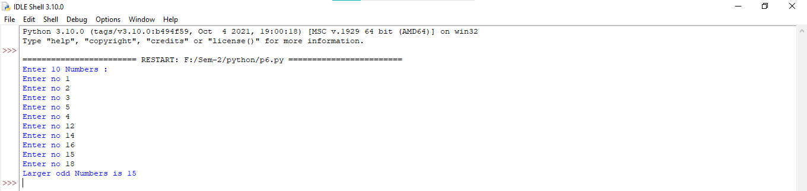

**Practical:-7**

**7. Write a Python program to check if the number provided by the user is an Armstrong number.15/2/22**

n=int(input("Enter Number: "))

temp=n

s=0

while n>0:

d=n%10;

s=s+d*d*d

n=n//10

if temp==s:

print("Armstrong")

else:

print("Not Armstrong")

**Output:-**

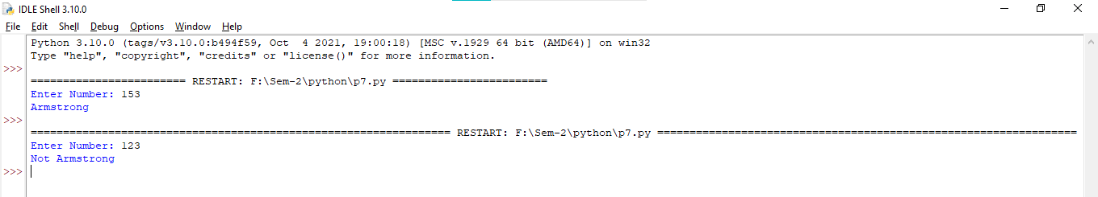

**Practical:-8**

**8. Write a Python program to check if the number provided by the user is a palindrome or not. 15/2/22.**

n=int(input("Enter Numbers : "))

temp=n

rev=0

while n>0:

d=n%10

rev=(rev*10)+d

n=n//10

if temp==rev:

print("Palindrom")

else:

print("Not Palindrom")

**Output:-**

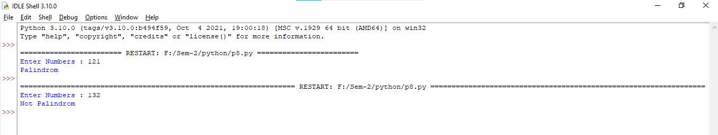

**Practical:-9**

**9.Write a Python program to perform following operation on given string input:**

**a) Count Number of Vowel in given string**

**b) Count Length of string (do not use Len ())**

**c) Reverse string**

**d) Find and replace operation**

**e) check whether string entered is a palindrome or not . 1/3/22**

def countVowel():

p=input("Enter String ")

a=e=i=o=u=c=0

for k in p:

if k=='a':

a=a+1

if k=='e':

e=e+1

if k=='i':

i=i+1

if k=='o':

o=o+1

if k=='u':

u=u+1

if k=='a' or k=='e' or k=='i' or k=='o' or k=='u':

c=c+1

print("A =",a)

print("E =",e)

print("I =",i)

print("O =",o)

print("U =",u)

print("total vowels =",c)

def countLength():

i=input("Enter string ")

s=0

for p in i:

s=s+1

print("Length is ",s)

def reverseString():

i=input("Enter string ")

print("Reverse string ",i[::-1])

def replaceString():

i=input("Enter string ")

f=input("Enter Find String ")

r=input("Enter Replace String ")

print("Original string",i)

print(i.replace(f,r))

def checkStringPaliorNot():

i=input("Enter string ")

if i==i[::-1]:

print("string is a palindrome")

else:

print("string is not a palindrome")

while("true"):

print("a. Count Number of Vowel in given string")

print("b. Count Length of string")

print("c. Reverse string ")

print("d. Find and replace operation")

print("e. check whether string entered is a palindrome or not")

print("Enter choice :")

c=input()

cl=c.lower()

if cl=='a':

countVowel()

elif cl=='b':

countLength()

elif cl=='c':

reverseString()

elif cl=='d':

replaceString()

elif cl=='e':

checkStringPaliorNot()

else:

print("Invalid Choice")

print("----------------------------------")

ch=input("Do you Want To Exit press(Y or y) ")

print("----------------------------------")

if ch=='Y' or ch=='y':

break

**Output:-**

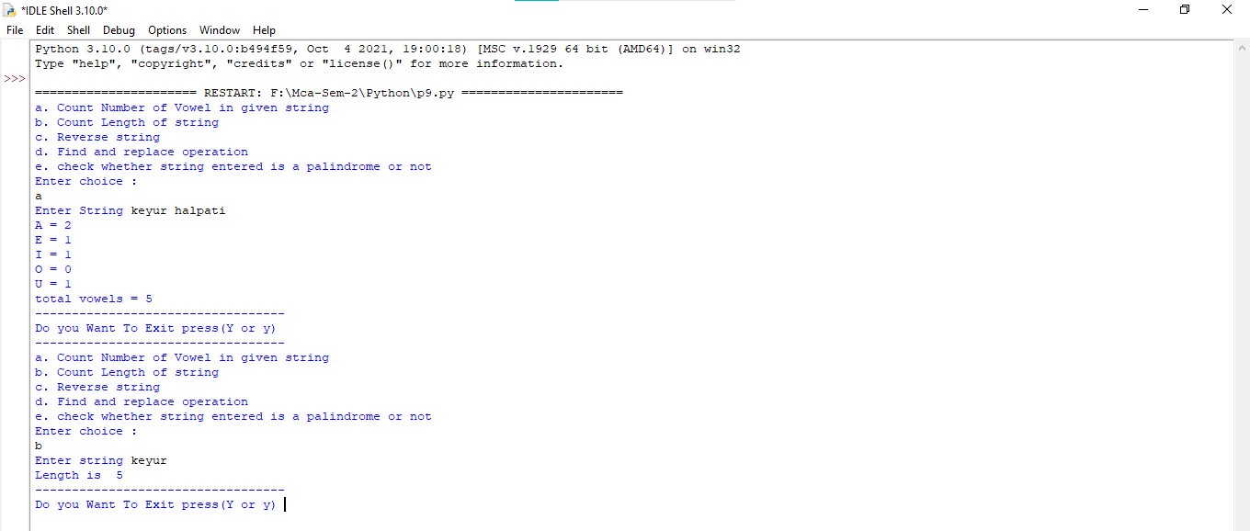

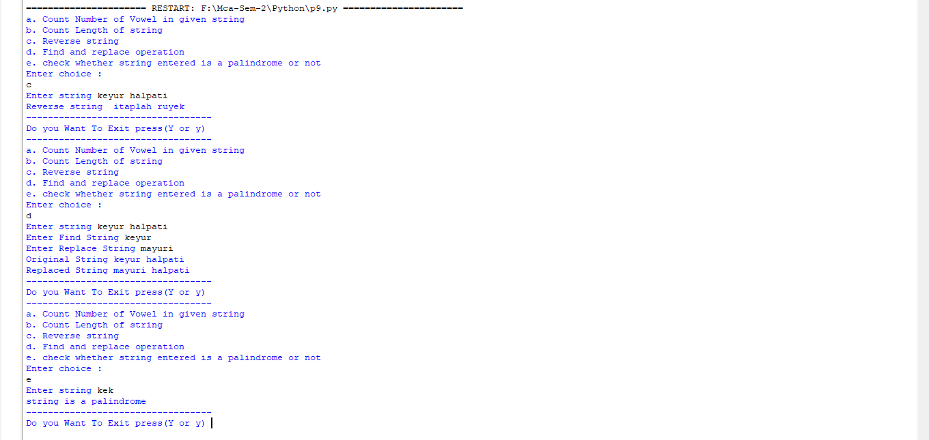

**Practical:-10**

**10 Define a procedure histogram () that takes a list of integers and prints a histogram to the screen. For example, histogram ([4, 9, 7]) should print the following:**

**\*\*\*\***

**\*\*\*\*\*\*\*\*\***

**\*\*\*\*\*\*\* 21/03/2022**

def histogram( items ):

for n in items:

output = ''

t = n

while( t > 0 ):

output += '*'

t = t - 1

print(output)

histogram([4,9,7])

**Output:-**

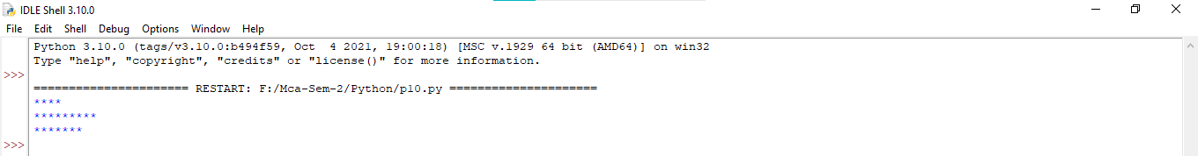

**Practical:-11**

**#11 Write a program in python to implement Fibonacci series up to user entered number.(Use recursive Function) 28/03/2022**

//normal

n=int(input("Enter Number"))

a=0

b=1

print("Fiboncci serias")

print(a)

print(b)

for i in range(0,n-2):

c=a+b

print(c)

a=b

b=c

**Output:-**

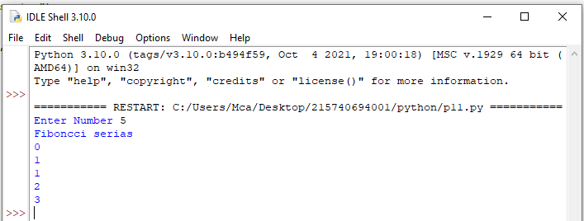

// Recursive

def fibrec(n):

if n==0:

return n

elif n==1:

return n

else:

return (fibrec(n-1) + fibrec(n-2))

n=int(input("Enter Number "))

print("Fiboncci serias")

for f in range(0,n):

print(fibrec(f))

**Output:-**

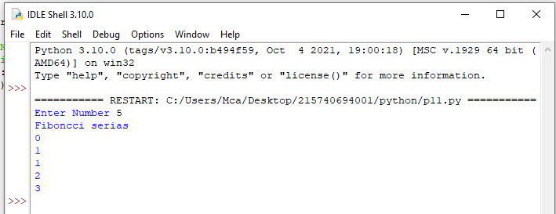

**Practical:-12**

**#12 Write a program in python to implement Factorial series up to user entered number. (Use recursive Function) 28/03/2022.**

//normal

n=int(input("Enter Number "))

print("Factorial serias")

fact=1

for i in range(1,n+1):

fact=fact*i

print(fact)

**Output:-**

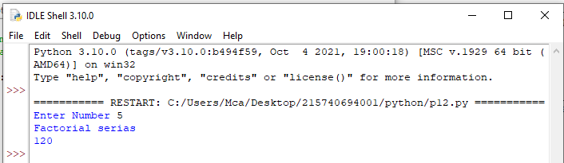

//recursive

def factrec(n):

if n==1:

print(n,end=" = ")

return n

else:

print(n,end=",")

return (n * factrec(n-1))

n=int(input("Enter Number "))

print("Factorial serias")

print(factrec(n),end="")

**Output:-**

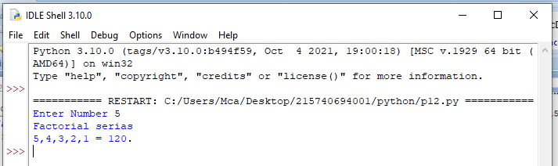

**Practical:-13**

**#13 Write a program in Python to implement readline, readlines, write line and writelines file handling mechanisms.**

while("True"):

f=open('F:\Mca-Sem-2\Python\Files\data.txt','r+')

print("select any one opration from below list")

print("1.readline")

print("2.readlines")

print("3.writeline")

print("4.writelines")

print("5.Exit")

choice = input("Enter choice between 1 to 4:")

if choice == '1':

print("reading file content using readline..")

ln = f.readline()

while ln != "":

ln = f.readline()

print(ln)

elif choice == '2':

print("reading file content using readlines..")

print(f.readlines())

elif choice == '3':

f.write("file opration \n in programming in python")

elif choice == '4':

print("writting line using writelines..")

f.writelines(["programming in ", "python"," \nhello"," python"])

elif choice == '5':

break;

f.close()

**Output:-**

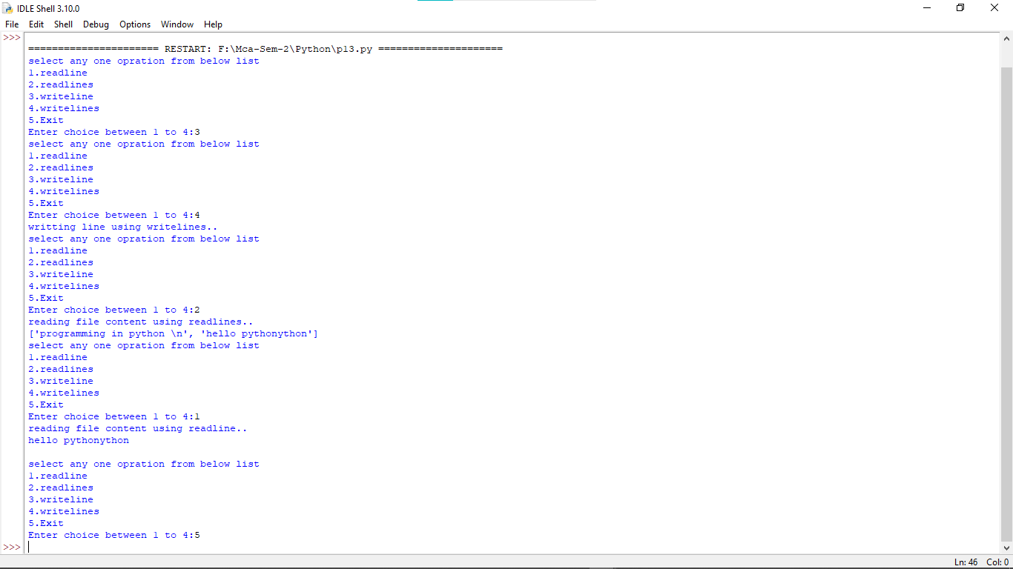

**Practical:-14**

**14. Write a program in python to implement Salary printing file read operation. (File format: Employee No, name, deptno, basic, DA, HRA, Conveyance) should perform below operations.**

**a) Print Salary Slip for given Employee Number**

**b) Print Employee List for Given Department Number.**

import pickle

while("true"):

print("1.Enter Data")

print("2.Print Salary Slip for given Employee Number")

print("3.Print Employee List for Given Department Number")

print("4.Print All Employee")

ch=int(input("Enter Your Choice"))

if ch==1:

f = open("F:\\Mca-Sem-2\\Python\\Files\\employee.txt","ab")

data = []

while("true"):

print("Append Data")

no=input("Enter EmployeeNo ")

name=input("Enter Name ")

deptno=input("Enter deptno ")

basic=input("Enter basic ")

da=input("Enter da ")

hra=input("Enter hra ")

Con=input("Enter Conveyance ")

#list1=["\n"+no+"\t",name+"\t",deptno+"\t",basic+"\t",da+"\t",hra+"\t",Con+"\t"]

list1=[no,name,deptno,basic,da,hra,Con+"\n"]

data.append(list1)

ch=input("Enter Y for more Entry otherwise N to exit..")

if ch=='N' or ch=='n':

break;

pickle.dump(data,f)

f.close()

elif ch==2:

f = open("F:\\Mca-Sem-2\\Python\\Files\\employee.txt","rb")

empno=input("Enter Employee Number :")

r=pickle.load(f)

f=0

print()

print("Basic"+"\t"+"DA"+"\t"+"HRA"+"\t"+"Conveyance")

for i in r:

if i[0]==empno:

print(i[3]+"\t",i[4]+"\t",i[5]+"\t",i[6])

f=1

break

if f==0:

print("Not")

elif ch==3:

f = open("F:\\Mca-Sem-2\\Python\\Files\\employee.txt","rb")

deptno=input("Enter Department Number :")

r=pickle.load(f)

f=0

print()

print("EmpNo"+"\t"+"name"+"\t"+"deptno"+"\t"+"Basic"+"\t"+"DA"+"\t"+"HRA"+"\t"+"Conveyance")

for i in r:

if i[2]==deptno:

print(i)

f=1

break

if f==0:

print("Not")

elif ch==4:

f = open("F:\\Mca-Sem-2\\Python\\Files\\employee.txt","rb")

r=pickle.load(f)

f=0

print()

print("EmpNo"+"\t"+"name"+"\t"+"deptno"+"\t"+"Basic"+"\t"+"DA"+"\t"+"HRA"+"\t"+"Conveyance")

for i in r:

print(i)

else:

print("Invalid Choices")

ch=input("Do u Want to Continue..?(Y/n)")

if ch=='N' or ch=='n':

break

**Output:-**

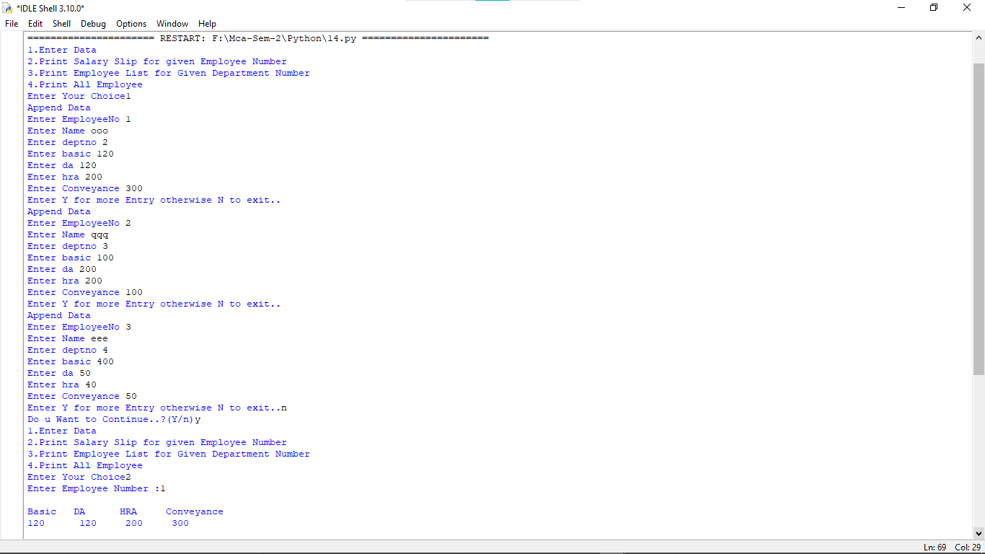

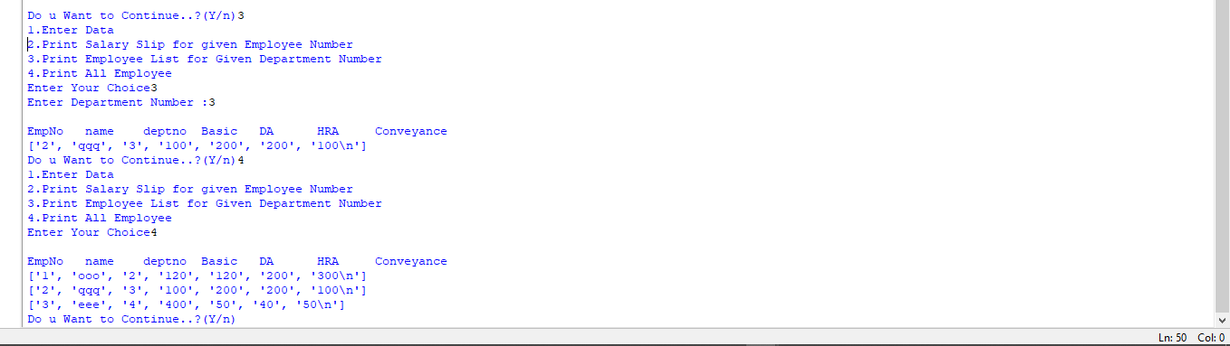

**Practical:-15**

**15 Write a program in python to implement Railway Reservation System using file handling technique. System should perform below operations.**

**a. Reserve a ticket for a passenger.**

**b. List information all reservations done for today’s trains.**

import pickle

from datetime import date

today=str(date.today())

while("true"):

print("1. Enter Data")

print("2. Reserve a ticket for a passenger")

print("3. List information all reservations done for today’s trains.")

n=input("Enter Choice: ")

if n=='1':

f = open("F:\\Mca-Sem-2\\Python\\Files\\Railway_Reservation_System.txt","ab+")

data = []

while("true"):

print("Append Data")

name=input("Enter Name ")

no=input("Enter phone ")

s1=input("Enter Source ")

s2=input("Enter Destination ")

ticket=input("Enter Ticket ")

list1=[name,no,s1,s2,today,ticket]

data.append(list1)

ch=input("Enter Y for more Entry otherwise N to exit..")

if ch=='N' or ch=='n':

break;

pickle.dump(data,f)

f.close()

elif n=='2':

book=input("Enter passenger Name for Reserve a ticket ")

f = open("F:\\Mca-Sem-2\\Python\\Files\\Railway_Reservation_System.txt","rb+")

r = pickle.load(f)

flag=0

l1=[]

for i in r:

if i[0]==book:

flag=1

i[5]="Done"

l1.append(i)

if flag==1:

f.seek(0)

pickle.dump(l1,f)

print("Update Record..")

else:

print("Not Update..")

f.close()

elif n=='3':

f = open("F:\\Mca-Sem-2\\Python\\Files\\Railway_Reservation_System.txt","rb+")

r = pickle.load(f)

for i in r:

if i[4]=='2022-05-02':

print(i)

else:

print("Invalid Choices")

ch=input("Do u want to Continue..(y/n)")

if ch=='N' or ch=='n':

break;x

**Output:-**

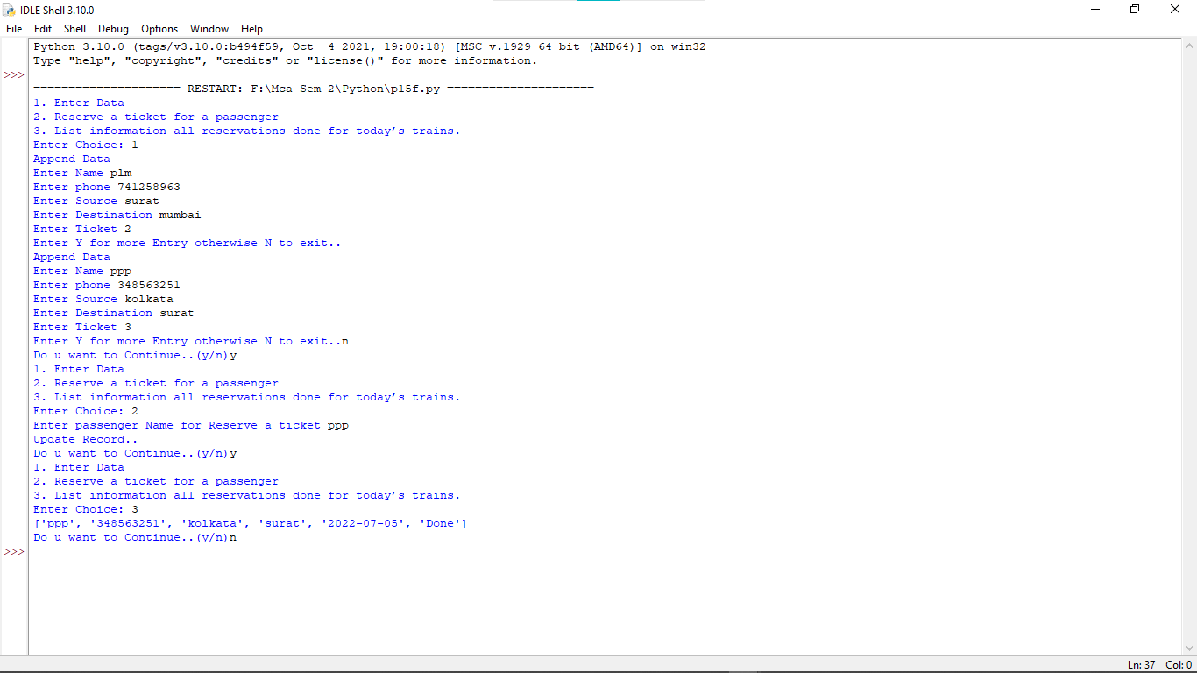

**Practical:-16**

**16. Write a Python program to implement module.**

**Module.py**

def name(n):

return "Your Name is "+n

tbl_student = {"sid":"1","st_enroll":"215740694001","st_code":"21mca01"}

**UseModule.py**

import module as m

p=m.name("yogu")

r=m.tbl_student["st_enroll"]

print(p,"And Your Enrollment number is ",r)

**Output:-**

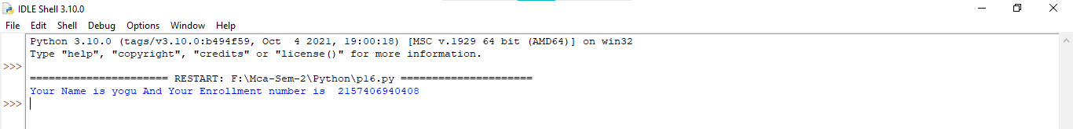

**Practical:-17**

**17. Write a program which will implement decorators for functions and methods in python.**

def deco(identity):

def inner():

a,b=identity()

return "my name is "+a+"\n"+"my ages is "+b

return inner

@deco

def demo():

n=input("Enter Name ")

age=input("Enter age ")

return n,age

print(demo())

**Output:-**

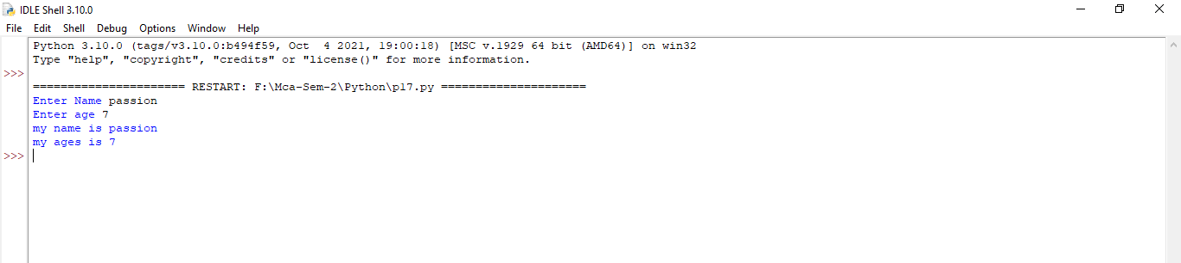

**Practical:-18**

**18. Write a program to read CSV file and generate output using HTML table.**

import pandas as p

d=p.read_csv("myfile_csv.csv")

d.to_html("record.html")

**Output:-**

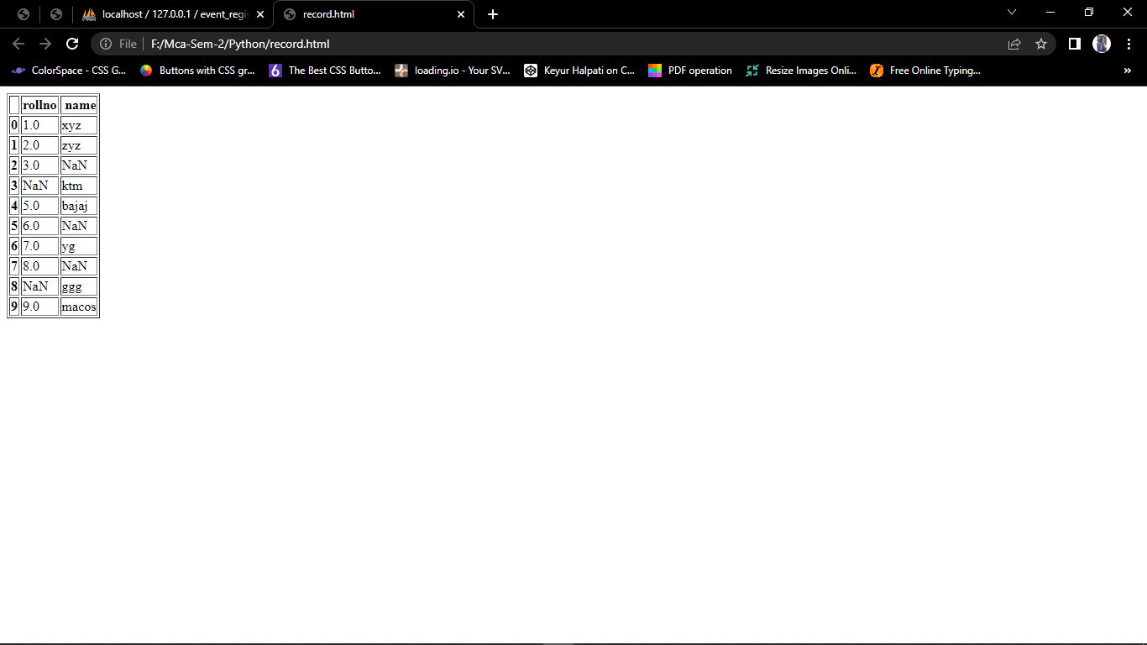

**Practical:-19**

**19. Write a program to process CSV file using CSV module.**

import csv as c

n=0

while(n!=3):

print("")

print("1.Display Data To csv File..")

print("2.Write Data To csv file..")

print("3.Exit")

print("")

n=int(input("Enter Choice: "))

if n==1:

with open('myfile_csv.csv','r') as f:

r=c.reader(f)

for i in r:

print(i)

f.close()

elif n==2:

role=input("Enter RollNo ")

name=input("Enter Name ")

list=[role,name]

with open('myfile_csv.csv','a') as f:

w=c.writer(f)

w.writerow(list)

f.close()

**Output:-**

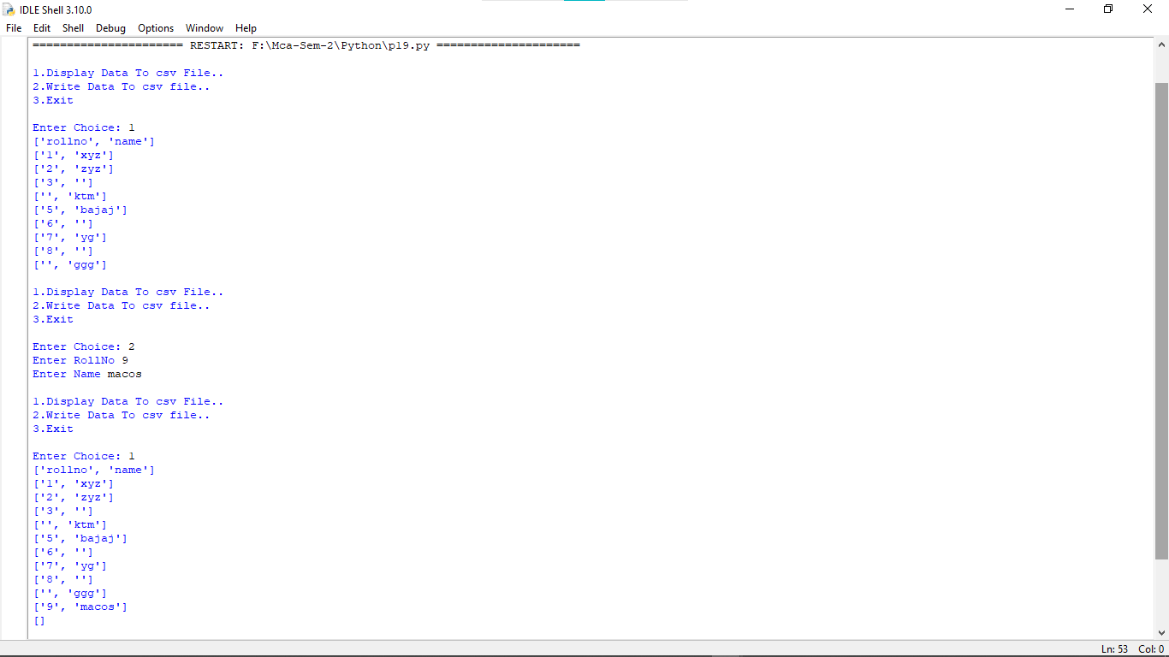



**Practical:-20**

**20. Desirable: Write a program to process JSON and XML data.**

import json as j

import xml.etree.ElementTree as x

n=0

while(n!=3):

print("")

print("1.Json file Read")

print("2.Json file Read")

print("3.Exit")

print("")

n=int(input("Enter Choice: "))

if n==1:

with open('data.json','r') as f:

data=j.load(f)

for i in data['tbl_student']:

print(i)

f.close()

elif n==2:

data=x.parse('data.xml')

root=data.getroot()

for i in root.findall('country'):

year=i.find('year').text

name=i.get('name')

print(name,"->",year)

**Output:-**

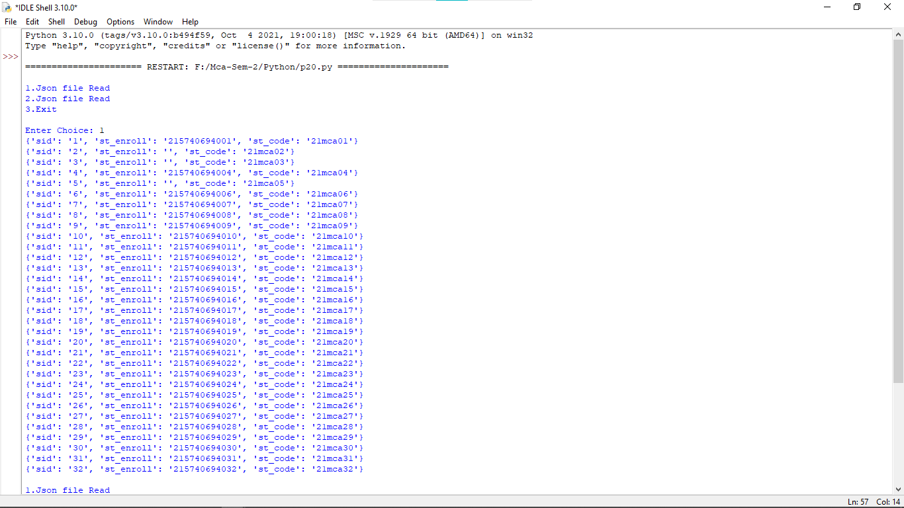

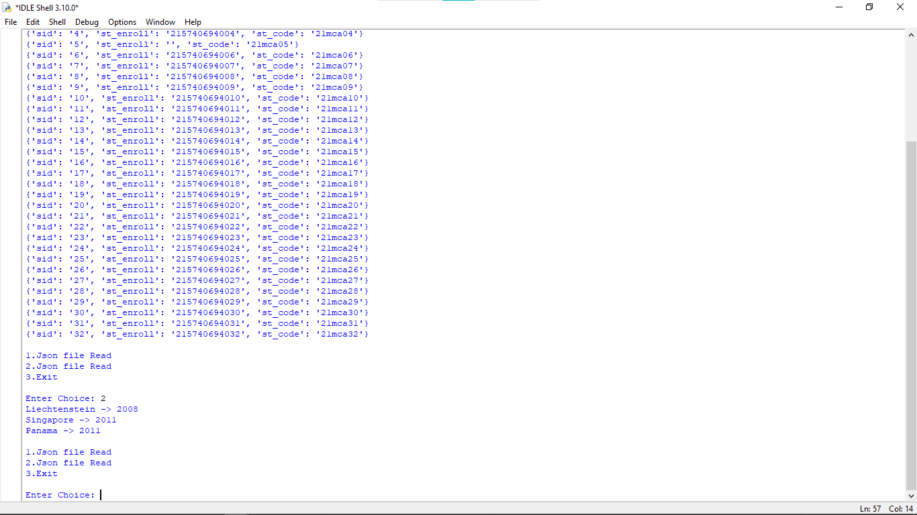

**Practical:-21**

**21.Create Web Database Application “Address Book” with options to**

**a) add/ insert a record**

**b) modify a record**

**c) display a record**

**d) delete a record. 6-6-2022**

import connection as con

def insert():

bname=input("Enter BookName ")

bpage=int(input("Enter Pages "))

q=con.mycon.cursor()

sql="INSERT INTO tbl_book(bname,bpage) VALUES (%s,%s)"

val=(bname,bpage)

try:

v=q.execute(sql,val)

con.mycon.commit()

print("Data Inserted...")

except:

con.mycon.rollback()

print("Data Not Inserted...")

def update():

q=con.mycon.cursor()

fetch="SELECT * FROM tbl_book"

try:

q.execute(fetch)

data=q.fetchall()

for i in data:

print(i)

except:

print("No Data")

print("")

bid=int(input("Enter BookId to Book Detail "))

sql="SELECT * FROM tbl_book where bid=%s"

upval=(bid,)

try:

q.execute(sql,upval)

data=q.fetchall()

for i in data:

bname=i[1]

bpage=i[2]

print("1. update bookname")

print("2. update bookpages")

ch=input("Enter choices ")

if(ch=='1'):

bname=input("Enter Bookname ")

elif(ch=='2'):

bpage=input("Enter Bookpage ")

else:

print("Invalid Input..")

sql="update tbl_book set bname=%s,bpage=%s where bid=%s"

val=(bname,bpage,bid)

try:

q.execute(sql,val)

con.mycon.commit()

print("Updated..")

except:

print("Not Updated..")

except:

print("No data available")

def delete():

bname=input("Enter BookName ")

q=con.mycon.cursor()

sql="DELETE FROM `tbl_book` WHERE bname=%s"

val=(bname,)

try:

v=q.execute(sql,val)

con.mycon.commit()

print("Deleted...")

except:

con.mycon.rollback()

print("Not Deleted...")

def select():

q=con.mycon.cursor()

fetch="SELECT * FROM tbl_book"

try:

q.execute(fetch)

data=q.fetchall()

for i in data:

print(i)

except:

print("No Data")

n=0

while n!=5:

print("")

print("---Menu---")

print("1.Insert")

print("2.Update")

print("3.Delete")

print("4.Display")

print("5.Exit")

print("")

ch=int(input("Enter Choice: "))

if ch==1:

insert()

elif ch==2:

update()

elif ch==3:

delete()

elif ch==4:

select()

else:

break

**Output:-**

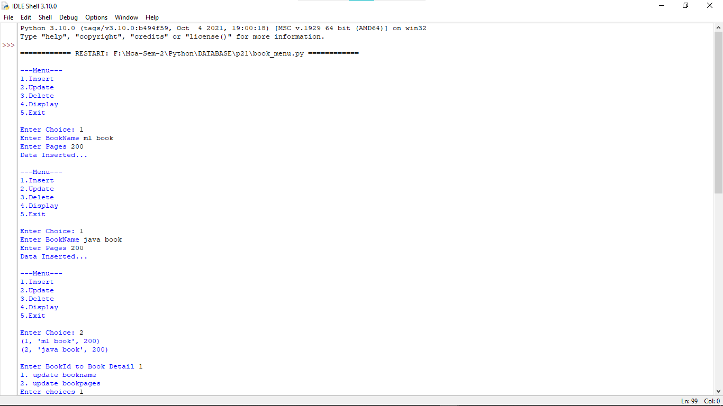

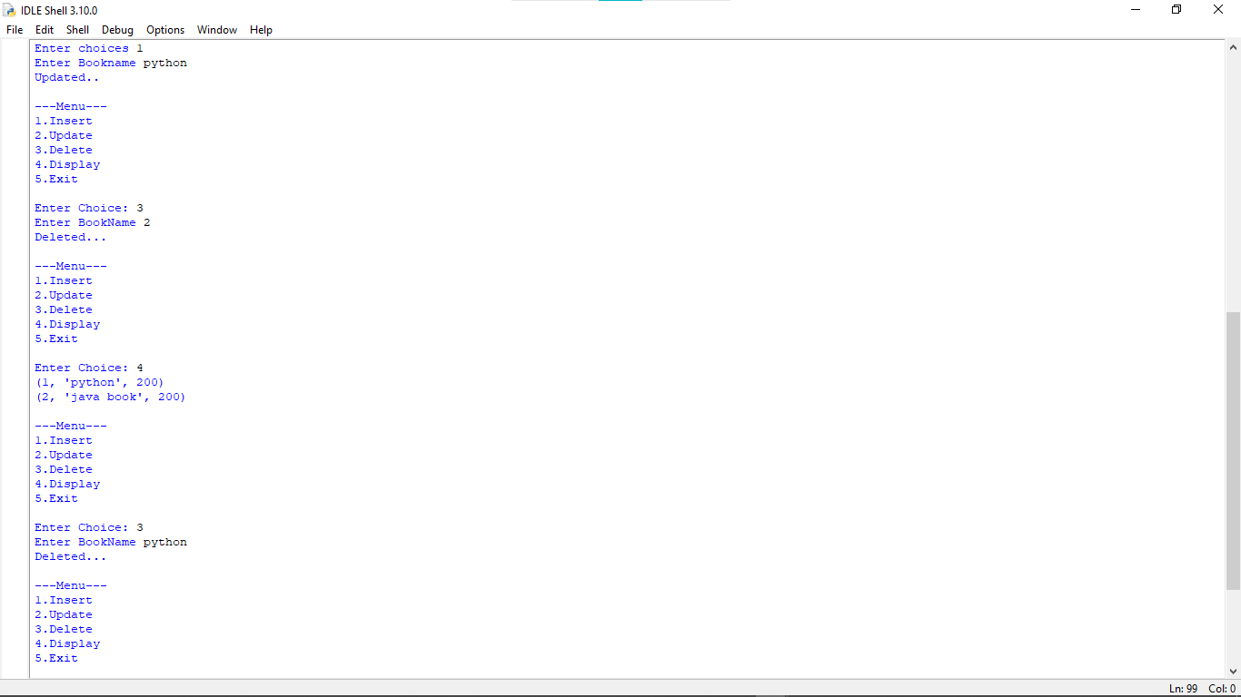

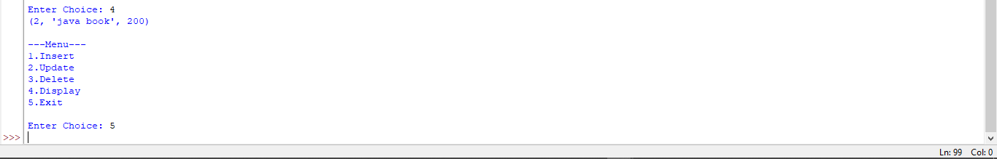

**Practical:-22**

**22.Create Web Database Application “Event Registration” with options to a) Event Registration**

**b) Cancel Registration**

**c) display a record**

import connection as con

def registration():

q=con.mycon.cursor()

name=input("Enter Name ")

phone=int(input("Enter Phone "))

name=input("Enter CollageName ")

data=(name,phone,name)

sql="insert into tbl_registration(rname,rphone,clgname)values(%s,%s,%s)"

try:

q.execute(sql,data)

con.mycon.commit()

print("Registration Successfully Done...")

except:

con.mycon.rollback()

print("Registration is Fail...")

def cancel():

q=con.mycon.cursor()

sql="select * from tbl_registration"

try:

q.execute(sql)

data=q.fetchall()

for i in data:

print(i)

rid=int(input("Enter Registration Id To Cancel Registration: "))

val=(rid,)

sql1="DELETE FROM tbl_registration where rid=%s"

try:

q.execute(sql1,val)

con.mycon.commit()

print("Cancel Registration...")

except:

con.mycon.rollback()

print("Pendding To cancel Registration...")

except:

print("No Data Available")

def display():

q=con.mycon.cursor()

sql="select * from tbl_registration"

try:

q.execute(sql)

data=q.fetchall()

for i in data:

print(i)

except:

print("No Data Available...")

n=0

while n!=4:

print("")

print("1.Event Registration")

print("2.Cancel Registration")

print("3.Display a record")

print("4.Exit")

print("")

n=int(input("Enter Choice "))

if n==1:

registration()

elif n==2:

cancel()

elif n==3:

display()

else:

break

**Output:-**

