**To,**

**State Bank of India**

**RACPC, Kalptaru Complex,**

**Ellora Park, Vadodara.**

**VALUATION REPORT (IN RESPECT OF RESIDENTIAL LAND & BUILDING)**

**Ref File No.225/SBI/Vadodara/2023-24 Date:-13-07-2023**

|  |  |  |  |  |  |  |  |  |  |  |  |  |  |
| --- | --- | --- | --- | --- | --- | --- | --- | --- | --- | --- | --- | --- | --- |
| **I.** | **GENERAL** | | | | | | | | | |  |  | |
| 1. | Purpose for which Valuation is made | | | | | | | | | | : | Banking Purpose | |
| 2. | a) | | | Date of inspection | | | | | | | : | **11-07-2023** | |
|  | b) | | | Date on which the valuation is made | | | | | | | : | **13-07-2023** | |
| 3. | List of documents produced for perusal | | | | | | | | | | | | |
|  | 1) | | | | : | Regd. Sale Deed No.:- **BRA-3/ATA/5777, Dated:-30-04-2008** | | | | | | | |
| 2) | | | | : | Construction Permission No.:- **GF:- L-187/1989-90, Dated:-09-01-1990**  **FF, SC:- Ward No.4, 392/1999-2000, Dated:-01-10-1999** | | | | | | | |
| 3) | | | | : | Map | | | | | | | |
| 4. | Name of the owner(s) and his / their address (es) with Phone no. (details of share of each owner in case of joint ownership) | | | | | | : | **Rameshchandra Natvarlal Panchal** | | | | | |
| 5. | Brief description of the property | | | | | | : | Residential | | | | | |
| 6. | Location of property | | | | | |  |  | | | | | |
|  | a) | | | | Plot No. / Survey No. / F.P.No. | | : | R.S.No. 172/1 Paiki, 172/2, C.S.No.1500/A | | | | | |
| b) | | | | Door No./Plot No. | | : | Plot No.C-54 | | | | | |
| c) | | | | T.S. No. / Village | | : | Moje Village Manjalpur | | | | | |
| d) | | | | Ward / Taluka | | : | Ta. Vadodara. | | | | | |
| e) | | | | Mandal / District | | : | Dist. Vadodara. | | | | | |
| 7. | Postal address of the property | | | | | | : | **Plot No.C-54, Amin Park Co.Op.Hou. Soc.,** Nr. Mani Nagar Soc., Manjalpur, Vadodara. | | | | | |
|  | City / Town | | | | | | : | Vadodara. | | | | | |
|  | Residential Area | | | | | | : | Yes | | | | | |
| Commercial Area | | | | | | : | Yes | | | | | |
| Industrial Area | | | | | | : | ------- | | | | | |
| 9 | Classification of the area | | | | | |  |  | | | | | |
|  | a) | | | High / Middle / Poor | | | : | Middle & High Class | | | | | |
|  | b) | | | Urban / Semi Urban / Rural | | | : | Urban | | | | | |
| 10 | Coming under Corporation limit / Village Panchayat / Municipality | | | | | | : | Under VMC Limit | | | | | |
| 11 | Whether covered under any State / Central Govt. enactments (e.g., Urban Land Ceiling Act) or notified under agency area / scheduled area / cantonment area. | | | | | | : | | N.A | | | | |
| 12 | In case it is an agricultural land, any conversion to house site plots is contemplated. | | | | | | : | | N.A | | | | |
| 13 | Boundaries of the property | | | | | | : | | **As Per Document** | | | | **As Per Site** |
|  |  | | East | | | | : | | | Road | | | Soc Road |
| West | | | | : | | | Block No.B-43/44 | | | Block No.B-43/44 |
| North | | | | : | | | Block No.C-55 | | | Block No.C-55 |
| South | | | | : | | | Block No.C-53 | | | Block No.C-53 |
| 14 |  | | Dimensions of the site | | | | : | | | **a b** | | | |
|  |  | |  | | | |  | | | **As Per Document** | | | **Actual Site** |
|  |  | | North | | | | : | | | 61.76 Sq.Mtr.  (665.00 Sq.Ft.) | | | 10.90 Mt. |
| South | | | | : | | | 10.90 Mt. |
| East | | | | : | | | 06.10 Mt. |
| West | | | | : | | | 06.10 Mt. |
| 14.1 |  | | Latitude, Longitude and Coordinates of the site | | | | : | | | Latitude:- 22°26'42.08"N Longitude:- 73°19'77.60"E | | | |
| 15 | Extent of the site | | | | | | : | | | 715.00 Sq.Ft. (66.49 Sq.Mt.) | | | |
| 16 | Extent of the site considered for valuation  (14A & 14B) | | | | | | : | | | 665.00 Sq.Ft. (61.76 Sq.Mt.) | | | |
| 17 | Whether occupied by the owner / tenant? If occupied by tenant since how long? Rent received per month. | | | | | | : | | | Owner Occupied | | | |
| **II** | **CHARACTERSTICS OF THE SITE** | | | | | |  | | |  | | | |
| 1 | Classification of locality | | | | | | : | | | Middle Class | | | |
| 2 | Development of surrounding areas | | | | | | : | | | Developed Area | | | |
| 3 | Possibility of frequent flooding / submerging | | | | | | : | | | No | | | |
| 4 | Feasibility to the Civic amenities like School, Hospital, Bus Stop, Market etc. | | | | | | : | | | @ 1.0 to 2.0 Km. | | | |
| 5 | Level of land with topographical conditions | | | | | | : | | | Plane Land | | | |
| 6 | Shape of land | | | | | | : | | | Rectangle | | | |
| 7 | Type of use to which it can be put | | | | | | : | | | Residential | | | |
| 8 | Any usage restriction | | | | | | : | | | No | | | |
| 9 | Is plot in town planning approved layout ? | | | | | | : | | | Yes | | | |
| 10 | Corner plot or intermittent plot ? | | | | | | : | | | Intermittent plot | | | |
| 11 | Road facilities | | | | | | : | | | Available | | | |
| 12 | Type of road available at present | | | | | | : | | | Soc. Internal RCC Road | | | |
| 13 | Width of road-is it below 20 ft. or more than 20 ft. | | | | | | : | | | Less than 20’ft. | | | |
| 14 | Is it a Land – Locked land ? | | | | | | : | | | No | | | |
| 15 | Water potentiality | | | | | | : | | | Available | | | |
| 16 | Underground sewerage system | | | | | | : | | | Available | | | |
| 17 | Power supply is available in the site | | | | | | : | | | Available | | | |
| 18 | Advantages of the site | | | | | | : | | | ---------- | | | |
|  | 1) | | | |  | | : | | | ----------- | | | |
|  | 2) | | | |  | | : | | | ----------- | | | |
| 19 | Special Remarks, if any like threat of acquisition of land for publics service purposes, road widening or applicability of CRZ provisions etc. (Distance from Sea Coast/ Tidal level must be incorporated) | | | | | | : | | | No | | | |
|  | 1) | | | |  | | : | | | **-----------** | | | |
|  | 2) | | | |  | | : | | | **-----------** | | | |
|  | **Part – A (Valuation of land)** | | | | | | : | | |  | | | |
| 1 | Size of Plot (As Per Sale-Deed) | | | | | | : | | | **665.00 Sq.Ft.** (61.76 Sq.Mt.) | | | |
|  | North & South | | | | | | : | | | 10.90 Mt. | | | |
|  | East & West | | | | | | : | | | 06.10 Mt. | | | |
| 2 | Total extent of the plot | | | | | | : | | | **665.00 Sq.Ft.** (61.76 Sq.Mt.) | | | |
| 3 | Prevailing Market rate | | | | | | : | | | **Rs.3700/- to 4200/- Per Sq.ft.**  Inquiries made with various estate agencies, developers of nearby area, and other reliable sources | | | |
| 4 | Guideline rate obtained from the Registrar’s Office (an evidence thereof to be enclosed)(As Per attached Annexure- A) | | | | | | : | | | **Rs.11500/- Per Sq.Mtr. X 1.8 = Rs.20,700/- Per Sq.Mtr. (As Per New Provisional Guideline Provided by Revenue Department – Gujarat Govt.)** | | | |
| The subject property under valuation, we have considered Guideline Rate as per the new provision guideline provided by revenue department (Gujarat Govt.) Order No. STP-122023-20-H.1, Dated:- 13-04-2023, which is attached below in annexure A, which please note. | | | | | | | | | | | | | |
| 5 | Assessed / adopted rate of valuation | | | | | | : | | | **Rs.4000/- Sq.ft.** | | | |
| 6 | Estimated value of land | | | | | | : | | | **Rs.26,60,000/-**  (665.00 Sq.ft. x Rs.4000/- Per Sq.ft.) | | | |
| **Part- B (Valuation of Building)** | | | | | | |  | | |  | | | |
| **1** | | Technical details of the building | | | | |  | | |  | | | |
| a) | | | Type of Building (Residential / Commercial / Industrial) | | : | | | Residential | | | |
| b) | | | Type of construction (Load bearing / RCC / Steel Framed) | | : | | | Load Bearing Wall Structure | | | |
| c) | | | Year of construction | | : | | | GF:-1989 – 90, FF,SC:-1999-2000 | | | |
| d) | | | Number of floors and height of each floor including basement, if any | | : | | | GF,FF & SC Only and 10’ft height of floor approximately | | | |
| e) | | | Built up Area floor-wise (As Per Map) | | : | | | G.F: - 344.00 Sq.Ft.  F.F: - 408.00 Sq.Ft.  S.C:- 060.00 Sq.Ft.  **Total:- 812.00 Sq. Ft.** (75.41 Sq.Mtr.) | | | |
| f) | | | Condition of the building | |  | | |  | | | |
|  | | i) | | | Exterior – Excellent, Good, Normal, Poor. | | : | | | Good | | | |
|  | | ii) | | | Interior – Excellent, Good, Normal, Poor | | : | | | Good | | | |
|  | | g) | | | Date of issue and validity of layout of approved map and plan | | : | | | GF:- L-187/1989-90, Dated:-09-01-1990  FF, SC :- Ward No.4, 392/1999-2000,  Dated:-01-10-1999 (1 Year Validity) | | | |
|  | | h) | | | Approved map/ Plan issuing Authority | | : | | | VMC | | | |
|  | | i) | | | Whether Genuineness or Authenticity of approved map/plan is verified | | : | | | Yes | | | |
|  | | j) | | | Any other comments by our empanelled valuer | | : | | | **------** | | | |

Specifications of construction (floor-wise) in respect of –

|  |  |  |  |  |  |
| --- | --- | --- | --- | --- | --- |
| S. No. | Description | | Ground Floor | | First Floor & SC |
| 1 | Foundation | | Open Spread Foundation | | ---do--- |
| 2 | Basement | | No | | ------- |
| 3 | Superstructure | | Brick Masonry With Cement Plaster | | ---do--- |
| 4 | Joinery / Doors & Windows (please furnish details about size of frames, shutters, glazing, fitting etc., and specify the species of timber) | | Wooden Door &  Aluminum Windows | | ---do--- |
| 5 | RCC Works | | RCC Slab | | ---do--- |
| 6 | Plastering | | Inside Smooth Plaster & Outside Sand faced | | ---do--- |
| 7 | Flooring, Skirting, dadoing | | Vitrified | | ---do--- |
| I | Special finish as marble, granite, wooden paneling, grills etc. | | **-** | | ---- |
| 9 | Roofing including weather proof course | | **-** | | ---- |
| 10 | Drainage | | Connected to Municipal Sewer Line | | ---do--- |
| S. No. | Description | | Ground floor | | First Floor |
| **2** | **Compound Wall** | |  |  |  |
|  | Height | | : | 4ft. (Approx.) | ------- |
|  | Length | | : | As Per Plot Site | ------- |
|  | Type of Construction | | : | Brick Masonry | ------- |
| **3** | **Electrical Installation** | | : |  |  |
|  | Type of wiring | | : | Concealed | ------- |
|  | Class of fittings (superior / ordinary / poor) | | : | Ordinary | ------- |
|  | Number of light points | | : | ----- | ------- |
|  | Fan Points | | : | ------ | ------- |
|  | Spare plug points | | : | ------ | ------- |
|  | Any other item | | : | ------ | ------ |
| **4** | **Plumbing Installation** | | : |  |  |
|  | a) | No. of water closets and their type | : | ------- | ------ |
|  | b) | No. of wash basins | : | -------- | -------- |
|  | c) | No. of urinals | : | ------- | -------- |
|  | d) | No. of bath tubs | : | ------- | -------- |
|  | e) | Water meters, taps etc. | : | ------- | -------- |
|  | f) | Any other fixtures | : | ------- | -------- |

**Details of Valuation**

|  |  |  |  |  |  |  |
| --- | --- | --- | --- | --- | --- | --- |
| Sr. No. | Particulars of item | Total  Built up  Area  in Sq.ft. | Roof  height | Age of Bldg. | Estimated replacement rate of construction Rs.  (Depr. Rate) | Net Value  Rs.  (Depr. Rate Value) |
| 1. | G.F: - 344.00 Sq.Ft.  F.F: - 408.00 Sq.Ft.  S.C:- 060.00 Sq.Ft.  **Total:- 812.00 Sq. Ft.** (75.41 Sq.Mtr.) | **812.00 Sq. Ft.** (75.41 Sq.Mtr.) | 3.00 Mt. | 33  Years | **Rs.1000/- Sq.Ft.** | **Rs.8,12,000/-** |

**(Amount in Rs. Eight Lacs Twelve Thousand Only.)**

**Part – C (Extra)**

|  |  |  |  |
| --- | --- | --- | --- |
| 1 | Portico | : | No |
| 2 | Ornamental front door | : | Rs.00/- |
| 3 | Sit out / Verandah with steel grills | : | Rs.00/- |
| 4 | Overhead Water tank | : | Rs.35,000/- |
| 5 | Extra steel / collapsible gates | : | No |
|  | Total |  | **Rs.35,000/-** |

**Part – D (Amenities)** (Amount in Rs.)

|  |  |  |  |
| --- | --- | --- | --- |
| 1 | Wardrobes | : | Rs.50,000/- |
| 2 | Glazed tiles | : | Rs.00/- |
| 3 | Extra sinks and bath tub | : | Rs.00/- |
| 4 | Marble / ceramic tiles flooring | : | Rs.00/- |
| 5 | Interior decorations | : | Rs.00/- |
| 6 | Architectural elevation works | : | Rs.00/- |
| 7 | Paneling works | : | Rs.00/- |
| 8 | Aluminum works | : | No |
| 9 | Aluminum hand rails | : | Rs.00/- |
| 10 | False ceiling | : | Rs.00/- |
|  | Total | : | **Rs.50,000/-** |

**Part – E (Miscellaneous)** (Amount in Rs.)

|  |  |  |  |
| --- | --- | --- | --- |
| 1 | Separate toilet room (L…..S) | : | **NA** |
| 2 | Separate lumber room | : | **NA** |
| 3 | Separate water tank / sump | : | Rs. 00/- |
| 4 | Trees, gardening | : | Rs. 00/- |
|  | Total | : | **NA** |

**Part – F (Services)**

|  |  |  |  |
| --- | --- | --- | --- |
| 1 | Water supply arrangements | : | NA |
| 2 | Drainage arrangements | : | NA |
| 3 | Compound wall, Paving, Gate etc. (L…S) | : | Rs.50,000/- |
| 4 | C.B. deposits, fittings etc. | : | NA |
| 5 | Solar Panel | : | Rs.000/- |
|  | Total | : | **Rs.50,000/-** |

**Total abstract of the entire property**

|  |  |  |  |
| --- | --- | --- | --- |
| Part – A | Land | : | Rs.26,60,000/- |
| Part – B | Building | : | Rs.08,12,000/- |
| Part – C | Extra items | : | Rs.35,000/- |
| Part – D | Amenities | : | Rs.50,000/- |
| Part – E | Miscellaneous | : | Rs.000/- |
| Part – F | Services | : | Rs.50,000/- |
| **Total** | | **:** | **Rs.36,07,000/-** |

(Valuation: Here the approved valuer should discuss in detail his approach to valuation of property and indicate how the value has been arrived at, supported by necessary calculations. Also such aspects as i) Salability ii) Likely rental values in future and iii) Any likely income it may generate may be discussed).

As a result of my appraisal and analysis it is my considered opinion that the present Fair Market value of the above property in the prevailing condition with aforesaid specifications is **Rs.36,07,000/-** (Rupees Thirty Six Lacs Seven Thousand Only), The book Value **(Regd. Sale-Deed No.:-BRA-3/ATA/5777, Dated:-30-04-2008, Rs.31,227/-)** (Rupees Thirty One Thousand Two Hundred Twenty Seven Only) the **Realizable Value** (95% of Present Market Value) **Rs.34,27,000/-** & the **Distress Value** (85% of present Market Value) **Rs.30,66,000/-**

Place:-**Vadodara.** Date:- **13-07-2023**  Signature

(Name of the Approved Valuer)

The undersigned has inspected the property detailed in the valuation report dated: _________ on ___________. We are satisfied that the fair & reasonable market value of the property is Rs.__________(Rupees_______________________________________________________Only).

Signature

(Name of the Branch Manager)

|  |  |  |  |  |  |  |
| --- | --- | --- | --- | --- | --- | --- |
|  | |  |  | | | **Date:-13-07-2023** |
| **CERTIFICATE OF STABILITY** | | | | | | |
| 1. | Name of the occupier of Property | | | : | **Rameshchandra Natvarlal Panchal** | |
| 2. | R.S. No. of the property | | |  | R.S.No.172/1 Paiki, 172/2, C.S.No.1500/A, Moje Village Manjalpur | |
| 3. | Situation of the property | | | : | **Plot No.C-54, Amin Park Co.Op.Hou. Soc.,** Nr. Mani Nagar Soc., Manjalpur, Vadodara. | |
| 4. | Plinth Area | | | : | 344.00 Sq.Ft | |
| 5. | Nos of floor on which the skeletal stand. | | | : | GF, FF & SC Only | |
| 6. | Types of Construction | | | : | Load Bearing Wall Structure | |
| 7. | Year of Construction | | | : | GF:- 1989 – 1990, FF,SC:-1999-2000 | |
| 8. | Age of Building | | | : | 33 Years | |
| 9. | Expected future life | | | : | 27 Years (If Maintained Properly) | |
| I certify that I have personally inspected the existing residential House (Property), I have gone through the approved architectural plans and drawings provided by the client.  **Rameshchandra Natvarlal Panchal** I am of the opinion that the building is structurally sound enough under the favorable circumstances at present to with stand the certified load according to norms. | | | | | | |

**DECLARATION – CUM- UNDERTAKING FROM VALUERS**

**(Annexure-IV)**

**I, Virendrabhai F. Panchal** Son of **Fullchand Panchal** do hereby solemnly affirm and state that :

1. I am a citizen of India
2. I will not undertake valuation of any assets in which I have a direct or indirect interest or become so interest or become so interested at any time during a period of three years prior to my appointment as valuer or three years after the valuation of assets was conducted by me.
3. The information furnished in my valuation report dated **13-07-2023** is true and correct to the best of my knowledge and belief and I have made an impartial and true valuation of the property.
4. Our Site Engineer has personally inspected the property on **11-07-2023.** The Work is not sub-contracted to any other valuer and carried out by myself.
5. Valuation report is submitted in the format as prescribed by the Bank.
6. I have not been depanelled/delisted by any other bank and in case any such depanelment by other banks during my empanelment with you, i will inform you within 3 days of such depanelment.
7. I have not removed / dismissed from service/employment earlier.
8. I have not been convicted of any offence and sentenced to a term of imprisonment;
9. I have not been found guilty of misconduct in my professional capacity.
10. I have not been declared to be unsound mind
11. I am not an undischarged bankrupt, or has not applied to be adjudicated as a bankrupt;
12. I am not an undischarged insolvent
13. I have not been levied a penalty under section 271J of Income-tax Act, 1961 (43 of 1961) and time limit for filing appeal before Commissioner of Income-tax (Appeals) or Income-tax Appellate Tribunal, as the case may be has expired, or such penalty has been confirmed by Income-tax Appellate Tribunal, and five years have not elapsed after levy of such penalty
14. I have not been convicted of an offence connected with any proceeding under the income Tax Act 1961, Wealth Tax Act 1957 or Gift Tax Act 1958 and
15. My PAN Card Number is **AAFCV637C.**

Service Tax number as applicable is **24AAFCV4637C1ZJ.**

1. I undertake to keep you informed of any events or happenings which would make me ineligible for empanelment as a valuer
2. I have not concealed or suppressed any material information, facts and records and I have made a complete and full disclosure
3. I have read the handbook on policy, Standards and procedure for real Estate Valuations, 2011 of the IBA and this report is in conformity to the “Standards”, enshrined for valuation in the Part-B of the above handbook to the best of my ability.
4. I have read the International valuation Standards (IVS) and the report submitted to the bank for the respective asset class is in conformity to the “Standards” as enshrined for valuation in the IVS in “General Standards” and “Asset Standards” as applicable.
5. I abide by the Model Code of Conduct for empanelment of valuer in the Bank. (Annexure V-A signed copy of same to be taken and kept along with this declaration)
6. I am registered under Section 34 AB of the Wealth Tax Act, 1957. (Strike off, if not applicable)
7. I am valuer registered with insolvency & Bankruptcy Board of India (IBBI) (Strike off, if not applicable)
8. My CIBIL Score and credit worthiness is as per Bank’s guidelines.
9. I am the proprietor / partner / authorized official of the firm/ company. Who is competent to sign this valuation report.
10. I will undertake the valuation work on receipt of Letter of Engagement generated from the system (i.e LLMS/LOS) Only.
11. Further, I hereby provide the following information.

**Place:-Vadodara**

**Date:-13-07-2023**

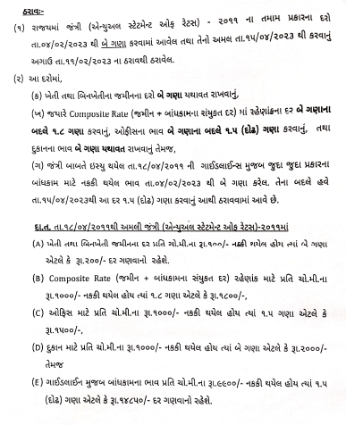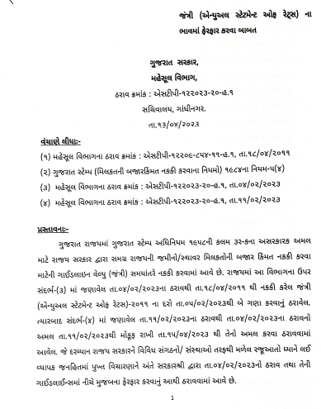 **Annexure A**

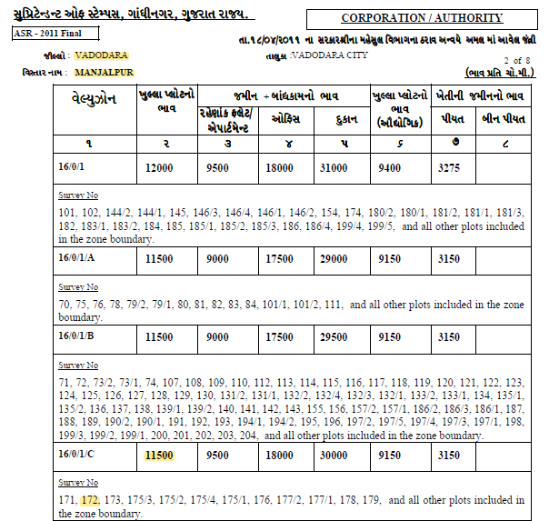

**MODEL CODE OF CONDUCT FOR VALUERS**

**{Adopted in line with companies (Registered Valuers and Valuation Rules, 2017)}**

All valuers empanelled with bank shall strictly adhere to the following code of conduct:

**Integrity and Fairness**

1. A valuer shall, in the conduct of his/its business, follow high standards of integrity and fairness in all his/its dealings with his/its clients and other valuers.

2. A valuer shall maintain integrity by being honest, straightforward and forthright in all professional relationships.

3. A valuer shall endeavor to ensure that he / it provide true and adequate information and shall not misrepresent any facts or situations.

4. A valuer shall retrain from being involved in any action that would bring disrepute to the profession.

5. A valuer shall keep public interest foremost while delivering his services.

**Professional Competence and Due Care**

6. A valuer shall render at all times high standard of service, exercise due diligence, ensure proper care and exercise independent professional judgment.

7. A valuer shall carry out professional services in accordance with the relevant technical and professional standards that may be specified from time to time.

8. A valuer shall continuously maintain professional knowledge and skill provide competent professional service based on up-to –date developments in practice, prevailing regulations / guidelines and techniques.

9. In the preparation of a valuation report, the valuer shall not disclaim liability for his / its expertise or deny his / its duty of care, except to the extent that the assumptions are based on statements of fact provided by the company or its auditors or consultants or information available in public domain and not generated by the valuer.

10. A valuer shall not carry out any instruction of the client in sofar as they are incompatible with the requirements of integrity, objectivity and independence.

11. A valuer shall clearly state to his client the services that he would be competent to provide and the services for which he would be relying on other valuers of professionals or for which the client can have a separate arrangement with other valuers.

**Independence and Disclosure of interest**

12. A valuer shall act with objectivity in his/ its professional dealing by ensuring that his / its decisions are made without the presence of any bias, conflict of interest, and coercion, or undue influence of any party, whether directly connected to the valuation assignment or not.

13. A valuer shall not take up an assignment if he /it or any of his /its relatives or associates is not independent in terms of association to the company.

14. A valuer shall maintain complete independence in his/its professional relationships and shall conduct the valuation independent of external influences.

15. A valuer shall wherever necessary disclose to the clients, possible sources of conflicts of duties and interests, while providing unbiased services.

16.A valuer shall not deal in securities of any subject company after any time when he/ it first becomes aware of the possibility of his/its association with the valuation, and in accordance with the Securities and Exchange Board of India (Prohibition of insider Trading) Regulations, 2015 or till the time the valuation report becomes public, whichever is earlier.

17. A valuer shall not indulge in “mandate snatching” or offering “convenience valuations” in order to cater to a company or client’s needs.

18. As an independent valuer, the valuer shall not charge success fee (Success fees may be defined as a compensation / incentive paid to any third party for successful closure of transaction. In this case, approval of credit proposals).

19. In any fairness opinion or independent expert opinion submitted by a valuer, if there has been a prior engagement in an unconnected transaction, the valuer shall declare the association with the company during the last five years.

**Confidentiality**

20. A valuer shall not use or divulge to other clients or any other party any confidential information about the subject company, which has come to his / its knowledge without proper and specific authority or unless there is a legal or professional right or duty to disclose.

**Information Management**

21. A valuer shall ensure that he / it maintains written contemporaneous records for any decision taken, the reasons for taking the decision, and the information and evidence in support of such decision. This shall be maintained so as to sufficiently enable a reasonable person to take a view on the appropriateness of his / its decisions and actions.

22. A valuer shall appear, co-operate and be available for inspections and investigations carried out by the authority, any person authority, the registered valuers organization with which he /it is registered or any other statutory regulatory body.

23. A valuer shall provide all information and records as may be required by the authority, the tribunal, Appellate Tribunal, the registered valuers organization with which he /it is registered, or any other statutory regulatory body.

24. A valuer white respecting the confidentiality of information acquired during the course of performing professional services shall maintain proper working papers for a period of three years or such longer period as required in its contract for a specific valuation, for production before a regulatory authority or for a peer review. In the event of a pending case before the Tribunal or Appellate Tribunal, the record shall be maintained till the disposal of the case.

**Gifts and hospitality:**

25. A valuer or his /its relative shall not accept gifts or hospitality which undermines or affects his independence as a valuer.

Explanation:- For the purposes of this code the term ‘relative’ shall have the same meaning as defined in clause (77) of section 2 of the companies Act, 2013(18 of 2013).

26. A valuer shall not offer gifts or hospitality or a financial or any other advantage to a public servant or any other person with a view to obtain or retain work for himself / itself, or to obtain or retain an advantage in the conduct of profession for himself / itself.

**Remuneration and costs**

27. A valuer shall provide services for remuneration which is charged in a transparent manner, is a reasonable reflection of the work necessarily and properly undertaken, and is not inconsistent with the applicable rules.

28. A valuer shall not accept any fees or charges other than those which are disclosed in a written contract with the person to whom he would be rendering service.

**Occupation, employability and restrictions.**

29. A valuer shall refrain from accepting too many assignments, if he/it is unlikely to be able to devote adequate time to each of his / its assignments.

30. A valuer shall not conduct business which in the opinion of the authority or the registered valuer organization discredits the profession.

**Date:- 13-07-2023**

**Place:- Vadodara.**

**Google Map**

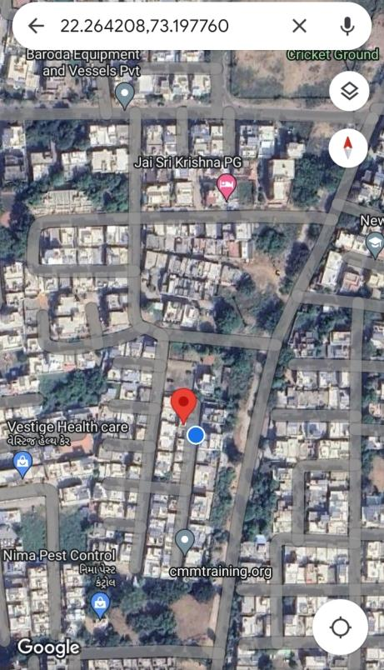

**Latitude:- 22°26'42.08"N, Longitude:- 73°19'77.60"E**

Property Photograph of **Plot No.C-54, Amin Park Co.Op.Hou.Soc.,**

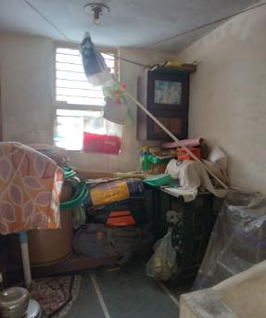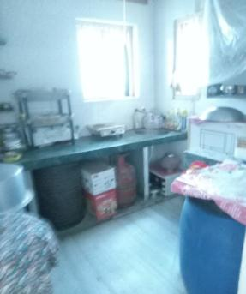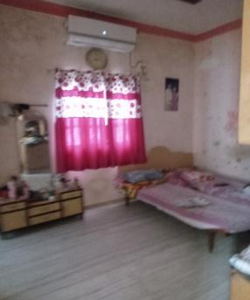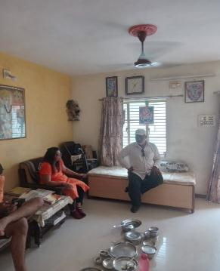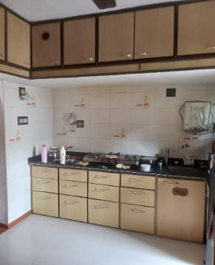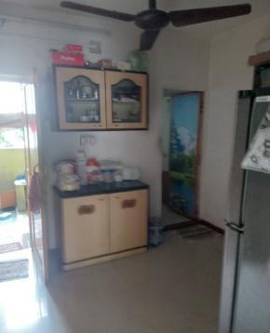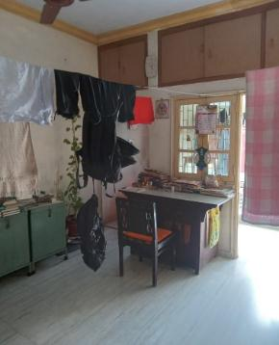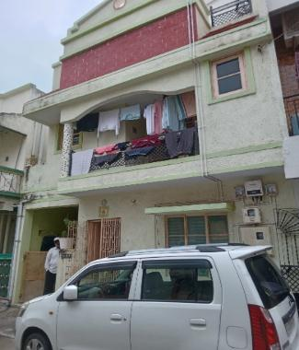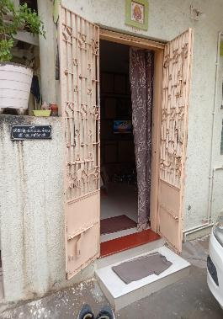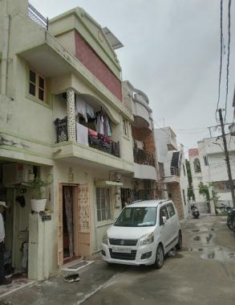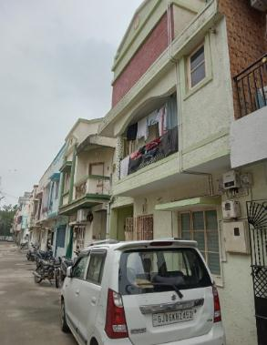 Nr. Mani Nagar Soc., Manjalpur, Vadodara.

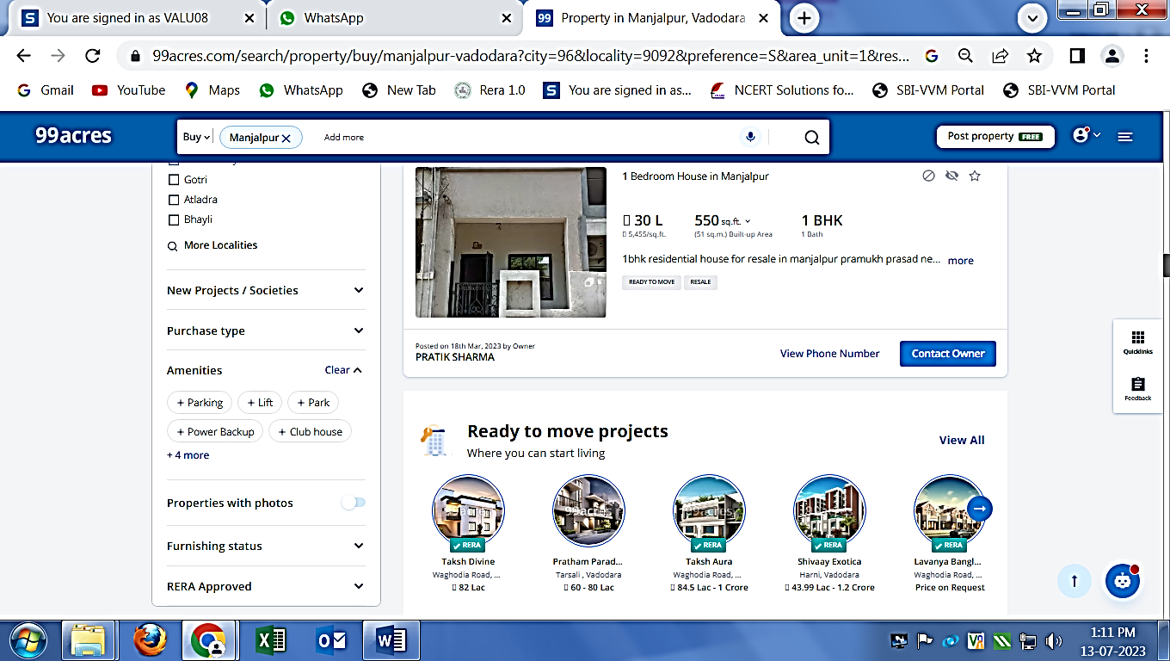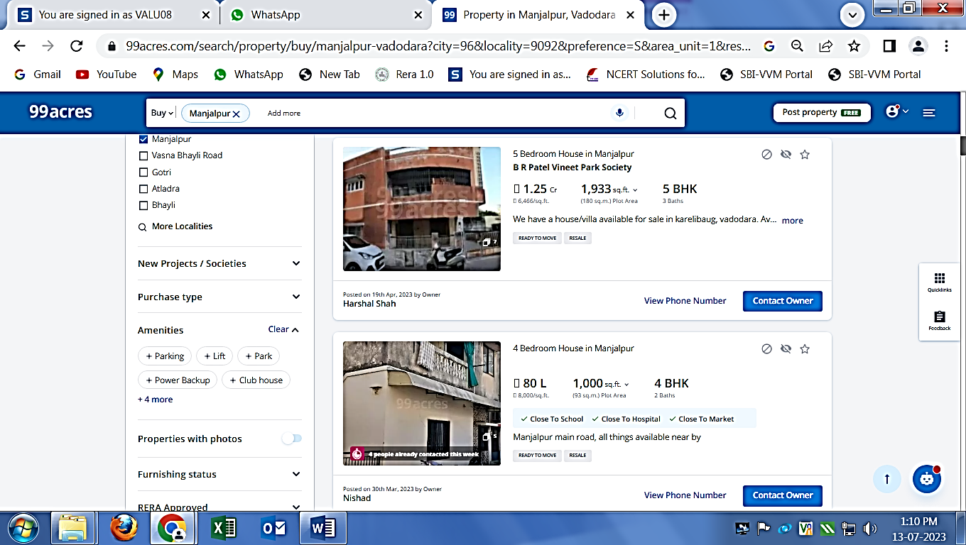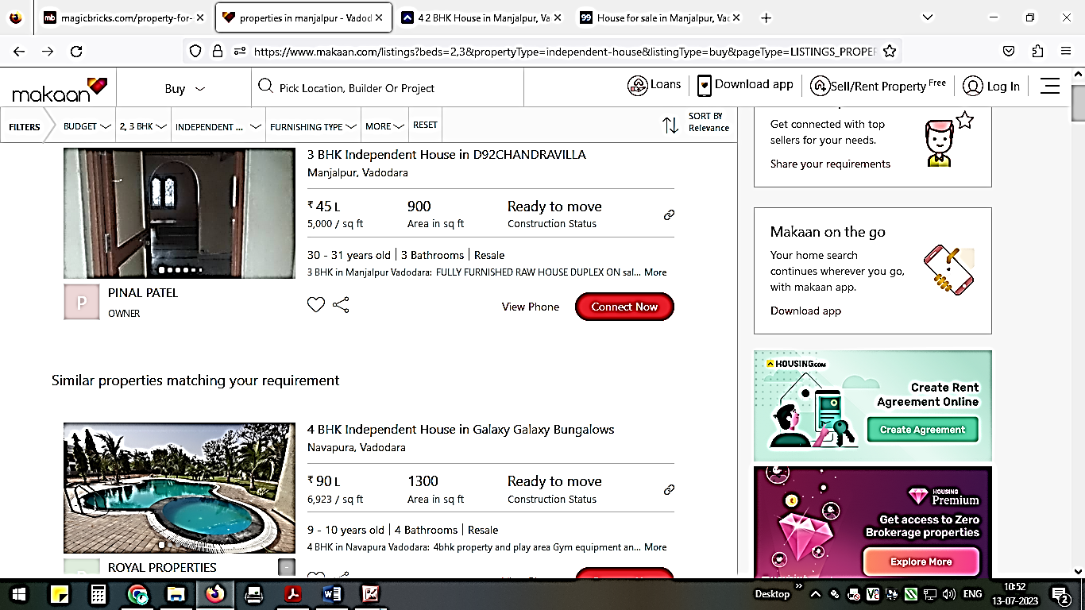**Popular Sales instance from famous website**

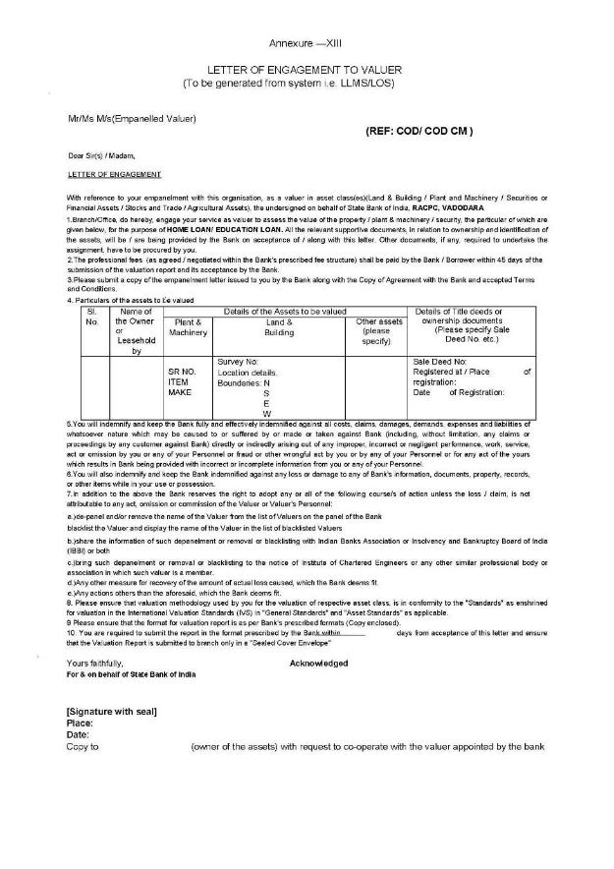

**Visit Sheet**

