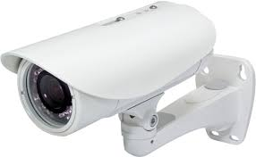

Original video Convert Video into Frames

Convert Frames into Grayscale

If anomaly Detected Predict the output from array with Convert Grayscale Frames into array

Perform respective reference to trained model

operations