**Diagram:**

**Use-case diagram:**

**Admin:**

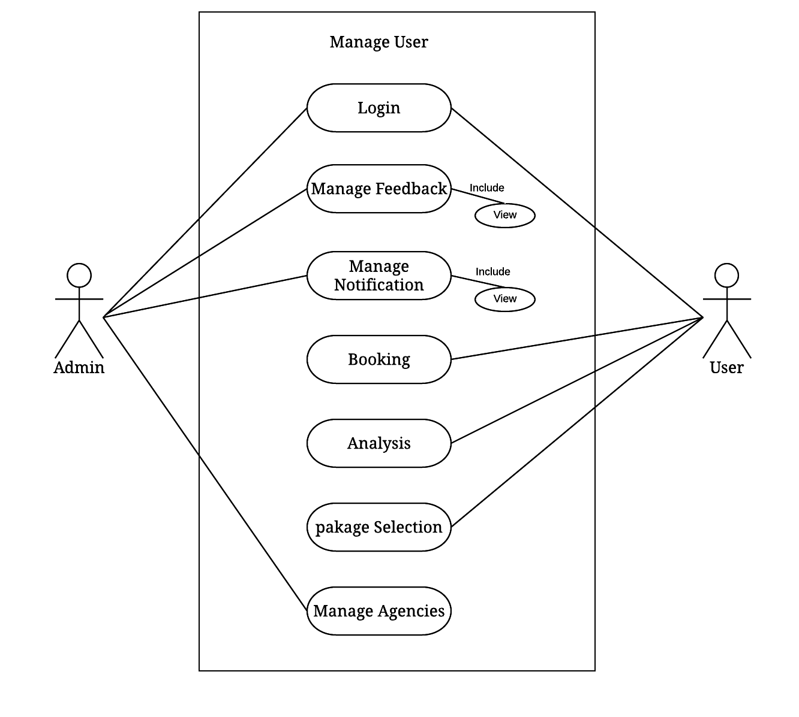

Figure 4.5.1 Use-Case

**Activity Diagram:**

**Admin:**

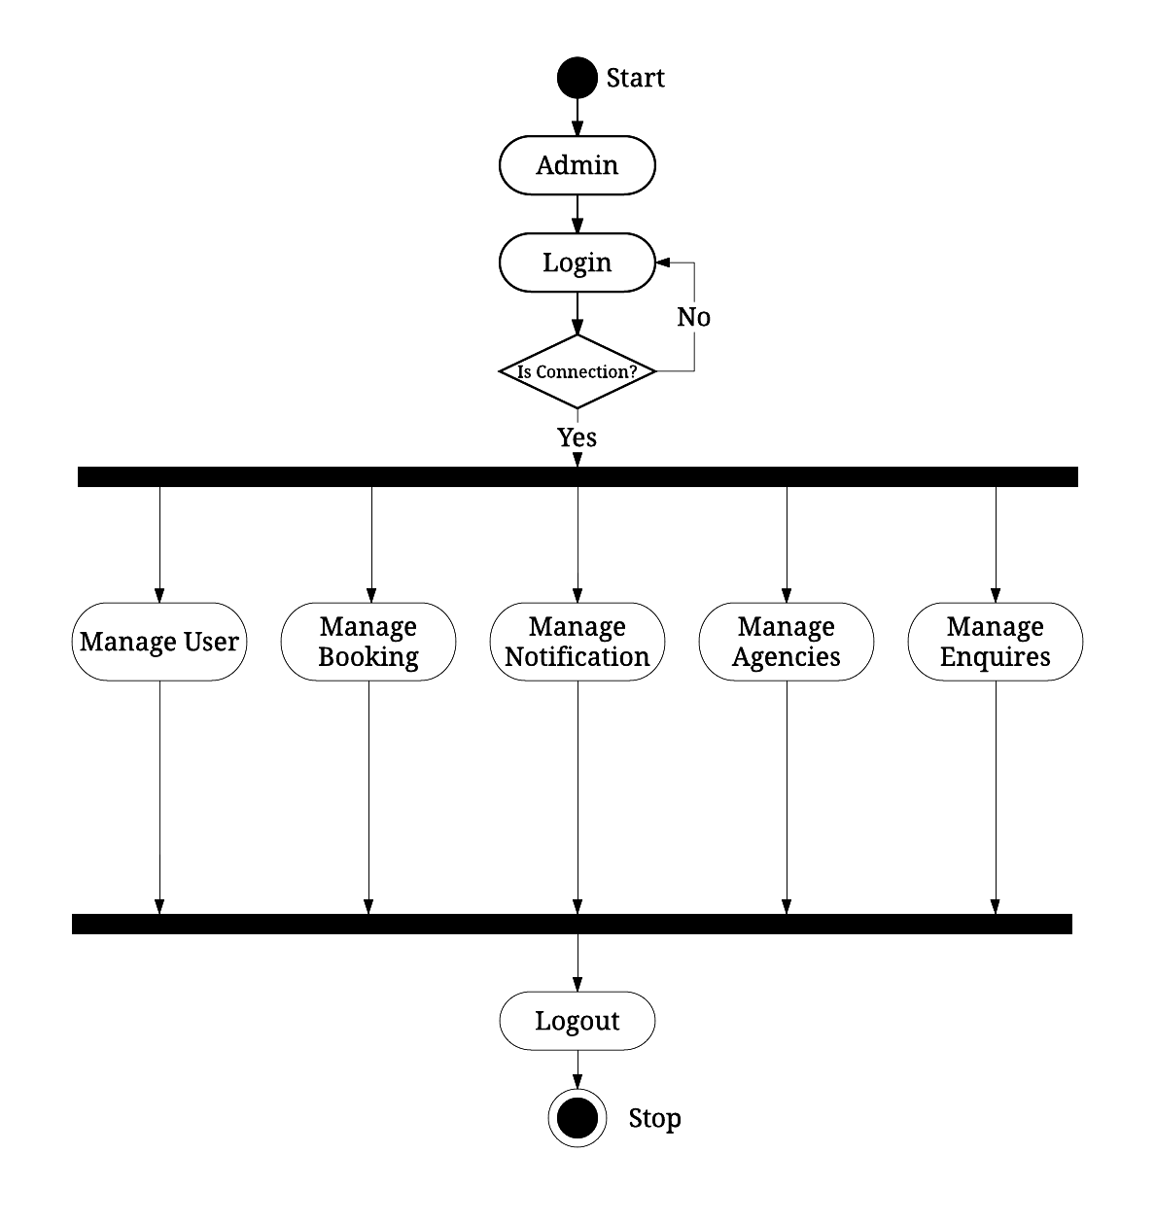

Figure 4.5.2 Admin

**User:**

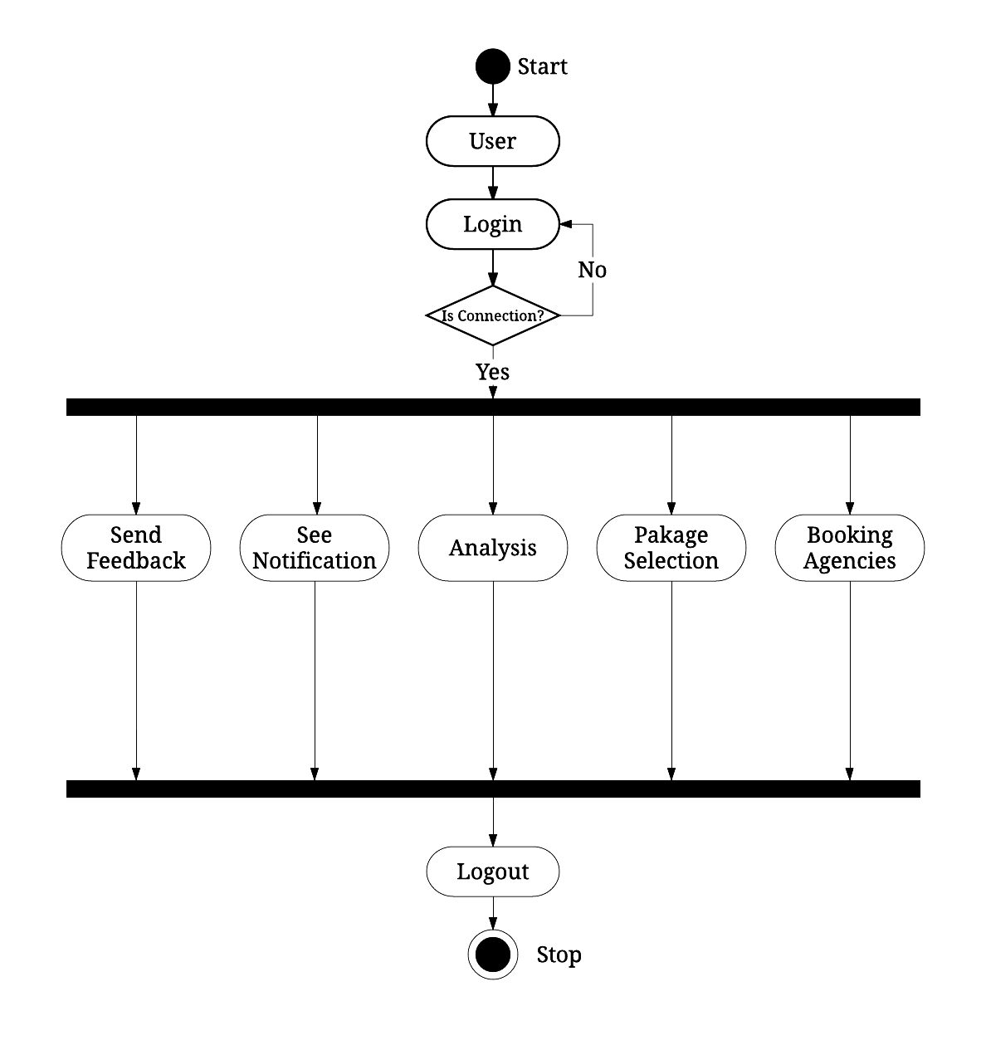

Figure 4.5.2 User

**Sequence Diagram:**

**Admin:**

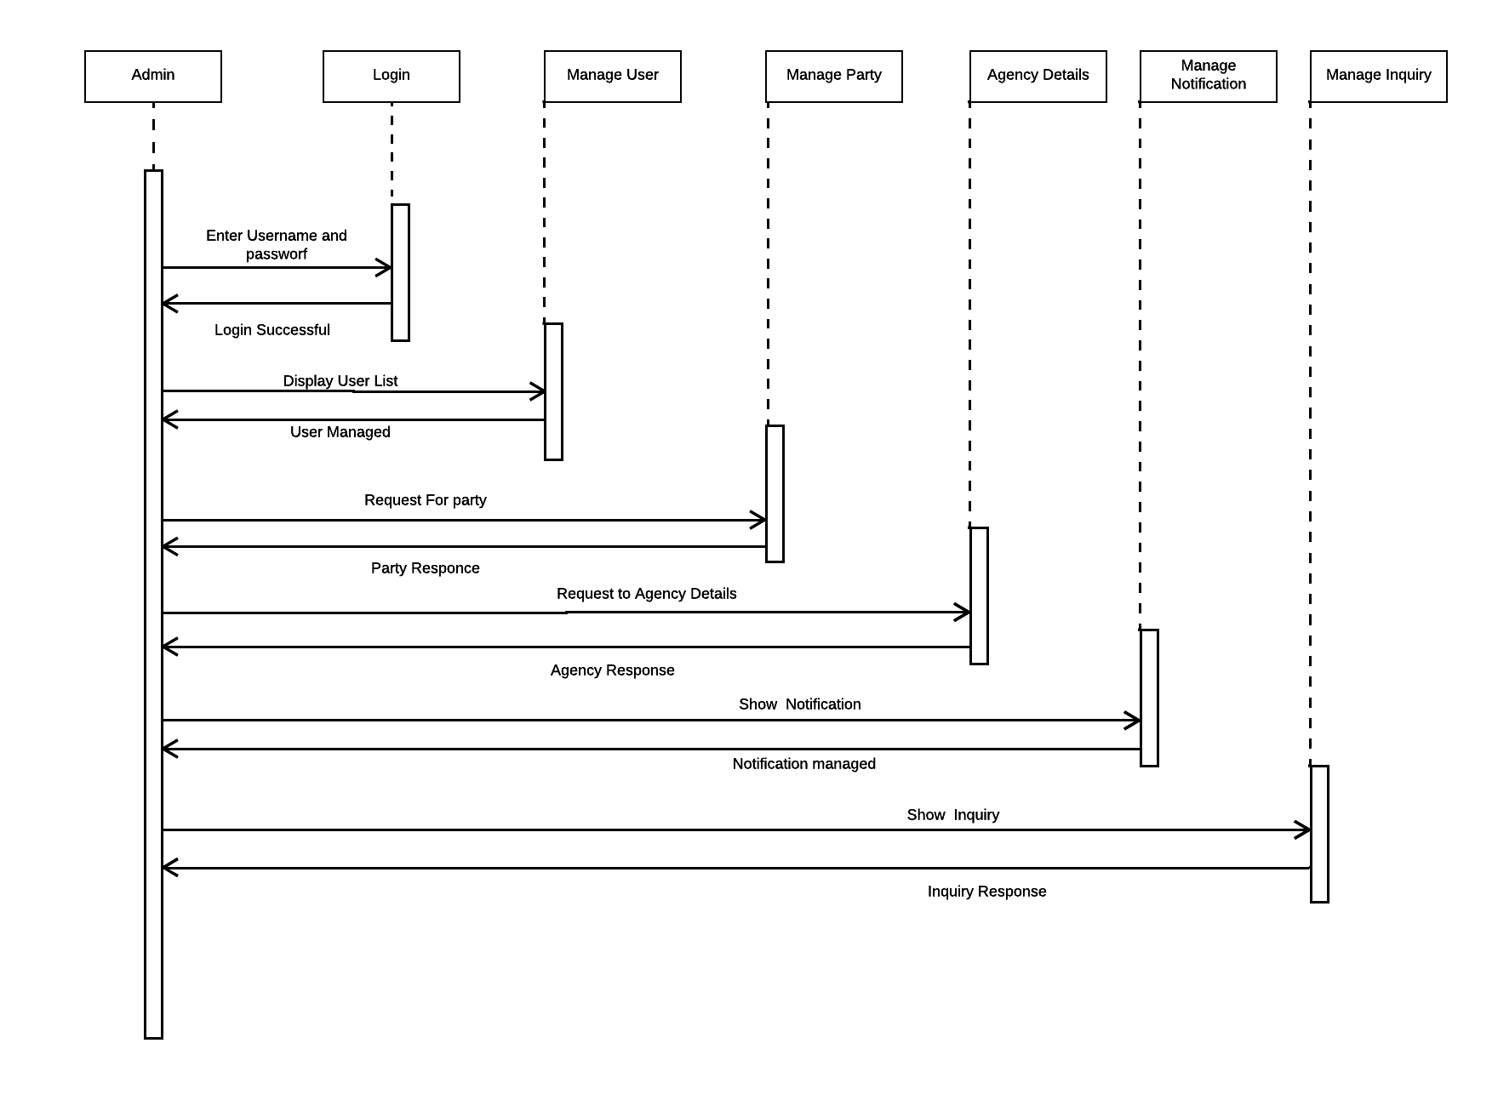

Figure 4.5.3 Admin

**User:**

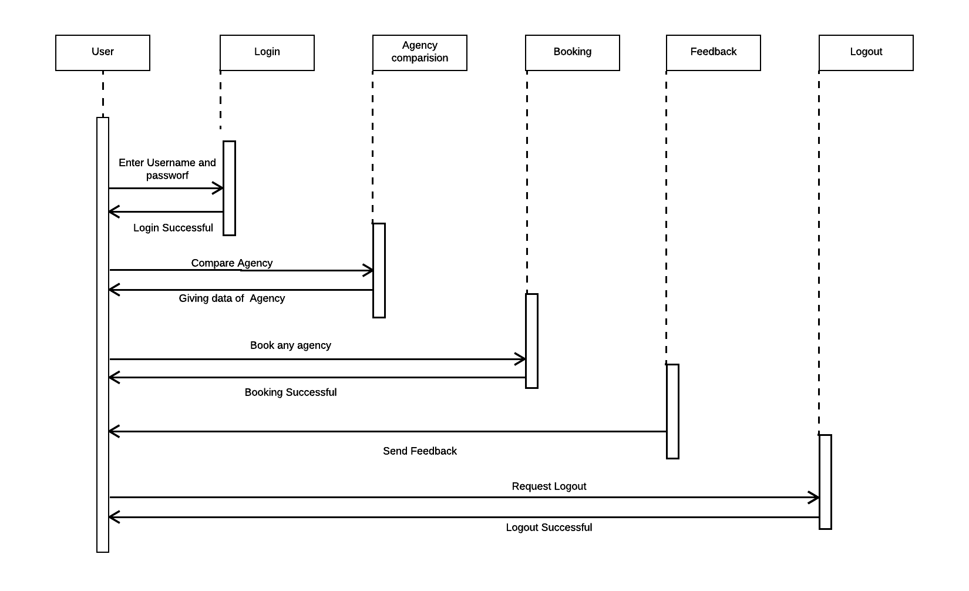

Figure 4.5.3 User

**E-R Diagram:**

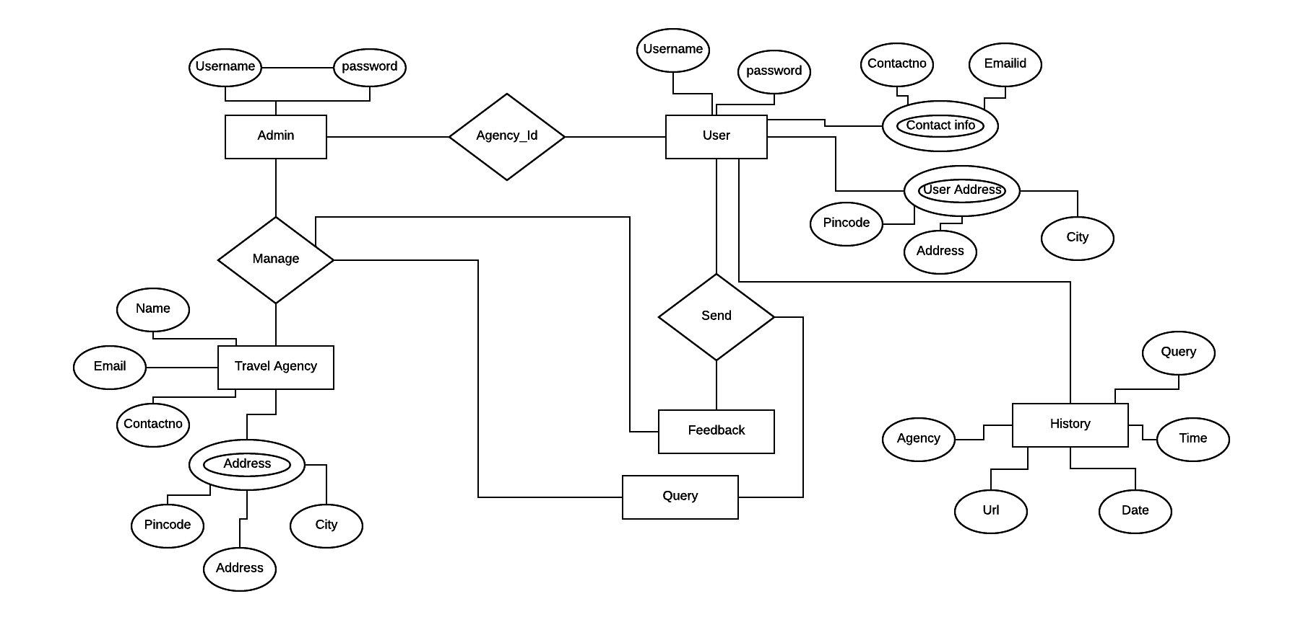

Figure 4.6.1 E-R Diagram

**Class Diagram:**

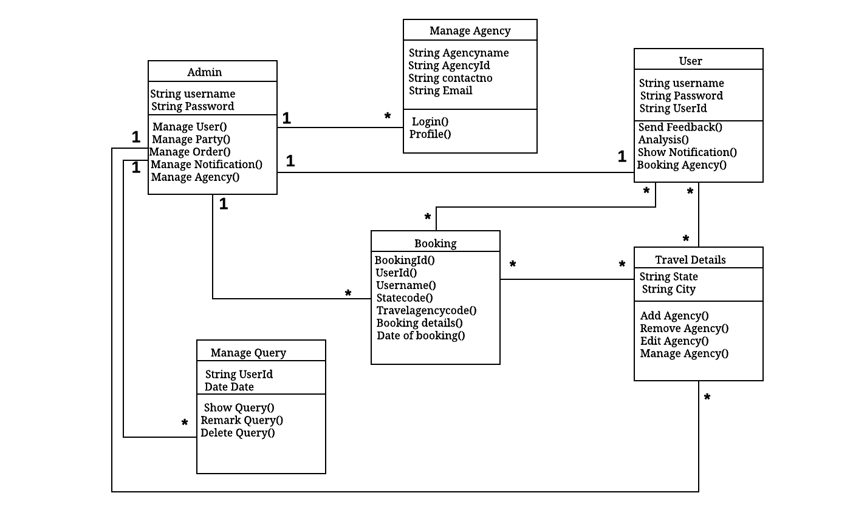

Figure 4.6.2 Class Diagram