**DAILY EXPENSE MANAGEMENT SYSTEM**

**A PROJECT REPORT**

***Submitted by***

**URVISH ASHOKBHAI PANCHAL**

**190060107038**

***In partial fulfillment for the award of the degree of***

**BACHELOR OF ENGINEERING**

***in***

**Computer Engineering**

**Bhagwan Mahavir Collage of Engineering and Technology,**

**Surat**

**Gujarat Technological University, Ahmedabad**

**May, 2024**

**Bhagwan Mahavir Collage of Engineering and Technology,**

**Surat**

**CERTIFICATE**

This is to certify that the project report submitted along with the Project **Daily Expense Management System** has been carried out by **Urvish Ashokbhai Panchal** under my guidance in partial fulfillment for the degree of bachelor of engineering in Computer Engineering, 8th semester of Gujarat Technological University, Ahmadabad during the academic year 2023-2024.

Prof. Rauki Yadav Prof. Rauki Yadav Internal Guide Head of the Department

Date: 02/05/2024

**TO WHOM IT MAY CONCERN**

This is to certify that **Urvish Ashokbhai Panchal**, a student of **Bhagwan Mahavir Collage of Engineering and Technology**, has successfully completed his internship in the field of Web Development from **01-Feb-2024** to **02-May-2024** (Total number of Weeks: 12) under the guidance of Virendrasinh Parmar.

During his internship, he engaged in various tasks such as gathering requirements, analyzing data, designing solutions, implementing plans, and conducting tests. Throughout this period, he exhibited a strong drive to acquire new skills and showed remarkable self-motivation. His performance surpassed what we anticipated, and he successfully finished the project within the specified timeframe.

During the period of his internship program with us, he had been exposed to different processes and was found diligent, hardworking and inquisitive.

We wish him every success in his life and career.

For Krtya Technologies Pvt. Ltd

**Bhagwan Mahavir Collage of Engineering and Technology,**

**Surat**

**DECLARATION**

I hereby declare that the internship report submitted along with the internship entitled **Daily Expense Management System** submitted in partial fulfillment for the degree of Bachelor of Engineering in Computer Engineering to Gujarat Technological University, Ahmedabad, is a bonafide record of original project work carried out by me at **Krtya Technology Pvt. Ltd.** under the supervision of Prof. Rauki Yadav and that no part of this report has been directly copied from any students reports or taken from any other source, without providing due reference.

Name of student Sign of Student

Urvish Ashokbhai Panchal

**Acknowledgment**

A project this extensive cannot be completed by one person. The collective endeavour is what makes it to the coast. Consequently, we would like to sincerely thank all of the dignitaries who helped to make this project a huge joy and a successful piece of work.

We are grateful to **Prof. Rauki Yadav**, the other faculty members, and the Head of the Master of Computer Application programme, who have consistently provided moral support and encouragement for learning.

We owe a debt of appreciation to **Virendrasinh Parmar**, our project guide, who showed a great deal of interest in our work and helped us every step of the way until the project was finished by giving us all the knowledge we needed to create a good system.

We also like to thank all of our friends and coworkers for their occasional support and encouragement. We sincerely appreciate our friends' unwavering support and encouragement, and we are appreciative of all the suggestions that helped us put this report together.

We express our gratitude to our parents for their invaluable guidance and inspiration.

|  |
| --- |
| Students Signature:  Urvish A. Panchal  __________________________ |

# 

# ABSTRACT

*The* ***Daily Expense Management System*** *was the primary goal of this internship. There are numerous programming languages available for creating web-based software and applications. Programming languages like HTML, CSS, JavaScript, Bootstrap Framework, and others used to create an application's front end. The backend uses languages like PHP. These days, certain frameworks are also heavily used. We would benefit greatly from developing web-based applications since we could access them from anywhere in the globe. It greatly facilitates our day-to-day lives. I decided to intern in "web development" for this reason.*

*My time with* ***Krtya Technologies*** *has given me a wealth of expertise for my future profession. Another important thing was to solve real-world issues. This report walks us through every element of the knowledge and experience we acquired throughout our internship using the* ***Daily Expense Management System*.**

**LIST OF FIGURES**

Fig 1.1 Html…………………………………………………………..…….3

Fig 1.2 CSS……………………………………………………………..…..4

Fig 1.3 JavaScript………………………………………………………......4

Fig 1.4 Bootstrap…………………………………………………………...5

Fig 1.5 MySQL…………………………………………………………......6

Fig 1.6 PHP…………………………………………………………............6

Fig 1.7 Visual Studio…………………………………………………….…7

Fig 1.8 Project scheduling……………………………………………….…8

Fig 2.1 Agile Methodology…………………………………………………9

Fig 4.1 Activity Digram…………………………………………………...15

Fig 4.2 Use Case Digram………………………………………………….17

Fig 4.3 ER Digram………………………………………………………...21

Fig 5.1 Login Screen………………………………………………………22

Fig 5.2 Registration Screen………………………………………………..23

Fig 5.3 Dashbord Screen…………………………………………………..23

Fig 5.4 Customers page Screen…………………………………………...24

Fig 5.5 Add Customers Form Page Screen………………………………..25

Fig 5.6 Delete Customers…………………………………………………25

Fig 5.7 Invoices Page……………………………………………………..26

Fig 5.8 Check Invoices Page……………………………………………...27

Fig 5.9.1 Edit Profile Page………………………………………………...27

Fig 5.9.2 Add Profile Page………………………………………………..28

**LIST OF TABLES**

Table 4.8.1.1 tbl_admin………………………………………………….18

Table 4.8.1.2 tbl_customer……………………………………………….18

Table 4.8.1.3 tbl_invoices………………………………………………..19

Table 4.8.1.4 tbl_profile………………………………………………….19

# Abbreviations

|  |  |
| --- | --- |
| [HTML](https://www.instagram.com/gtu_brainheaters) | [Hyper](https://www.instagram.com/gtu_brainheaters)Text Markup Language |
| [CSS](https://www.instagram.com/gtu_brainheaters)  Bootstrap | [Cascading](https://www.instagram.com/gtu_brainheaters) Style Sheet  Open-source CSS framework |
| [JS](https://www.instagram.com/gtu_brainheaters) | [Java](https://www.instagram.com/gtu_brainheaters) Script |
| SQL  PHP | Structured Query Language  Hypertext Preprocessor |
| VS code  Git | Visual Studio Code  Version control |

**TABLE OF CONTENT (INDEX)**

Declaration…………………………………………………………………..i

Acknowledgement ii

Abstract iii

List of Figures iv

List of Tables v

Abbreviations vi

Table of Contents vii

Chapter 1 INTRODUCTION 1

1.1 PROJECT SUMMARY 1

1.2 PURPOSE 1

1.3 OBJECTIVE AND SCOPE………………………………………………1

1.4 TECHNOLOGY………………………………………………………...3

1.5 LITERATURE REVIEW………………………………………………...8

1.**6 PROJECT / INTERNSHIP SCHEDULING**………………………………..8

Chapter 2 PROJECT MANAGEMENT 9

2.1 Project Planning. 9

2.1.1 Project Development Approach & Justification …………………………...9

Chapter 3 SYSTEM REQURIMENTS STUDY 12

3.1 User Characteristics 12

3.2 Software Specification. 12

Chapter 4 SYSTEM ANALYSIS 13

4.1 Study of Current System………………………………………………..13

4.2 Problem and Weakness of Current System………………………………..13

4.3 Requirement of New System……………………………………………13

4.4 System feasibility………………………………………………………14

4.5 Activity Diagram..……………………………………………………...15

4.6 Features of new system…………………………………………………….16

4.7 Use-Case diagram…………………………………………………………17

4.8 Data modelling……………………………………………………………18

4.8.1 Data dictionary………………………………………………………...18

4.8.2 ER digram…………………………………………………………….21

4.9 List of main modules of new system………………………………………...21

Chapter 5 System Design 22

5.1 Interface design…………………………………………………………..22

5.1.1 Implementation Screenshot…………………………………………….22

Chapter 6 Implementation Planning 29

6.1 Implementation Environment………………………………………………29

6.2 Modules Specification…………………………………………………….29

Chapter 7 Conclusion 30

Chapter 8 Limitation and Future Enhancement 31

8.1 Limitations………………………………………………………………31

8.2 Future Enhancements……………………………………………………..31

**REFERENCES**………………………………………………………………32

# CHAPTER 1 INTRODUCTION

## **PROJECT SUMMARY**

The Daily Expense Management System is a software application designed to help individuals or businesses track and manage their daily expenses effectively. Here's a summary of the project. Overall, the Daily Expense Management System provides users with a convenient and efficient way to monitor their spending, adhere to budgets, and make informed financial decisions. It empowers individuals and businesses to achieve better financial health by promoting awareness and accountability in managing their expenses.

## **PURPOSE**

The purpose of project is to provide individuals or organizations with a tool to effectively track, manage, and analyze their expenses on a daily basis.the purpose of a Daily Expense Management System project is to empower individuals and organizations to make informed financial decisions, improve budgeting and saving habits, and achieve better financial stability.

## **OBJECTIVE AND SCOPE**

The primary objective of the Daily Expense Management System is to provide individuals or organizations with a convenient and efficient way to track and manage their daily expenses. The system aims to streamline the process of recording, categorizing, analyzing, and controlling expenses to help users achieve financial goals, maintain budgets, and make informed financial decisions.

1. **Expense Tracking:** The system allows users to record their daily expenses, including details such as date, amount, category, and description.
2. **Expense Categorization:** Users can categorize expenses into predefined or customizable categories (e.g., food, transportation, utilities, entertainment) to facilitate organization and analysis.
3. **Budget Management:** Users can set budget limits for different expense categories, and the system provides alerts or notifications when approaching or exceeding these limits.
4. **Reporting and Analysis:** The system generates various reports and visualizations to analyze spending patterns, identify areas of overspending or saving, and track progress towards financial goals.
5. **Data Security:** Ensuring the security and privacy of users' financial data is paramount. The system implements robust security measures to protect sensitive information from unauthorized access or breaches.
6. **User Authentication and Access Control:** User authentication mechanisms are implemented to ensure that only authorized individuals can access and modify expense data. Access control features allow administrators to manage user permissions and roles.
7. **Multi-Platform Accessibility:** The system is designed to be accessible across multiple platforms, such as web browsers, mobile devices, and desktop applications, to accommodate the diverse needs and preferences of users.
8. **User-Friendly Interface:** A user-friendly and intuitive interface is essential to ensure ease of use and enhance user experience. The system incorporates design principles that prioritize simplicity, clarity, and efficiency.

## **TECHNOLOGY**

The following technologies were used in the development

**HTML5**

*Fig 1.1 HTML*

HTML represents HyperText Markup Language. HTML5 is the most recent variant of HTML. HTML5 is a markup language that is utilized to construction and present the substance on the internet browser. To structure the substance on an internet browser, labels are utilized. Labels are a few held words encased in rakish sections, "<" and ">". Each tag has an end tag too and between the initial label the substance to be shown is composed. For instance, <p> tag is utilized for section, so <p>Content of the paragraph</p> is the punctuation to show passage. In any case, there are a few exemptions where there is no end tag, for example, <img> tag, <br> tag and so on. HTML5 has added semantics labels which were absent in past renditions of HTML, for example, <header>, <section>, <article>, <footer> and so on. These semantic labels give importance to the substance on the internet browsers which is exceptionally useful to outwardly disables clients, screen perusers and so on.

**CSS**

*Fig 1.2 CSS*

CSS stands for Cascading Style Sheets. It is used to style the content of the HTML file. Prior to CSS, nearly all of the presentational attributes of HTML documents were contained within the HTML mark-up (specifically inside the HTML tags); all the font colors, background styles, element alignments, borders and sizes had to be explicitly described within the HTML. As a result, development of the large websites became a long and expensive process. To solve this problem CSS was introduced. CSS styles the property of elements such as background-colour, colour, font-family, font-size etc. Following are some important things that we can do with CSS.

**JavaScript**

*Fig 1.3 JavaScript*

### JavaScript is a text-put together programming language utilized both with respect to the client-side and server-side that permits you to make site pages intuitive. Where HTML and CSS are dialects that give design and style to pages, JavaScript gives website pages intuitive components that draw in a client. Normal instances of JavaScript that you could utilize consistently incorporate the inquiry box, interactive buttons, pop-ups requesting consents and so on. Integrating JavaScript further develops the client experience of the website page by changing over it from a static page into an intuitive one. To recap, JavaScript adds conduct to site pages. JavaScript is for the most part utilized for electronic applications and internet browsers.

### Bootstrap

*Fig 1.4 Bootstrap*

### Bootstrap is a free and open-source device assortment for making responsive sites and web applications. It is the most famous HTML, CSS, and JavaScript structure for creating responsive, versatile first sites. It takes care of numerous issues which we had once, one of which is the cross-program similarity issue. These days, the sites are ideally suited for every one of the programs (IE, Firefox, and Chrome) and for all sizes of screens (Work area, Tablets, Tablets, and Telephones). All on account of Bootstrap designers - Imprint Otto and Jacob Thornton of Twitter, however being an open-source project was subsequently pronounced. Bootstrap can be remembered for the site utilizing two different ways, from CDN interface or by downloading bootstrap from getbootstrap.com and use it.

### MySql



*Fig 1.5 MySQL*

### MySQL is free and open-source programming under the details of the GNU Overall population Permit, and is likewise accessible under various exclusive licenses. MySQL was possessed and supported by the Swedish organization MySQL Stomach muscle, which was purchased by Sun Microsystems (presently Prophet Partnership). In 2010, when Prophet gained Sun, Widenius forked the open-source MySQL task to make MariaDB.

### PHP

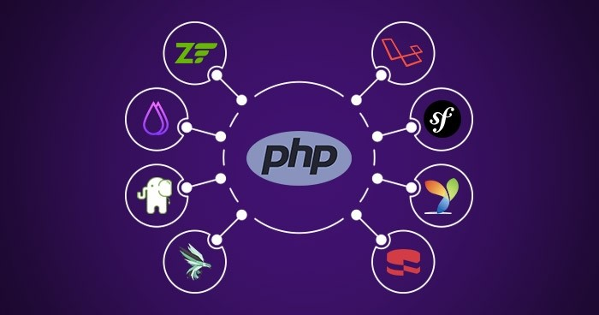

*Fig 1.6 PHP*

PHP is a server prearranging language, and an amazing asset for making dynamic and intuitive Pages.

PHP is a broadly utilized, free, and proficient option in contrast to contenders like Microsoft's ASP.

PHP is a universally useful prearranging language particularly fit to web improvement. It was initially made by Danish-Canadian software engineer Rasmus Lerdorf in 1994. The PHP reference execution is currently delivered by The PHP Gathering. PHP initially represented Individual Landing page, however it presently represents the recursive initialism PHP: Hypertext Preprocessor.

PHP code is normally handled on a web waiter by a PHP mediator carried out as a module, a daemon or as a Typical Passage Point of interaction (CGI) executable.

### Visual Studio



*Fig 1.7 Visual Studio*

Visual Studio is a Coordinated Advancement Environment(IDE) created by Microsoft to foster GUI(Graphical UI), console, Web applications, web applications, portable applications, cloud, and web administrations, and so on. With the assistance of this IDE, you can make oversaw code as well as local code. It utilizes the different foundation of Microsoft programming advancement programming like Windows store, Microsoft Silverlight, and Windows Programming interface, and so on. It's anything but a language-explicit IDE as you can utilize this to compose code in C#, C++, VB(Visual Essential), Python, JavaScript, and a lot more dialects. It offers help for 36 different programming dialects. It is accessible for Windows as well with respect to macOS.

## **LITERATURE REVIEW**

I have researched and examined the system in use for expenses management globally in order to do the literature study. The existing worldwide system is large and primarily subscription based; hence, a significant amount of processing power should be set aside for system deployment.

* 1. **PROJECT / INTERNSHIP SCHEDULING**

*Fig 1.8 Project scheduling*

# CHAPTER 2 PROJECT MANAGEMENT

## **2.1 PROJECT PLANNING**

**2.1.1 Project Development Approach & Justification**

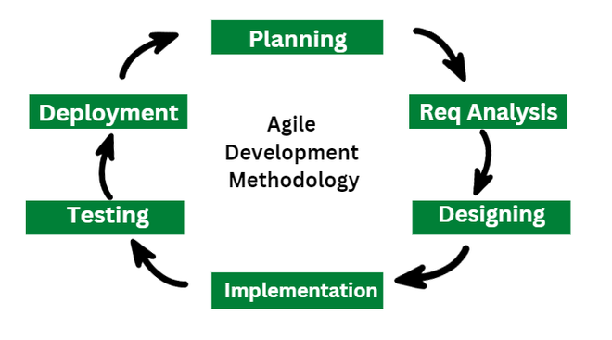

*Fig 2.1 Agile Methodology*

The Agile methodology is a project management and software development approach that emphasizes flexibility, collaboration, and customer-centricity. It is the latest model used by major companies today like Facebook, google, amazon, etc. It follows the iterative as well as incremental approach that emphasizes the importance of delivering of working product very quickly.

Agile Software Development is a software development methodology that values flexibility, collaboration, and customer satisfaction. It is based on the Agile Manifesto, a set of principles for software development that prioritize individuals and interactions, working software, customer collaboration, and responding to change.

Agile Software Development is an iterative and incremental approach to software development that emphasizes the importance of delivering a working product quickly and frequently. It involves close collaboration between the development team and the customer to ensure that the product meets their needs and expectations.

## [life cycleAgile methodology](https://www.geeksforgeeks.org/agile-sdlc-software-development-life-cycle/)

### Requirement Gathering

* In this stage, the project team identifies and documents the needs and expectations of various stakeholders, including clients, users, and subject matter experts.
* It involves defining the project’s scope, objectives, and requirements.

### 2. Design

* Developing a high-level system architecture.
* Creating detailed specifications, which include data structures, algorithms, and interfaces.

### 3. Development (Coding)

* Writing the actual code for the software. Conducting unit testing to verify the functionality of individual components.

### 4. Testing

This phase involves several types of testing:

1. **Integration Testing:** Ensuring that different components work together.
2. **System Testing:** Testing the entire system as a whole.
3. **User Acceptance Testing:** Confirming that the software meets user requirements.
4. **Performance Testing:**Assessing the system’s speed, scalability, and stability.

### 5. Deployment

1. Deploying the software to a production environment.
2. Put the software into the real world where people can use it.
3. Make sure it works smoothly in the real world.
4. Providing training and support for end-users.

### Advantage of Agile Model

* **Focus on Customer Value**
* **Enhanced Team Morale and Motivation**
* **Stakeholder Collaboration**
* **Early and Continuous Delivery**
* **Delivering high-quality software**

### Disadvantage of Agile Model

* **Lack of Predictability**
* **Dependency on Customer Availability**
* **Dependency on Team Dynamics**
* **Increased Overhead**

# CHAPTER 3 SYSTEM REQUIREMENTS STUDY

## **3.1 USER CHARACTERISTICS**

### User Profiles

Admin

* Admin will manage all data of companies.
* Admin will manage all invoices as per the listed companies of the system.
* Admin can mange their own profile.

## **3.2 Software Specification**

* Php latest version
* Wampp or Xampp server
* Mysql Database
* Vscode editor
* Some useful extensions for HTML, CSS support in vs code
* Git – version control

# CHAPTER 4 SYSTEM ANALYSIS

## **4.1 STUDY OF CURRENT SYSTEM**

QuickBooks is a widely-used accounting software designed for small and medium-sized businesses. It helps businesses manage their finances efficiently by providing tools for tasks such as invoicing, expense tracking, payroll management, inventory management, and financial reporting.

**Key features**:

* Invoicing
* Expense Tracking
* Payroll Management
* Inventory Management
* Financial Reporting
* Integration

## **4.2 PROBLEM AND WEAKNESSES OF CURRENT SYSTEM**

## QuickBooks is subscription based, to get premium features their customers need to buy plan according to their requirements.

**4.3 Requirements of New System**

* Users should be able to record their daily expenses with details such as date, amount, category, and description.
* The system should generate various reports and visualizations to analyze spending patterns, identify areas of overspending or saving, and track progress towards financial goals.
* Ensuring the security and privacy of users' financial data is crucial, requiring robust security measures to prevent unauthorized access or breaches.
* An intuitive and user-friendly interface is essential for ease of use, incorporating design principles focused on simplicity, clarity, and efficiency.

**4.4 System Feasibility**

**4.4.1 Does the system contribute to the overall objectives of the organization?**

The system aligns with the overall objective of promoting better financial management for individuals and organizations, contributing to improved budgeting, informed decision-making, and financial stability.

**4.4.2 Can the system be implemented using the current technology and within the given cost and schedule constraints**

The system's implementation feasibility hinges on its compatibility with existing technology and whether it can be developed within the allocated budget and schedule constraints.

**4.4.3 Can the system be integrated with other systems which are already in place?**

It is important to evaluate whether the new system can be seamlessly integrated with any pre-existing systems to ensure smooth operations and data consistency across the organization.

**4.5 ACTIVITY DIAGRAM**

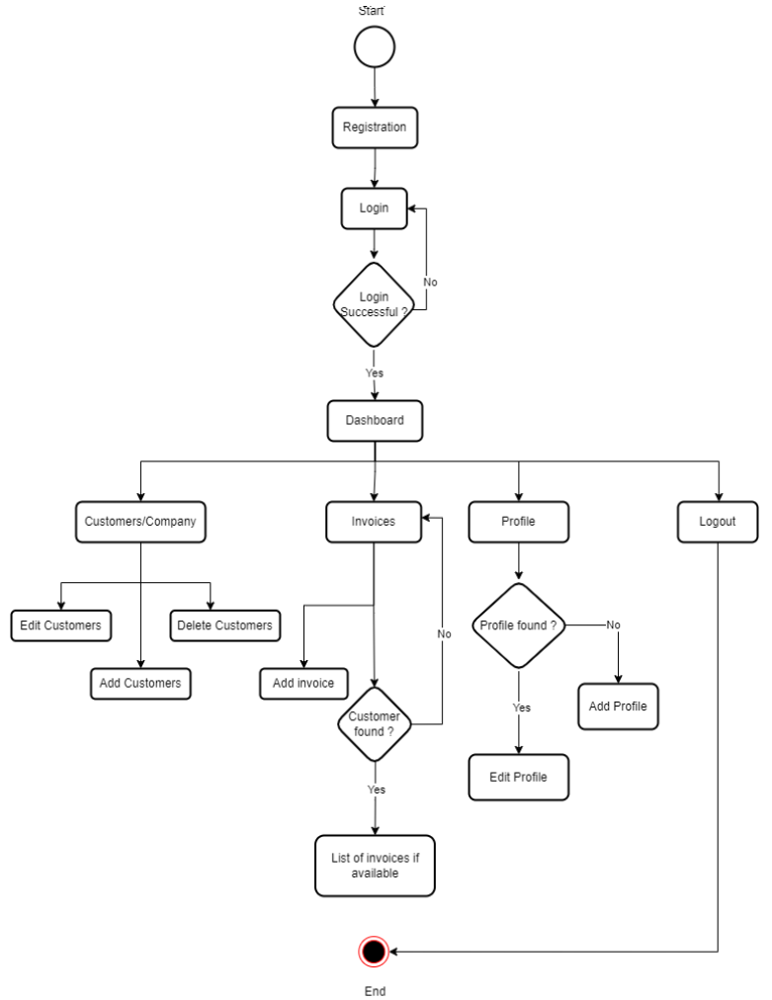

*Fig 4.1 Activity Digram*

## **4.6 FEATURES OF NEW SYSTEM**

* Expense management system is mostly used for small business.
* Business owner can manage customers as per their requirements i.e. add customers in the system, edit and delete customers.
* Also, admin can manage invoices as per their requirements i.e. add invoices, change status of invoices like pending and paid.
* Admin can manage their own profile like add profile information and edit their profile information.

## **4.7 USE-CASE DIAGRAM**

*Fig 4.2 USE-CASE DIAGRAM*

## **4.8 DATA MODELING**

**4.8.1** Data dictionary

**tbl_admin**

|  |  |  |
| --- | --- | --- |
| Field Name | Data Type | Description |
| User_id | Int | User_id is primary key in this table. Id of the admin user |
| firstname | Varchar | Firstname of the admin user |
| lastname | varchar | Lastname of the admin user |
| email | varchar | Email of the admin user |
| password | varchar | Password needs to enter by admin user |
| Date_of_birth | Date | Birthdate of admin user |

**tbl_customer**

|  |  |  |
| --- | --- | --- |
| Field Name | Data Type | Description |
| customer_id | int | customer_id |
| customer_company_name | varchar | Company name of customer |
| customer_fname | varchar | First name of customer |
| customer_lname | varchar | Last name of customer |
| customer_mobilenumber | bigint | Mobile number of customer |
| customer_email | varchar | Email of customer |

**tbl_invoices**

|  |  |  |
| --- | --- | --- |
| Field Name | Data Type | Description |
| inv_id | int | Invoices_id |
| customer_id | int | customer_id |
| inv_date | date | Invoices date of customer |
| inv_title | varchar | Invoices title of customer |
| inv_desc | varchar | Invoices desc of customer |
| inv_tax | varchar | Invoices tax of customer |
| inv_status | varchar | Invoices status of customer |
| inv_amount | int | Invoices amount of customer |

**tbl_profile**

|  |  |  |
| --- | --- | --- |
| Field Name | Data Type | Description |
| profile_id | int | Profile id of admin user |
| user_id | int | User id |
| gender | tinyint | profile gender of admin user |
| address | varchar | Profile address of admin user |
| city | varchar | Profile city of admin user |
| country | varchar | Profile country of admin user |
| postal_code | varchar | Profile postal code of admin user |
| profile_picture | int | Profile profile picture of admin user |

### 4.8.2 ER Diagram

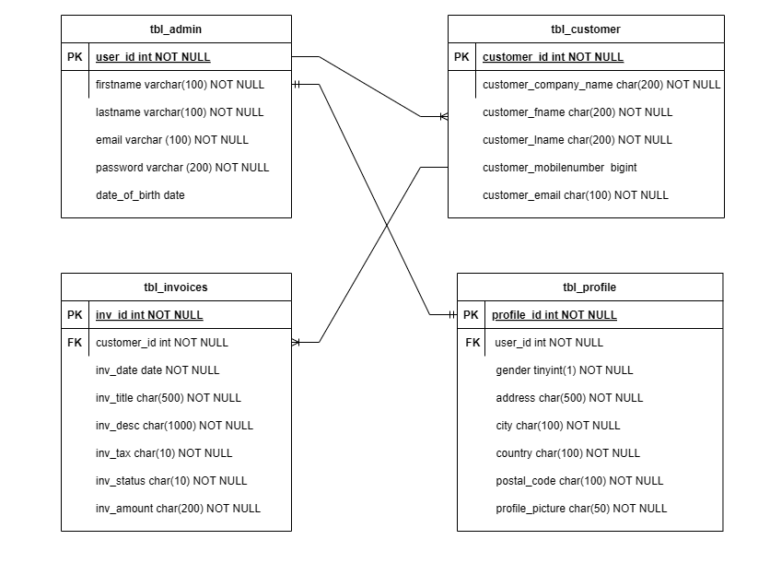

*Fig 4.3 ER DIAGRAM*

## **4.9 LIST MAIN MODULES OF NEW SYSTEM**

* Admin
  1. Companies (customers)
  2. Invoices

# CHAPTER 5 SYSTEM DESIGN

# 5.1 INTERFACE DESIGN

**5.1.1 Implementation Screenshot**

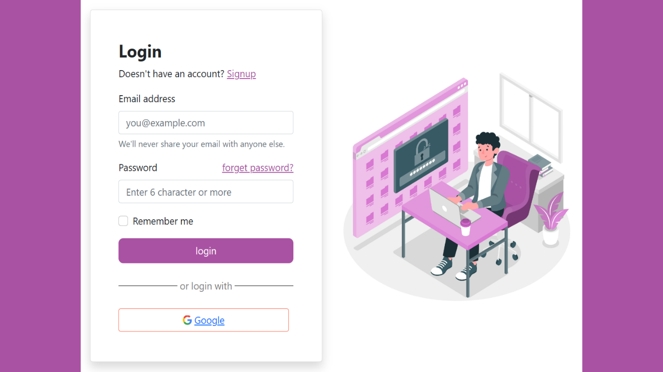  
*Figure 5.1 Login Screen*

This is a home page screen of expense management system when user will come for the first time as user, they will be able to see this screen. This is a login screen for the users.

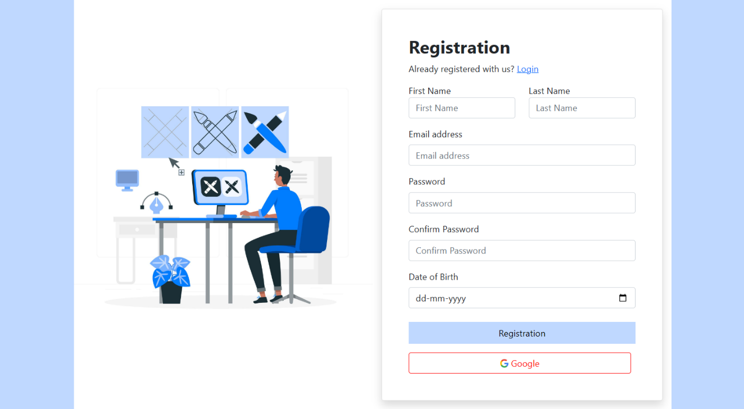

*Figure 5. 2 Registration Screen*

With the use of this screen user will register into the system.

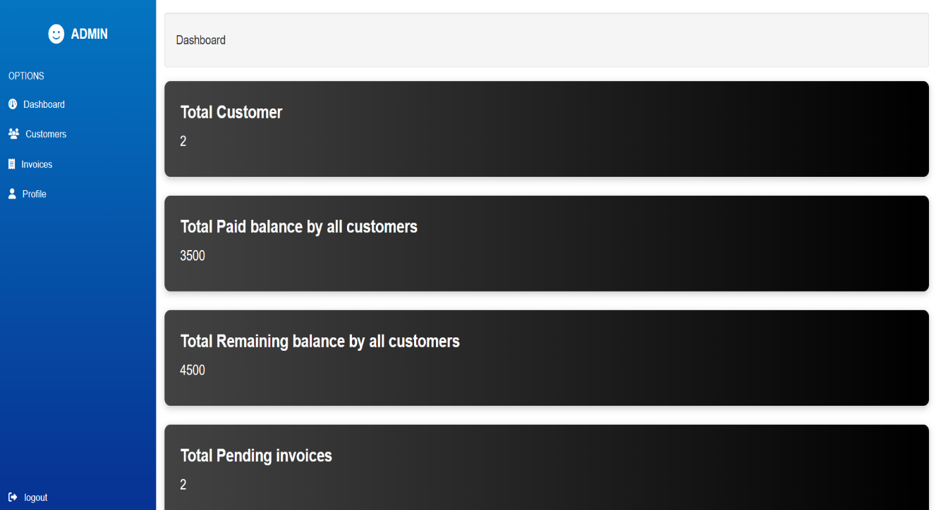

*Figure 5. 3 Dashboard Screen*

This is a dashboard of the system. There are many options we can see on the dashboard like customers, invoices, profile, logout etc. User can perform different operations using these options.

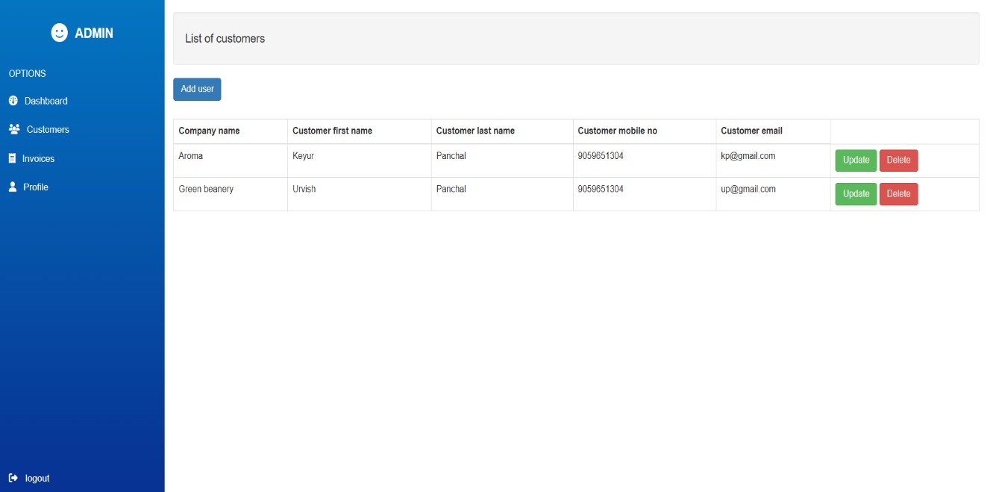

*Figure 5. 4 Customers page Screen*

This is customer list page of the system. There are many features we can see on the customer page like add customer, update customer, delete customer and show all customers list on the screen. User can perform different operations using these features.

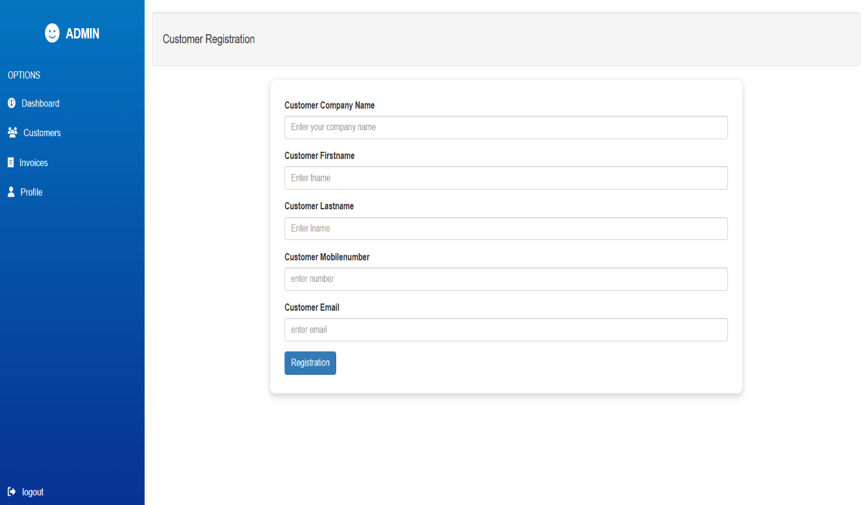

*Figure 5. 5 Add Customers form page Screen*

When admin will click on the add customer button, it will open the Customer Registration form. Form has many fields like company name, customer first name, customer last name, customer mobile number and email. All the fields are required. When user will click on the registration button, all information will be stored in the database.

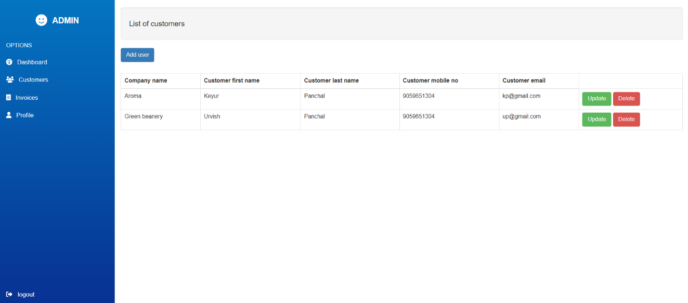

*Figure 5.6 Delete Customers*

When admin will click on the delete button then customer will be deleted from the system.

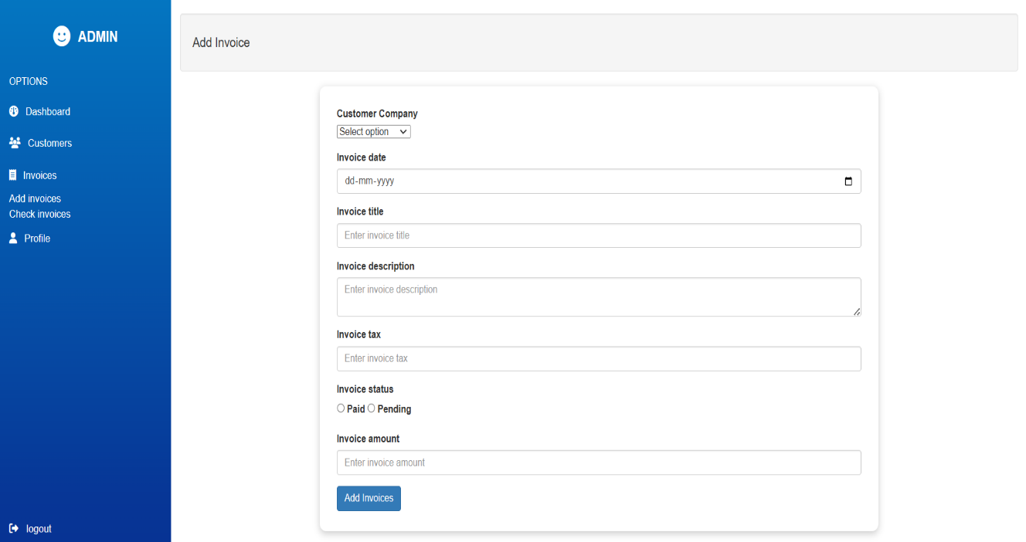

*Figure 5. 7 Invoices page*

When admin will click on the invoices option then it will open two more options add invoices and check invoices. When admin click on the first option add invoices then it will open add invoices form. All fields are required like select company, invoice date, invoice title, invoice tax, invoice status, and amount. When admin will click on the add invoice button, all data will be stored in the database.

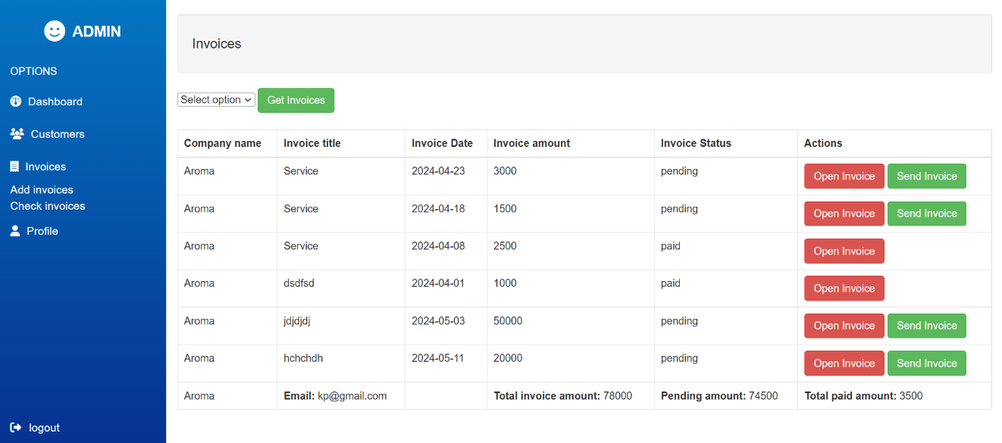

*Figure 5. 8 check Invoices page*

When admin will click on the check invoice option, admin must select company to display all invoices related to that company.

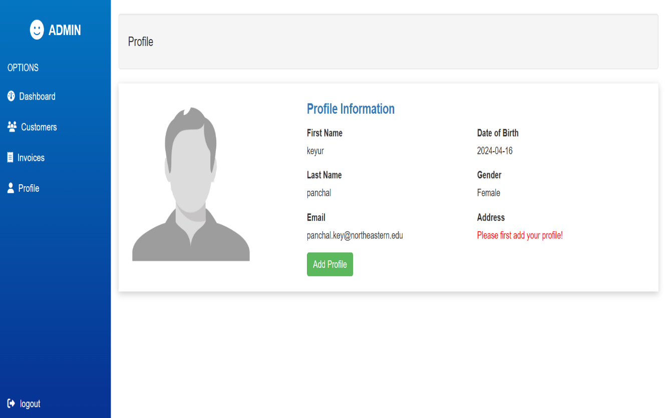

*Figure 5.9.1 Edit Profile page*

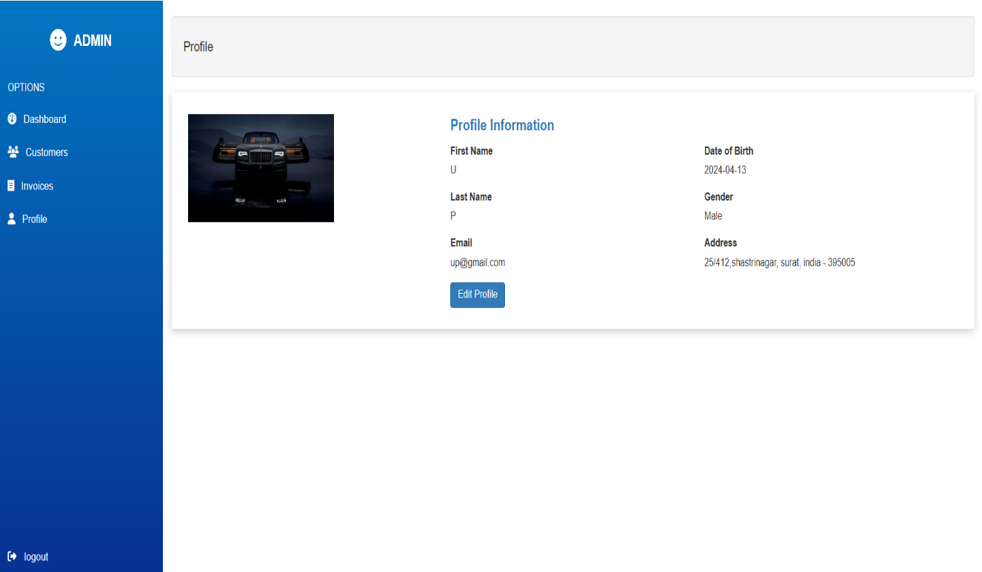

*Figure 5.9.2 Add Profile page*

When user will click on the Profile features, here all the information related to profile will be displayed. When admin will access this feature first time, profile information will not display here. From the clicking on ‘Add Profile’ button, admin will be able to add their profile information into the system (Refer Figure 5.9.2 – Add profile page). After that, ‘Edit Profile’ button will be displayed with the use of that features admin can edit their profile as per their requirements. (Refer Figure 5.9.1 – Edit profile page)

# CHAPTER 6 IMPLEMENTATION PLANNING

## **6.1 IMPLEMENTATION ENVIRONMENT**

1. PHP latest version
2. Wampp or Xampp server of 64-bit
3. MySQL Database
4. Git – version control

## **6.2 MODULES SPECIFICATION**

**Admin**

* The administrator oversees the data for all companies within the system.
* The administrator handles invoicing for the listed companies.
* The administrator could manage their own profile.

**CHAPTER 7 CONCLUSION**

The internship project involved the creation of a web application system designed to manage daily expenses. The system incorporates a range of technologies for both frontend and backend development, demonstrating a diverse skill set.

For the frontend development, HTML, CSS, and JavaScript were utilized, along with the Bootstrap framework for efficient and responsive design. This indicates a proficiency in designing user interfaces and ensuring a seamless user experience across various devices.

On the backend side, PHP technology was employed, showcasing competence in server-side scripting and backend logic implementation. Additionally, MySQL was chosen as the database management system, highlighting familiarity with relational databases and data storage solutions.

The system encompasses several key features, including a manage dashboard for overview and analysis, functionality to manage customers, handle customer invoices, and facilitate user profile management. These features suggest a thorough understanding of business requirements and the ability to implement various functionalities to meet those needs.

Overall, the project demonstrates a strong grasp of web development principles, encompassing frontend design, backend logic, and database management. It showcases a well-rounded skill set and the ability to deliver a functional and user-friendly web application for managing daily expenses.

**CHAPTER 8 LIMITATION AND FUTURE ENHANCEMENT**

**8.1 Limitations:**

* In the current version of expense management system, admin is not able to manage taxes as per the requirements.
* Registration and login functionality is not configured with 2-factor authentication.
* Right now, admin will not be able to send an email to the customers regarding their OPEN invoices.
* In the invoice feature, admin will not be able to add more than one items in the process of creation invoice i.e. admin is not allowed to breakdown their services with specific amount.
* In the current system, user has to enter address manually instead of selecting state or city according to their country.

**8.2 Future Enhancements:**

* We will try to develop the system with support of multiple languages.
* We will try to integrate TAXES modules to manage taxes for the invoice as per the government regulations.
* We will try to develop REPORTS modules to get detailed information related to customer’s data.
* We will try to generate some graphs according to some useful information like sales, profit, expenses, and other parameters.
* We will try to solve limitation of the current version as well.
* We will try to develop PAYROLL calculation and other important features that will create smooth execution of payroll process.

**REFERENCES**

HTML tutorial - <https://www.w3schools.com/html/>

CSS tutorial - <https://www.w3schools.com/css/>

Java Script tutorial - <https://www.w3schools.com/js/>

Bootstrap tutorial - <https://www.w3schools.com/bootstrap5/>

My SQL tutorial - <https://www.w3schools.com/mysql/>

PHP tutorial <https://www.youtube.com/playlist?list=PL0b6OzIxLPbyrzCMJOFzLnf_-_5E_dkzs>

What is Agile Methodology? - <https://www.geeksforgeeks.org/what-is-agile-methodology/>