**Experiment No. : 6**

**Title: Floyd-Warshall Algorithm using Dynamic**

**programming approach**

**Batch: A2 Roll No.: 16010421073 Experiment No.:6**

**Aim:** To Implement All pair shortest path Floyd-Warshall Algorithm using Dynamic programming approach and analyse its time Complexity.

**Algorithm of Floyd-Warshall Algorithm:**

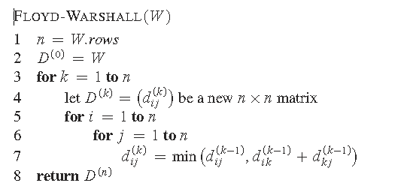

**Constructing Shortest Path:**

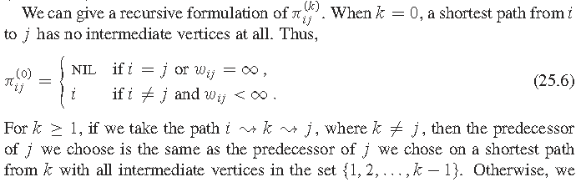

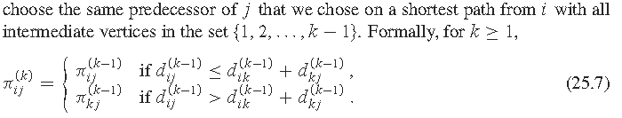

**Working of Floyd-Warshall Algorithm:**

**Problem Statement**

Find Shortest Path for each source to all destinations using Floyd-Warshall Algorithm for the following graph



**Solution**

**Derivation of Floyd-Warshall Algorithm:**

Time complexity Analysis

• Floyd Warshall Algorithm consists of three loops over all the nodes.

• The inner most loop consists of only constant complexity operations.

• Hence, the asymptotic complexity of Floyd Warshall algorithm is O(n3).

• Here, n is the number of nodes in the given graph.

**Program(s) of Floyd-Warshall Algorithm:**

#include<iostream>

using namespace std;

#define V 4

#define INF 99999

void printSolution(int dist[][V]);

void floyd_Warshall(int graph[][V])

{

    int dist[V][V], i, j, k;

    for (i = 0; i < V; i++)

        for (j = 0; j < V; j++)

            dist[i][j] = graph[i][j];

    for (k = 0; k < V; k++) {

        for (i = 0; i < V; i++)

        {

            for (j = 0; j < V; j++)

            {

                if (dist[i][j] > (dist[i][k] + dist[k][j]) && (dist[k][j] != INF && dist[i][k] != INF))

                    dist[i][j] = dist[i][k] + dist[k][j];

            }

        }

    }

    printSolution(dist);

}

void printSolution(int dist[][V]){

    cout << "The following matrix shows the shortest distances between every pair of vertices \n";

    for (int i = 0; i < V; i++) {

        for (int j = 0; j < V; j++) {

            if (dist[i][j] == INF)

                cout << "INF"<< "  ";

            else

                cout << dist[i][j] << "    ";

        }

    cout << "\n";

    }

}

int main()

{

    int graph[V][V] = { { 0, 8, INF, 16 },

                        { INF, 0, 3, INF },

                        { INF, 7, 0, 12 },

                        { INF, INF, INF, 0 } };

    floyd_Warshall(graph);

    return 0;

}

**Output(o) of Floyd-Warshall Algorithm:**

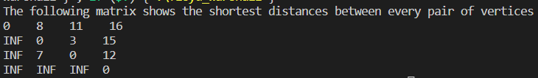

**Post Lab Questions:-** **Explain dynamic programming approach for Floyd-Warshall algorithm and write the various applications of it.**

The Floyd-Warshall algorithm is a classic example of a dynamic programming approach to finding the shortest path between all pairs of vertices in a graph.

It is based on the idea of solving subproblems and combining their solutions to obtain the optimal solution for the whole problem.

**The dynamic programming approach for Floyd-Warshall algorithm can be summarized as follows:**

1. We create a matrix D of size n x n, where n is the number of vertices in the graph. The entry D[i][j] will hold the length of the shortest path from vertex i to vertex j.
2. We initialize the matrix D with the lengths of the edges in the graph. If there is no edge between two vertices, we set the length to infinity.
3. We then use a nested loop to update the matrix D. For each pair of vertices i and j, we consider all intermediate vertices k and check if the path from i to k and then from k to j is shorter than the current path from i to j. If it is, we update the value of D[i][j] to the new, shorter path.
4. After the nested loop has finished executing, the matrix D will hold the shortest path between all pairs of vertices in the graph.

**The Floyd-Warshall algorithm has several applications, including:**

* Finding the shortest path between all pairs of vertices in a graph.
* Detecting negative cycles in a graph.
* Finding the transitive closure of a directed graph.
* Solving the all-pairs shortest path problem in a weighted graph.
* Finding the shortest path in a weighted graph with negative edges.

**Conclusion: (Based on the observations):**

**Thus we successfully implemented Floyd-Warshall Algorithm using Dynamic**

**programming approach and analyse its time Complexity.**

**Outcome:**

**CO2 :**Implement Greedy and Dynamic Programming algorithms.

**References:**

1. Richard E. Neapolitan, " Foundation of Algorithms ", 5th Edition 2016, Jones & Bartlett Students Edition
2. Harsh Bhasin , " Algorithms : Design & Analysis", 1st Edition 2013, Oxford Higher education, India
3. T.H. Coreman ,C.E. Leiserson,R.L. Rivest, and C. Stein, " Introduction to algorithms", 3rd Edition 2009, Prentice Hall India Publication
4. Jon Kleinberg, Eva Tardos, " Algorithm Design", 10th Edition 2013, Pearson India Education Services Pvt. Ltd.