**Mod-4**

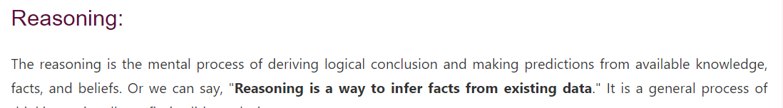

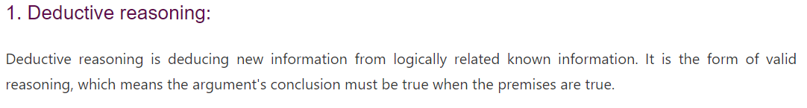

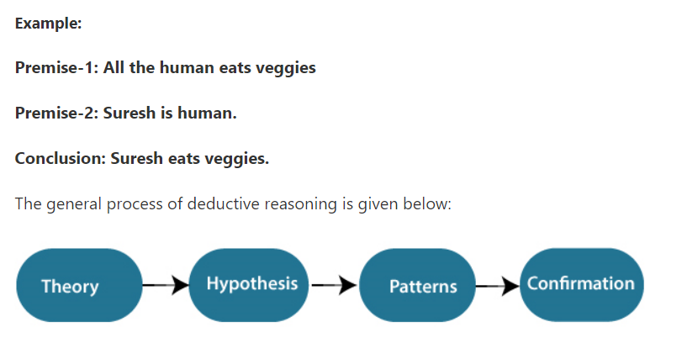

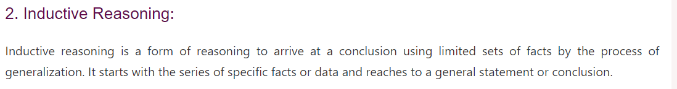

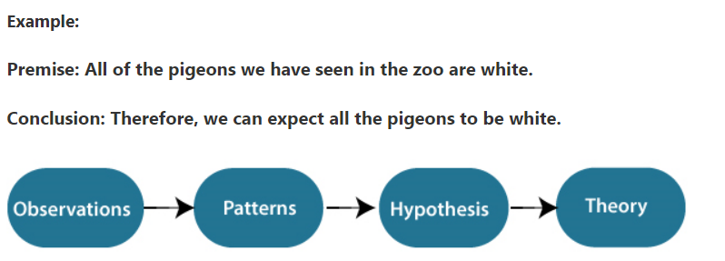

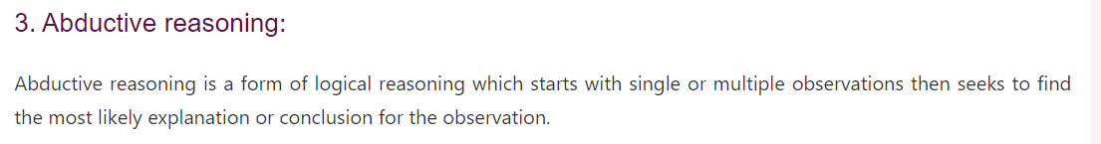

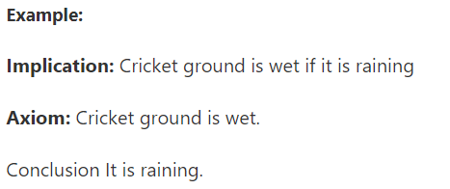

**Acting under uncertainty**

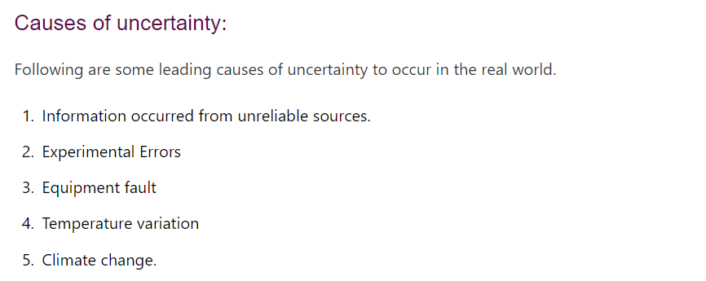

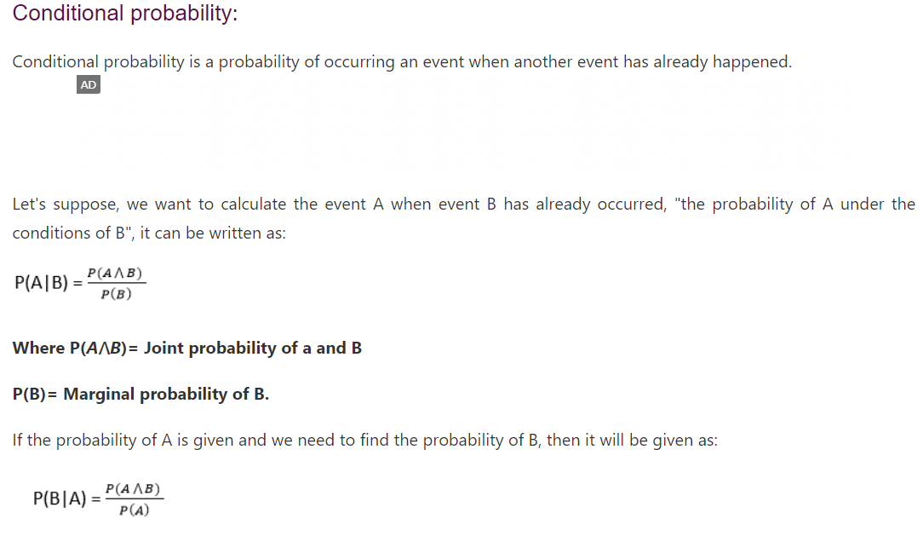

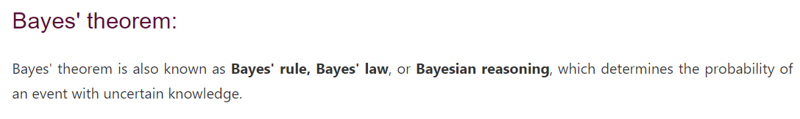

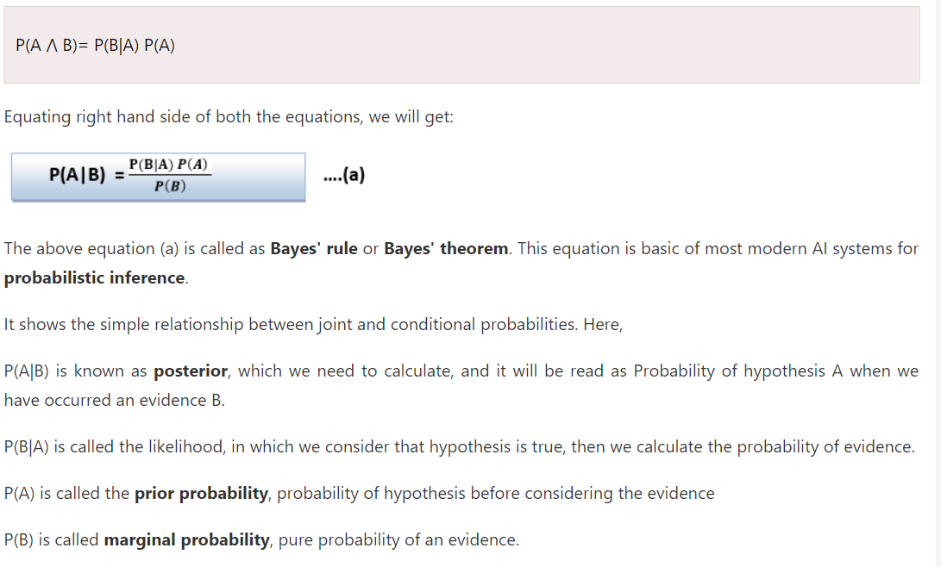

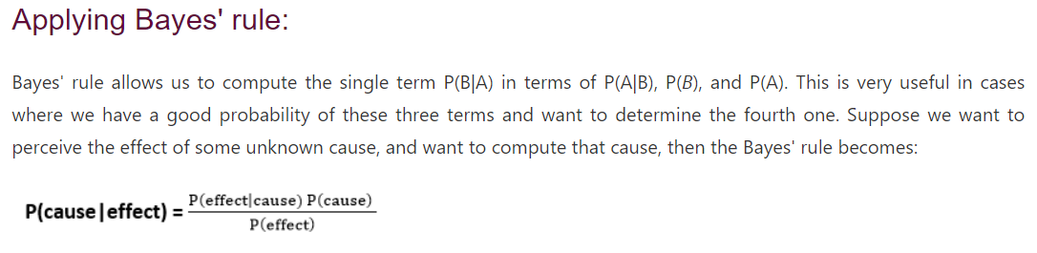

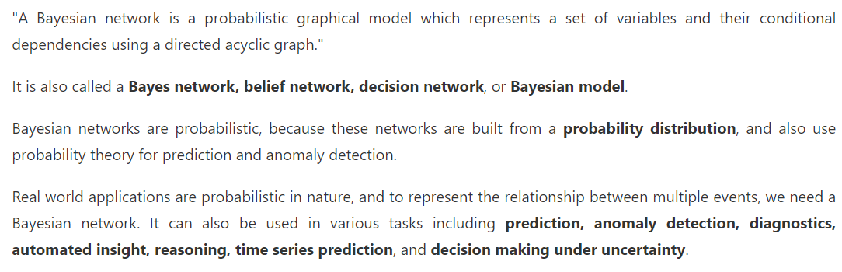

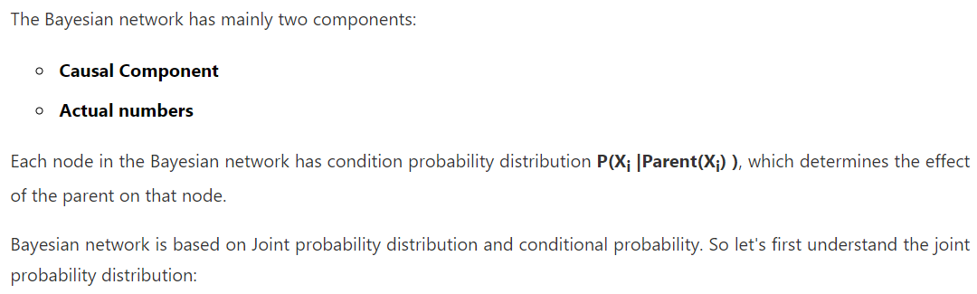

**Basic probability notation**

**Inference using full joint distributions**

**Bayes’ rule and its use.**

**Representing knowledge in an uncertain domain**

**Semantics of Bayesian networks**

**Efficient representation of conditional distributions**

**Exact inference in Bayesian networks**