KJSCE/IT/SY/SEM IV/HO-IAI/2022-23

Batch: A2 Experiment Number: 2

Roll Number: 16010421073 Name: Keyur Patel

Aim of the Experiment: To implement DFS - Uninformed search algorithm in state space

Program/ Steps:

#include <stdio.h>

#include <stdlib.h>

//defining size of max nodes as 200

#define MAX_NODES 200

int graph[MAX_NODES][MAX_NODES];

int visited[MAX_NODES];

int num_nodes, num_edges;

void dfs(int node) {

    int i;

    printf("%d ", node);

    visited[node] = 1;

    for (i = 0; i < num_nodes; i++)

{

        if (graph[node][i] == 1 && visited[i] == 0) {

            dfs(i);

        }

    }

}

int main() {

    int i, j, node1, node2;

    printf("Enter the number of nodes and edges: ");

    scanf("%d%d", &num_nodes, &num_edges);

    for (i = 0; i < num_nodes; i++) {

        for (j = 0; j < num_nodes; j++) {

            graph[i][j] = 0;

        }

        visited[i] = 0;

    }

    for (i = 0; i < num_edges; i++) {

        printf("Enter two nodes that form an edge: ");

        scanf("%d%d", &node1, &node2);

        graph[node1][node2] = 1;

        graph[node2][node1] = 1;

    }

    int start_node;

    printf("Enter the starting node: ");

    scanf("%d", &start_node);

    dfs(start_node);

    return 0;

}

Output/Result:

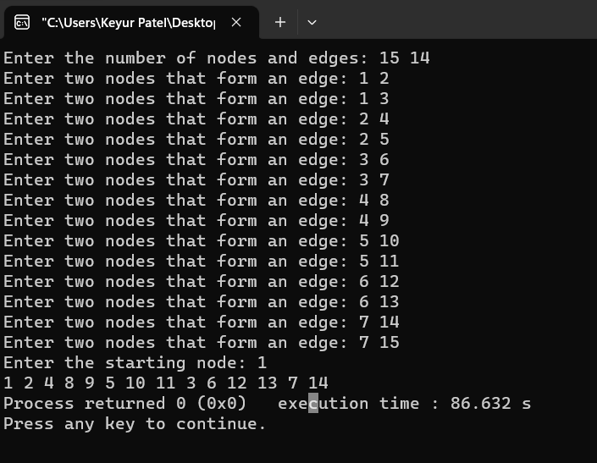

# Outcomes:

# CO2 : Analyze and formalize the problem (as a state space, graph, etc.) and select the appropriate search method and write the algorithm.

**Conclusion (based on the Results and outcomes achieved):**

Hence we learned about the implementation of DFS using Uninformed search algorithm in state space.

# References:

# 1. Stuart Russell and Peter Norvig, Artificial Intelligence: A Modern Approach, Second Edition, Pearson Publication

# 2. Luger, George F. Artificial Intelligence : Structures and strategies for complex problem solving , 2009 ,6th Edition, Pearson Education

(A Constituent College of Somaiya Vidyavihar University)