**IAI : Exp-5(Inlab)**

**Name :** Keyur Patel **Roll No :** 16010421073  **Batch :** A-2

**Code:**

male(jack).

male(oliver).

male(ali).

male(james).

male(simon).

male(harry).

female(helen).

female(sophie).

female(jess).

female(lily).

parent_of(jack,jess).

parent_of(jack,lily).

parent_of(helen, jess).

parent_of(helen, lily).

parent_of(oliver,james).

parent_of(sophie, james).

parent_of(jess, simon).

parent_of(ali, simon).

parent_of(lily, harry).

parent_of(james, harry).

/* Rules */

father_of(X,Y):- male(X),

parent_of(X,Y).

mother_of(X,Y):- female(X),

parent_of(X,Y).

grandfather_of(X,Y):- male(X),

parent_of(X,Z),

parent_of(Z,Y).

grandmother_of(X,Y):- female(X),

parent_of(X,Z),

parent_of(Z,Y).

sister_of(X,Y):- %(X,Y or Y,X)%

female(X),

father_of(F, Y), father_of(F,X),X \= Y.

sister_of(X,Y):- female(X),

mother_of(M, Y), mother_of(M,X),X \= Y.

aunt_of(X,Y):- female(X),

parent_of(Z,Y), sister_of(Z,X),!.

brother_of(X,Y):- %(X,Y or Y,X)%

male(X),

father_of(F, Y), father_of(F,X),X \= Y.

brother_of(X,Y):- male(X),

mother_of(M, Y), mother_of(M,X),X \= Y.

uncle_of(X,Y):-

parent_of(Z,Y), brother_of(Z,X).

ancestor_of(X,Y):- parent_of(X,Y).

ancestor_of(X,Y):- parent_of(X,Z),

ancestor_of(Z,Y).

**Output:**

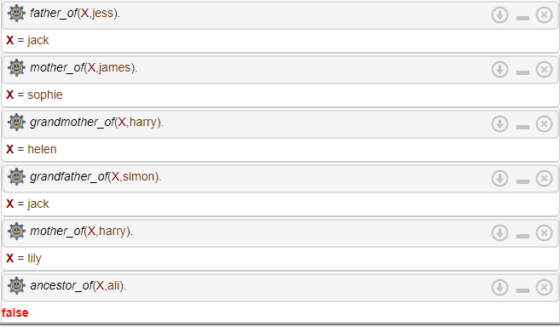

**Outcomes:**

**CO3 :** Ability to formally state the problem and develop the appropriate proof for given a logical deduction problem.