**IAI : Exp-6(Inlab)**

**Name :** Keyur Patel **Roll No :** 16010421073  **Batch :** A-2

**Code:**

/* Facts */

man(dr_black).

man(reverend_green).

man(colonel_mustard).

man(professor_plum).

woman(mrs_peacock).

woman(madame_rose).

woman(miss_scarlett).

woman(mrs_white).

victim(dr_black).

playing_cards(colonel_mustard).

playing_cards(reverend_green).

playing_cards(mrs_peacock).

gardening(mrs_white).

gardening(reverend_green).

played_golf(professor_plum).

played_golf(colonel_mustard).

smoker(miss_scarlett).

smoker(colonel_mustard).

smoker(mrs_white).

smoker(dr_black).

smoker(mrs_peacock).

room(room_21).

room(room_22).

room(room_23).

room(room_24).

room(room_25).

stay_in(dr_black,room_22).

stay_in(reverend_green,room_24).

stay_in(miss_scarlett,room_21).

stay_in(colonel_mustard,room_24).

stay_in(professor_plum,room_22).

stay_in(mrs_peacock,room_23).

stay_in(madame_rose,room_21).

stay_in(mrs_white,room_23).

owns_revolver(reverend_green).

owns_revolver(colonel_mustard).

owns_revolver(madame_rose).

/* Rules */

suspect(X):- man(X), \+victim(X).

suspect(X):- woman(X), \+victim(X).

has_alibi(X):- suspect(X), playing_cards(X).

went_outside(X):- gardening(X).

went_outside(X):- smoker(X).

went_outside(X):- played_golf(X).

share_room(X,Y):- room(R), stay_in(X,R), stay_in(Y,R), X \= Y.

revolver_access(X):- owns_revolver(X).

revolver_access(X):- share_room(X,Y), owns_revolver(Y).

guilty(X):- suspect(X), went_outside(X), \+has_alibi(X), revolver_access(X).

**Output:**

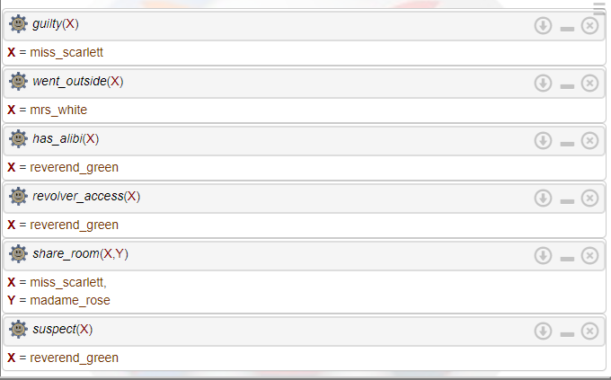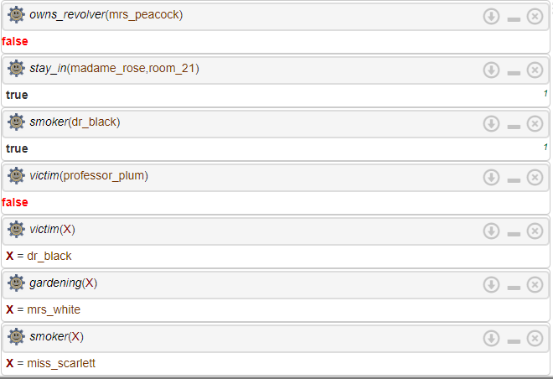

**Outcomes:**

**CO3 :** Ability to formally state the problem and develop the appropriate proof for given a logical deduction problem.