KJSCE/IT/SY/SEM IV/HO-IAI/2022-23

Batch: SY IT B2 Experiment Number: 6

Roll Number: 16010421073 Name: Keyur Patel

Aim of the Experiment: Write a program for implementation of solution of based a Murder Mystery using knowledge agent architecture.

Program/ Steps:

/* Facts */

man(dr_black).

man(reverend_green).

man(colonel_mustard).

man(professor_plum).

woman(mrs_peacock).

woman(madame_rose).

woman(miss_scarlett).

woman(mrs_white).

victim(dr_black).

playing_cards(colonel_mustard).

playing_cards(reverend_green).

playing_cards(mrs_peacock).

gardening(mrs_white).

gardening(reverend_green).

played_golf(professor_plum).

played_golf(colonel_mustard).

smoker(miss_scarlett).

smoker(colonel_mustard).

smoker(mrs_white).

smoker(dr_black).

smoker(mrs_peacock).

room(room_21).

room(room_22).

room(room_23).

room(room_24).

room(room_25).

stay_in(dr_black,room_22).

stay_in(reverend_green,room_24).

stay_in(miss_scarlett,room_21).

stay_in(colonel_mustard,room_24).

stay_in(professor_plum,room_22).

stay_in(mrs_peacock,room_23).

stay_in(madame_rose,room_21).

stay_in(mrs_white,room_23).

owns_revolver(reverend_green).

owns_revolver(colonel_mustard).

owns_revolver(madame_rose).

/* Rules */

suspect(X):- man(X), \+victim(X).

suspect(X):- woman(X), \+victim(X).

has_alibi(X):- suspect(X), playing_cards(X).

went_outside(X):- gardening(X).

went_outside(X):- smoker(X).

went_outside(X):- played_golf(X).

share_room(X,Y):- room(R), stay_in(X,R), stay_in(Y,R), X \= Y.

revolver_access(X):- owns_revolver(X).

revolver_access(X):- share_room(X,Y), owns_revolver(Y).

guilty(X):- suspect(X), went_outside(X), \+has_alibi(X), revolver_access(X).

Output/Result:

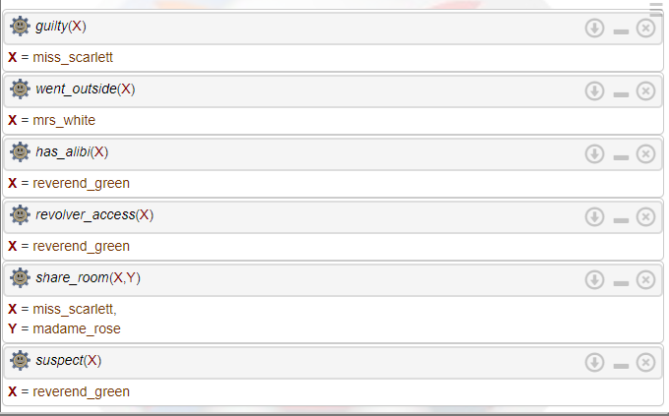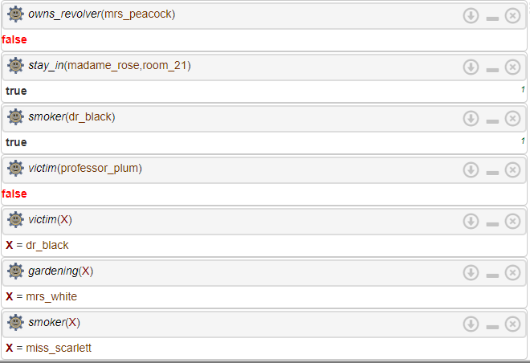

Outcomes:

CO3: Ability to formally state the problem and develop the appropriate proof for given a logical deduction problem.

**Conclusion (based on the Results and outcomes achieved):**

With this experiment we successfully solved murder mystery using PROLOG with set rules and facts and drew appropriate conclusions.

# References:

# Stuart Russell and Peter Norvig, Artificial Intelligence: A Modern Approach, Second Edition, Pearson Publication

# Luger, George F. Artificial Intelligence : Structures and strategies for complex problem solving , 2009 ,6th Edition, Pearson Education

# https://www.101computing.net/solving-a-murder-mystery-using-prolog/

(A Constituent College of Somaiya Vidyavihar University)