KJSCE/IT/SY/SEM IV/HO-IAI/2022-23

Batch : B2 Experiment Number: 7

Roll Number:16010421073 Name: Keyur Patel

Aim of the Experiment: Bayesian Network Problem Solving

Program/ Steps:

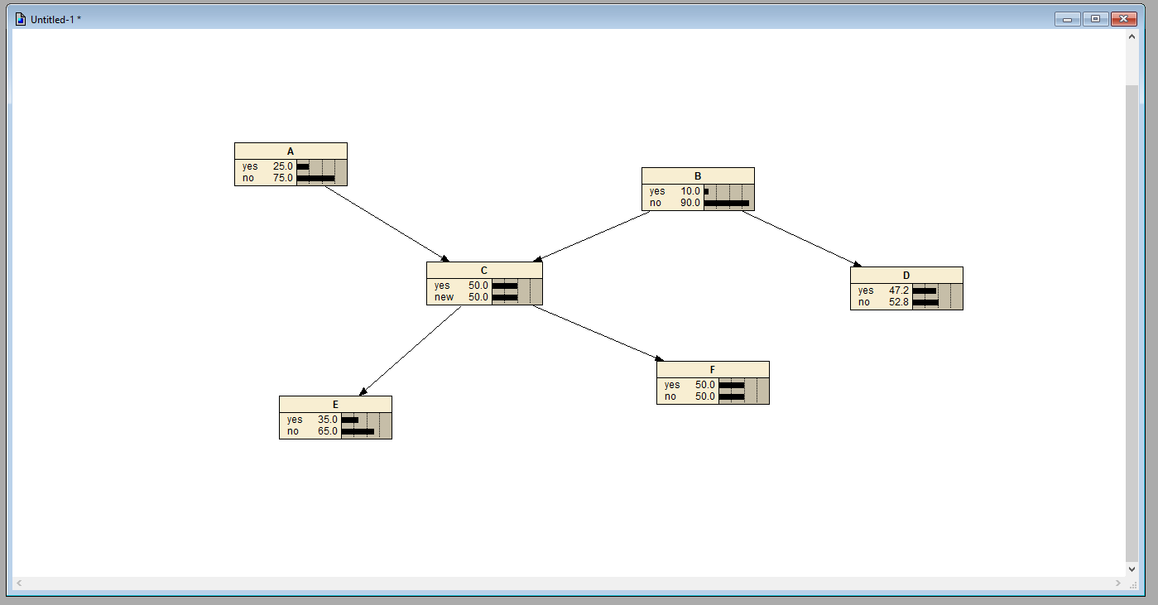

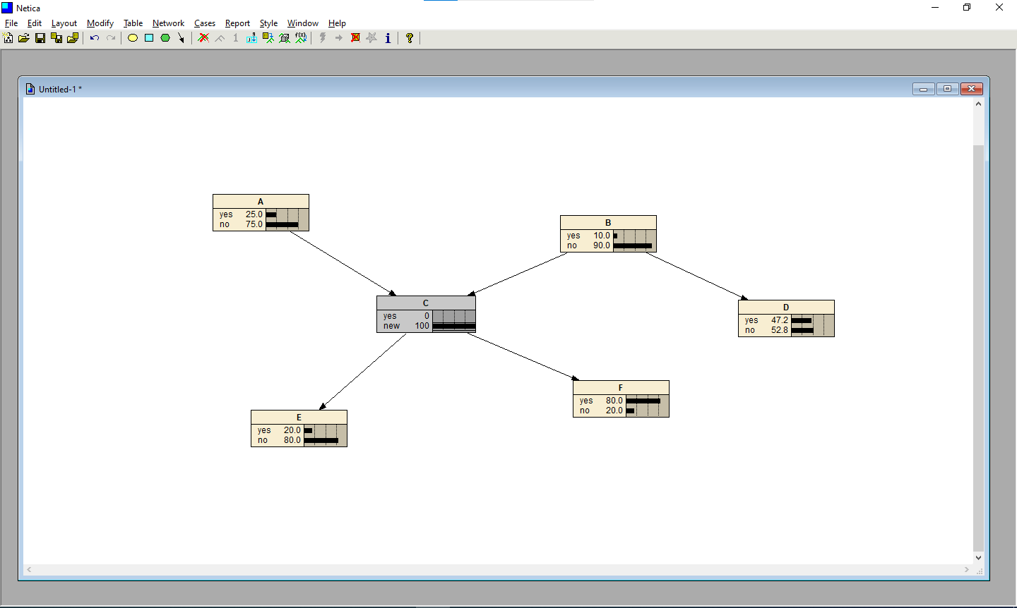

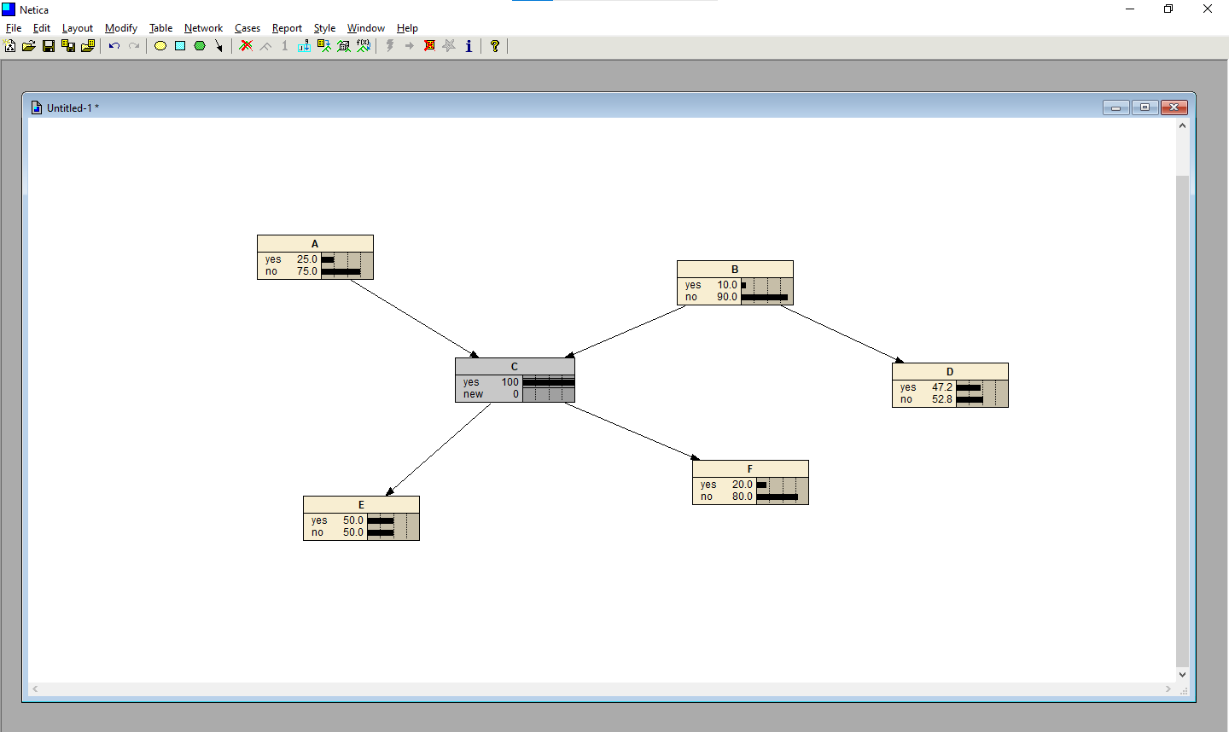



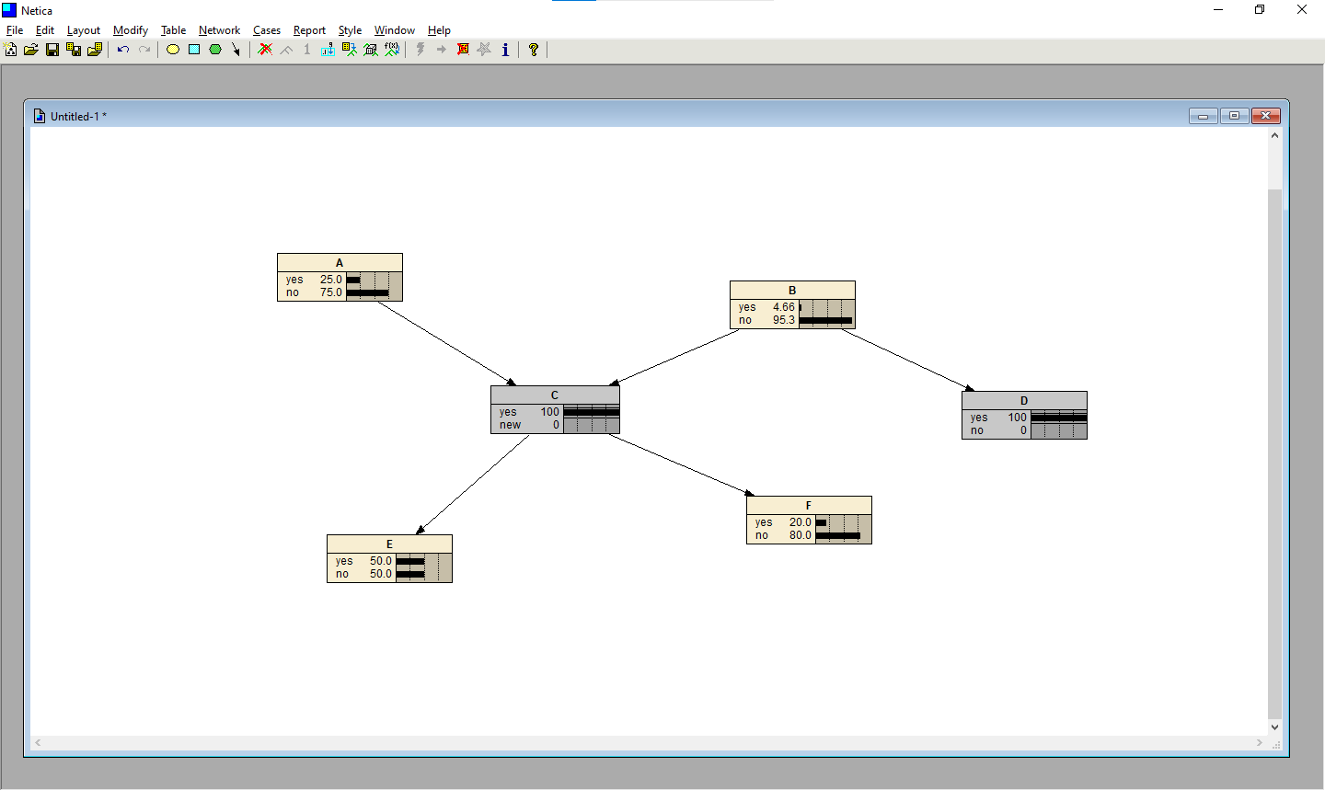

Post Lab Question-Answers:

**Q1. List the features of Netica.**

Ans.

● Auto Netica generates websites from Bayes nets. Example site

● Generates presentation quality graphics which can be incorporated into other

documents.

● Version 5.0 and later can do TAN learning of link structure from data.

● Compiles belief (Bayesian) networks into a junction tree of cliques for fast

probabilistic reasoning.

● Extensive built-in and online help.

● Utility-free sensitivity analysis.

● Can generate highly customizable reports on many aspects of the Bayes net,

nodes, states, CPTs, cases, findings, beliefs, sensitivity results, other inference

results, etc.

● Can test the performance of a network using a file of cases.

● Netica will print out a confusion matrix, error rate, logarithmic and quadratic (Brier)

scoring rule results, calibration table and surprise indexes for each node desired.

● Can find optimal decisions for sequential decision problems (i.e., later decisions are

dependent on the results of earlier ones).

● Can solve influence diagrams efficiently by using clique trees.

● Can learn probabilistic relations from data, even with missing data.

● Provides easy graphical editing of belief networks and influence diagrams, including:

o cut / paste / duplicate nodes without losing their probabilistic relation

o many ways of displaying the nodes (bar graphs, meters, etc.)

o links with bends to keep complex diagrams orderly

o allows comments, keeps track of author, when changed, etc. for each node

o unlimited levels of undo / redo

● Allows the entry of probabilistic relations by equation, with an extensive built-in

library of probabilistic functions and other mathematical functions.

● Has facilities for the easy discretization of continuous variables.

● Can reverse individual links and "sum out" nodes of influence diagrams or belief

nets, for model exploration.

● Supports disconnected links, which makes possible libraries of probabilistic

relationships

● It is possible to represent networks with nodes whose values change over time (a

persistence is defined for such nodes), and to have links with time delays (which

allows cycles). The software can automatically convert these networks into expanded

regular networks covering a limited period of time

● Accepts likelihood findings (i.e., virtual evidence), and findings of the form that some

variable

is not in some state.

● Can display nodes and inference results in a number of forms, including bar graphs

of beliefs and a true/false meter

● Easy to customize the display to be suitable for an end-user.

● Supports documentation and tracking of every node and network (with

comments, titles, author, when last changed, etc.)

● Has no built in limits on the size or complexity of networks, so they are limited

only by available memory.

● Can work hand-in-hand with the Netica API product (for example, sharing the same

files).

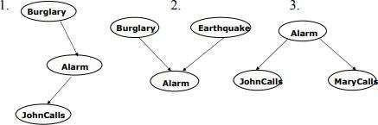Q2. State the following statements with respective to the diagrams are **true or false** and Justify your answer

1. John Calls is independent of Burglary,given Alarm

Ans: **TRUE**

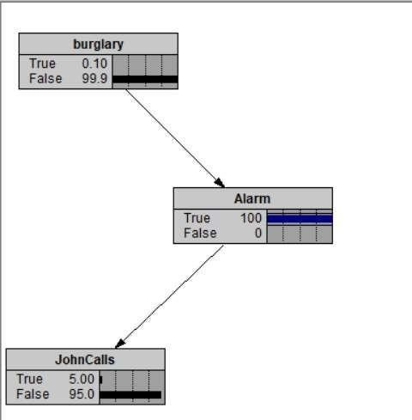

# P (J | A, B) = P (J | A)

P (J, B | A) = P (J | A) P (B | A)

1. Burglary is independent of Earthquake (not knowing Alarm) but Burglary and Earthquake

become dependent,given Alarm

Ans: **FALSE**

# Burglary is independent of Earthquake (not knowing Alarm) Burglary and Earthquake become dependent given Alarm.

P (B, E) = P(B)P(E)

# Initially B and E are independent

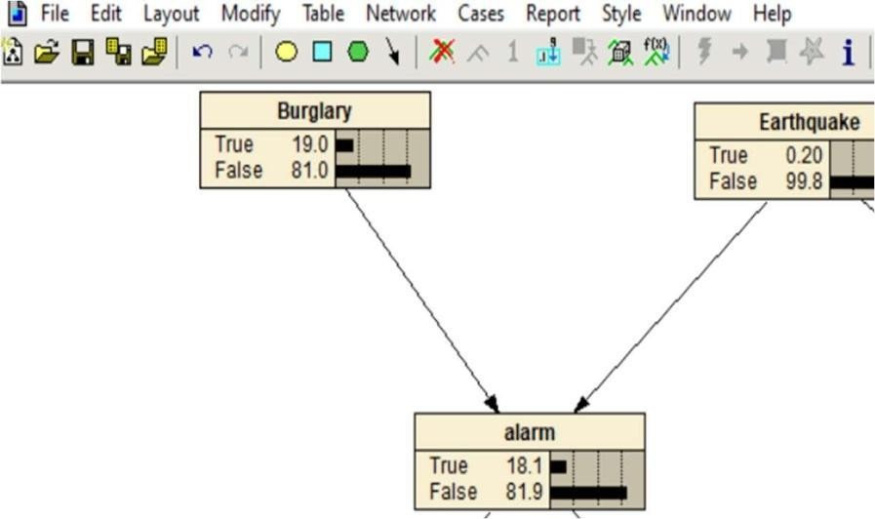

On setting alarm=TRUE B and E they are still independent

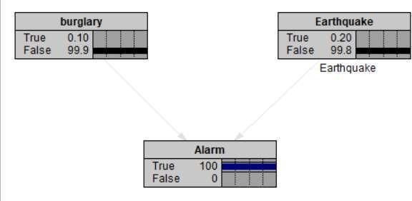

1. Mary Calls is independent of John Calls, given Alarm

Ans: **TRUE**

P (J | A, M) = P (J | A) P (J,M | A) = P( J | A)P(M | A)

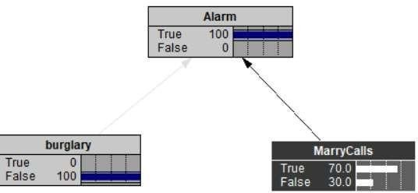

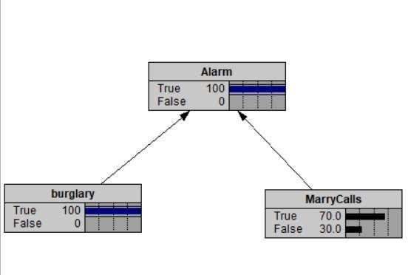

# Results:-(Soft copy Submission)

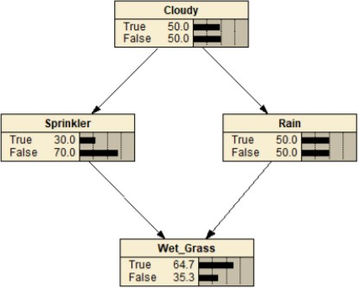

Demonstrating how changing the initial probability of the Cloudy node affects the rest of the network. Here the higher likelihood of cloudiness has reduced the likelihood of the sprinkler being used but raised the likelihoods for both the Rain and Wet Grass nodes. The ability to quickly test many potential states make Netica particularly useful for analyzing a system.

# Outcomes:

# CO4 : Comprehend problems with uncertainty, formalize the problem and understand how

# solutions are found.

**Conclusion (based on the Results and outcomes achieved):**

**Thus we successfully solved the Bayesian network problem using netica software.**

# References:

1. Stuart Russell and Peter Norvig, Artificial Intelligence: A Modern Approach,

Second Edition, Pearson Publication

2. https://www.norsys.com/netica_api.html

3. https://www.norsys.com/tutorials/netica/nt_toc_A.htm.

(A Constituent College of Somaiya Vidyavihar University)