**Name : Keyur Patel**

**Roll No : 16010421073**

**Batch : A3**

**Exp-no : 7**

**Date: 21-10-23**

Code:

#include <stdio.h>

#include <stdlib.h>

#define MAX_FRAMES 3

// Structure to represent a page

typedef struct {

int page_number;

int time;

} Page;

// Structure to represent a frame

typedef struct {

int frame_number;

Page page;

} Frame;

Frame frames[MAX_FRAMES];

void initializeFrames() {

for (int i = 0; i < MAX_FRAMES; i++) {

frames[i].frame_number = i;

frames[i].page.page_number = -1;

frames[i].page.time = -1;

}

}

void displayFrames() {

printf("Frames: ");

for (int i = 0; i < MAX_FRAMES; i++) {

if (frames[i].page.page_number != -1) {

printf("%d ", frames[i].page.page_number);

} else {

printf("empty ");

}

}

printf("\n");

}

int findLRUFrame() {

int min_time = frames[0].page.time;

int lru_frame = 0;

for (int i = 1; i < MAX_FRAMES; i++) {

if (frames[i].page.time < min_time) {

min_time = frames[i].page.time;

lru_frame = i;

}

}

return lru_frame;

}

int main() {

initializeFrames();

int pages[] = {1, 2, 3, 4, 1, 3, 5, 4, 6, 7, 8, 2, 1};

int page_count = sizeof(pages) / sizeof(pages[0]);

int page_index = 0;

for (int i = 0; i < page_count; i++) {

int page_number = pages[i];

displayFrames();

// Check if the page is already in a frame

int found = 0;

for (int j = 0; j < MAX_FRAMES; j++) {

if (frames[j].page.page_number == page_number) {

frames[j].page.time = i;

found = 1;

break;

}

}

// If the page is not found in any frame, perform replacement

if (!found) {

int lru_frame = findLRUFrame();

frames[lru_frame].page.page_number = page_number;

frames[lru_frame].page.time = i;

}

}

return 0;

}

Output:

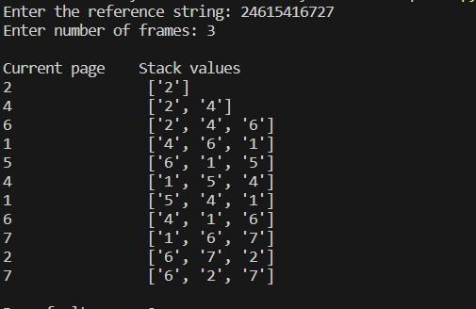

# Outcomes:

**CO3:** Understand I/O management, memory management and file management

# Conclusion: (Conclusion to be based on outcomes achieved)

Through this experiment we implemented the Least Recently Used (LRU) page replacement algorithm. We calculated number of hits and miss and also calculated their ratios.