**Module-3**

* **In Page Editing**

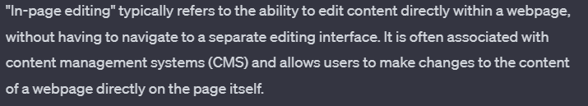

* ***Single-Field Inline Edit***

***Example:*** 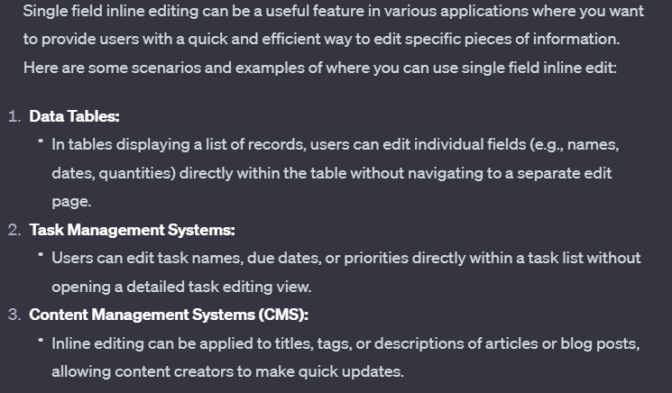

* ***Multi-Field Inline Edit***

***Example:***

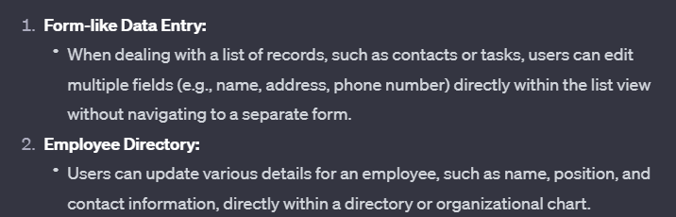

* ***Overlay Edit***

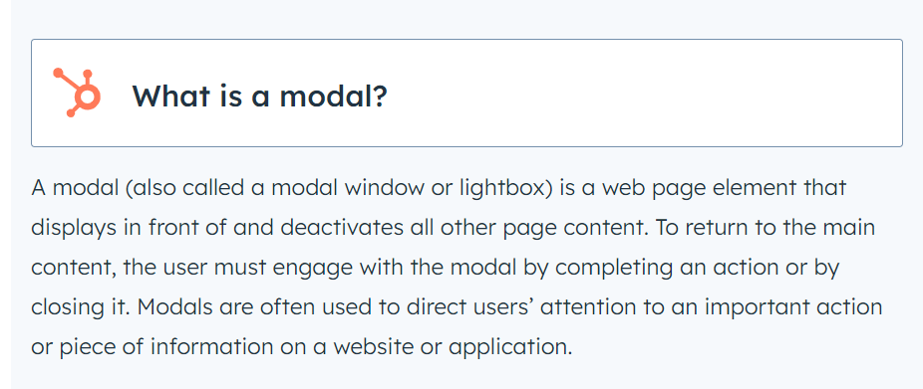

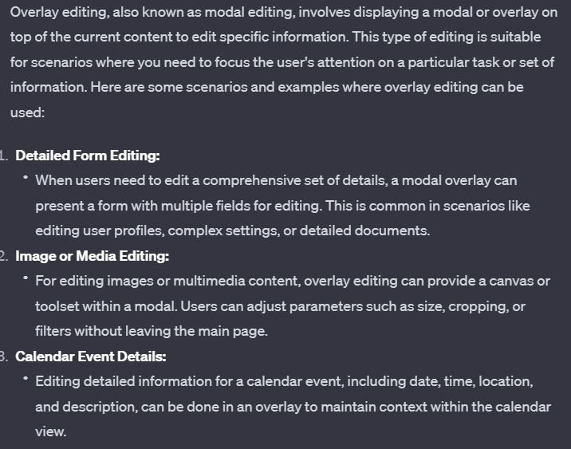

* ***Table Edit***

***Example:***

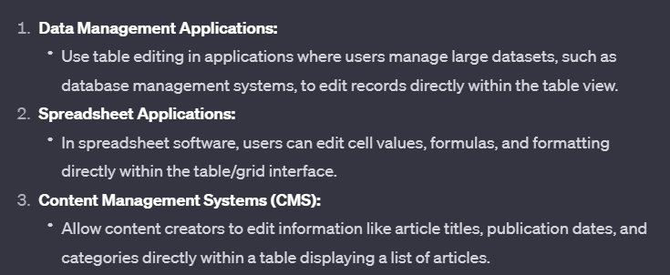

* ***Group Edit***

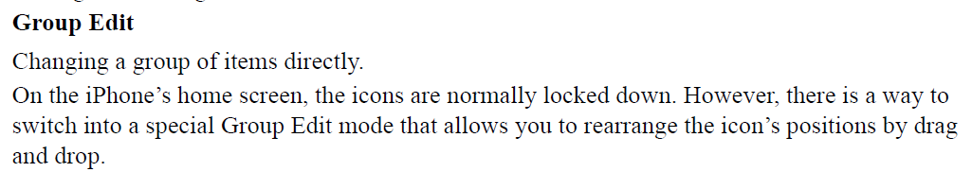

* ***Module Configuration***

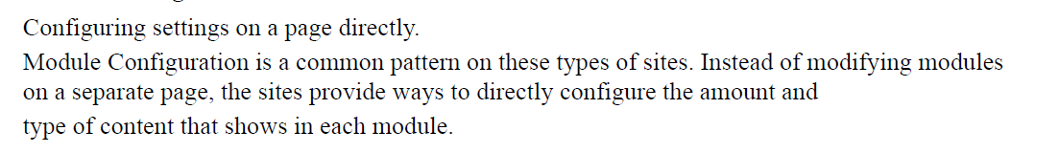

* ***Challenges associated with In-Page Editing***

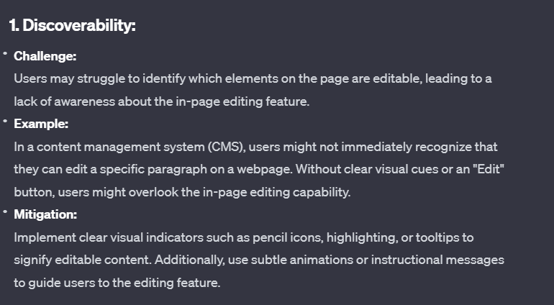

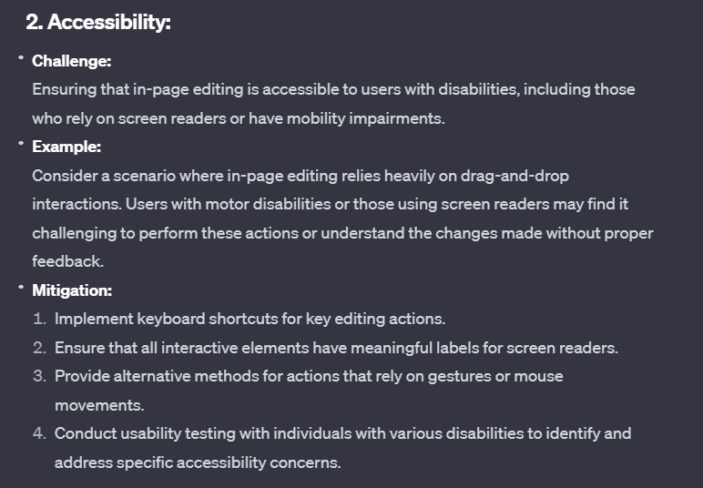

* **Drag And Drop**

***Common approaches for Drop***

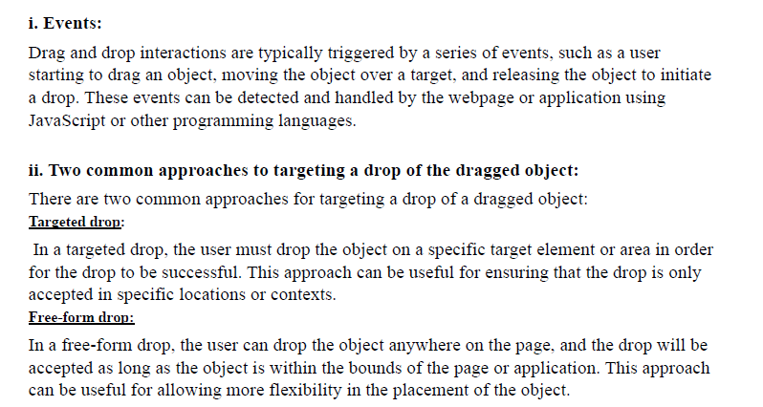

* ***Drag and Drop List***

***Examples:***

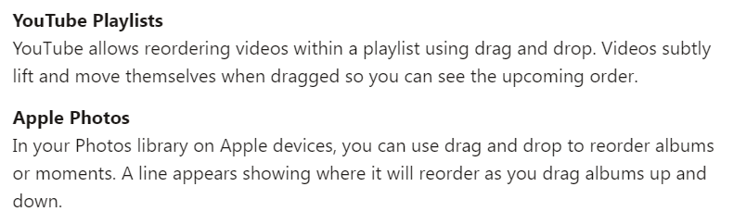

* ***Drag and Drop Object***

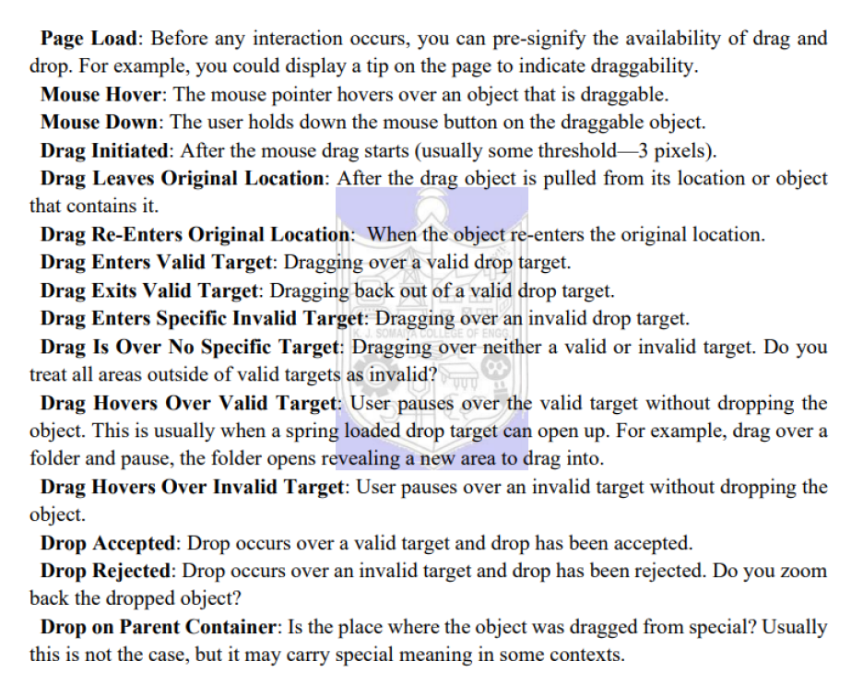

* ***Fitts Laws***

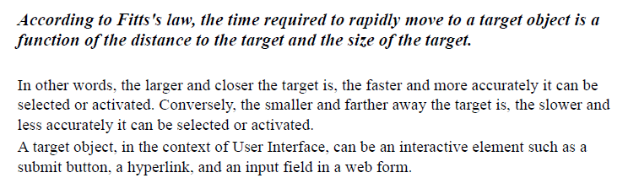

* ***Contextual tools***

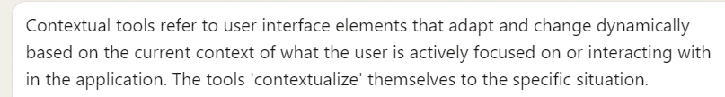

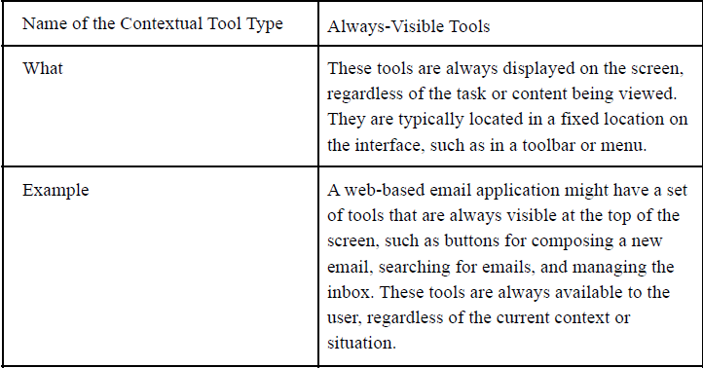

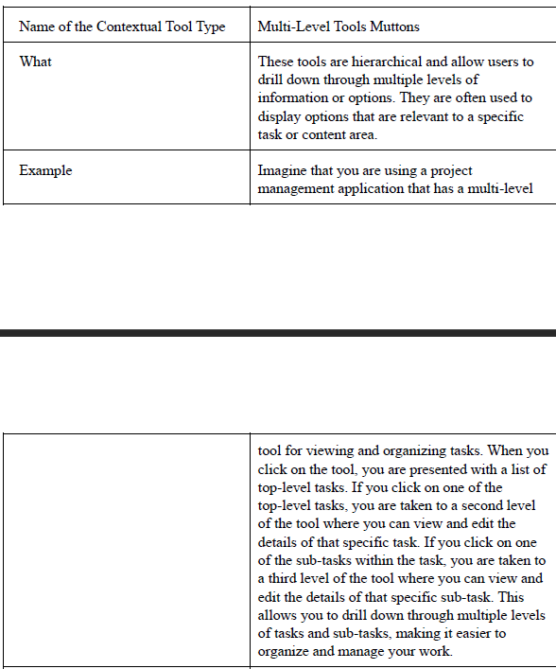

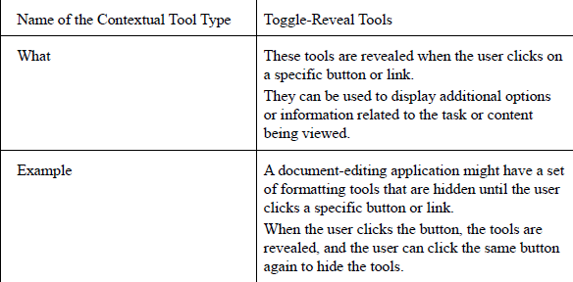

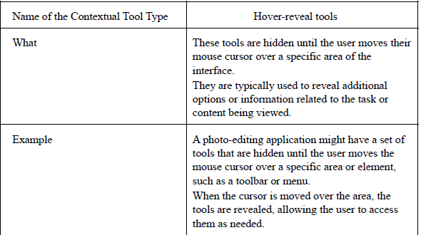

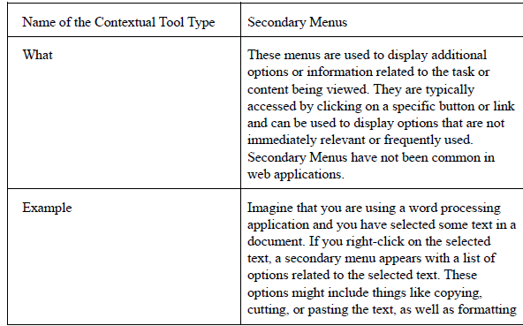

* ***Overlays and Inlays in UI***

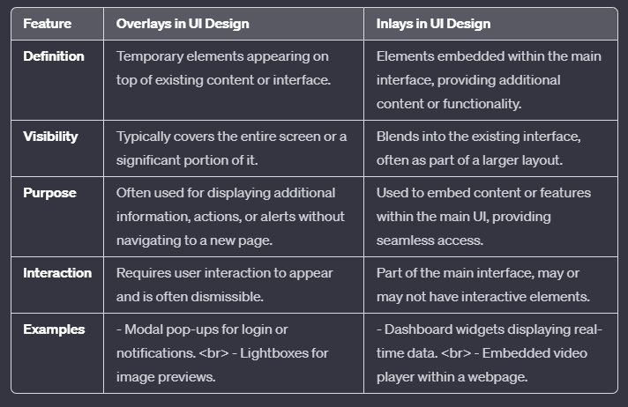

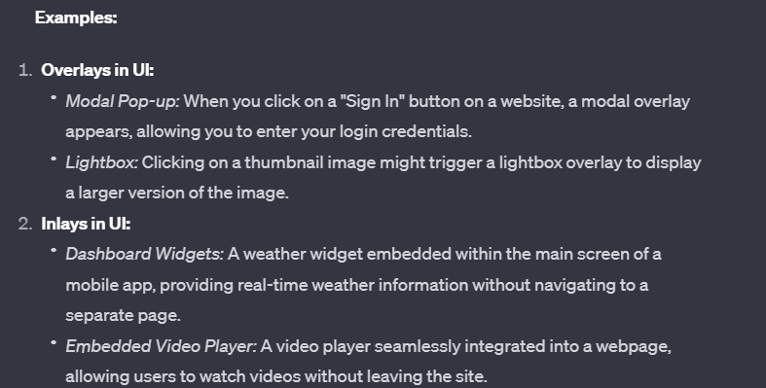

* ***Static Invitation***

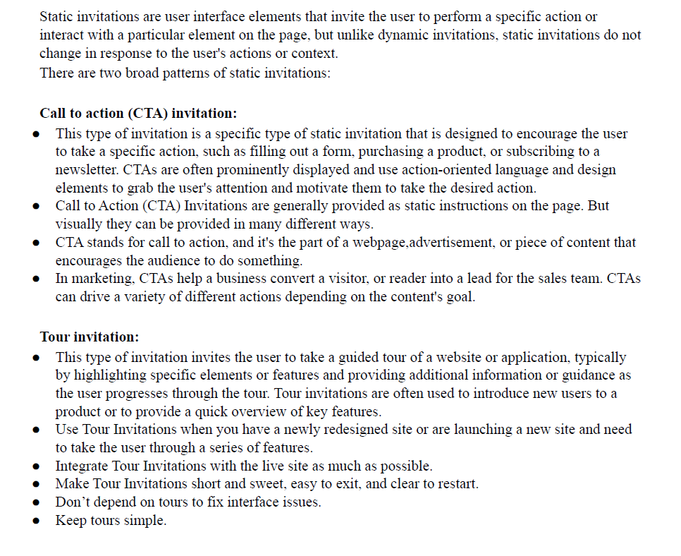

* ***Transistion Patterns***

