

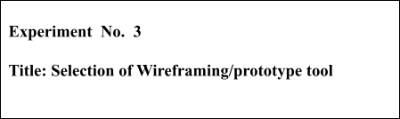



# Batch: A3 Roll No.: 16010421073 Experiment No.: 3 Aim: To write case study on selection of Wireframing/prototype tool

**--------------------------------------------------------------------------------------------**

**Resources needed:** Web Resources

# Theory:

Wireframing, in the context of user experience design, is the act of creating user interface wireframes. Originally, the term "wireframe" meant a visual representation of three-dimensional objects, like those used in product design and development. Now it is also used to describe 3D modeling in computer animation and in the design and development of 2D web pages and mobile apps.

In web design, a wireframe or wireframe diagram is a grey-scale visual representation of the structure and functionality of a single web page or a mobile app screen. Wireframes are used early in the development process to establish the basic structure of a page before visual design and content is added, and can be created using paper, straight into HTML/CSS or using software apps.

Wireframing sets expectations about how features will be implemented by showing how features will work, where they will be located and how much benefit they'll provide. A feature may be pulled out because it doesn’t fit into your site's goals. Wireframing provides an objective look at link names, paths to conversion, ease of use, navigation, and the placement of features. Instead of merging the full functionality, layout and creative elements into a single step, wireframes guarantee that these considerations are taken on separately. This allows stakeholders to provide feedback much sooner in the process.

Wireframes often end up evolving into the requirements for a system. Wireframes can be created using a variety of software applications, for example, Visio, Excel, Word, Illustrator, Photoshop and Power Point.

Wireframes should include all the important elements of a Web page. These include: Navigation, Company logo, Content area sections, Search function, User log in areas if appropriate. This is another type of wireframe that is used in building web applications. It shows not only how each page is structured but information about each widget, button, field, each piece of content, and what page is rendered by an action. It provides a map of the entire page in the Web site, its function and features. Even the message that may be rendered by behaviour can be included on this type of wireframe.



**Procedure:**

Discuss one Wireframing/Prototyping tool selected and elaborate on the same.

# 1(a). Search for Tools available for any one of categories of UI design.

1. Wireframing
2. Mock up
3. Prototyping
4. Proof of Concept

# 1(b). Explain the tool searched for each techniques in format given below.

|  |  |
| --- | --- |
| Type of Tool |  |
| Name: Of the Tool (Include Company Name, Website etc.) |  |
| License/ Open Source |  |
| Explanation of Tool |  |
| Procedure | 1. How tool accepts the input? 2. How tool processes the data? 3. How tool displays the output/result? (Attach Screen shot whenever required) |
| Conclusion | Whether tool will be selected for laboratory activities? |



**Results:**

# Attached print out about each selected tool in prescribed format.

1. Wireframing - Figma
2. Mock up - Marvel, Balsamiq



1. Prototyping – Adobe XD, Figma
2. Proof of Concept – Ux Pin

# 1(b)Wire Framing:



|  |  |
| --- | --- |
| Type of Tool | Wire framing |
| Name: Of the Tool  (Include Company Name, Website etc.) | Figma  Company Name: Figma Inc. Website : [www.figma.com](http://www.figma.com/) |
| License/ Open Source | Open Source |
| Explanation of Tool | * [Figma](https://www.figma.com/) is a web-based graphics editing and user interface design app. We can use it to do all kinds of graphic design work from wire framing websites, designing mobile app interfaces, prototyping designs, crafting social media posts, and everything in between .Figma is different from other graphics editing tools. * Mainly because it works directly on our browser. This means we get to access your projects and start designing from any computer or platform without having to buy multiple licenses or install software .Another reason why designers love this app is that Figma offers a generous free plan where we can create and store 3 active projects at a time. * It’s more than enough for us to learn, experiment, and work on small projects. |
| Procedure | 1. How tool accepts the input?   Ans) Figma offers users a variety of options. They can import and export frames, as well as choose a frame depending on its size and kind. Additionally, it offers the ability to draw shapes, scribble, and fill in colors using a color picker or hex code. The user can import SVGs and pictures as well. All kinds of drawing and designing tools are provided on a sizable canvas.   1. How tool processes the data?   Ans) Figma is a collaborative tool which stores data in the cloud and auto saves our work. Data is processed in real time.   1. How tool displays the output/result?   A) We can view the produced wire frame with actual device screen size by running a particular frame, many frames, or all the frames in the canvas on a screen. Frames can be exported in a variety of formats as well. |
| Conclusion | Whether tool will be selected for laboratory activities?  Yes |

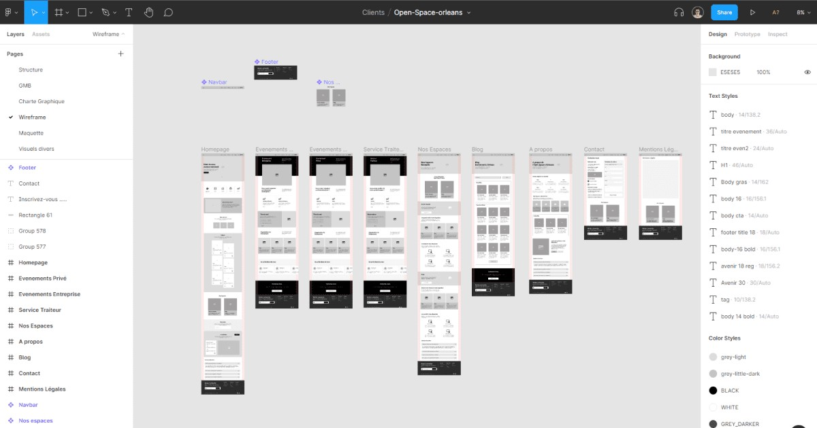

**Mock Up:**

|  |  |
| --- | --- |
| Type of Tool | Mock Up |
| Name: Of the Tool (Include Company Name, Website etc.) | Mockplus  Company Name : MockPlus Software Co. Ltd Website : https:/[/www.mockplus.com/](http://www.mockplus.com/) |
| License/ Open Source | Open Source |
| Explanation of Tool | * Mockplus is one of the most common and powerful website mockup free tools that allow you to create website designs and build mobile and desktop app mockups. * If you are a [web](https://www.webdew.com/blog/hire-a-web-designer) [designer](https://www.webdew.com/blog/hire-a-web-designer) and want to create scalable sites that look good on different sites, then this tool is for you. * By using this tool, you can create [web design mockups](https://www.webdew.com/blog/what-is-mockup-design) in a few minutes with a [drag and drop editor](https://www.hubspot.com/products/cms/drag-and-drop-website-builder?__hstc=45270139.03d736b2c4b91a0c2e0ab8c6f8b5aed3.1664298641845.1664298641845.1664298641845.1&__hssc=45270139.1.1664298641846&__hsfp=1072425495). This tool is perfect for you, especially if you are a solo designer or running a small team. You can utilize the free version of this website design |

|  |  |
| --- | --- |
|  | mock up tool to create five projects. |
| Procedure | 1. How tool accepts the input?  Ans) Add buttons, labels, textboxes, checkboxes, tabs, combo boxes, hyperlinks, scroll bars, splitters, and more to your mockup using the design surface and a list of standard UI |

|  |  |
| --- | --- |
|  | components. Additionally, there are built-in controls for video players, dialogue boxes, and browser windows.   1. How tool processes the data?   Ans) A mockup can be exported as an XML file, a.PNG image, or to storage after it has been created.   1. How tool displays the output/result?   Ans) We can view the result by opening the saved mockup icon. |
| Conclusion | Whether tool will be selected for laboratory activities?  No |

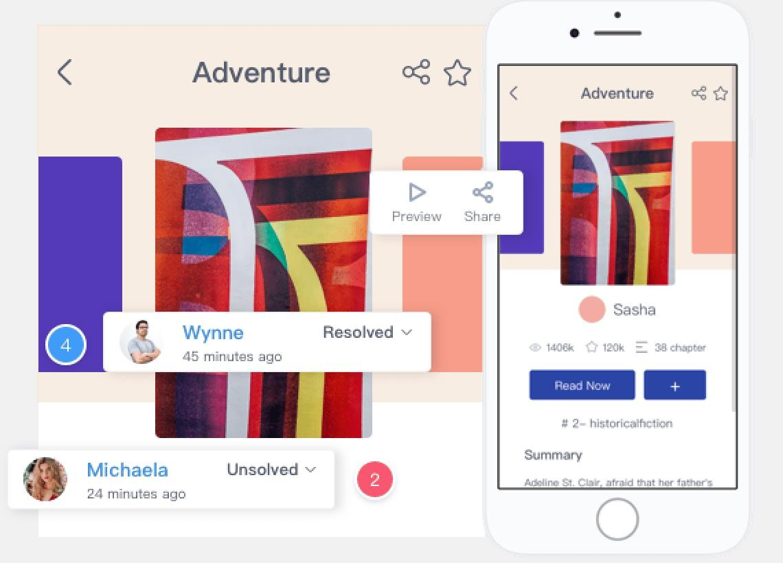

|  |  |
| --- | --- |
| Type of Tool | Mock Up |
| Name: Of the Tool (Include Company Name, Website etc.) | Fluidui  Company Name : Fluidui Website : https:/[/www.fluidui.com/](http://www.fluidui.com/) |

|  |  |
| --- | --- |
| License/ Open Source | Open Source MIT License |
| Explanation of Tool | With Fluid UI, ideas can be prototyped in  minutes and shared instantly. Sharing, feedback and collaboration are all built in. Fluid UI focuses on fast, easy and fun. Prototype in high or low fidelity. Fluid UI supports whatever style you need. Test your prototypes on any mobile or tablet with the free player apps. Visually linking your prototype together makes adding interactions fast, fun and productive. |
| Procedure | 1. How tool accepts the input?  Ans) Add buttons, labels, textboxes, checkboxes, tabs, combo boxes, hyperlinks, scroll bars, splitters, and more to your mockup using the design surface and a list of standard  UI |

|  |  |
| --- | --- |
|  | components. Additionally, there are built-in controls for video players, dialogue boxes, and browser windows.   1. How tool processes the data?   Ans) A mockup can be exported as an XML file, a.PNG image, or to storage after it has been created.   1. How tool displays the output/result?   Ans) We can view the result by opening the saved mockup icon. |
| Conclusion | Whether tool will be selected for laboratory activities?  No |

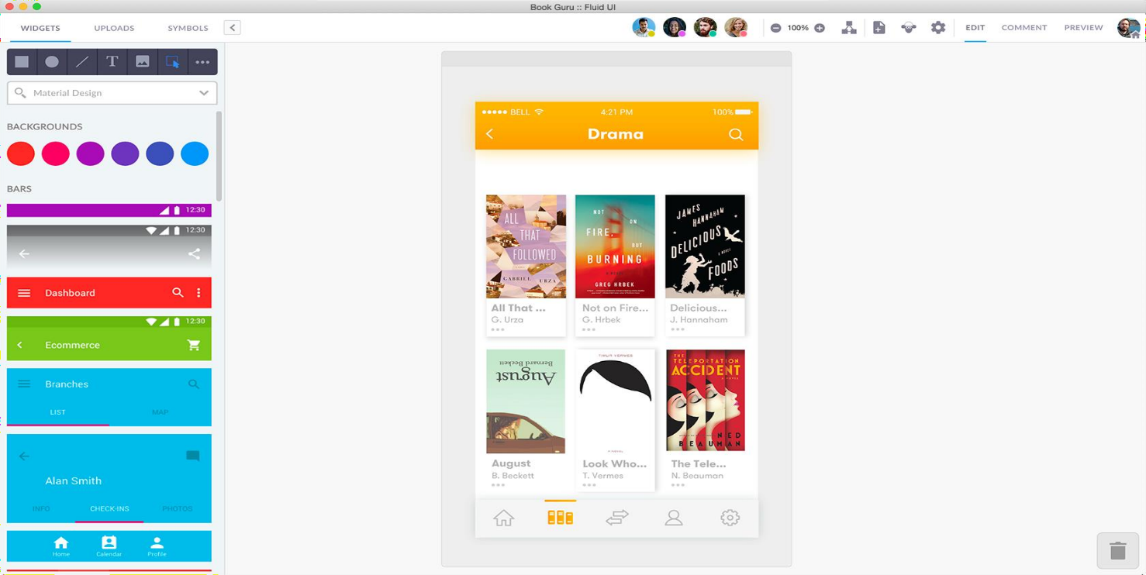

**Prototyping:**

|  |  |
| --- | --- |
| Type of Tool | Prototyping |
| Name: Of the Tool (Include Company Name, Website etc.) | Adobe XD  Company Name: Adobe Experience Design Website : [www.adobe.com/products/xd.html](http://www.adobe.com/products/xd.html) |
| License/ Open Source | Open Source |

|  |  |
| --- | --- |
| Explanation of Tool | [Adobe XD](https://www.adobe.com/products/xd.html) offers a vector-based system for putting together prototypes, including tools for creating interactions, transitions, and other types of dynamic functionality. Because it’s vector based, scaling and resizing elements is no problem. Adobe XD works well alongside other Adobe family apps like Illustrator and Photoshop. It’s nice to be able to edit Adobe images, like a  .psd file, right in the application.From UI design to UX design, Adobe XD covers all the tools a designer needs from conceptualization through high-resolution prototypes. And  they’re continually adding to this product with monthly updates that expand its functionality. |
| Procedure | 1. How tool accepts the input?   Ans) When introducing actions to a prototype, any element or set of elements can be used as a trigger. One element may have multiple triggers or actions chosen for it. You can also copy and paste previous interactions to avoid having to recreate them.   1. How tool processes the data?   Ans) Adobe XD is a collaborative tool which stores data in the cloud and auto saves our work. Data is processed in real time.   1. How tool displays the output/result?   Ans) We can view the produced wire frame with actual device screen size by running a particular frame, many |

|  |  |
| --- | --- |
|  | frames, or all the frames in the canvas on a screen. Frames can be exported in a variety of formats as well. |
| Conclusion | Whether tool will be selected for laboratory activities?  No |

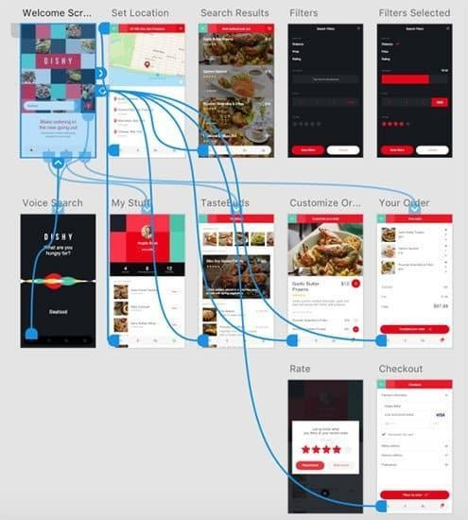

# Proof of Concept:

|  |  |
| --- | --- |
| Type of Tool | Proof of Concept |
| Name: Of the Tool  (Include Company Name, Website etc.) | UX Pin  Company Name: UXPin Inc. Website : <http://uxpin.com/> |

|  |  |
| --- | --- |
| License/ Open Source | Open Source |
| Explanation of Tool | UX Pin is a product design platform used by the designers.  Let us easily design, collaborate, and present from  low-fidelity wireframes to fully-interactive prototypes. |
| Procedure | 1. How tool accepts the input?  Ans) With only one click in UXPin, elements can be filled with actual data from Google Sheets, JSON, or CSV.  Additionally, you can use a variety of example data, including names, addresses, and avatars  . |

|  |  |
| --- | --- |
|  | 1. How tool processes the data?   Ans) UXPin uses the layer names to link the elements with the relevant columns in the Google Sheet. Each CSV file has rows and columns. This structure makes each CSV file resemble a table.   1. How tool displays the output/result?   Ans) Every time a user draws something on the canvas using the code-based design tooling paradigm (UXPin), the tool generates the HTML, CSS, and JSON code and uses the browser rendering engine to represent it visually. |
| Conclusion | Whether tool will be selected for laboratory activities?  No |
|  |  |

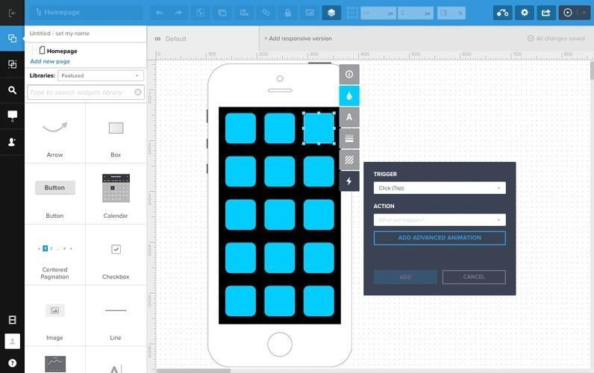

**Outcomes:**

**CO1: Understand concepts related to User Interface Design.**

# Conclusion: (Conclusion to be based on the objectives and outcomes achieved)

From the experiment, various mock ups, wireframing, proof of concept designing tools were explored and a few choices were made for selection of the tools for the project.

.



# Grade: AA / AB / BB / BC / CC / CD /DD



**Signature of faculty in-charge with date**

**References:**

Wilbert O. Galitz, “The Essential Guide to User Interface Design - An Introduction to GUI Design Principles and Techniques”, Wiley Computer Publishing, Second Edition, 2002

Bill Scott, Theresa Neil, “Designing Web Interfaces Principles & Patterns for Rich

Interaction”, O’rielly Media, First Edition, 2009