

**Experiment No. 6**

**Title: Patterns with form design**

**Batch: A3 Roll No.: 16010421073 Experiment No.:6**

## Aim: To create patterns with form design

**--------------------------------------------------------------------------------------------**

**Resources needed:** Wireframing tool

## Theory:

The patterns, techniques, and controls described here apply mostly to form design—a form being simply a series of question/answer pairs. However, they will also be useful in other contexts, such as for single controls on web pages or on application toolbars. Input design and form design are core skills for interaction designers.

Following are some samples of form design:

# Forgiving Format:



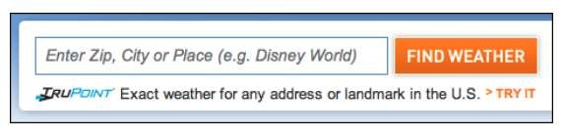

**Figure 1 Forgiving Form Format**

Forgiving form format permits users to enter text in a variety of formats and syntax, and make the application interpret it intelligently.

Use When:

UI asks for data that users might type with an unpredictable mix of whitespace, hyphens, abbreviations, or capitalizations. More generally, the UI can accept input of various kinds from the user—different meanings, formats, or syntax.

Examples:

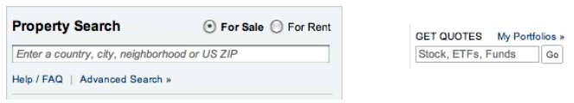The New York Times uses Forgiving Format in several features that need information from users. Figure shows examples from its real estate search and from its financial quotes feature.

**Figure 2: Two text fields in the New York Times website**

One place where this pattern should be used, but usually isn’t, is when credit card numbers are requested from the user. As long as 16 digits are typed, why should the form care whether the user separates them by spaces, or by hyphens, or by nothing at all? It’s not difficult to strip out separating characters. PayPal, for example, doesn’t accept spaces in credit card numbers shown in figure 3.

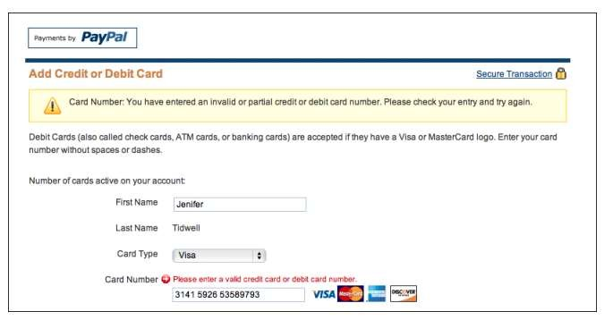

**Figure 3 PayPal Form**



Figure 4 comes from Outlook’s tool for setting up a meeting. Look at the “Start time:” and “End time:” fields at the bottom of the screenshot—one don’t need to give it a fully defined date, like what’s in the text fields now. If today is April 24 and one wants to set up a meeting for April 29, one can type any of the following terms:

• next Thu • 29/4/2004 • 4/29

* nxt thu • 4/29/2004 • five days
* thu • 29/4 • 5 days

And so on—there are probably other accepted formats, too. The specified date then is “echoed back” to the user in the appropriate format for the user’s language and location.

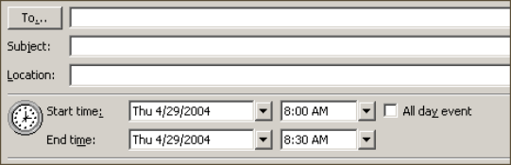

**Figure 4 Outlook’s tool form**

# Structured Format :

**Figure 5 Structured Form Format 1**

Instead of using one text field, use a set of text fields that reflect the structure of the requested data.



Use When:

Form interface requests a specific kind of text input from the user, formatted in a certain way. That format is familiar and well defined, and designer don’t expect any users to need to deviate from the format designer expect. Examples include credit card information, local telephone numbers, and license strings or numbers. It’s generally a bad idea to use this pattern for any data in which the preferred format may vary from user to user. Consider especially what might happen if interface is used in other countries. Names, addresses, postal codes, and telephone numbers all have different standard formats in different places. Consider using Forgiving Format in those cases.

Examples:

At its simplest, Structured Format literally can take the shape of the data, complete with spaces, hyphens, and parentheses, as illustrated in the following figure.

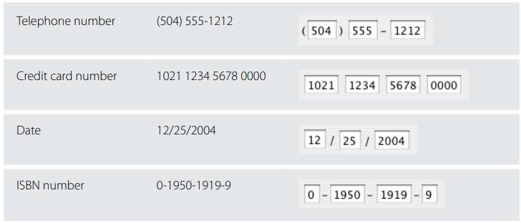

**Figure 6 Structured Form Format 2**

For date input, LiveJournal uses Structured Format in combination with a drop down to choose a month (see Figure 7). It defaults to the current day and time.



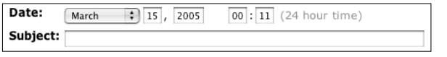

**Figure 7 Structured Form Format 3**

## Procedure:

* + Create wireframes incorporating patterns with Form design for the chosen topic

## Result:

## 

## In this design frame the pattern is used for searching song either by typing artist name, album, genre,lyrics etc.

**Outcomes:** **CO2 :** Apply principles of Web interface design.

## Conclusion: (Conclusion to be based on the objectives and outcomes achieved)

Thus we successfully designed music player web UI pattern design for searching song.

**Grade: AA / AB / BB / BC / CC / CD /DD**

## Signature of faculty in-charge with date

**References:**



1. Tidwell, Jenifer, “Designing interfaces: Patterns for effective interaction design. " O'Reilly Media, Inc.", 2010.
2. Wilbert O. Galitz, “The Essential Guide to User Interface Design - An Introduction to GUI Design Principles and Techniques”, Wiley Computer Publishing, Second Edition, 2002
3. Bill Scott, Theresa Neil, “Designing Web Interfaces Principles & Patterns for Rich Interaction”, O’rielly Media, First Edition, 2009