

**Experiment No. 7**

**Title: Design Dashboard**

**Batch: A3 Roll No.:16010421073 Experiment No.: 7**

# Aim: To create wireframe for Web UI – Dashboard

**--------------------------------------------------------------------------------------------**

**Resources needed:** Wireframing tool

# Theory:

Dashboard is a familiar and recognizable page style. Dashboards have a long history, both online and in the physical world, and people have well-established expectations about how they work: they show useful information, they update themselves, they usually use graphics to display data, and so on. A dashboard is also a guild of interlocking patterns and components.

Dashboard arranges data displays into a single information-dense page, updated regularly. It showd users relevant, actionable information, and let them customize the display as necessary.



A site or application deals with an incoming flow of information from something— web server data, social chatter, news, airline flights, business intelligence information, or financials, for example. Users would benefit from continuous monitoring of that information.

Dashboard determines what information users need or want to see. This isn’t as simple as it sounds, because one needs an editorial eye—one can’t just splatter the screen with confusing or unimportant data, or people won’t be able to pick out the parts that matter. Remove, or at least deemphasize, information that doesn’t help the user. Use a good visual hierarchy to arrange lists, tables, and information graphics on the page. Try to keep the main information on one page, with little or no scrolling, so people can keep the window on-screen and see everything at a glance. Group related data into Titled Sections, and use tabs only when confident that users won’t need to see the tab contents side by side. Use One-Window Drilldown to let users see additional details about the data—they should be able to click on links or graphics to find out more.

Choose appropriate and well-designed information graphics for the data one need to show. Gauges, dials, pie charts, and 3D bar charts look nice, but they are rarely the best way to show comparative information at a glance—simple line and bar charts express data better, especially time-based data. When numbers and text are more relevant than graphics, use lists and tables. Row Striping is a common pattern for multicolumn data tables. People will try to get actionable information from the dashboard at a glance, without looking hard at every element on the page. So, when showing a text, consider highlighting keywords and numbers so that they stand out from surrounding text.

Should users be able to customize their dashboard displays? Many dashboards do offer customization, and users may expect it. One way to customize a dashboard page is to rearrange the sections—Google and My Yahoo! both offer Movable Panels to users, in addition to choosing which gadgets get shown.

# Following are some examples:

* My Yahoo! is a portal-style dashboard, showing weather, news, email, and other personalized information to a signed-in user. This is the kind of window that someone would check frequently throughout the day or week. It can be rearranged via Movable Panels, and a user can decide which sections and widgets to show.



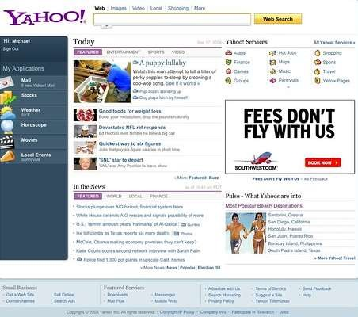

* Google Analytics uses information graphics to show a visual snapshot of a system. In the figure below, the system is a website, and the dashboard illustrates log data.

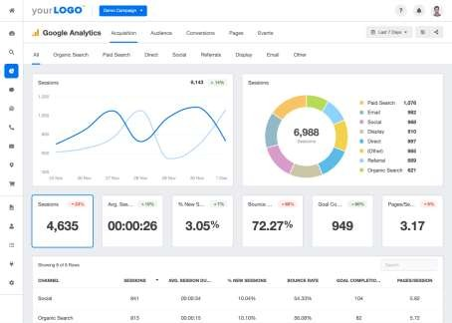

* Netvibes offers fully customizable dashboards that can be hooked up to a broad-based web search. With this, someone can stay abreast of conversations, pictures, and articles about a fast-moving topic. A tool tip shows the first few words of an article, which can help the user to decide whether to click through or not.



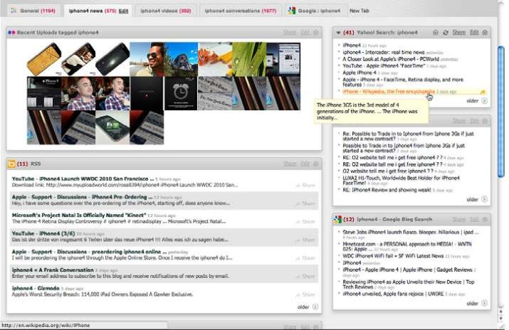

# Procedure:

* Create wireframes incorporating patterns with Form design for the chosen topic

# Result:

# 

**Outcomes:** **CO2:** Apply principles of Web interface design



# Conclusion: (Conclusion to be based on the objectives and outcomes achieved)

# Thus we successfully designed a wireframe for dashboard.(medical dashboard)

**Grade: AA / AB / BB / BC / CC / CD /DD**

# Signature of faculty in-charge with date

**References:**

1. Tidwell, Jenifer, “Designing interfaces: Patterns for effective interaction design. " O'Reilly Media, Inc.", 2010.
2. Wilbert O. Galitz, “The Essential Guide to User Interface Design - An Introduction to GUI Design Principles and Techniques”, Wiley Computer Publishing, Second Edition, 2002



1. Bill Scott, Theresa Neil, “Designing Web Interfaces Principles & Patterns for Rich Interaction”, O’rielly Media, First Edition, 2009