**Name : Keyur Patel**

**Roll no : 16010421073**

**Batch : A3**

**Basics of PHP**

**Strings:**

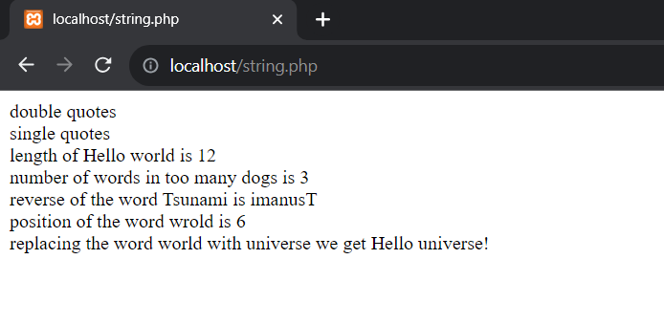

**Code:**

<?php

$x = "double quotes";

$y = 'single quotes';

echo $x;

echo "<br>";

echo $y;

echo "<br>";

echo "length of Hello world is ";

echo strlen("Hello world!");

echo "<br>";

echo "number of words in too many dogs is ";

echo str_word_count("too many dogs");

echo "<br>";

echo "reverse of the word Tsunami is ";

echo strrev("Tsunami");

echo "<br>";

echo "position of the word wrold is ";

echo strpos("Hello world!", "world");

echo "<br>";

echo "replacing the word world with universe we get ";

echo str_replace("world", "universe", "Hello world!");

?>

**Arrays:**

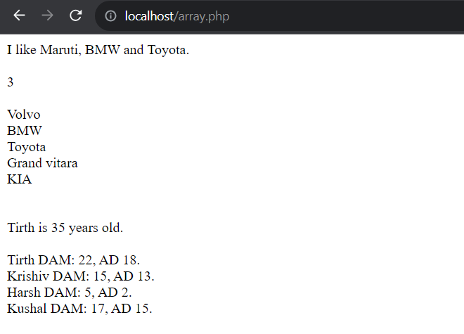

**Code:**

<?php

$cars = array("Maruti", "BMW", "Toyota");

echo "I like " . $cars[0] . ", " . $cars[1] . " and " . $cars[2] . ".";

?>

<?php

echo "<br>";

echo "<br>";

$cars = array("Volvo", "BMW", "Toyota");

echo count($cars);

?>

<?php

//indexed array

echo "<br>";

echo "<br>";

$cars = array("Volvo", "BMW", "Toyota", "Grand vitara", "KIA");

$arrlength = count($cars);

for($x = 0; $x < $arrlength; $x++) {

echo $cars[$x];

echo "<br>";

}

?>

<?php

//associative array

echo "<br>";

echo "<br>";

$age = array("Tirth"=>"35", "Ben"=>"37", "Joe"=>"43");

echo "Tirth is " . $age['Tirth'] . " years old.";

?>

<?php

echo "<br>";

echo "<br>";

$Marks = array (

array("Tirth",22,18),

array("Krishiv",15,13),

array("Harsh",5,2),

array("Kushal",17,15)

);

echo $Marks[0][0]." DAM: ".$Marks[0][1].", AD ".$Marks[0][2].".<br>";

echo $Marks[1][0]." DAM: ".$Marks[1][1].", AD ".$Marks[1][2].".<br>";

echo $Marks[2][0]." DAM: ".$Marks[2][1].", AD ".$Marks[2][2].".<br>";

echo $Marks[3][0]." DAM: ".$Marks[3][1].", AD ".$Marks[3][2].".<br>";

?>

<?php

//sorting array

echo "<br>";

echo "<br>";

$cars = array("Volvo", "BMW", "Toyota");

sort($cars);

?>

<?php

echo "<br>";

echo "<br>";

$numbers = array(4, 6, 2, 22, 11);

rsort($numbers);

?>