**Batch: A3 Experiment Number:8**

**Roll Number: 16010421073 Name:Keyur Patel**

**Aim of the Experiment: Mini Project**

**Output/Result:**

**Problem Statement:**

Fake news and misinformation in today's digital age has become a significant concern. False information, deliberately or inadvertently spread through various online platforms, can have far-reaching consequences, including political, social, and economic impact. Therefore, the development of effective tools to identify and combat fake news is essential. Machine learning models can play a crucial role in automating the process of fake news detection.

Develop a machine learning model that can accurately and efficiently identify fake news articles from genuine ones, based on the content and context of the text.

**Dataset Details(US News):**

1. True News dataset
2. Fake News dataset
3. Manual Testing dataset(consisting of true and fake news)

**CODE :**

* **Importing Libraries**

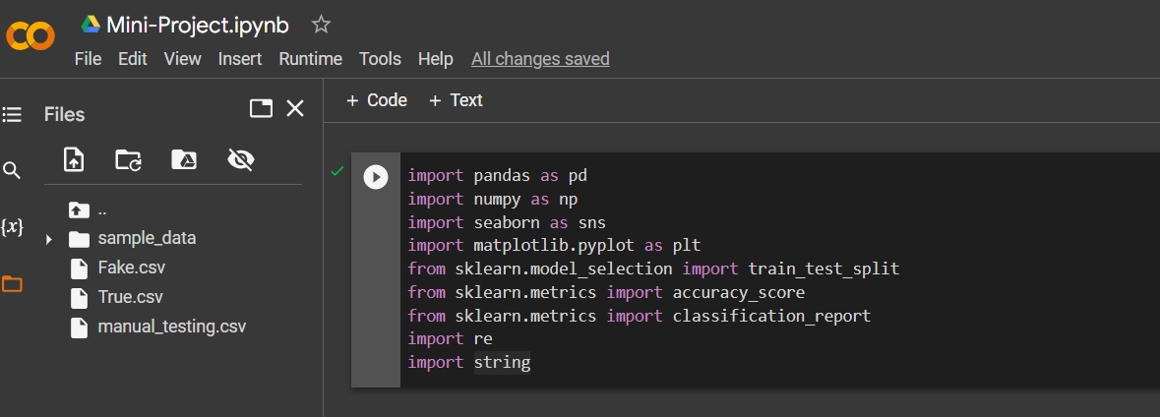

* **Importing Fake news and True news Dataset**



* 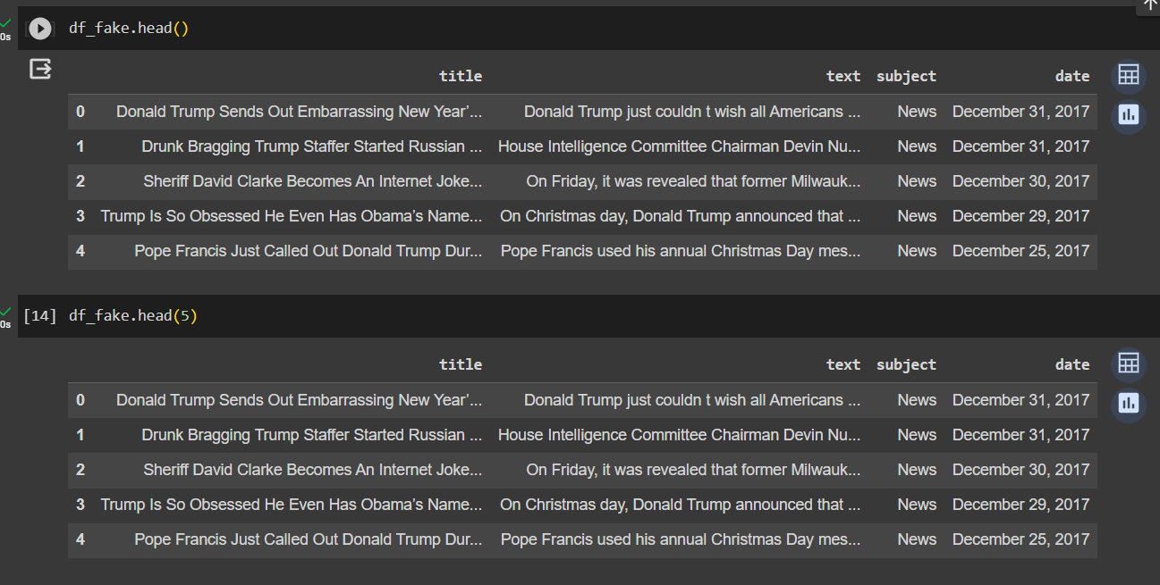
* **Inserting a column "class" as target feature (0 & 1 representing fake and true news )**

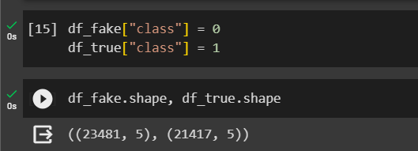

* **Removing last 10 rows from fake and true dataset for manual testing**

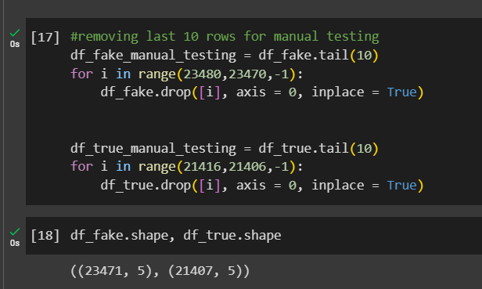

* 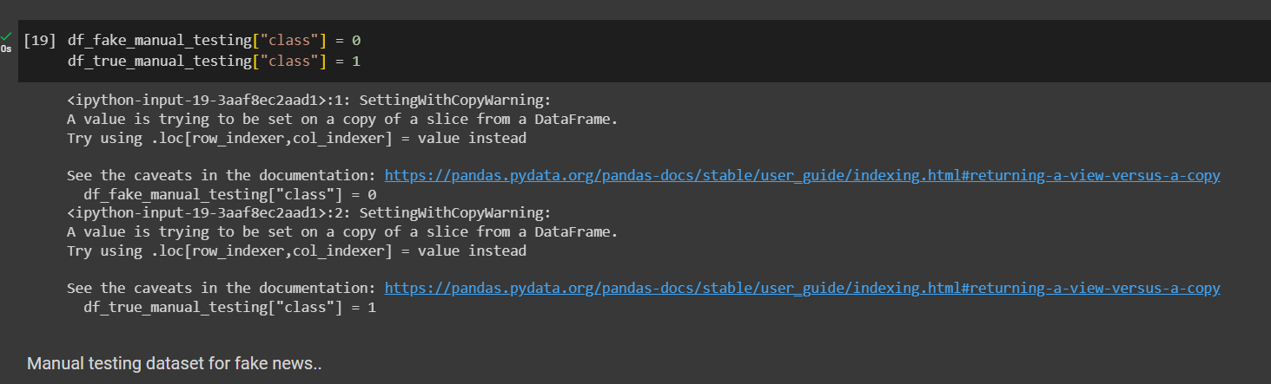
* 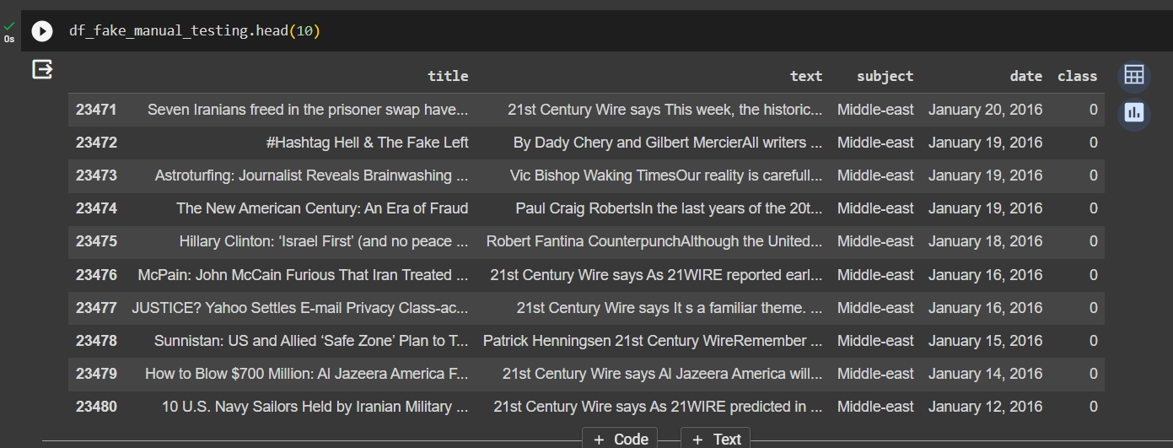
* 

**Manual testing dataset for true news**

* **Concatenating two dataframes manual testing fake and true dataframes and merging true and fake dataframes creating a single manual_testing.csv.**

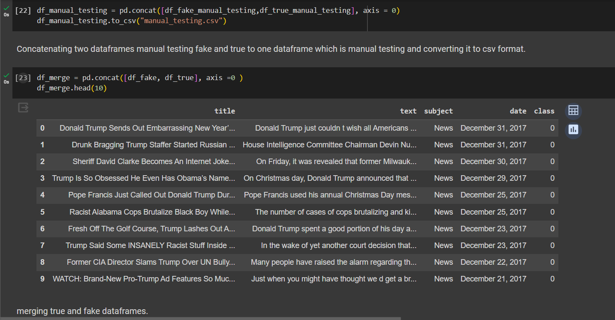

* **Removing columns which are not required. Then shuffling the dataframe manual_testing.csv**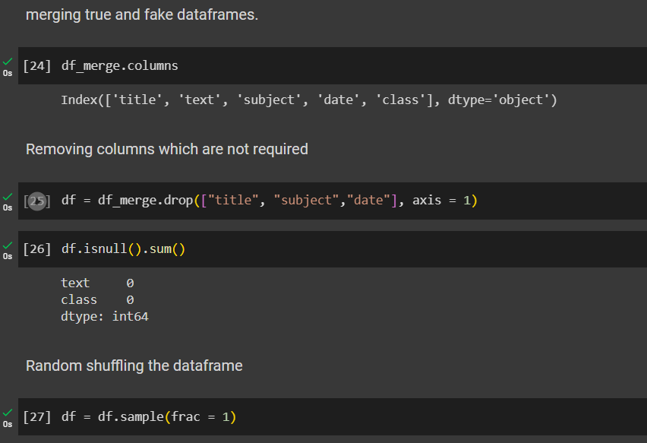
* 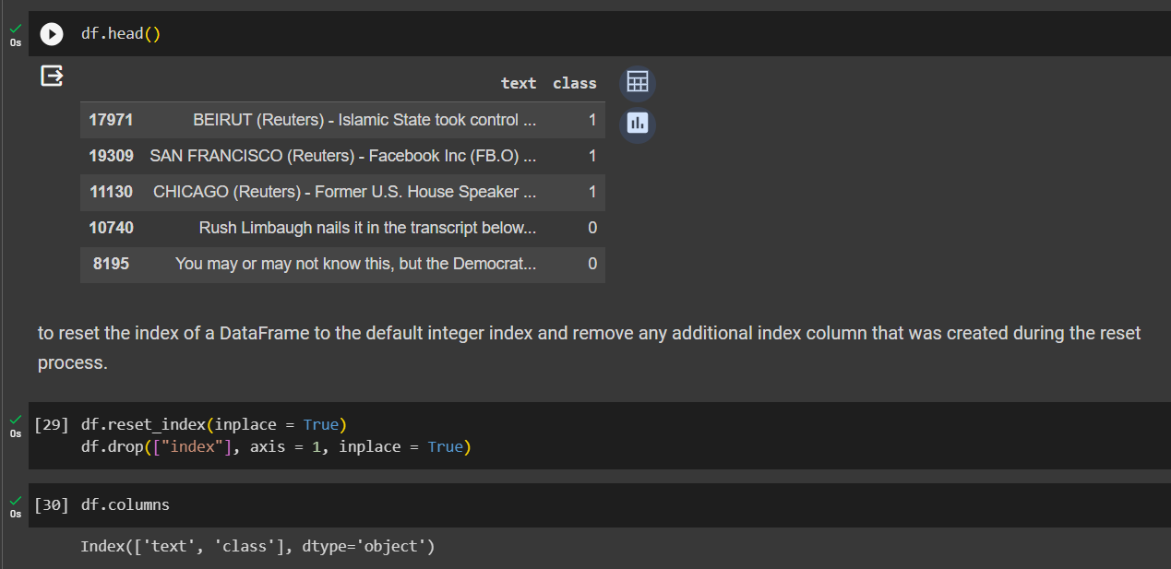
* **Creating a function to process the texts.(regular expressions)**

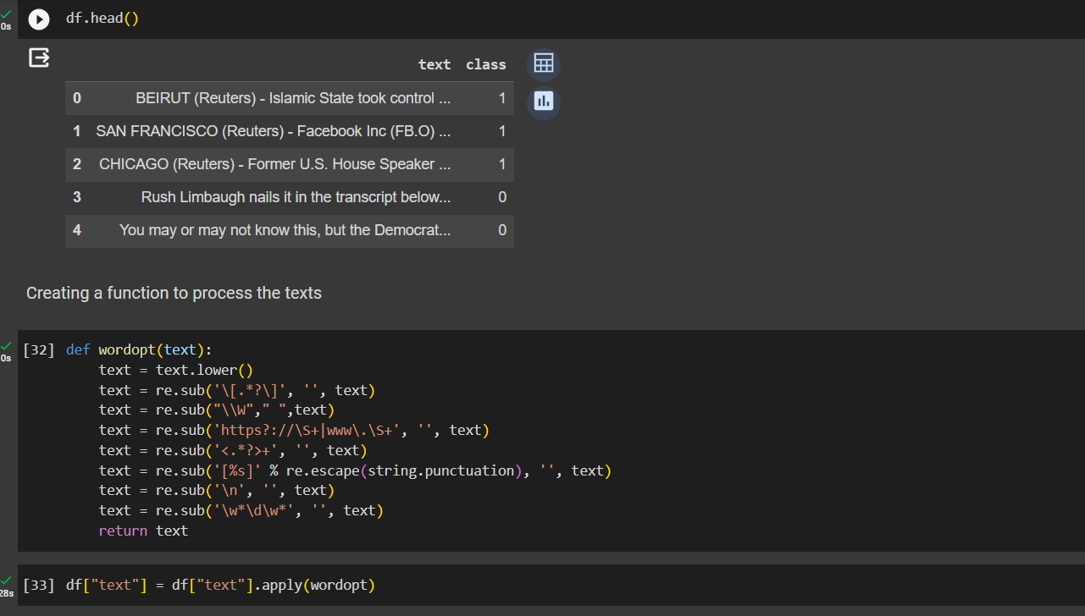

* **Defining dependent and independent variables .Then splitting training and testing of datasets 25%(testing dataset)**

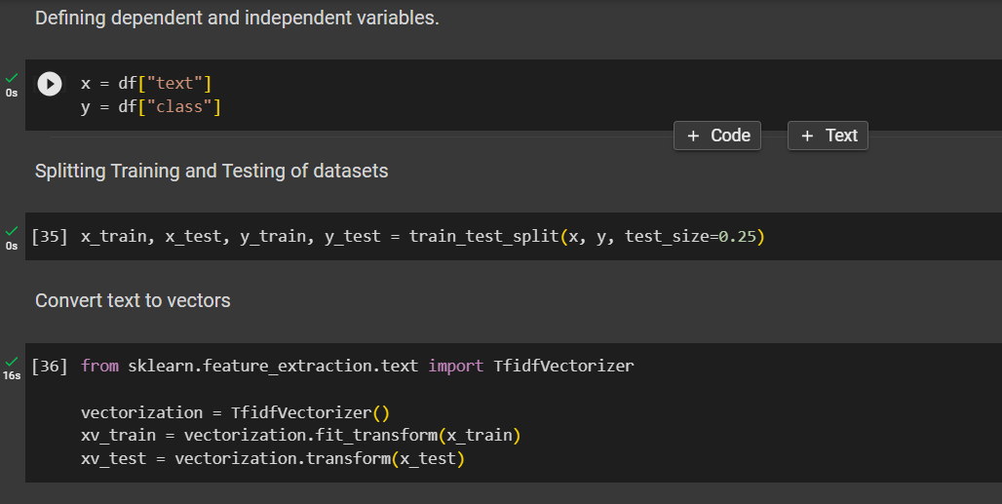

**Implementing machine learning algorithms**

* **Logistic regression**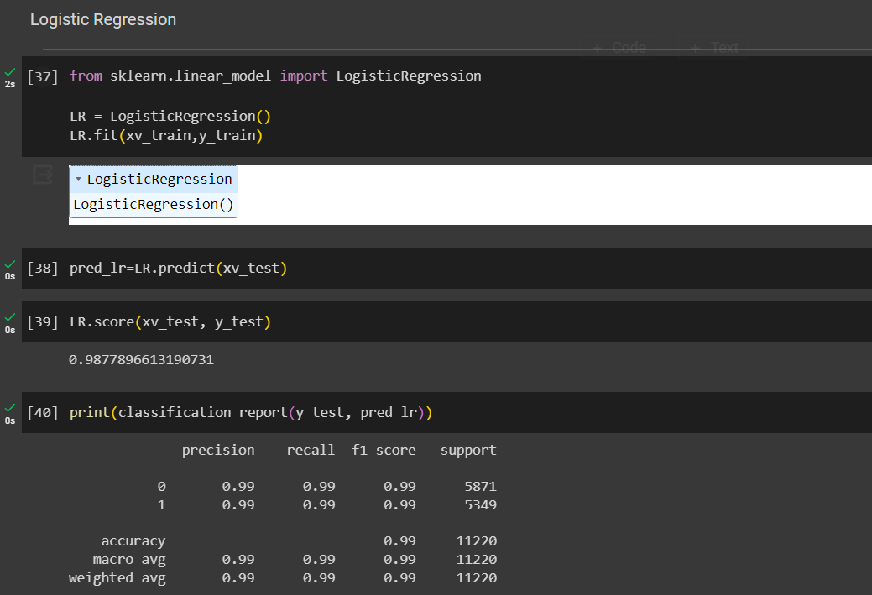
* **Decision Tree classification**

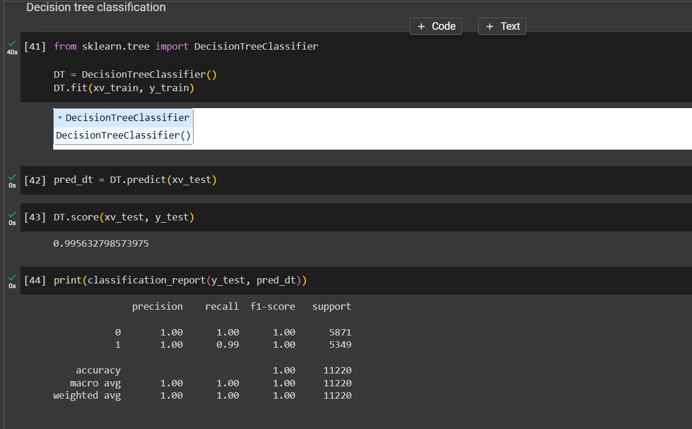

* **Gradient booster classfier**

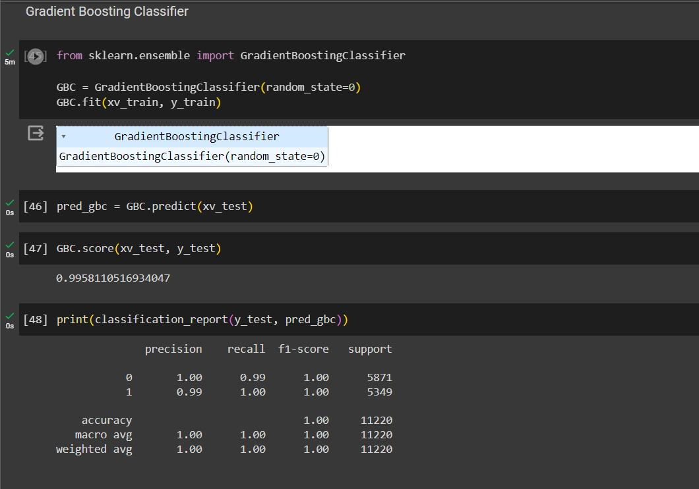

* **Random forest Classifier**

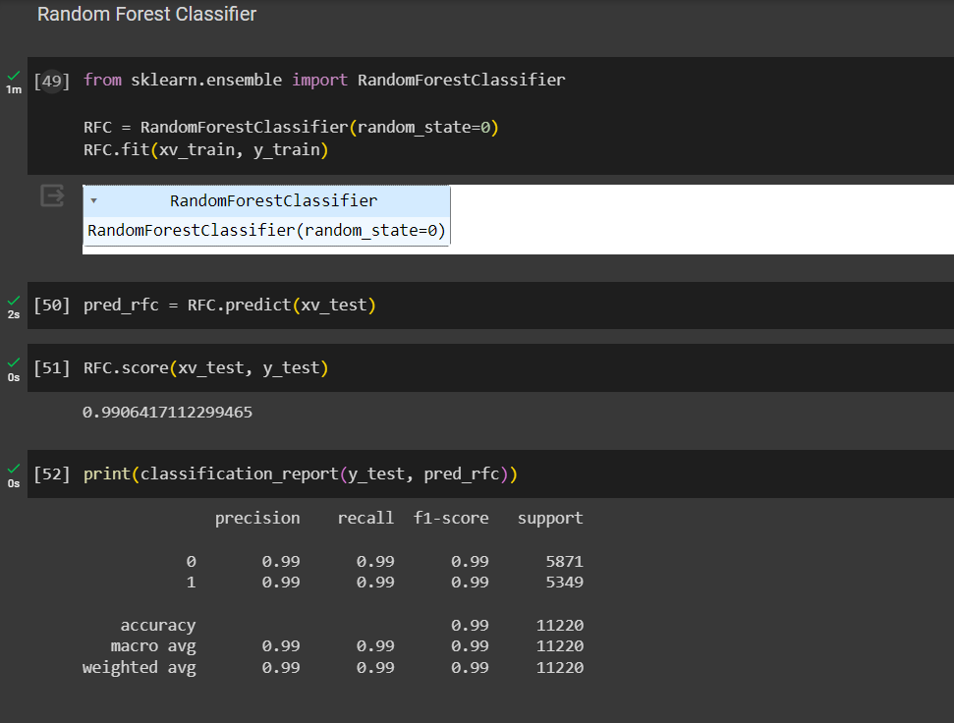

**Model Testing**

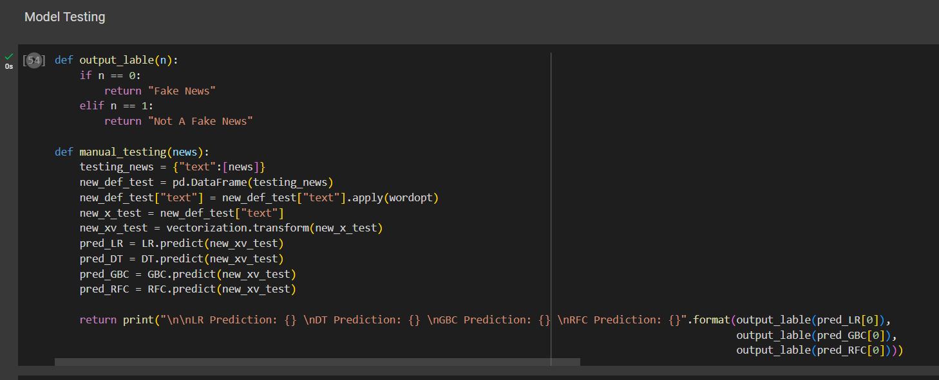

**Results**

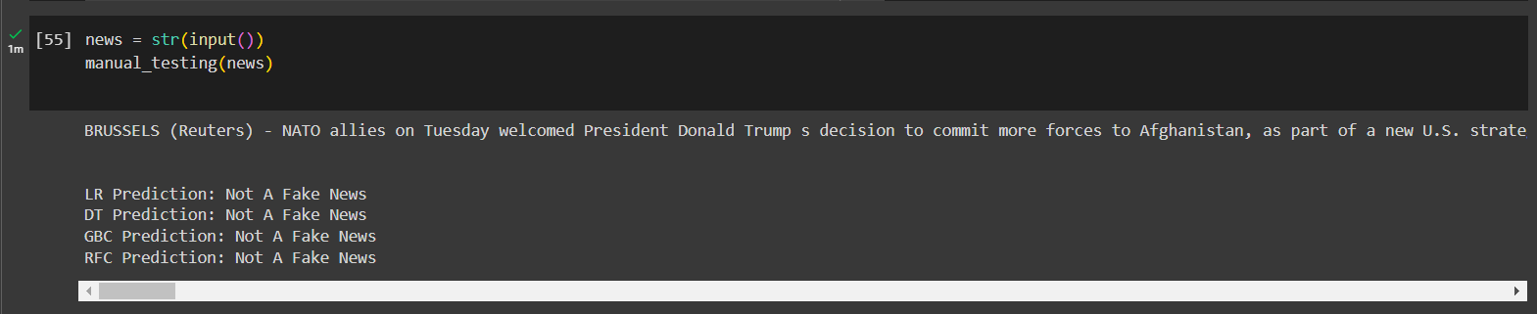

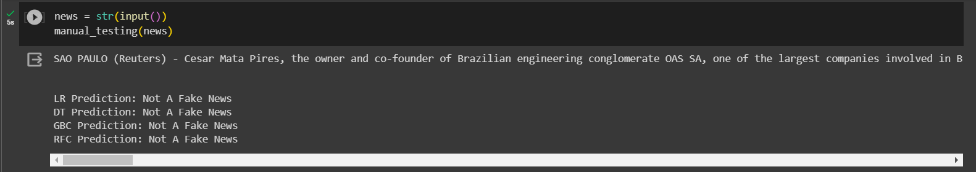

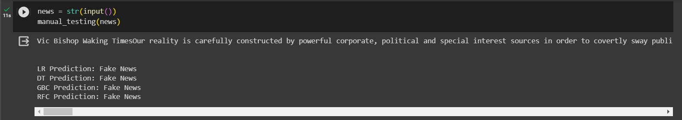

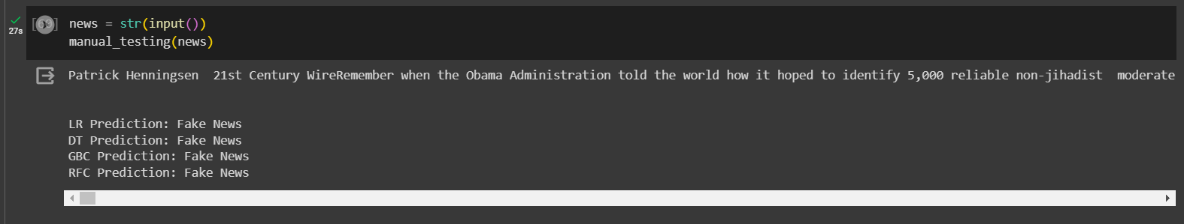

**Outcomes:** **CO3: Comprehend radial-basis-function (RBF) networks and Kernel learning method**

**Conclusion (based on the Results and outcomes achieved):**

**Thus we successfully did a mini project for fake news detection consisting of**

**True and fake datasets and merged it into manual_testing dataframe.**

**References:**

**Books,Journals etc.**