**Mod-4**

**4.1)**

Modeling is an essential activity in software development, and it plays a crucial role in the design and documentation of software systems. The Unified Modeling Language (UML) is a widely adopted standard for modeling software systems, providing a comprehensive set of diagrams and notations to represent various aspects of the system.

Importance of Modeling:

1. **Visualization:** Models provide a visual representation of the system, making it easier to understand, communicate, and reason about complex concepts and relationships.
2. **Abstraction:** Modeling allows developers to focus on the essential aspects of the system by abstracting away unnecessary details, making it easier to manage complexity.
3. **Communication:** Models serve as a common language for stakeholders, facilitating effective communication and collaboration among team members, clients, and domain experts.
4. **Documentation:** Models document the design and architecture of the system, providing a reference for future maintenance and evolution.
5. **Analysis:** Models can be used to analyze and validate the system's behavior, identify potential issues, and explore alternative designs before implementation.
6. **Code Generation:** In some cases, models can be used as input for code generation tools, automating parts of the development process and ensuring consistency between the design and implementation.

**Design Concepts**

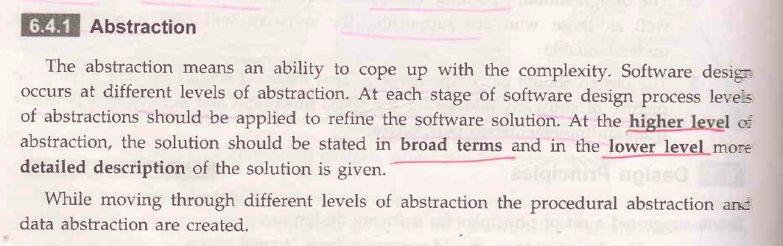

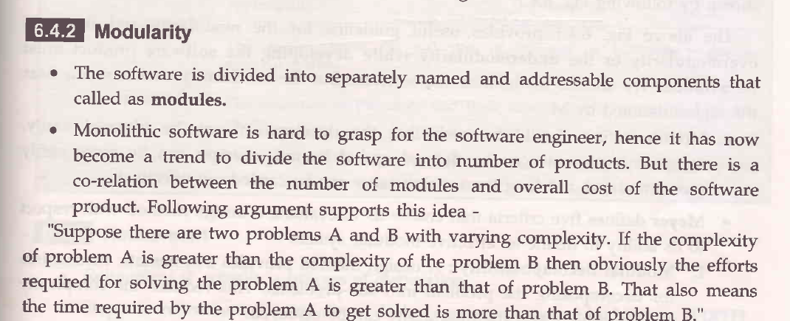

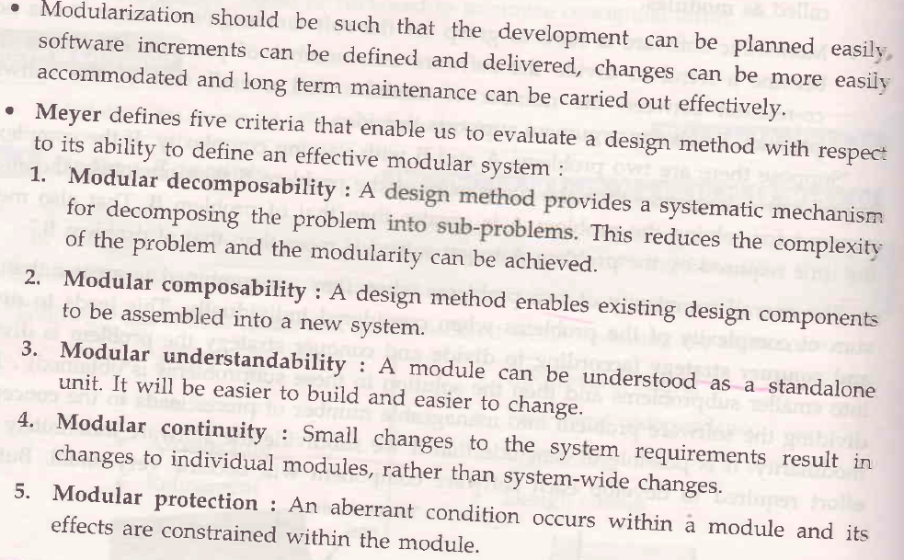

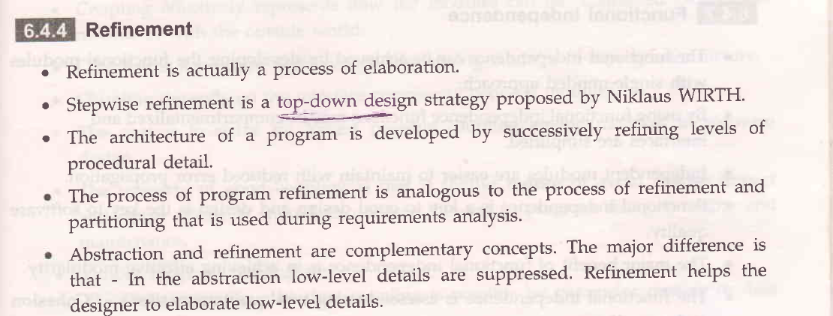

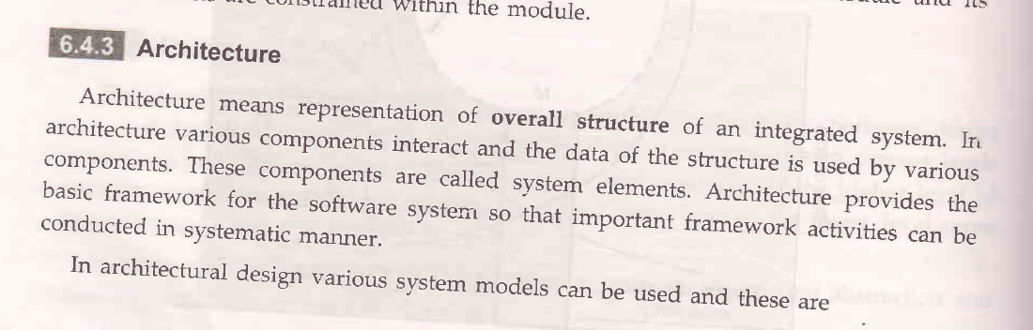

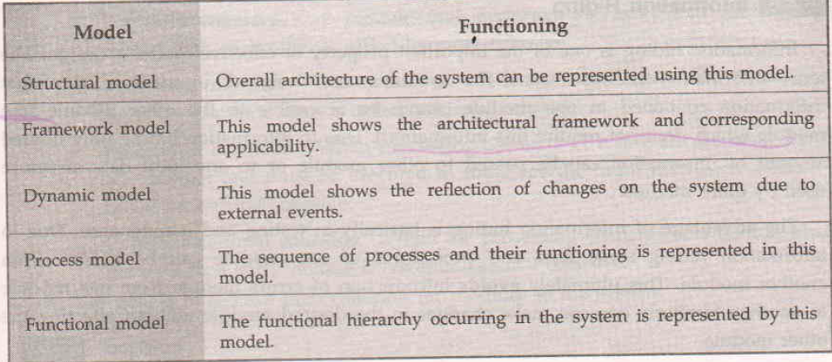

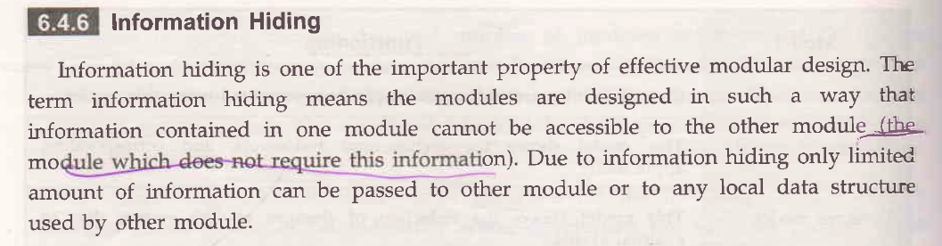

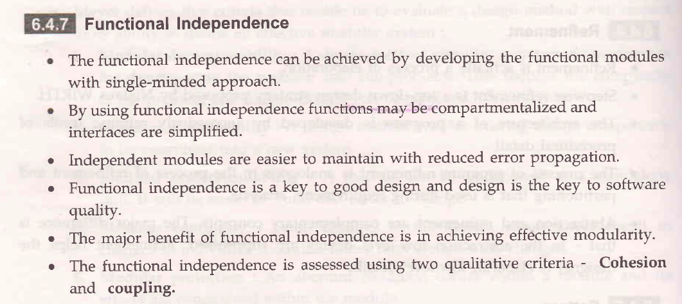

**4.4)**

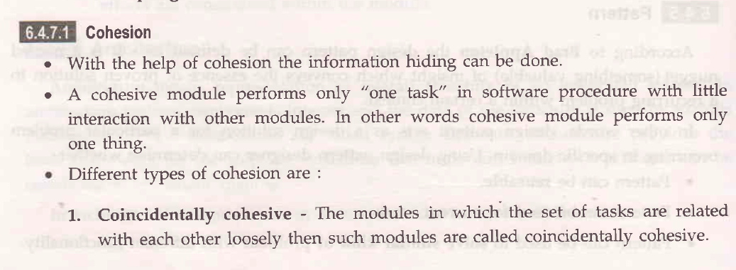

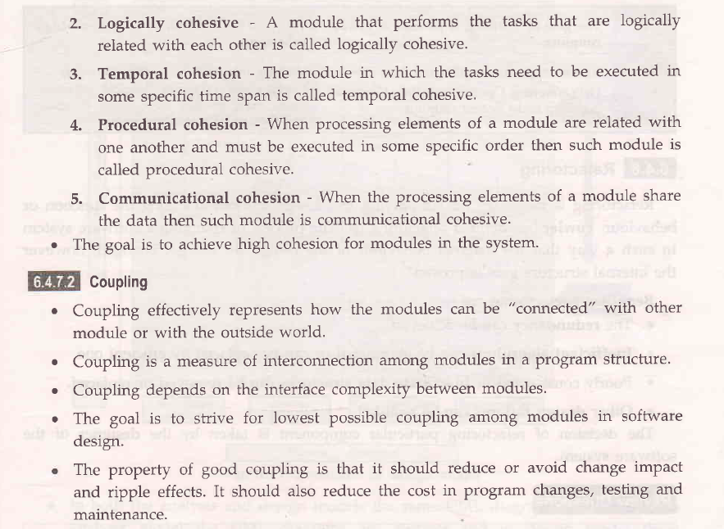

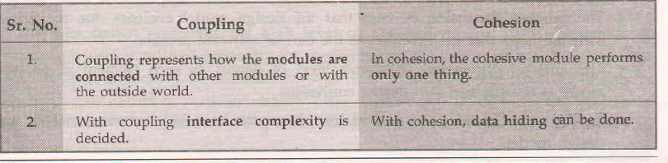

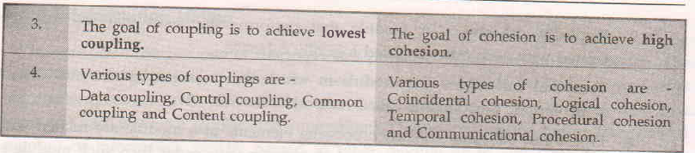

**Mod-5**

**Reverse Engineering**

Reverse Engineering: Reverse engineering is the process of analyzing and understanding an existing system or component to determine its design, architecture, and implementation details. The primary goal of reverse engineering is to extract knowledge or recreate design information from an existing system without having access to its original design documentation or source code.

The main tasks involved in reverse engineering include:

1. Disassembly: Breaking down the executable code or compiled components into a lower-level representation.
2. Code analysis: Analyzing the disassembled code to understand its structure, logic, and functionality.
3. Data structure recovery: Identifying and understanding the data structures and data formats used in the system.
4. Architecture recovery: Reconstructing the overall architecture and design of the system from the analyzed components.

**Ex:** • Security Auditing: Security researchers often reverse engineer software applications or systems to identify potential vulnerabilities, security flaws, or backdoors that could be exploited by malicious actors.

• Hardware Reverse Engineering: Reverse engineering techniques are used in the hardware domain to analyze and understand the design and functionality of electronic devices, integrated circuits, or firmware, particularly when the original design specifications are not available.

**Re-Engineering**

Re-engineering: Re-engineering, on the other hand, is the process of modifying or restructuring an existing system to improve its quality, performance, or maintainability. It involves analyzing the current system, identifying areas for improvement, and then making the necessary changes.

The main tasks involved in re-engineering include:

1. Reverse engineering: Analyzing and understanding the existing system, as described above.
2. Restructuring: Modifying the system's architecture, design, or implementation to address identified issues or improve specific aspects.
3. Optimization: Enhancing the system's performance, scalability, or resource utilization.
4. Migration: Transitioning the system to a new platform, programming language, or technology stack.
5. Refactoring: Improving the internal structure and code quality of the system without changing its external behavior.

**Ex:** • Cloud Migration: A company might re-engineer its on-premises software application to migrate it to a cloud environment, such as AWS or Azure. This could involve restructuring the application to take advantage of cloud-native services, scaling capabilities, and DevOps practices.

• Performance Optimization: A e-commerce website might undergo re-engineering to optimize its performance and handle increased traffic during peak seasons. This could involve caching strategies, database optimization, load balancing, or other architectural changes to improve responsiveness and throughput.

