**Experiment No. 01**

**Title: Mini Project**

**Batch:A2 Roll No.: 16010421073 Experiment No.:01**

**Aim:** Mini Project on object oriented software engineering for a business application.

**___________________________________________________________________________**

**Resources needed:**

**___________________________________________________________________________**

**Activities:**

**Students are required to choose one business application and prepare following for the same.**

1. Problem Definition
2. Project Scope
3. Choice of Process Model
4. Roles and Responsibilities
5. GUI based Implementation of one Module(one use case)

**___________________________________________________________________________**

**Results:**

1. **Problem Definition**

* Weather application that provides users with accurate and real-time weather information based on their location.
* The application should allow users to view current weather conditions, forecasts, and additional details for a specified location.
* The system should support multiple users and offer a personalized experience, including the ability to save favorite locations.

1. **Project Scope**

The application will be designed for ease of use, providing a personalized experience with features such as current weather conditions, forecasts, and user preferences.

* Allow users to create accounts, log in securely, and manage their profiles.
* Enable users to input their location or use geolocation services.
* Display real-time information, including temperature, humidity, wind speed, and atmospheric pressure.
* Implement a feature for users to save and manage favorite locations.
* Integrate with a reliable weather API to fetch accurate and timely weather data.
* Ensure secure and efficient handling of API requests.
* Define well-structured classes for entities such as User, Location, Weather Data, and Weather Service.

1. **Choice of Process Model**

**Iterative model:**

* The iterative development model develops a system by building small portions of all the features.
* This helps to meet the initial scope quickly and release it for feedback.
* In the iterative model, you start off by implementing a small set of software requirements. These are then enhanced iteratively in the evolving versions until the system is completed. This process model starts with part of the software, which is then implemented and reviewed to identify further requirements.

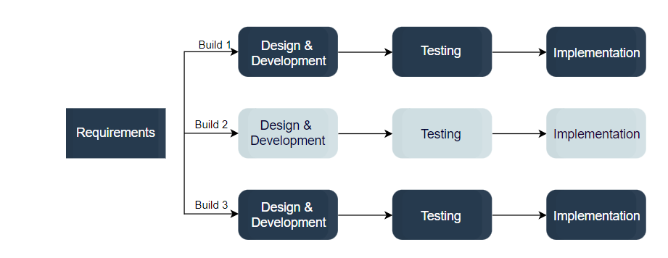

* Like the incremental model, the iterative model allows you to see the results at the early stages of development. This makes it easy to identify and fix any functional or design flaws. It also makes it easier to manage risk and change requirements.
* The deadline and budget may change throughout the development process, especially for large complex projects. The iterative model is a good choice for large software that can be easily broken down into modules.

1. **Roles and Responsibilities**

|  |  |
| --- | --- |
| **Keyur** | **Ronit** |
| Software developer | Software developer |
| UI/UX designer | Quality assurance enginner |

1. **GUI based Implementation of one Module(one use case)**

___________________________________________________________________________

**Outcomes:**

**CO1:** Comprehend process models.

**__________________________________________________________________________**

**Conclusion: (Conclusion to be based on the outcomes achieved)**

**Thus we successfully decided specifications, process models ,roles and responsibilities for our mini project.**

**Grade: AA / AB / BB / BC / CC / CD /DD**

**Signature of faculty in-charge with date**

**___________________________________________________________________________**

**References:**

**Books/ Journals/ Websites:**

1. Roger S. Pressman, Software Engineering: A practitioners Approach, 7th Edition, McGraw Hill, 2010
2. https://www.sharelatex.com/