**Name: Keyur Patel**

**Roll No: 16010421073**

**Batch : A2**

**Inlab**

**Sequence Diagram**

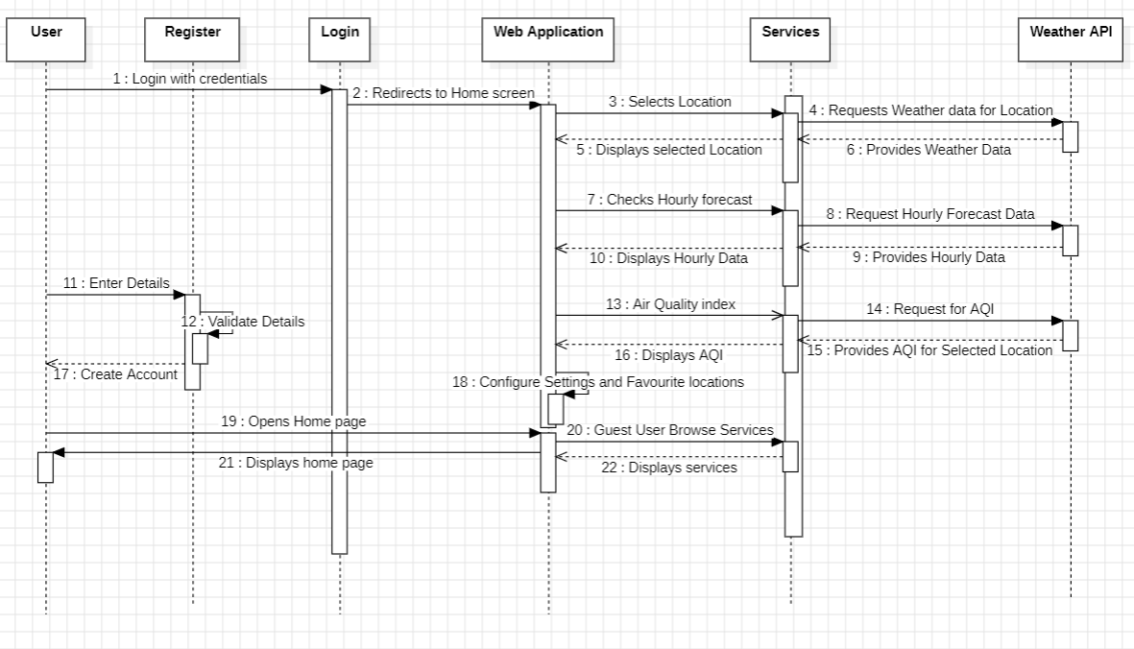

**Use Case Diagram**

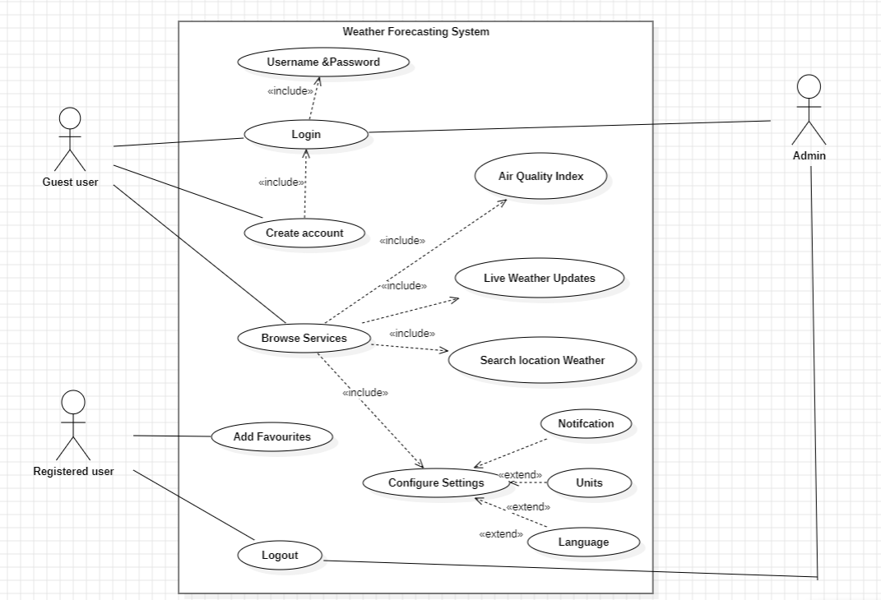

**State diagram**

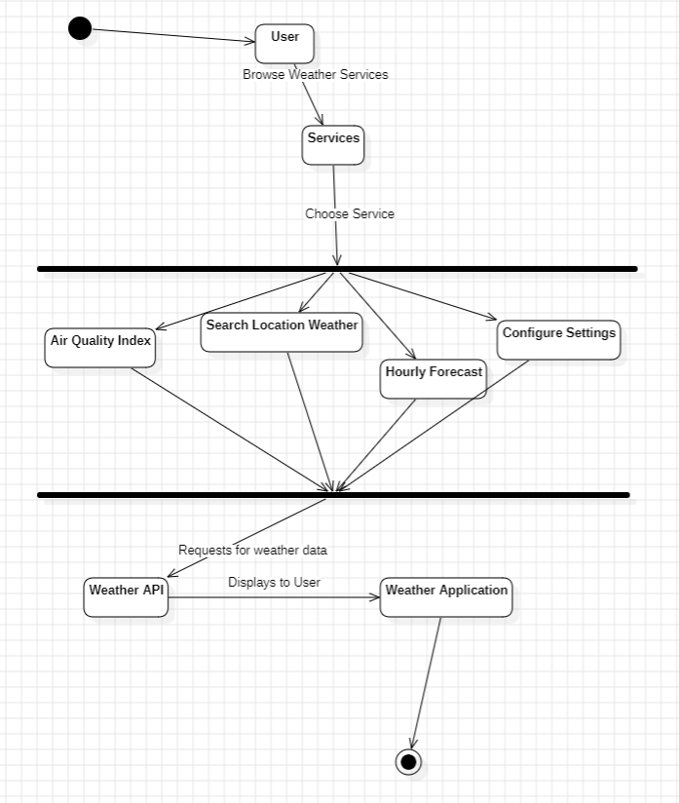

**Activity Diagram**

