**Name : Keyur Patel**

**Roll No : 16010421073**

**Branch : IT**

**Batch : A2**

**MS IA-1**

1. **To simulate rolling a six-sided die 100 times.**
2. Creating required tables and naming the columns

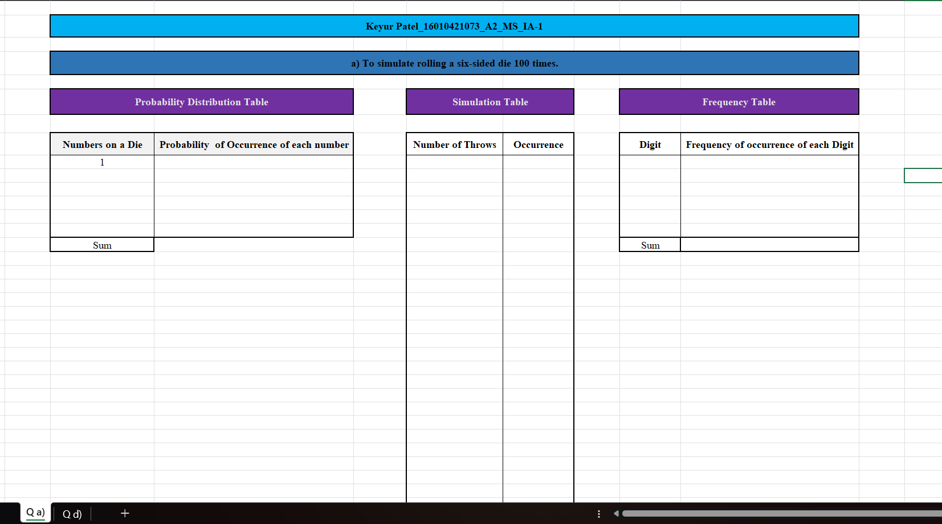

1. Applying Formulae to generate-

Numbers on a die (C9 +1) –

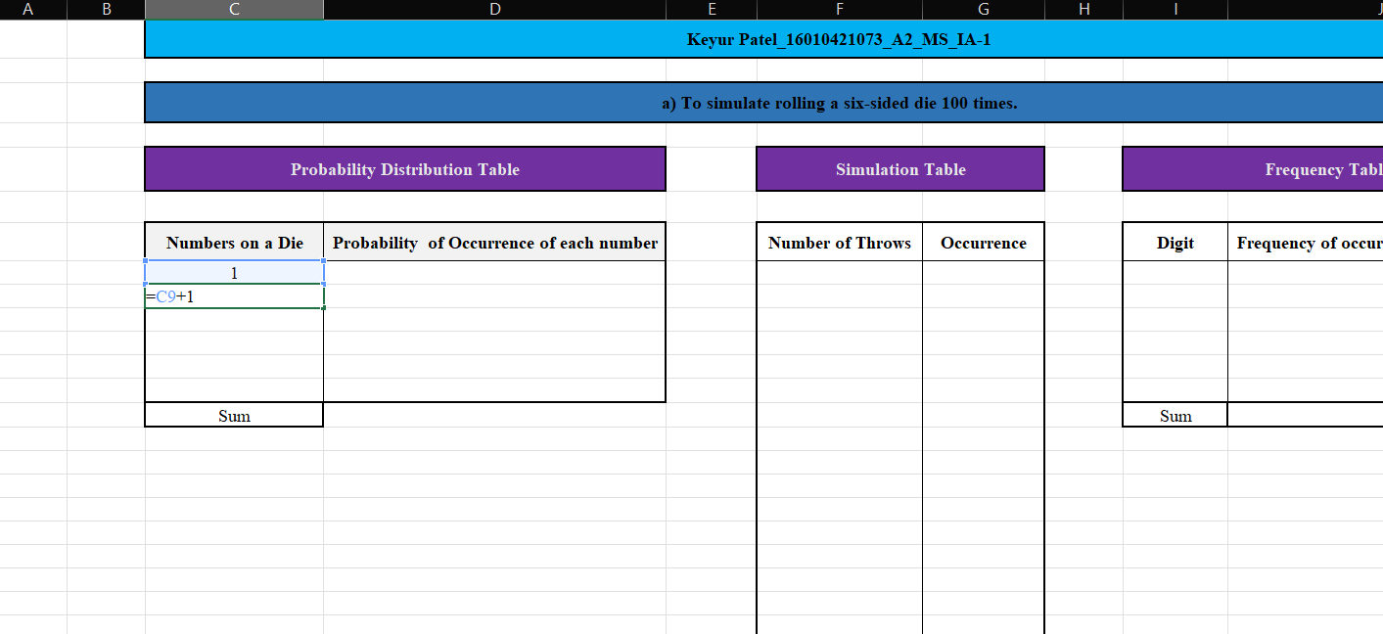

Dragging down-

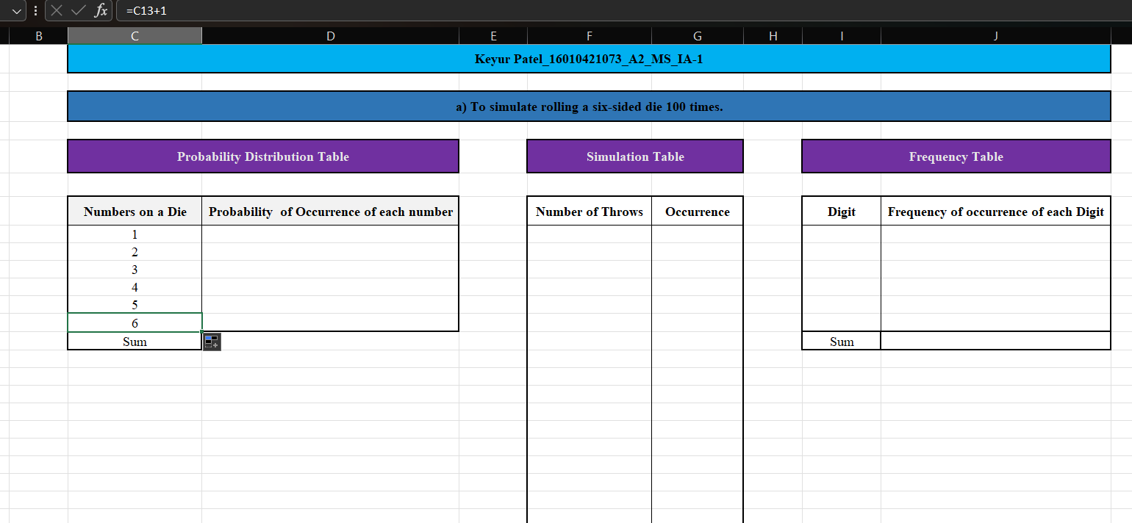

Probability of occurrence of each number =1/6 –

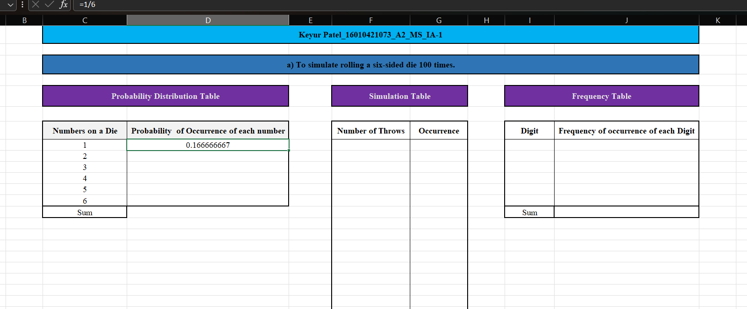

Dragging down –

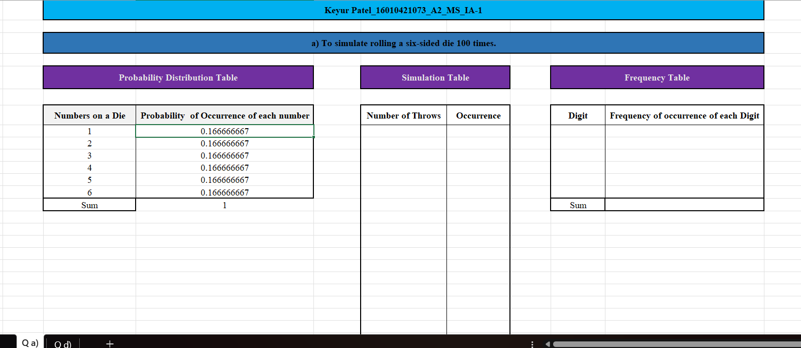

Number of throws (F9+1) –

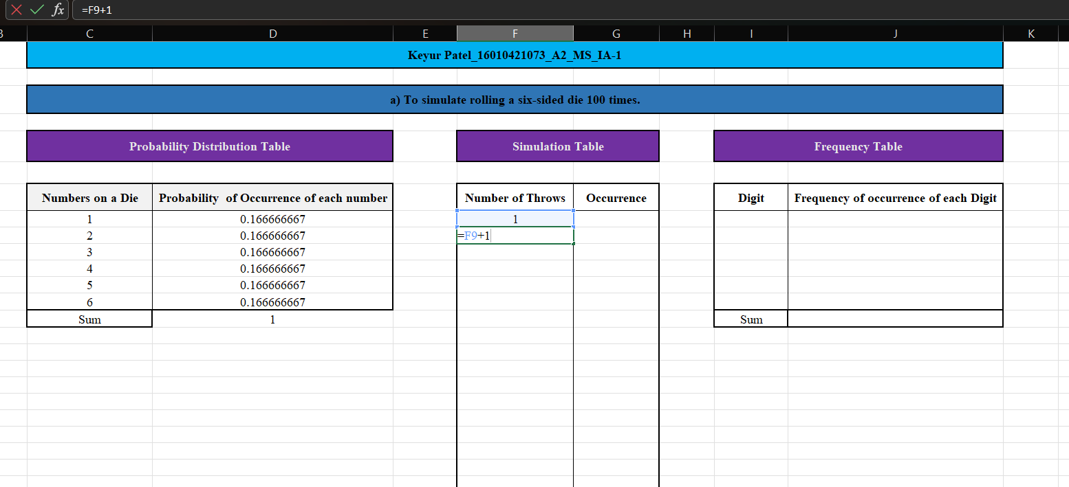

Dragging down –

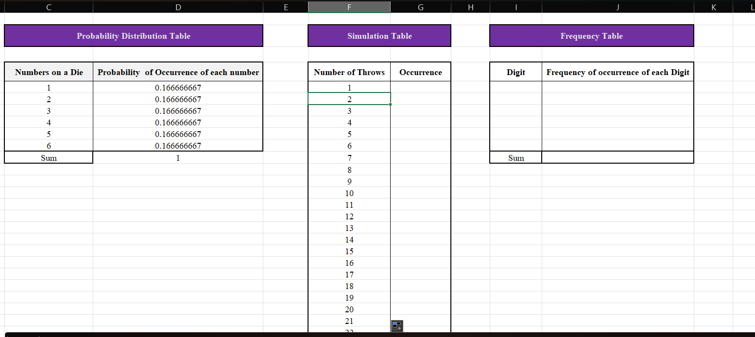

Till 100 –

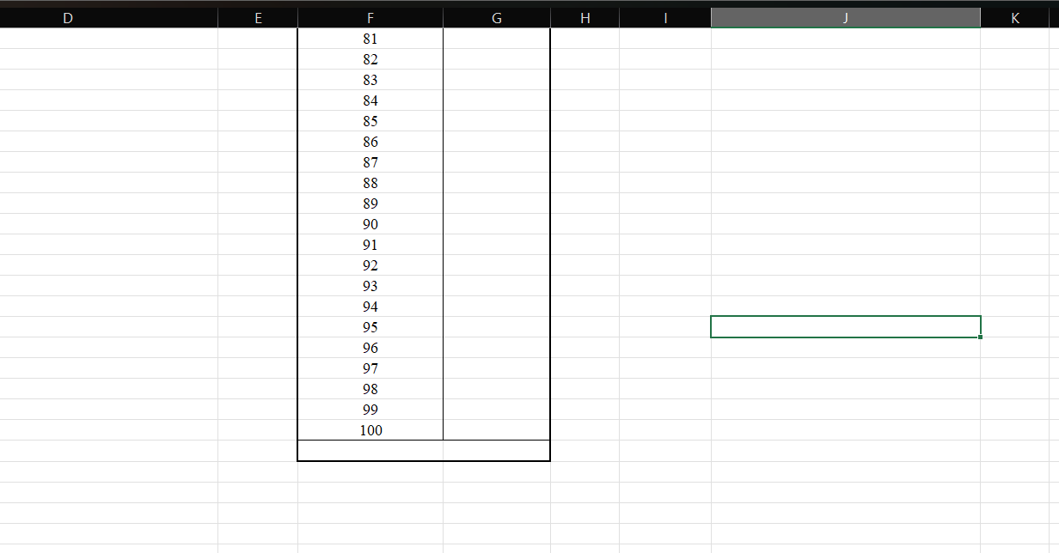

Occurrence –

For occurrence, we will use the “Data Analytics” tool pack in excel.

Selecting Data Analysis option –

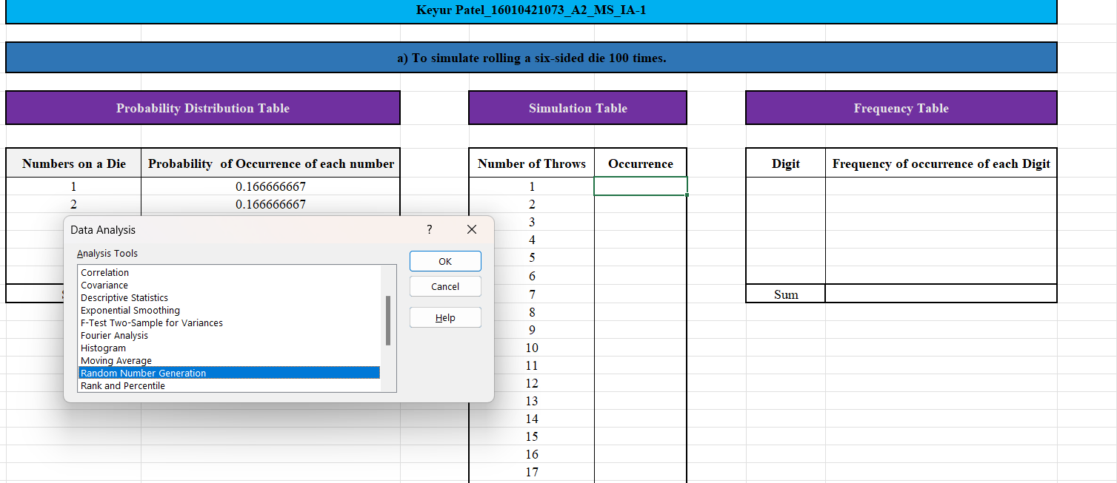

After clicking on “Random Number Generation”-

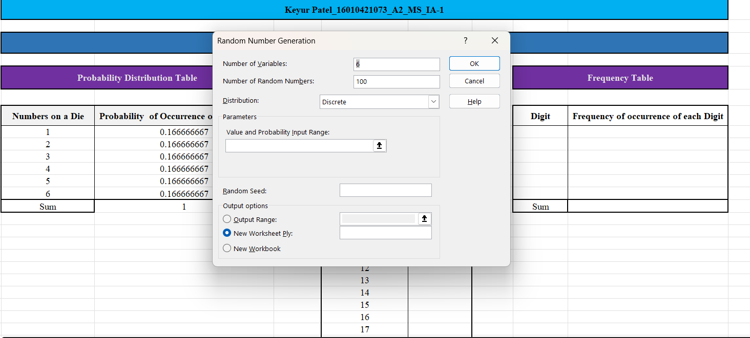

Selecting the Value and Probability input range –

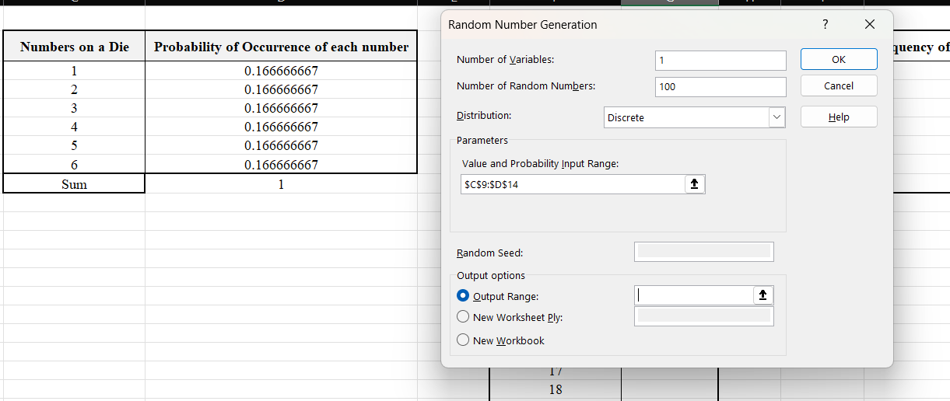

Selecting the Output range –

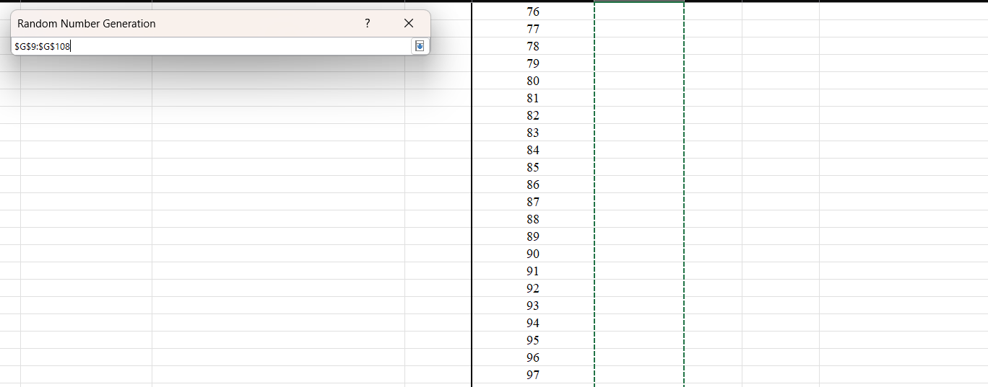

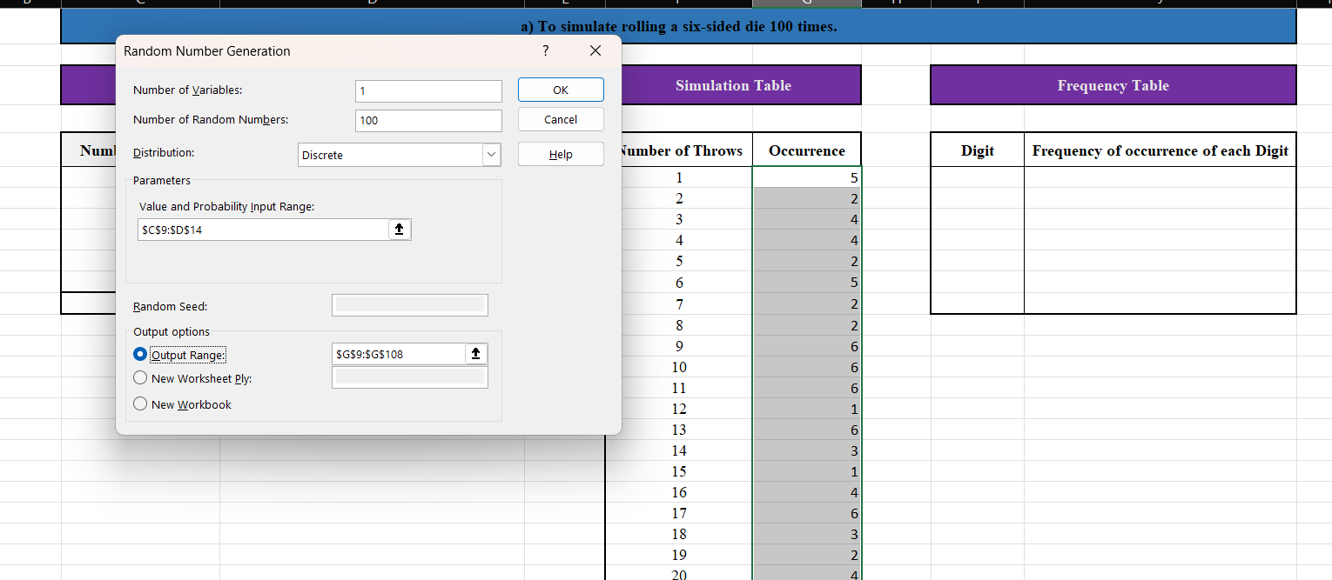

After clicking on OK, the random numbers get generated –

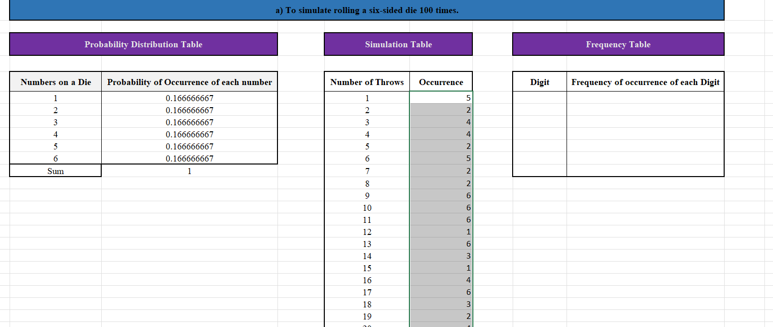

Frequency & digit – We are doing this to tally our answer which we will get from histogram. This step can be excluded.

Digit –

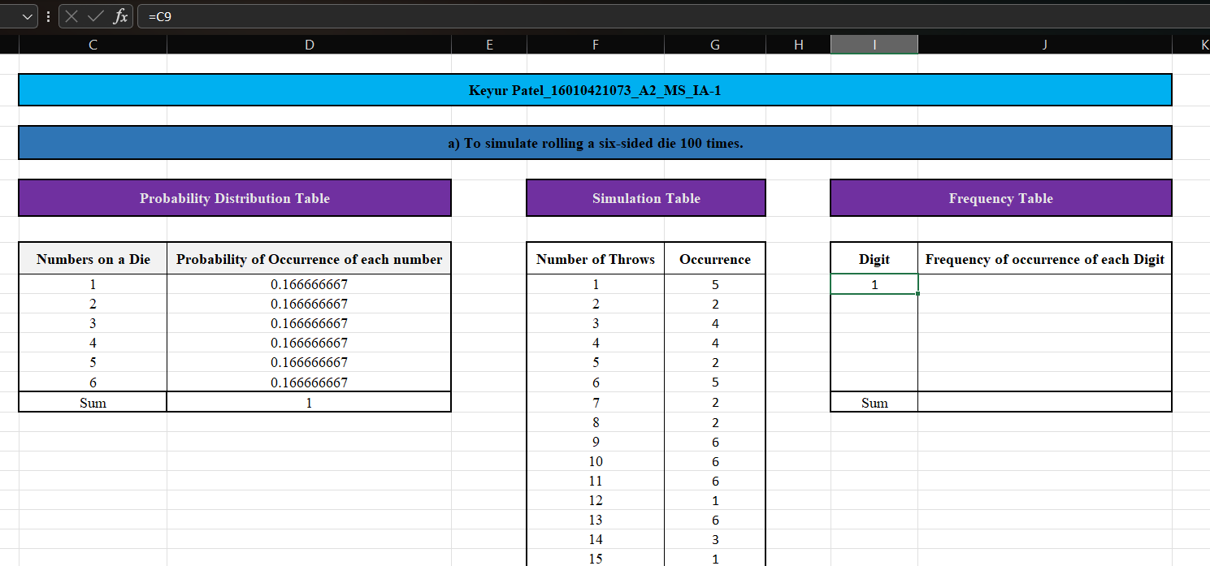

Dragging down –

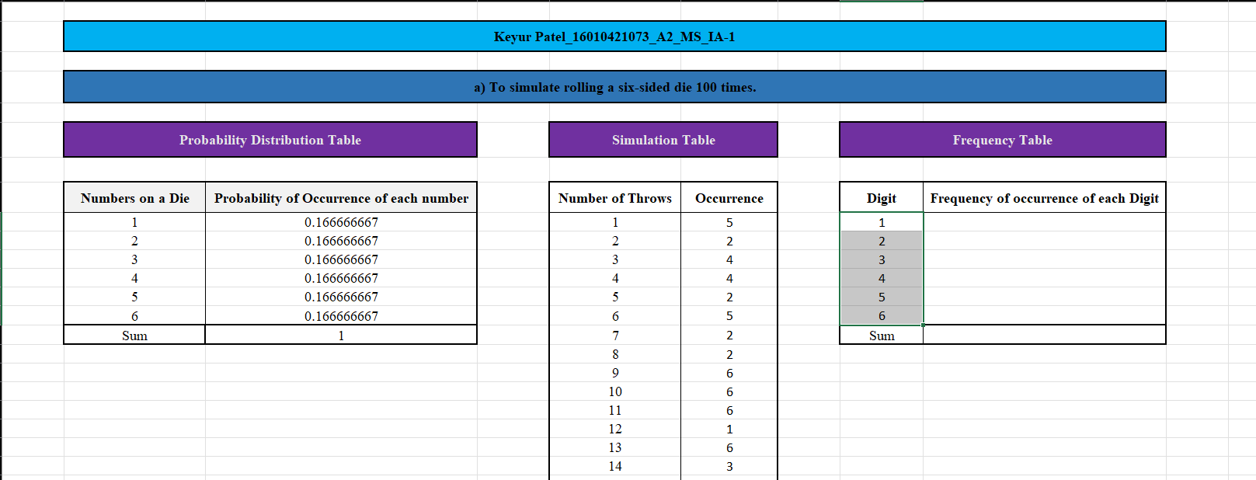

Frequency of occurrence of each digit –

We will use “COUNTIF” function of excel to calculate frequency of each digit.

First parameter is the range and the second parameter is the criteria

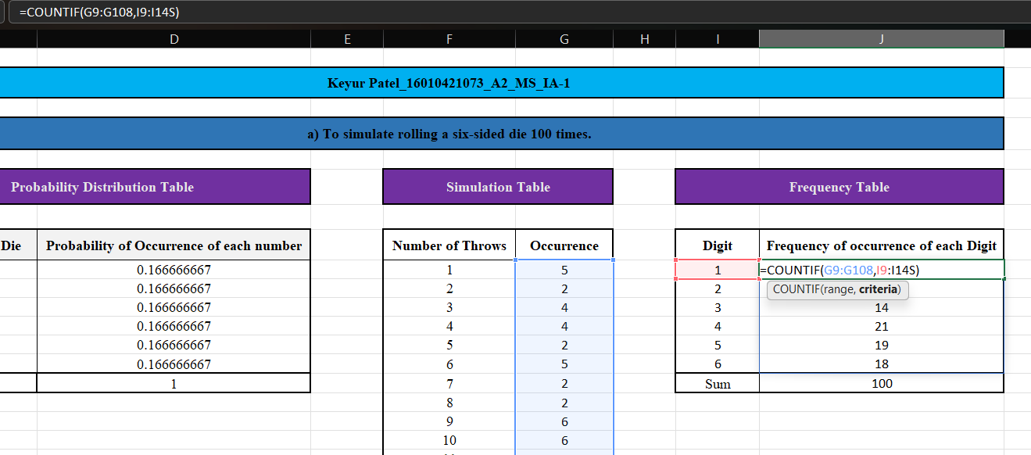

Dragging down –

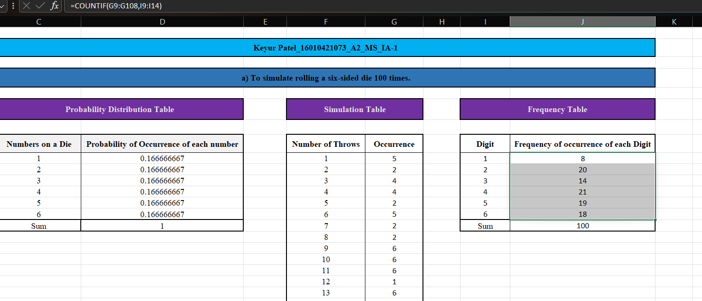

1. Creating a Histogram

For this again we will use “Data Analysis” tool pack in excel.

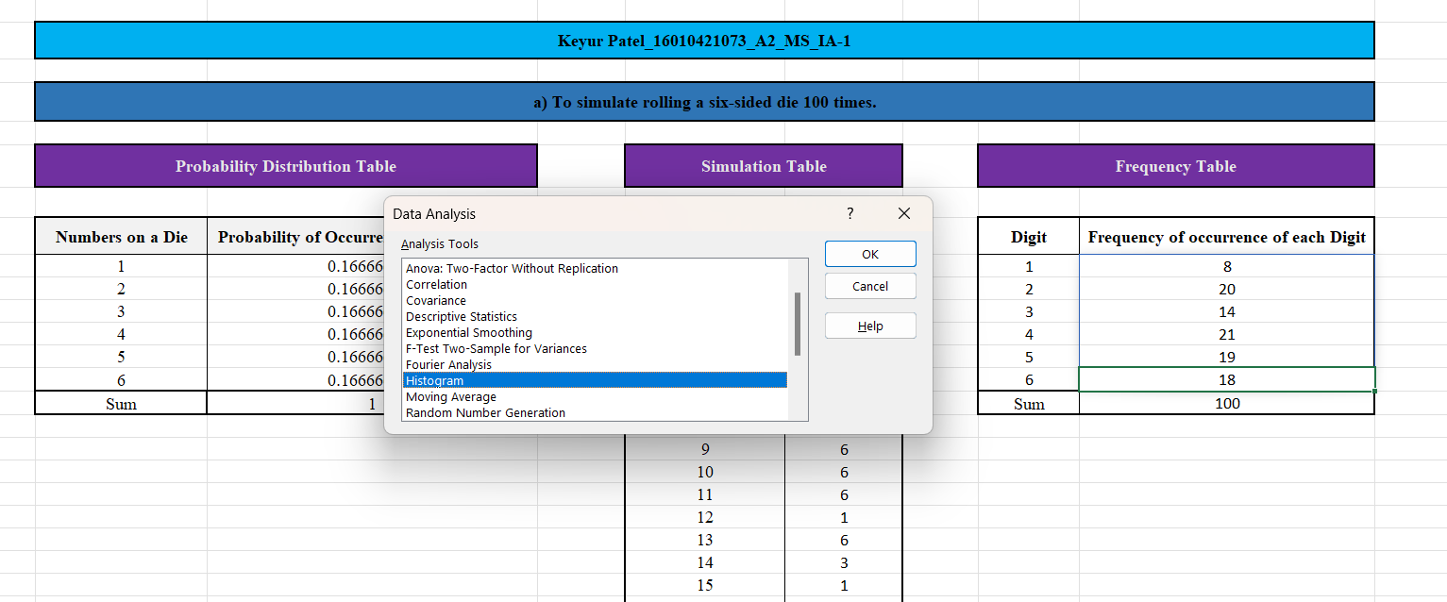

After clicking on “OK” –

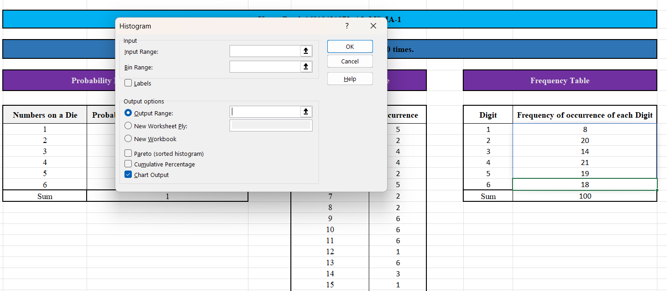

Selecting the input range –

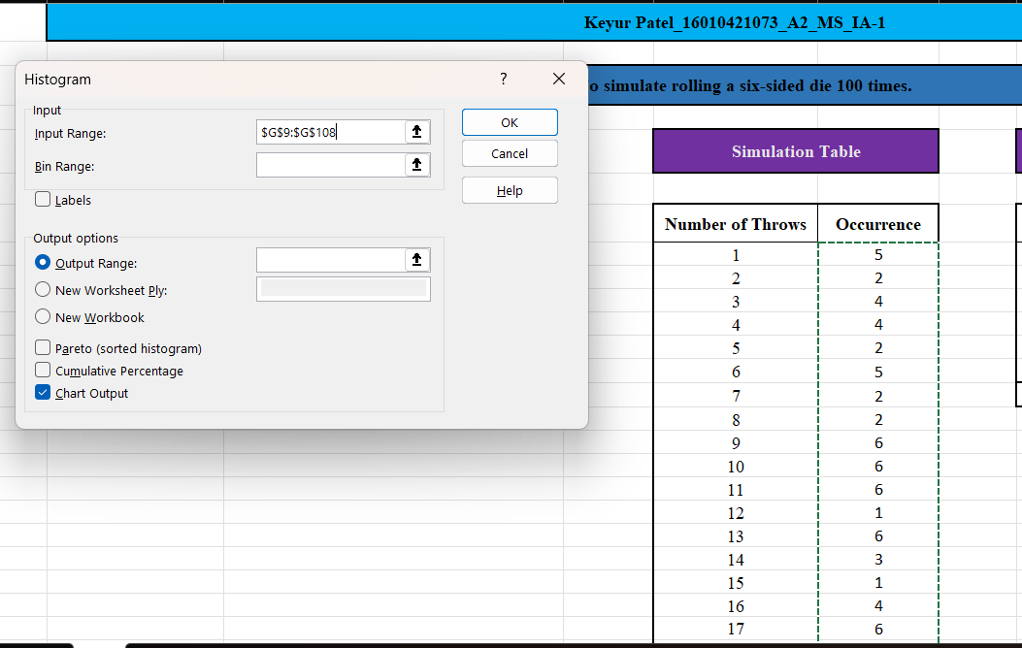

Selecting bin range –

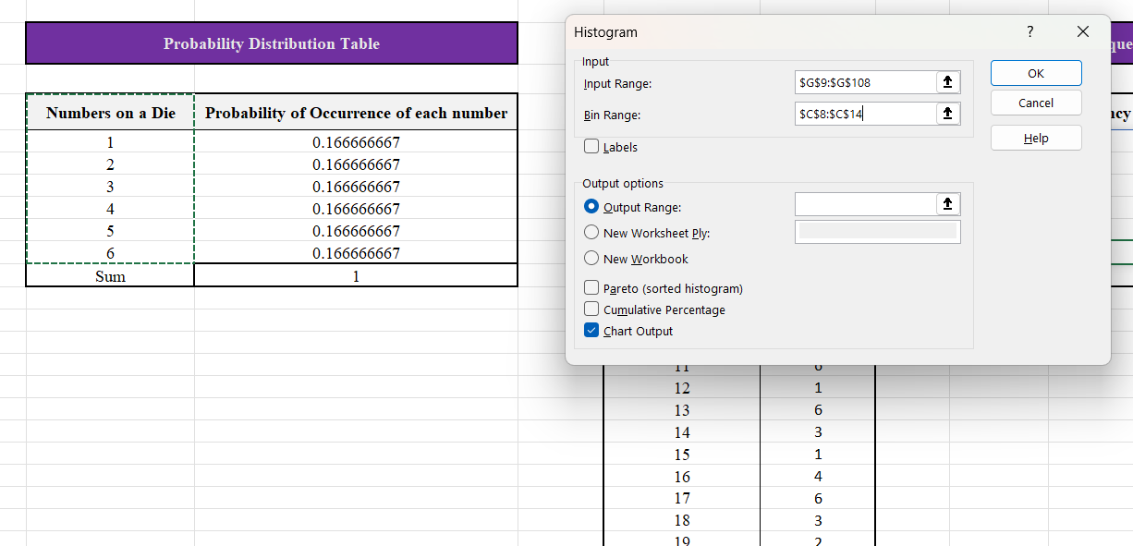

Selecting the output range –

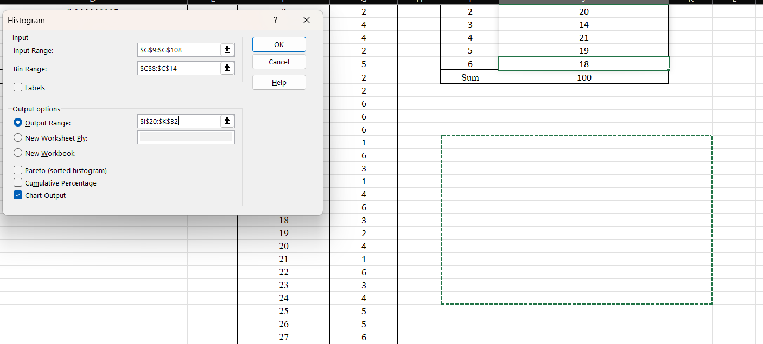

After clicking on “OK” –

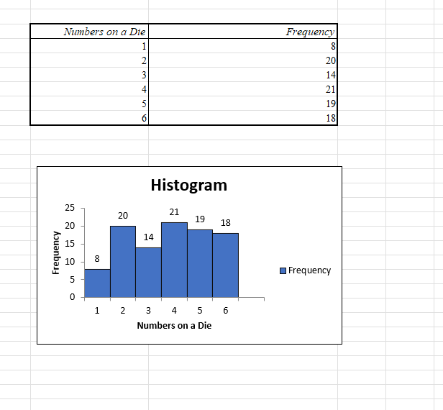

Hence this is the final histogram –

1. Final

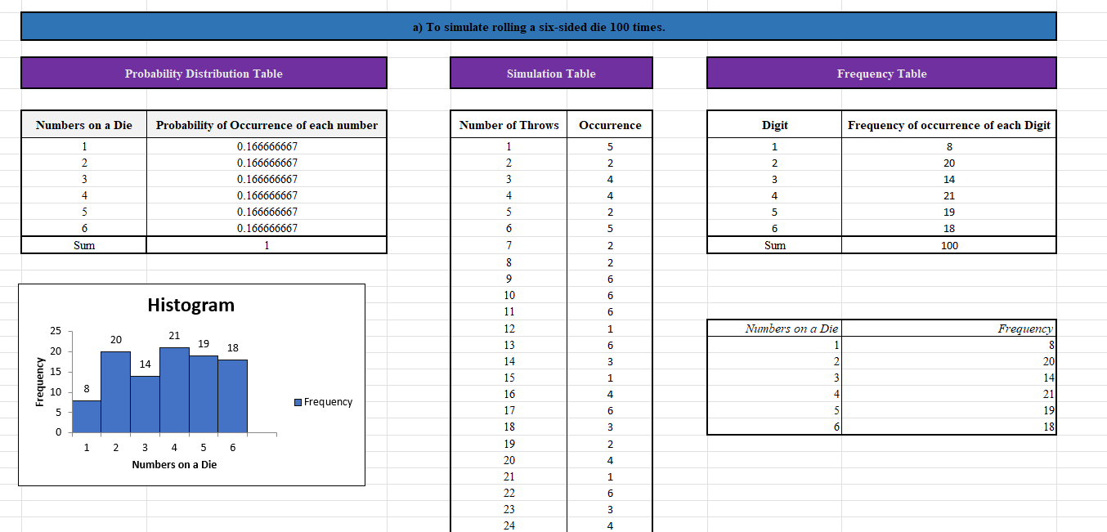

**d) To simulate rolling two six-sided dice and recording the sum 250 times.**

Creating required tables and naming the columns

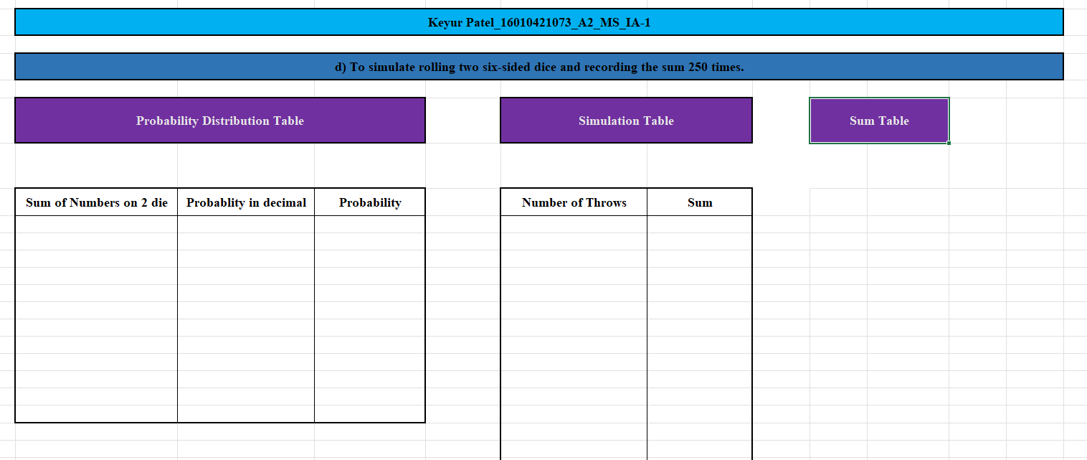

1. To find the probability of occurrence of sum of each digit, we need to make a sum table as follows –

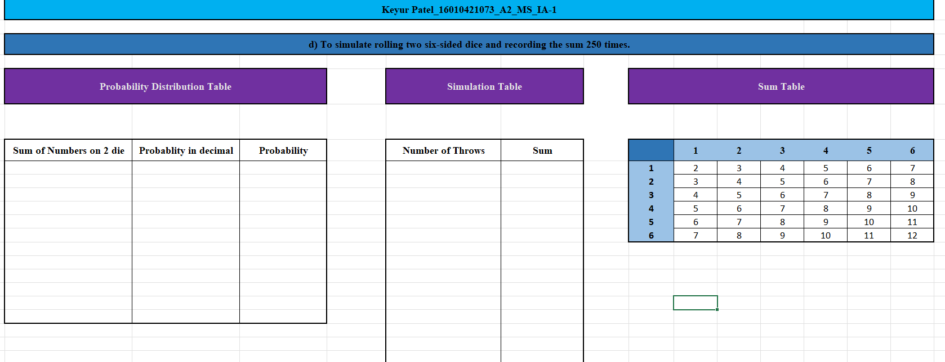

The light blue numbers depict the digits on 2 dies and white cell digits depicts the sum.

1. Based on the sum table, we can calculate the probability of occurrence of sum of each digit for numbers from 2-12 –

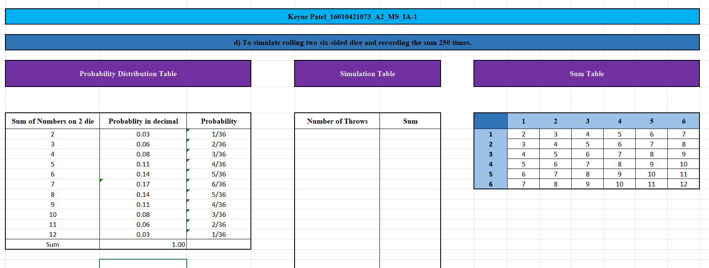

As seen from the sum table, there are total 36 possibilities. We count the number of times each digit has appeared and then divide it by 36 to get the probability.

1. Applying Formulae to generate-

Number of throws –

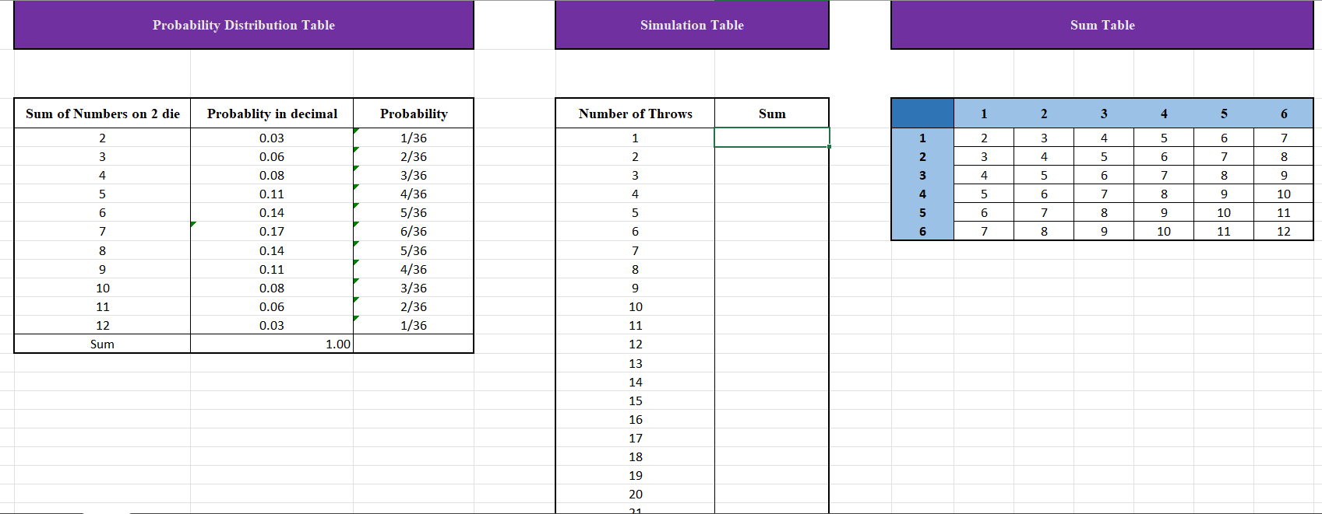

Till 250 –

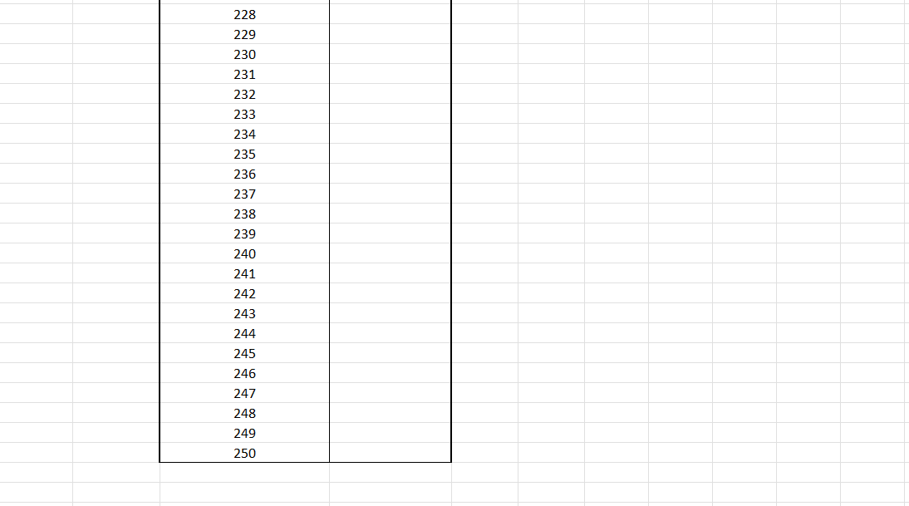

Sum –

To simulate the sum, we will use the “Data Analytics” tool kit of excel.

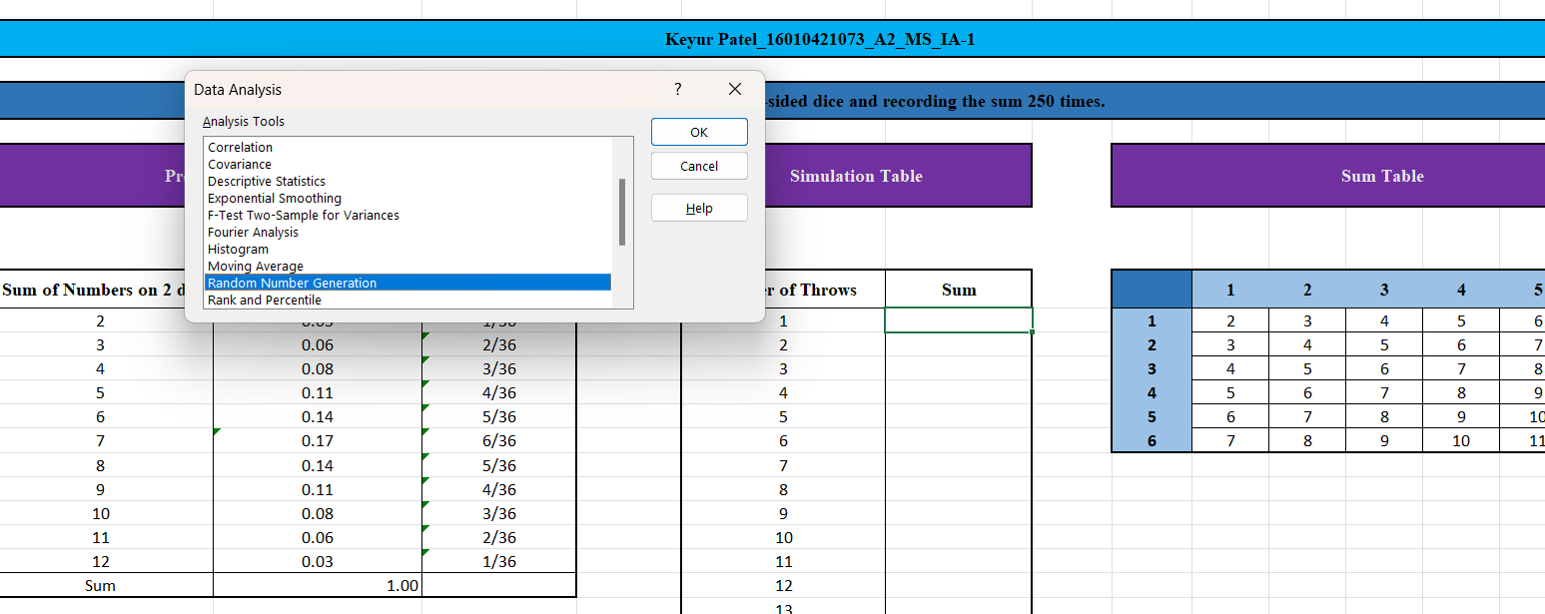

Selecting the value and probability range –

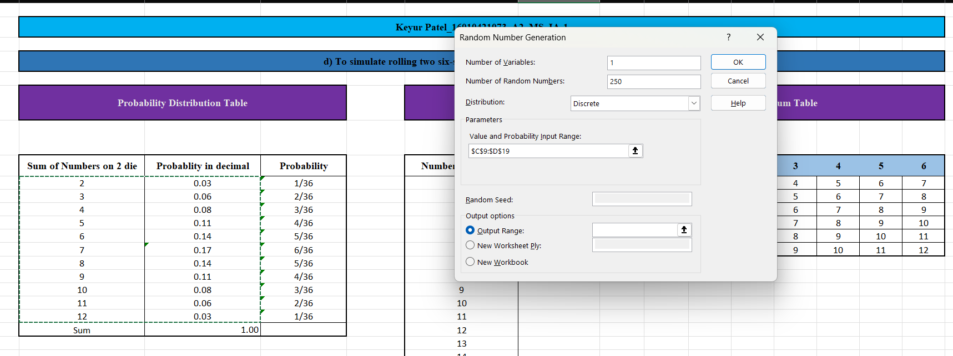

Selecting the output range –

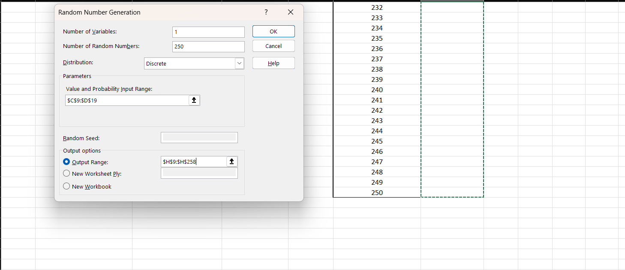

After clicking on “OK” , random numbers for sum get generated–

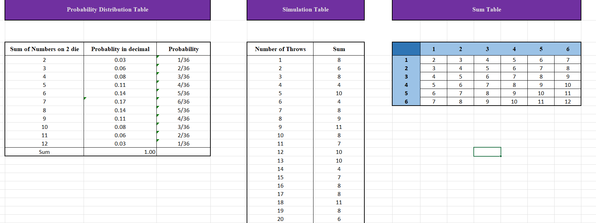

1. Creating a histogram

For creating histogram, we will again use “Data Analysis” tool pack in excel.

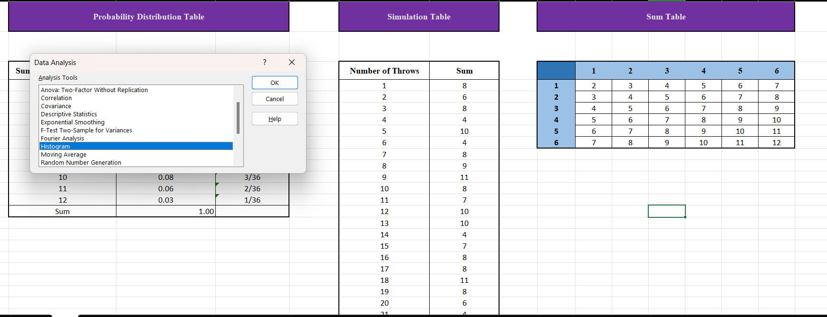

After clicking on “OK” –

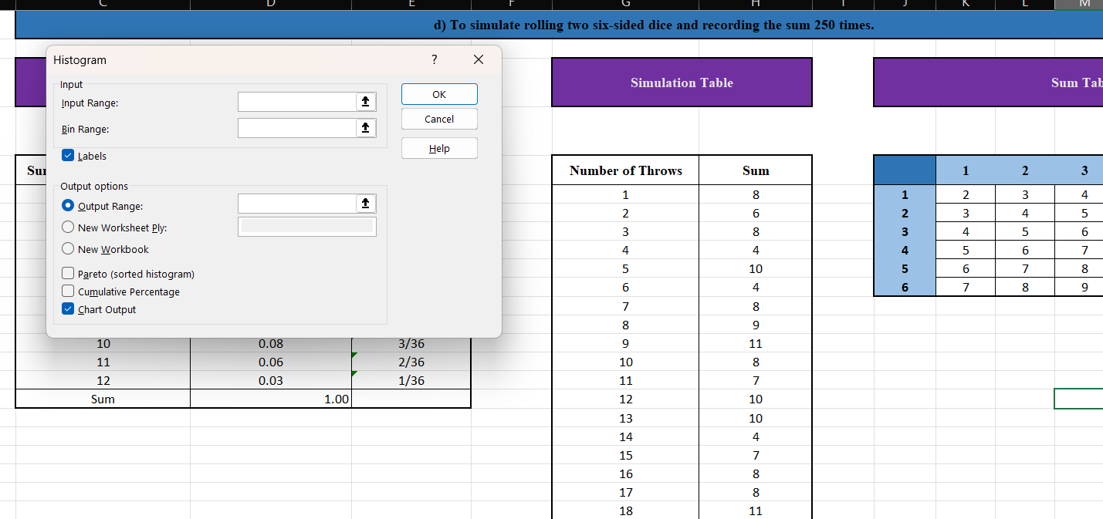

Selecting input range –

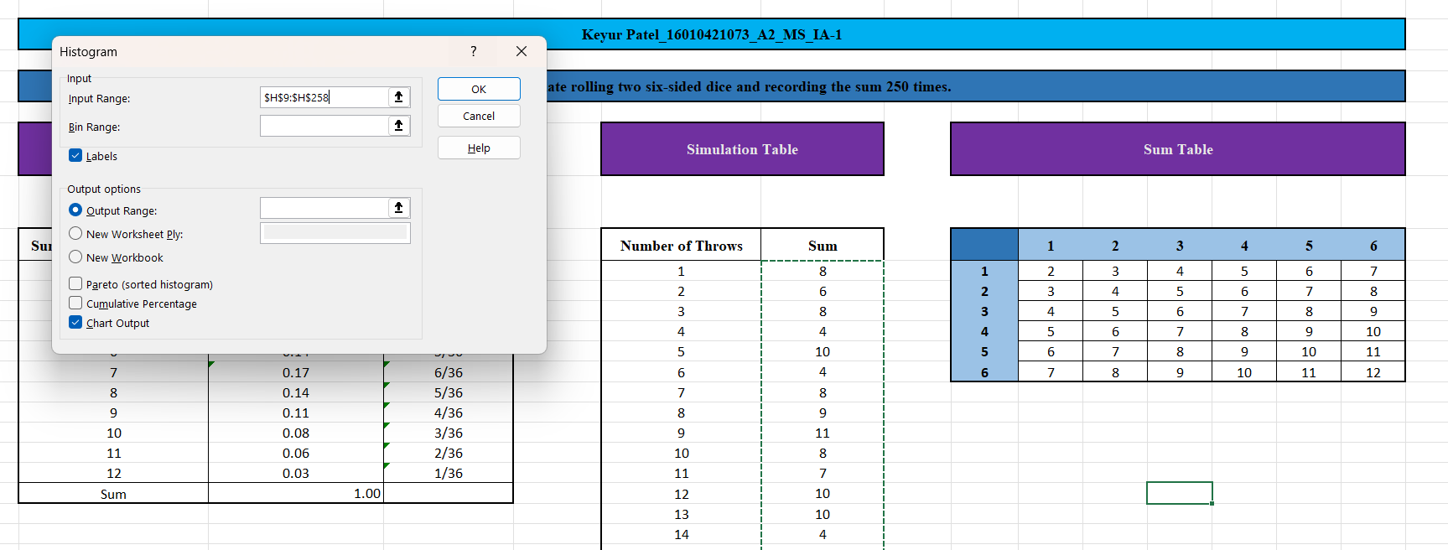

Selecting bin range –

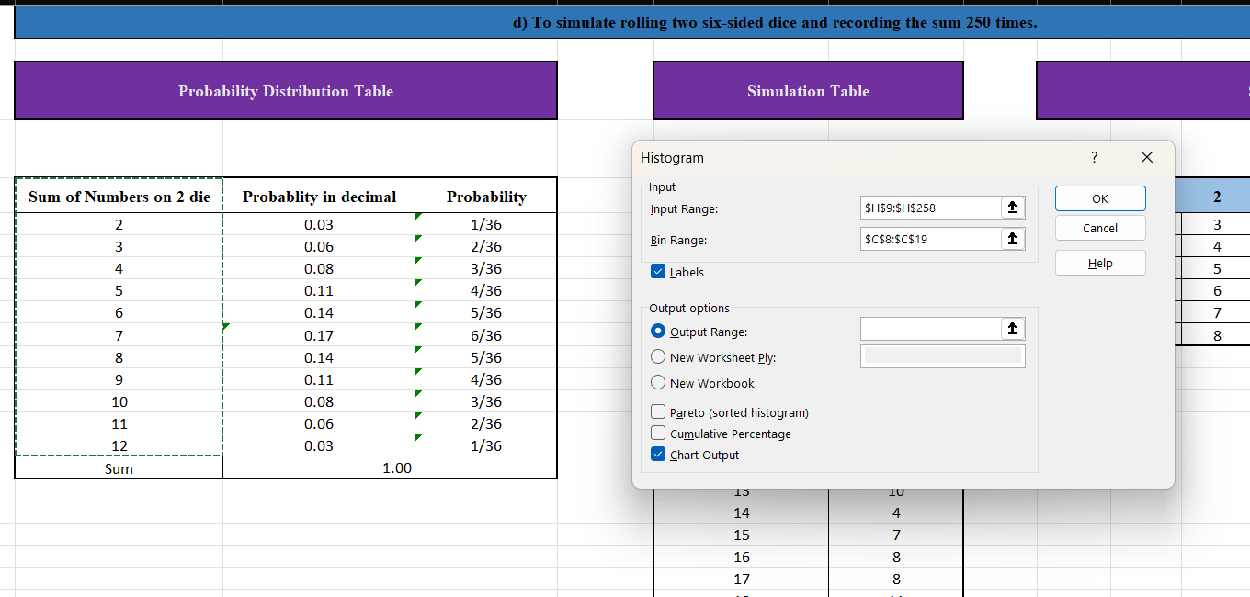

Selecting output range –

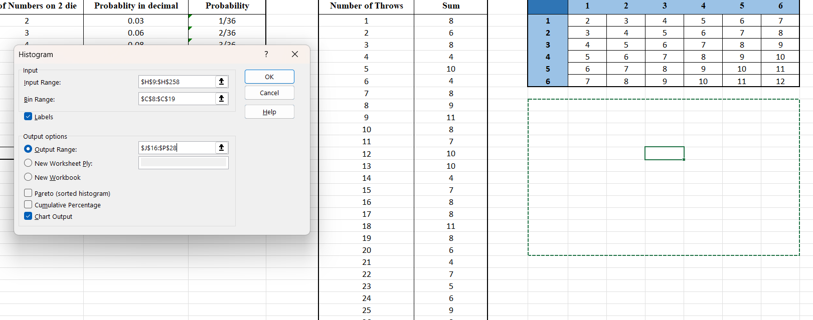

After clicking on “OK” –

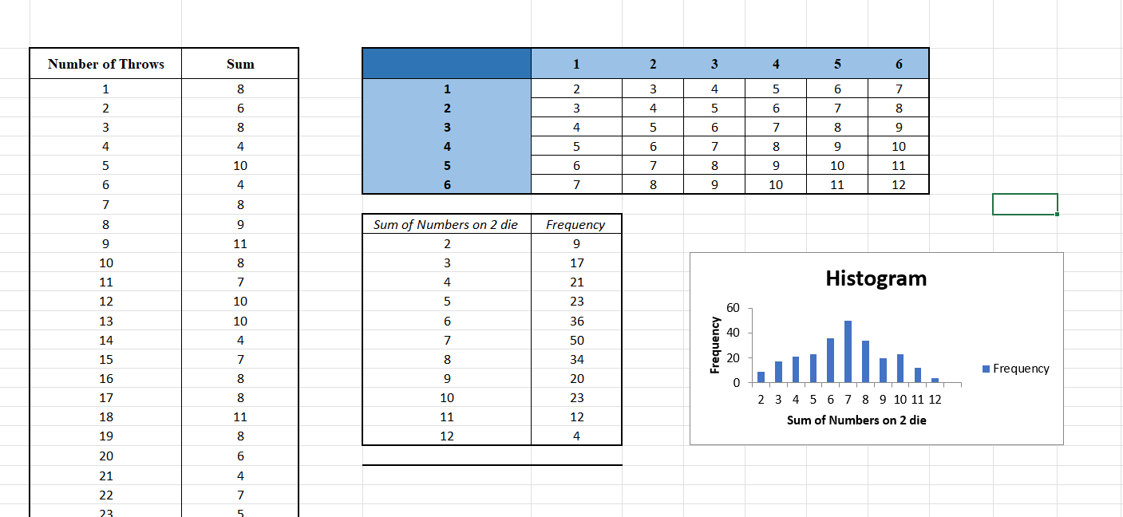

Final histogram –

1. Final

