**Name :Keyur Patel**

**Roll No : 16010421073**

**Batch : A2**

**Exp no -3(Inlab)**

|  |  |  |  |  |
| --- | --- | --- | --- | --- |
| Service time | | | | |
| **Service time** | **Probability** | **Cumulative Probability** | **Range(Min)** | **Range(Max)** |
| 1 | 0.05 | 0.05 | 0 | 5 |
| 2 | 0.1 | 0.15 | 6 | 15 |
| 3 | 0.2 | 0.35 | 16 | 35 |
| 4 | 0.3 | 0.65 | 36 | 65 |
| 5 | 0.25 | 0.9 | 66 | 90 |
| 6 | 0.1 | 1 | 91 | 100 |

|  |  |  |  |  |
| --- | --- | --- | --- | --- |
| Arrival Time | | | | |
| **Arrival Time** | **Probability** | **Cumulative Probability** | **Range(Min)** | **Range(Max)** |
| 1 | 0.1 | 0.1 | 0 | 100 |
| 2 | 0.1 | 0.2 | 101 | 200 |
| 3 | 0.1 | 0.3 | 201 | 300 |
| 4 | 0.1 | 0.4 | 301 | 400 |
| 5 | 0.1 | 0.5 | 401 | 500 |
| 6 | 0.1 | 0.6 | 501 | 600 |
| 7 | 0.1 | 0.7 | 601 | 700 |
| 8 | 0.1 | 0.8 | 701 | 800 |
| 9 | 0.1 | 0.9 | 801 | 900 |
| 10 | 0.1 | 1 | 901 | 0 |

**Simulation**

**Customer No RD for ITA Look Up Value Arrival Time D for Service Tim Service Time Time Service beginaiting Time in queTime Service end ime Spent in Syste Ideal Time of Server**

1 0 0 0 2 0 0 0 0 0 0

2 989 10 10 88 5 10 0 15 5 10

3 644 7 7 28 3 17 0 20 3 2

4 786 8 25 75 5 25 0 30 5 5

5 145 2 27 43 4 31 3 35 7 0

6 120 2 29 76 5 36 6 41 11 0

7 427 5 34 18 3 42 7 45 10 0

8 384 4 38 27 3 46 7 49 10 0

9 306 4 42 90 5 50 7 55 12 0

10 761 8 50 56 4 56 5 60 9 0

11 282 3 53 35 3 61 7 64 10 0

12 49 1 54 38 4 65 10 69 14 0

13 557 6 60 38 4 70 9 74 13 0

14 874 8 68 48 4 75 6 79 10 0

15 807 8 76 8 2 80 3 82 5 0

16 930 8 84 69 5 84 0 89 5 2

17 388 4 88 97 6 90 1 96 7 0

18 252 3 91 22 3 97 5 100 8 0

19 389 4 95 98 6 101 5 107 11 0

20 12 1 96 22 3 108 11 111 14 0

|  |  |  |
| --- | --- | --- |
| **Performance Measures** | | |
| 1 | Average Waiting Time | 4.6 |
| 2 | Probability of customers waiting | 0.75 |
| 3 | Probability of Idle server | 0.2 |
| 4 | Average Time between arrival | 4.8 |
| 5 | Average Time of those who wait | 6.133333333 |
| 6 | Average time spent in system | 8.45 |

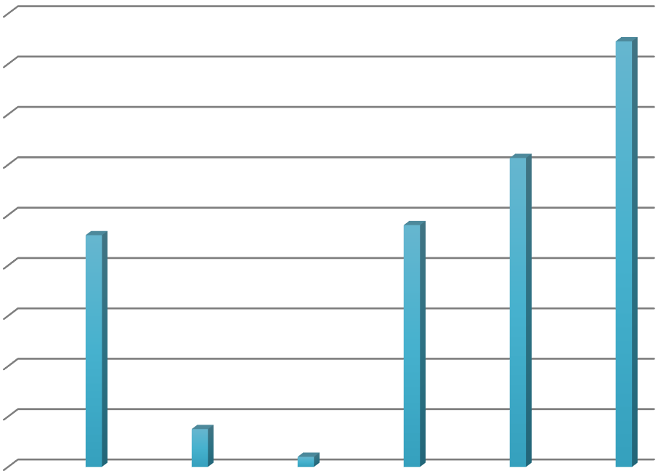

9

8

7

6

5

4

3

2

1

0

Average Probability Probability Average

Waiting of of Idle Time Time customers server between

waiting arrival

Average

Time of those who wait

Average

time spent in system

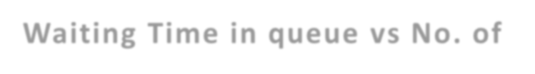

**Waiting Time in queue vs No. of**

12

**customers**

10

8

6

4

2

0

1 2 3 4 5 6 7 8 9 10 11 12 13 14 15 16 17 18 19 20

Waiting Time in queue