**Name :Keyur Patel**

**Roll No : 16010421073**

**Batch : A2**

**Exp no -4(Inlab)**

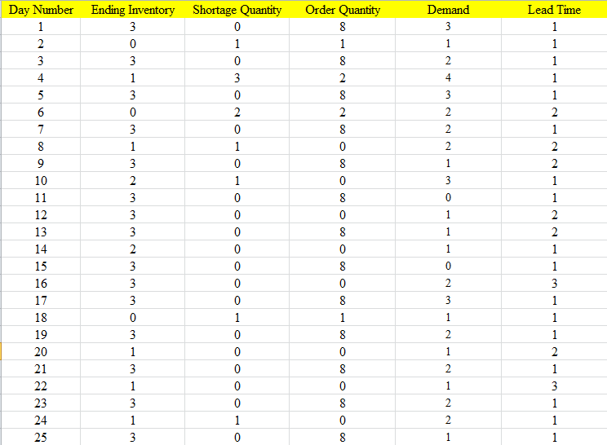

*Average ending inventory = 2.84*

*Average Shortage = 0.32*

*Average Demand = 1.56*

