**Experiment No. : 3 Title: Single Server system**

**(The Grocery Store problem)**

**Batch: A2 Roll No.: 16010421073 Experiment No.:3 Aim:** To simulate Single Channel Queuing System

**Resources needed:** Microsoft Excel / Open Office

# Problem Statement:

A small grocery store has only one checkout counter. Customer arrives at this check out counter at random.

In order to evaluate the system performance

1. Let the arrival distribution be uniformly distributed between 1 to 10 minutes.
2. Let service time distribution be as:

|  |  |  |  |  |  |  |
| --- | --- | --- | --- | --- | --- | --- |
| Service Time(minutes) | 1 | 2 | 3 | 4 | 5 | 6 |
| Probability | 0.05 | 0.1 | 0.2 | 0.3 | 0.25 | 0.1 |

1. Perform simulation for 20 customers and compute the performance measures.

# Concepts:

The key elements of queuing system are customers & servers. The term customer can refer to people, machines, and trucks. The server might refer to receptionist, person etc.

A queing system is described by its calling population, the nature of the arrivals, the service mechanism, the system capacity and the queing discipline.

1. **Calling population**: The population of potential customer is referred to as calling population. In systems with large population the calling population is usually assumed to be infinity. E.g. population of potential customer of a bank. The actual population may be finite. The main difference between finite & infinite population is based on the definition of the arrival rate.
2. **System Capacity**: The system capacity has no limit meaning that any no. of units comes and waits in the queue. In many queuing system there is a limit to the no. of customers thatmay be waiting.
3. **Nature of Arrivals**: Arrivals for service occur at a time in random fashion and once they join the waiting line, they are served.
4. **Service Mechanism:** The units are served in order of their arrival by a single server or a channel.
5. **Queuing Discipline:** It refers to the logical ordering of customers that will be chosen for service when a server becomes busy.
6. **State Of System:** It is the no. of units in the system & status of server (busy / idle).
7. **Events:** It is a set of circumstances that causes an instantaneous change in the state of system

Possible events in a single server system:

* + The Entry of a unit in the system.
  + Departure of unit from system on completion of service.

1. **Simulation Clock**: It is used to track simulation time.

# Conceptual Model:

The grocery store with one checkout counter is simulated by using a Semi – automatic approach by using simulation table to record successive system snapshots as time advances. The simulation requires mainly a service time distribution and an interarrival time distribution of customers.

# Characteristics of Grocery Store checkout counter System:

1. Calling Population: Infinite.
2. System capacity: Infinite.
3. Nature of Arrival: Random arrival uniformly distributed.
4. Service Mechanism: At a time only one customer is served; service time is random, probability distribution is given.
5. Queuing Discipline: FIFO.

# System State:

1. Waiting time in queue.
2. Status of Able and Baker (Busy / Idle)
3. Time customer spends in the system.

# Entities:

The entities in single channel queue are queue & server.

# Events:

* 1. Arrival Event
  2. Departure Event

# Activities:

1. Interarrival time.
2. Service time.

# Delay:

Waiting time in the queue.

# Use of Random Nos.:

* For generating interarrival time
* For generating service time
* RAND () function of Excel can be used to generate random nos. in simulation.

# Real life Examples:

1. Customers queuing in the Telephone Bill Payment System Customers form single channel queue. Customer is chosen in FIFO manner.

**Performance measures:**

1. **Average Waiting Time** = (Total time customers wait in queue) / (Total no. of Customers)
2. **Probability. Of Customers waiting** =(No. of Customers who waits) / (Total no. of Customers)
3. **Probability. Of Idle Server** = (Total Idle Time Of Server) / (Total runtime of simulation)
4. **Average Time between Arrival** = (Total Time between arrivals) / (No. of arrivals)-1
5. **Average Waiting Time of Those Who Wait** = (Total Time Customer waits in queue) / (Total no. of Customers who wait)
6. **Average Time Customers Spends In System** = (Total Time Customer spends in system) / (Total no. of Customers).

# Activity Diagram:

1. **Flowchart Arrival event:**



Arrival Event

# NO YES

Server Busy?

Enters service

Unit Enters queue

1. **Flowchart Departure event:**

**NO**

**YES**

Another unit waiting?

Begin server Idle Time

Remove waiting unit from queue

Departure Event

**Results: (Program printout as per the format)**

|  |  |  |  |  |
| --- | --- | --- | --- | --- |
| Service time | | | | |
| **Service time** | **Probability** | **Cumulative Probability** | **Range(Min)** | **Range(Max)** |
| 1 | 0.05 | 0.05 | 0 | 5 |
| 2 | 0.1 | 0.15 | 6 | 15 |
| 3 | 0.2 | 0.35 | 16 | 35 |
| 4 | 0.3 | 0.65 | 36 | 65 |
| 5 | 0.25 | 0.9 | 66 | 90 |
| 6 | 0.1 | 1 | 91 | 100 |

|  |  |  |  |  |
| --- | --- | --- | --- | --- |
| Arrival Time | | | | |
| **Arrival Time** | **Probability** | **Cumulative Probability** | **Range(Min)** | **Range(Max)** |
| 1 | 0.1 | 0.1 | 0 | 100 |
| 2 | 0.1 | 0.2 | 101 | 200 |
| 3 | 0.1 | 0.3 | 201 | 300 |
| 4 | 0.1 | 0.4 | 301 | 400 |
| 5 | 0.1 | 0.5 | 401 | 500 |
| 6 | 0.1 | 0.6 | 501 | 600 |
| 7 | 0.1 | 0.7 | 601 | 700 |
| 8 | 0.1 | 0.8 | 701 | 800 |
| 9 | 0.1 | 0.9 | 801 | 900 |
| 10 | 0.1 | 1 | 901 | 0 |

**Simulation**

**Customer No RD for ITA Look Up Value Arrival Time D for Service Tim Service Time Time Service beginaiting Time in queTime Service end ime Spent in Syste Ideal Time of Server**

1 0 0 0 2 0 0 0 0 0 0

2 989 10 10 88 5 10 0 15 5 10

3 644 7 7 28 3 17 0 20 3 2

4 786 8 25 75 5 25 0 30 5 5

5 145 2 27 43 4 31 3 35 7 0

6 120 2 29 76 5 36 6 41 11 0

7 427 5 34 18 3 42 7 45 10 0

8 384 4 38 27 3 46 7 49 10 0

9 306 4 42 90 5 50 7 55 12 0

10 761 8 50 56 4 56 5 60 9 0

11 282 3 53 35 3 61 7 64 10 0

12 49 1 54 38 4 65 10 69 14 0

13 557 6 60 38 4 70 9 74 13 0

14 874 8 68 48 4 75 6 79 10 0

15 807 8 76 8 2 80 3 82 5 0

16 930 8 84 69 5 84 0 89 5 2

17 388 4 88 97 6 90 1 96 7 0

18 252 3 91 22 3 97 5 100 8 0

19 389 4 95 98 6 101 5 107 11 0

20 12 1 96 22 3 108 11 111 14 0

|  |  |  |
| --- | --- | --- |
| **Performance Measures** | | |
| 1 | Average Waiting Time | 4.6 |
| 2 | Probability of customers waiting | 0.75 |
| 3 | Probability of Idle server | 0.2 |
| 4 | Average Time between arrival | 4.8 |
| 5 | Average Time of those who wait | 6.133333333 |
| 6 | Average time spent in system | 8.45 |

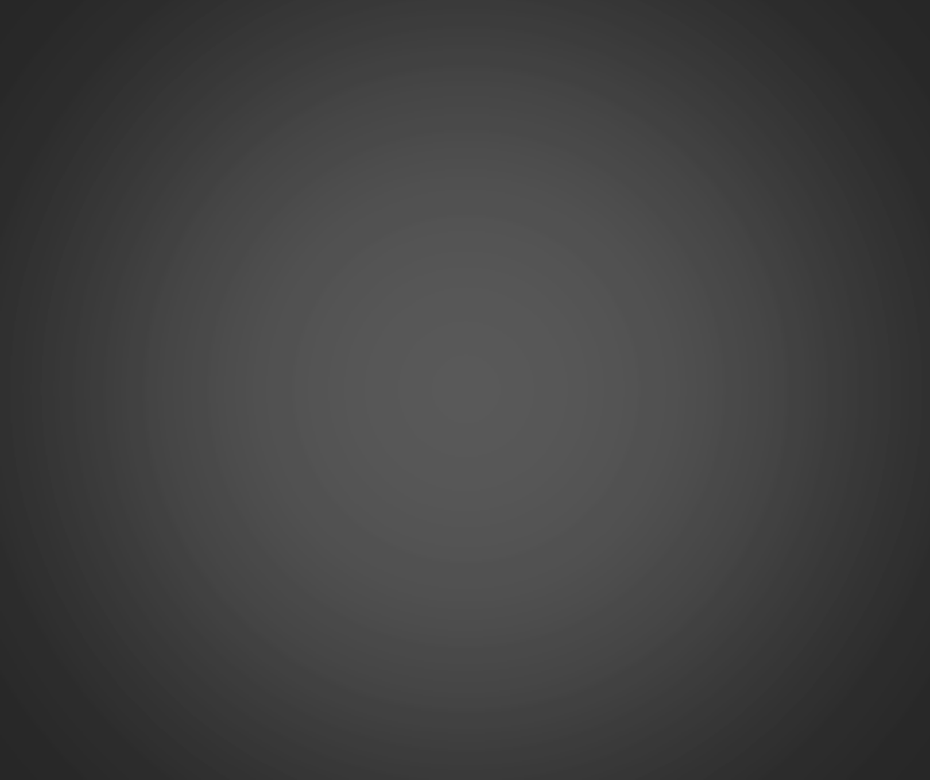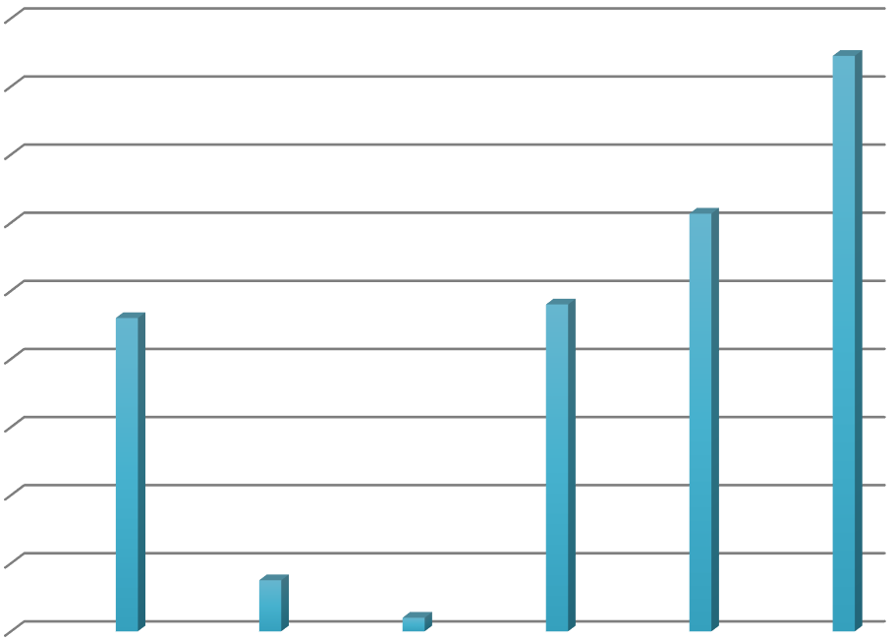

9

8

7

6

5

4

3

2

1

0

Average Probability Probability Average

Waiting of of Idle Time Time customers server between

waiting arrival

Average

Time of those who wait

Average

time spent in system

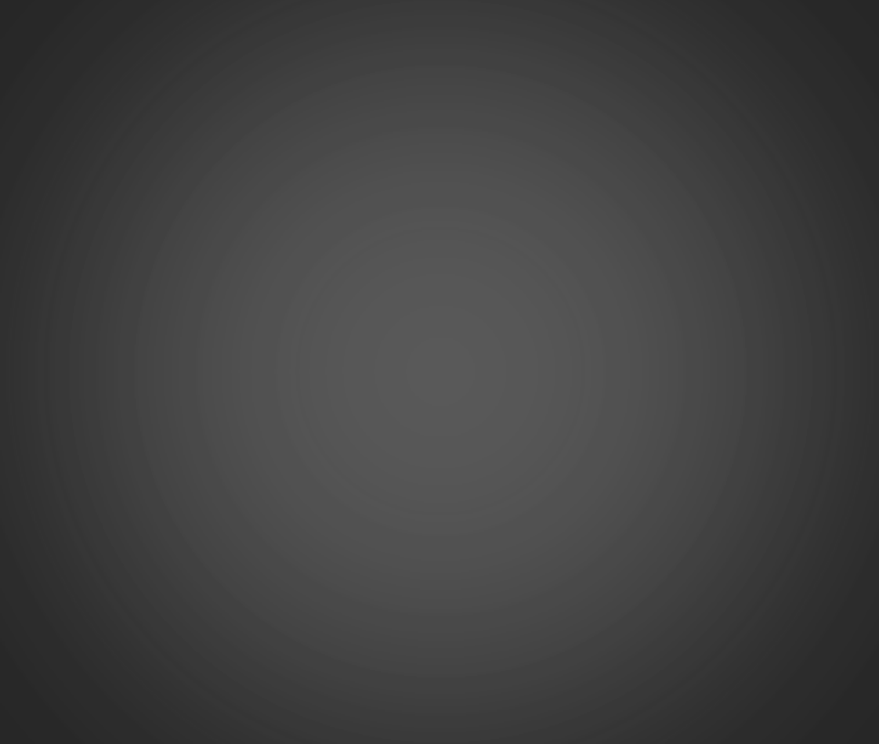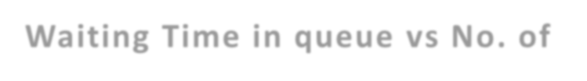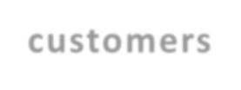

**Waiting Time in queue vs No. of**

12

**customers**

10

8

6

4

2

0

1 2 3 4 5 6 7 8 9 10 11 12 13 14 15 16 17 18 19 20

Waiting Time in queue

**Questions:**

1. **What is simulation? List the different types of simulation.**

**Ans :** A simulation is an animated model that mimics the operation of an existing or proposed system, like the day-to-day operation of a bank, running an assembly line, or assigning staff in a hospital or call center.

Different types of Simulations are:

* + Monte Carlo / Risk Analysis Simulation
  + Agent-Based Modeling & Simulation
  + Discrete Event Simulation
  + System Dynamic Simulation Solutions

# List the queue disciplines used in simulation?

**Ans:** Queuing Discipline represents the way the queue is organized (rules of inserting and removing customers to/from the queue). There are these ways:

* + FIFO (First In First Out) also called FCFS (First Come First Serve) - orderly queue.
  + LIFO (Last In First Out) also called LCFS (Last Come First Serve) - stack.
  + SIRO (Serve In Random Order).
  + Priority Queue, that may be viewed as a number of queues for various priorities

# Outcomes:

CO1: Apply the experimental process of simulation for model building using simulation languages and tool.

# Conclusion:



I learnt to simulate the Single Channel Queuing System(Grocery store problem).

**Grade: AA / AB / BB / BC / CC / CD /DD**

**Signature of faculty in-charge with dateReferences:**

**Books/ Journals/ Websites:**

1. Jerry Banks, John Carson, Barry Nelson, and David M. Nicol; “Discrete Event SystemSimulation”, Fifth Edition, Pearson Education.
2. Jerry Banks, John Carson, Barry Nelson, and David M. Nicol; “Discrete Event SystemSimulation”, Third Edition, Pearson Education.
3. Real Queuing Examples:[http://www2.uwindsor.ca/hl](http://www2.uwindsor.ca/)ynka/qreal.html This site contains excerptsfrom news articlesthat deal with aspects of waiting lines.
4. ClearQ :[http://clearq.com/ This c](http://clearq.com/)ompany produces “take-a-number” systems for servicefacilities (e.g., delis), but also providesperformance

information about the waiting line.

1. Qmatic:[http://us.q-matic.com/index.htmlThi](http://us.q-matic.com/index.html)scompany produces informational displays andotherproducts to keep customers informedabout waiting times.
2. “Queuing Presentation” by Richard Larson, givenat the Institute for Operations Researchand the Management.
3. cience[s:http://caes.mit.edu/people/larson/MontrealINFORMS1/sld001.htm.](http://caes.mit.edu/people/larson/MontrealINFORMS1/sld001.htm)
4. Queuing Tutor

:[http://www.dcs.ed.ac.uk/home/jeh/Simjava/queueing](http://www.dcs.ed.ac.uk/home/jeh/Simjava/queuei)/mm1_q/mm1_q.html This site has twoanimated displays of waiting lines. The user canchange arrival and service rates to see howperformance is affected.

1. Myron Hlynka‟s Queuing Page:[http:www2.uwindsor.ca/hlynka/queue.html](http://www2.uwindsor.ca/hlynka/queue.html) This web site contains information about waiting linesas well as links to other interesting sites.
2. Queuing ToolPa[k:http://www.bus.ualberta.ca/aingolfsson/qtp/](http://www.bus.ualberta.ca/aingolfsson/qtp/)
3. The Queuing ToolPak is an Excel add-in that allowsyou to easily compute performance measures fora number of different waiting line models