**Experiment No. : 4**

**Title:** Simulation of an Order-Up-To-Level Inventory System

**Batch: A2 Roll No.: 16010421073 Experiment No.: 4 Aim:** Simulation of an Order-Up-To-Level (M, N) Inventory System

# Resources needed: Excel Spreadsheet

**Theory**

# Problem Statement:

Consider a situation in which a company sells refrigerators. The system they use for maintaining inventory is to review the situation after a fixed number of days (say N) and make a decision about what is to be done.

The policy is to order up to a level (the order up to level-say, M), using the following relationship:

Order quantity = (Order-up-to level) - (Ending inventory) + (Shortage quantity) Generate a simulation table for 25 days (5 cycles)

Table 4.1 Distribution of Daily Demand

|  |  |  |
| --- | --- | --- |
| Distribution of Daily Demand | | |
| Demand | Probability | Cumulative Probability |
| 0 | 0.10 | 0.10 |
| 1 | 0.25 | 0.35 |
| 2 | 0.35 | 0.70 |
| 3 | 0.21 | 0.91 |
| 4 | 0.09 | 1.00 |

Table 4.1 Distribution of Lead Time

|  |  |  |
| --- | --- | --- |
| Distribution of Lead Time | | |
| Lead Time | Probability | Cumulative Probability |
| 1 | 0.60 | 0.60 |
| 2 | 0.30 | 0.90 |
| 3 | 0.10 | 1.00 |

The Excel spreadsheet allows for numerous changes in the input. The policy can be changed (i.e., the values of M and N). The distribution of daily demand and lead time can be changed within the limits of the demand and lead time that is, demand can be 0, l, 2, 3, or 4 refrigerators per day and lead times can be 1, 2,. or 3 days.

# Characteristics of Inventory System:

An important class of simulation problems involves inventory systems. The inventory system has a periodic review of length N, at which time the inventory level is checked. An order is made to bring the inventory up to the level M. At the end of the first review period, an order quantity, Q is placed. In this inventory system, the lead time (i.e., the length of time between the placement and receipt of an order) is zero. Demands are not usually known with certainty, so the order quantities are probabilistic.

Carrying stock in inventory has an associated cost attributed to the interest paid on the funds borrowed to buy the items (this also could be considered as the loss from not having the funds available for other investment purposes). Other costs can be placed in the carrying or holding cost column renting of storage space, hiring of guards, and so on. An alternative to carrying high inventory is to make more frequent reviews and, consequently, more frequent purchases or replenishments. This has an associated cost: the ordering cost. Also, there is a cost in being short. Customers could get angry, with a subsequent loss of good will. Larger inventories decrease the possibilities of shortages. These costs must be traded off in order to minimize the total cost of an inventory system. The total cost (or total profit) of an inventory system is the measure of performance. This can be affected by the policy alternatives. For example, the decision maker can control the maximum inventory level, M; and the length of the cycle, N. What effect does changing N have on the various costs? In an (M, N) inventory system, the events that may occur are the demand for items in the inventory, the review of the inventory position, and the receipt of an order at the end of each review period. When the lead time is zero, the last two events occur simultaneously.

# Conceptual Model of an Order-Up-To-Level (M, N) Inventory System: System State:

1. Ending Inventory
2. Shortage

# Entities:

The entities in inventory system are the goods

# Events:

1. Demand
2. Receipt of reordered goods

# Activities:

1. Lead time

# Stopping event:

5 cycles or 25 days

# Use of Random Nos.:

* For generating Demand
* For generating Lead time

**Performance measures:**

1. **Average ending inventory**

# Average Shortage

1. **Average Demand**

# Procedure / Approach /Algorithm / Activity Diagram:

**Simulate using simulation table**

Let's say that the order-up-to level (M) is 11 and the ending inventory is three. Further, let's say that the review period (N) is five days. Thus, on the fifth day of the cycle, 8 refrigerators will be ordered from the supplier. If there is a shortage of two refrigerators on the fifth day, then 13 refrigerators will be ordered.

(There can't be both ending inventory and shortages at the same time.) If there were a shortage of three refrigerators, the first three received would be provided to the customers when the order arrived. That's called "making up backorders." The lost sales case occurs when customer demand is lost if the inventory is not available.

The number of refrigerators ordered each day is randomly distributed as shown in Table 4.1. Another source of randomness is the number of days after the order is placed with the supplier before arrival, or lead time. The distribution of lead time is shown in Table 4.2. Assume that the orders are placed at the end of the day. If the lead time is zero, the order from the supplier will arrive the next morning, and the refrigerators will be available for distribution that next day. If the lead time is one day, the order from the supplier arrives the second morning after, and will be available for distribution that day. The simulation starts with the inventory level at 3 refrigerators and an order for 8 refrigerators to arrive in 2 days' time.

In this example, there cannot be more than one order outstanding from the supplier at any time, but there are situations where lead times are so long that the relationship shown so far needs to be modified to the following:

Order quantity = (Order-up-to level) - (Ending inventory) - (On order) + (Shortage quantity)

This relationship makes sure that extra ordering doesn't occur. To make an estimate of the mean refrigerators in ending inventory by using simulation, many trials would have to be simulated.

# Results: (Program printout with output / Document printout as per the format)

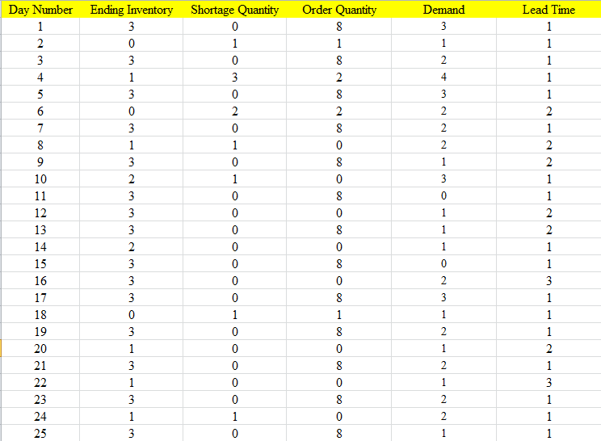

Average ending inventory = 2.84

Average Shortage = 0.32

Average Demand = 1.56

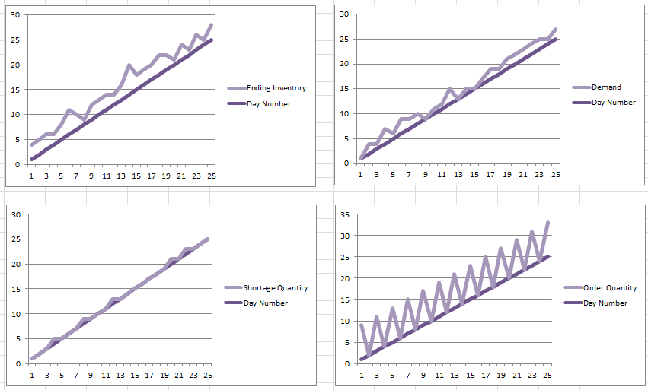

**Questions:**

1. **Give real world examples which can be modelled as inventory systems?**

**Answer**: Real-world examples that can be modeled as inventory systems include:

1. **Retail stores:** Retailers need to manage inventory levels of various products to meet customer demand while minimizing carrying costs and stockouts.
2. **Manufacturing companies:** Manufacturers must control inventory of raw materials, work-in-progress items, and finished goods to ensure smooth production processes and timely deliveries.
3. **Wholesale distributors:** Distributors must balance inventory levels to fulfill orders from retailers and maintain sufficient stock to meet fluctuating demand.
4. **E-commerce businesses:** Online retailers need to manage inventory across multiple warehouses or fulfillment centers to fulfill customer orders efficiently and minimize shipping costs.
5. **Healthcare facilities:** Hospitals and clinics must manage inventory of medical supplies, equipment, and pharmaceuticals to ensure patient care while controlling costs and minimizing waste.
6. **Name simulation language or package which can be used for modeling inventory systems?**

**Answer:** Simulation languages or packages that can be used for modeling inventory systems include:

1. **SimPy:** SimPy is a process-based discrete-event simulation framework implemented in Python. It allows users to model complex systems, including inventory systems, by defining processes and events.
2. **Arena:** Arena is a simulation software developed by Rockwell Automation. It provides a graphical interface for building and simulating discrete-event simulation models, making it suitable for modeling inventory systems.
3. **AnyLogic:** AnyLogic is a multi-method simulation software that supports both discrete-event and agent-based modeling. It provides a user-friendly environment for building complex simulation models, including inventory systems.
4. **MATLAB Simulink:** MATLAB Simulink is a simulation and modeling tool widely used in engineering and research. It offers capabilities for modeling and simulating dynamic systems, including inventory systems, using block diagrams and mathematical models.
5. **ExtendSim:** ExtendSim is a simulation software package that enables users to build discrete-event simulation models for various applications, including inventory management. It provides a visual interface for model development and analysis.

# Outcomes: CO1 Apply the experimental process of a simulation using spreadsheets as well as Simulation language/package.

**Conclusion:** In this experiment, we simulated an Order-Up-To-Level (M, N) Inventory System using Excel spreadsheets. Through the analysis of inventory policies and performance measures, we gained insights into the dynamics and trade-offs involved in managing inventory systems effectively. Further exploration using simulation languages/packages can offer deeper understanding and optimization of inventory management strategies.

# Grade: AA / AB / BB / BC / CC / CD /DD

**Signature of faculty in-charge with date**

# References:

**Books/ Journals/ Websites:**

**Text Book:**

Banks J., Carson J. S., Nelson B. L., and Nicol D. M., “Discrete Event System Simulation”, 3rd edition, Pearson Education, 2001.

# Additional Web Resources:

* Real Queuing Examples:<http://www2.uwindsor.ca/>hlynka/qreal.html

This site contains excerpts from news articlesthat deal with aspects of waiting lines.

* ClearQ :<http://clearq.com/> This company produces “take-a-number” systems for servicefacilities (e.g., delis), but also providesperformance information about the waiting line.
* Qmatic:<http://us.q-matic.com/index.html>Thiscompany produces informational displays andother products to keep customers informedabout waiting times.
* “Queuing Presentation” by Richard Larson, givenat the Institute for Operations Research and the

Management Science[s:http:](http://caes.mit.edu/people/larson/MontrealINFORMS1/sld001.htm)//[caes.mit.edu/people/larson/MontrealINFORMS1/sld001.htm.](http://caes.mit.edu/people/larson/MontrealINFORMS1/sld001.htm)

•The Queuing Theory Tutor

:<http://www.dcs.ed.ac.uk/home/jeh/Simjava/queuei>ng/mm1_q/mm1_q.html

This site has twoanimated displays of waiting lines. The user canchange arrival and service rates to see howperformance is affected.

* Myron Hlynka’s Queuing Page:http:www2.uwindsor.ca/hlynka/queue.html

This web site contains information about waiting linesas well as links to other interesting sites.

* Queuing ToolPa[k:http:](http://www.bus.ualberta.ca/aingolfsson/qtp/)/[/www.bus.ualberta.](http://www.bus.ualberta.ca/aingolfsson/qtp/)c[a/aingolfsson/qtp/](http://www.bus.ualberta.ca/aingolfsson/qtp/)

The Queuing ToolPak is an Excel add-in that allowsyou to easily compute performance measures fora number of different waiting line models